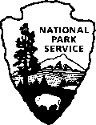
National Park Service
U.S. Department of the Interior
George Washington Memorial Parkway
700 George Washington Memorial Parkway Mclean, VA 22101

Superintendent’s Compendium of Designations, Closures, Permit Requirements and Other Restrictions Imposed Under Discretionary Authority.
703-289-2500 phone

Approved:
JENNIFER MADELLO

Digitally signed by JENNIFER MADELLO
Date: 2025.12.04 16:52:33 -05'00'

The George Washington Memorial Parkway (GWMP) administers federal parkland located in District of Columbia, Maryland and Virginia. The GWMP includes, but is not limited to:

- Arlington House, The Robert E. Lee Memorial
- Arlington Memorial Bridge
- Memorial Avenue
- Belle Haven Park & Marina
- Clara Barton National Historic Site
- Clara Barton Parkway
- Collingwood Picnic Area
- Columbia Island Marina
- Daingerfield Island
- Dyke Marsh Wildlife Preserve
- Fort Hunt Park
- Fort Marcy
- Glen Echo Park
- Gravelly Point
- Great Falls Park, Virginia
- Jones Point Park
- Lady Bird Johnson Park (formerly known as Columbia Island)
- Lyndon Baines Johnson Memorial Grove-on-the-Potomac
- Mount Vernon Circle (Terminus) and Parking Lots
- Mount Vernon Trail
- Netherlands Carillon
- Potomac Heritage Trail
- Riverside Park
- Roaches Run Waterfowl Sanctuary
- South Turkey Run Park
- Spout Run Parkway
- Theodore Roosevelt Island
- Turkey Run Park
- U.S. Marine Corps War Memorial
- Washington Sailing Marina

INTRODUCTION

Superintendent’s Compendium Described
The Superintendent’s Compendium is the summary of park specific actions implemented under 36 Code of Federal Regulations (36 CFR). It serves as public notice, identifies areas closed for public use, provides a list of activities requiring either a special use permit or reservation, and elaborates on public use and resource protection regulations pertaining specifically to the administration of the park. The Superintendent’s Compendium does not repeat regulations found in 36 CFR and other United States Code and CFR Titles, which are enforced without further elaboration at the park level.
The regulations contained in 36 CFR, Parts 1-7, are the basic mechanism used by the National Park Service (NPS) to preserve and protect the natural and cultural resources of the park, manage visitor use, provide for visitor safety, and protect property within the park. Parts 1 through 6 are general regulations applicable to all areas of the national park system, and Part 7 contains special regulations specific to individual parks. Within some of these Part 1-7 sections, the Superintendent is granted discretionary authority to develop local actions to be responsive to the needs of a specific park resource or activity, park plan, program, and/or special needs of the general public.

This Compendium should be used in conjunction with Title 36 CFR, Parts 1-7, to more fully understand the regulations governing the use and enjoyment of all the areas of the national park system.
A copy of Title 36, CFR, can be purchased from the U.S. Government
Printing Office at: Superintendent of Documents
P.O. Box 371954
Pittsburgh, PA 15250-
7954
The CFR is also available online at: https://www.ecfr.gov/current/title-36/chapter-I

Applicability of the Compendium
The rules contained in this Compendium apply to all persons entering, using, visiting or otherwise present on federally owned lands, including submerged lands, and waters administered by the NPS within the legislative boundaries of the park. This includes all waters subject to the jurisdiction of the United States, including all navigable waters.

Enforcement of Compendium Requirements
NPS Law Enforcement Park Rangers and United States Park Police enforce the requirements of the United State Code, 36 CFR, and this Superintendent’s Compendium.

Penalties for Not Adhering to the Compendium Requirements
A person who violates any provision of the regulations found in 36 CFR, Parts 1-7, or provisions of this Compendium, is subject to a fine as provided by law (18 U.S.C. 3571) up to $5,000 for individuals and $10,000 for organizations, or by imprisonment not exceeding six months (18 U.S.C. 3559), or both, and shall be adjudged to pay all court costs associated with any court proceedings. You may receive a list of fines associated with any particular provision by contacting the US Park Police or the park address.

Comments on the Compendium
The Compendium is reviewed annually and revised as necessary. The park welcomes comments about its program and activities at any time.

Effective Date of the Superintendent Compendium
The Superintendent’s Compendium is effective on the approval date listed on the first page of this document and remains in effect until revised.

Additional Information
Some of the terms used in this Compendium may have specific meanings defined in 36 CFR
1.4 Definitions.

Availability
Copies of the Compendium are available at 700 George Washington Memorial Parkway, Mclean, VA 22101. It may also be found at https://www.nps.gov/gwmp/learn/management/lawsandpolicies.htm

Superintendent’s COMPENDIUM
Written determinations that explain the reasoning behind the Superintendent’s use of discretionary authority, as required by Section 1.5(c), appear in this document identified by italicized print.

36 CFR §1.5 – VISITING HOURS, PUBLIC USE LIMITS, CLOSURES,AND AREA DESIGNATIONS FOR SPECIFIC USE OR ACTIVITIES
(a)(1) The following visiting hours and public use limits are established for all or for the listed portions of the park, and the following closures are established for all or a portion of the Park to all public use or to a certain use or activity:

Visiting Hours:
GWMP areas are closed to the public between the hours 10:00 PM and 6:00 AM unless otherwise posted or as noted below:
  - Arlington House, The Robert E. Lee Memorial, is open:
- All Year 9:30 AM to 4:30 PM
- Closed Thanksgiving Day, Christmas Day and New Year's Day
  - Arlington Ridge Park grounds, which includes the U.S. Marine Corps War Memorial, and the Netherlands Carillon grounds, are open: 6:00 AM to 12:00 AM (midnight) daily
  - Netherlands Carillon (structure) is closed for all uses at all times, except administrative use
  - Restrooms at the U.S. Marine Corps War Memorial are open.
- April 15 through October 31 7:30 AM to 8:00 PM
- November 1 through April 14 7:30 AM to 6:00 PM
  - Belle Haven Marina boat ramp is open Sunrise to Sunset.
- Belle Haven Marina Offices are open:
  - April 1 through October 31, 9:00 AM to 7:00 PM seven days per week.
- November 1 through March 31 9:00 AM to 5:00 PM seven days per week
  - Clara Barton National Historic Site is open from 1:00 PM to 5 PM on Friday and Saturday by tour only
  - Columbia Island Marina and Daingerfield Island/Washington Sailing Marina are open:6:00 AM to 12:00 AM (midnight) daily; Marina slip holders may use the Marina docks for vessel arrivals and departures during closed hours
  - Glen Echo Park is open: 6:00 AM to 1:00 AM daily
  - Gravelly Point Parking Lot and Boat Ramp areas are open: 6:00 AM to 10:00 PM
  - Great Falls Park is open:
- 7:00 AM to thirty (30) minutes after sunset, daily.
- Great Falls Park Visitor Center is open:
- At daylight savings beginning (2nd Sunday in March) 10 AM to 5 PM until 1st Sunday in November
- At daylight savings end (1st Sunday in November) 10 AM to 4PM until 2nd Sunday in March
  - Closed Christmas Day.
  - The parking lot at Roaches Run on the southbound lanes of the George Washington Memorial Parkway is open from 6:00 AM to 12:00 AM (midnight)
  - The Clara Barton Parkway
- Access in and out of DC across Chain Bridge is restricted during morning (6:15 AM to 10:00 AM) and afternoon (2:45 PM to 7:15 PM) rush hours.
- From 6:15 AM to 10:00 AM, no traffic allowed Westbound from Chain Bridge. Two lanes allowed Eastbound from Chain Bridge parking lot to the Chain Bridge.
- From 2:45 PM to 7:15 PM access to the Eastbound Clara Barton Parkway from the MacArthur Boulevard Exit (aka Glen Echo turn-around) and Chain Bridge will be closed. Vehicles leaving the parking areas, along the parkway during this timeframe required to exit Eastbound then make a U- turn at the Chain Bridge Parking area to travel westbound. There is no access to Chain Bridge from 2:45 PM to 7:15 PM.
  - GWMP Headquarters Offices at Turkey Run Park are open 8:00 AM to 4:15 PM, Monday through Friday, and closed on all federal holidays.
  - The George Washington Memorial Parkway, the Clara Barton Parkway, and Spout Run Parkway roadways are normally open 24 hours a day year-round. Certain weather conditions or incidents/events may require a temporary closure of GWMP-administered roadways.

  - Mount Vernon Trail is closed between 10:00 PM and 6:00 AM, except for bicycle and pedestrian commuter traffic.

Public Use Limits:
  - Maintenance and repair of any vehicle, except for emergencies, is prohibited in all public use areas.
  - Washing and waxing, of vehicles is prohibited anywhere in all public use areas.
  - Flying kites using glass-coated or other abrasive and/or non-biodegradable kite string or line in the park is prohibited. The flying of kites must not negatively affect other visitors. Each kite being flown must be under direct, constant control of a person, and all persons engaged in kite flying must make a reasonable effort to prevent resource damage, including collecting all kite materials. The flying of kites may not interfere with NPS or United States Park Police (USPP) operations. Kites should be flown at least 50 yards away from trees and may not be flown at Gravelly Point and Daingerfield Island (including the Washington Sailing Marina).
  - Filming, still photography, and audio recording activity may require a permit, consistent with 54 U.S.C. 100905.
- Filming, still photography, and audio recording activity that occurs in closed areas, requires exclusive use of a site or area, or involves a set or staging equipment other than handheld equipment (such as a tripod, monopod, and handheld lighting equipment) requires a permit, unless the activity is affiliated with an activity or event that has been allowed under a written authorization, such as a special use permit.
- Filming, still photography, and audio recording that involves more than eight individuals requires a permit, unless the NPS has specifically notified an individual or group that a permit is not required, or if the activity is affiliated with an activity or event that has been allowed under a written authorization, such as a special use permit.
- If a permit is required for the reasons stated above, or if the NPS otherwise determines and then notifies an individual or group that a permit is required for a filming, still photography, or audio recording activity, then engaging in that activity without a permit is prohibited. Violating a term or condition of a permit issued by the NPS for a filming, still photography, or audio recording activity is prohibited, and may result in the suspension or revocation of the permit, in addition to any penalties that may apply under 36 CFR 1.3.

Determination: Federal law at 54 U.S.C. 100905 states that permits and fees are not required for filming, still photography, or audio recording in park areas if certain requirements are met. These requirements address various topics, including, but not limited to, group size, location, equipment, potential impacts to resources and visitors, and the likelihood that the NPS will incur related administrative costs. If any of these requirements are not met, the law allows the Secretary of the Interior, acting through the NPS, to require a permit for the subject activity. Permit requirements are imposed by the superintendent under discretionary authority provided by 36 CFR 1.5(a)(2), which allows the superintendent to impose conditions or restrictions on a use or activity, consistent with applicable legislation, to implement management responsibilities. The general regulations for permits in 36 CFR 1.6 do not apply to permits issued for filming, still photography, and audio recording, which instead are governed by the statutory provisions in 54 U.S.C. 100905. The imposition of permit requirements, on a case-by-case basis, for filming, still photography, or audio recording does not require rulemaking under 36 CFR 1.5(b). Requiring a permit with reasonable terms and conditions in accordance with statutory requirements at 54 U.S.C. 100905 is not highly controversial, will not result in a significant alteration in the public use pattern of the System unit, will not adversely affect the System unit’s natural, aesthetic, scenic or cultural values, or require a long-term or significant modification in the resource management objectives of the System unit, because the permit requirement is limited in time and scope to the specific activities authorized by the permit, which contain terms and conditions that protect the values, resources, and visitors of the System unit, and implements federal law.
  - No cleats are allowed, except on designated athletic fields.
  - No access to turf is allowed during frosts, saturated conditions, or conditions that would cause turf damage. Notice of the closure will occur through one of the following signage, fencing, flags, posting on the Park’s website, in the park permit office, by ranger, or officer on-site.
  - Digging or otherwise damaging turf is prohibited.
  - Visitors are required to wear or carry a personal flotation device during boating activities.
  - Staking is permitted in most areas of the Park if stakes are under 18" or a utility location survey was completed.

  - Tents and canopies must be open on all four sides.
  - The use of park tap water is limited to one gallon per person per day.
  - Legally taken, tagged wildlife may be transported through federal land administered by GWMP.

Parking:
  - Parking is permitted in designated areas only.
  - Parking is not permitted on any grass or lawn areas except by permit unless otherwise posted.
  - Parking in closed areas is prohibited.
  - Commuter parking is prohibited in all George Washington Memorial Parkway parking areas.
  - Overnight parking is prohibited on all National Park Service land administered by the George Washington Memorial Parkway unless subject to a permit issued by the National Park Service. The only exception is a vehicle belonging to a slip-holder at the three concession-operated marinas (Belle Haven Marina, Columbia Island Marina, and Daingerfield Island/Washington Sailing Marina).
  - Unless otherwise posted, parking for other than recreational purposes for longer than six hours Monday through Friday is prohibited in the following lots:
- Turkey Run Park
- Scenic Overlooks #1 & #2
- Theodore Roosevelt Island
- Lady Bird Johnson Park
- LBJ Memorial Grove
- Columbia Island
- Gravelly Point
- Glen Echo Park
- Daingerfield Island
- Belle Haven Park
- Clara Barton National Historic Site
- Roaches Run Parking Lot
- Jones Point Park
  - Parking in the parking lot at the U.S. Marine Corps War Memorial (Iwo Jima Memorial) for longer than one
    - hour is prohibited.
  - Front-end parking is required in the following parking lots:
- Turkey Run Park
- Fort Marcy
- LBJ Memorial Grove
- Columbia Island
- Daingerfield Island overflow parking
- Riverside Park

Closures:
  - Public parking in the area under the Woodrow Wilson Bridge is prohibited .
- Determination: The closure of these lots to the public for parking, as well as to special use vehicular traffic and parking, is necessary to comply with the recommendations of the Transportation Security Administration (TSA). This action is intended to prevent vehicle access to critical structural components of the Woodrow Wilson Bridge and to ensure the safe use of the area by pedestrians and cyclists
  - Launching, landing, or operating an unmanned aircraft from or on lands and waters administered by the National Park Service within the boundaries of George Washington Memorial Parkway is prohibited except as approved in writing by the Superintendent.
- Determination - The Superintendent has determined recreational use of unmanned aircraft within the George Washington Memorial Parkway may conflict with, or impact, a variety of park uses including visitor experience of unimpaired view sheds through the Mather Gorge and along the Potomac River; the disturbance, displacement or harassment of wildlife in areas such as, but not limited to, Great Falls Park, Roaches Run Waterfowl Sanctuary, Theodore Roosevelt Island and Dyke Marsh Wildlife Preserve. Their use could also lead to the creation of public safety hazards per operation near roadways or large aggregations of visitors. A hazard would also exist in a large portion of the parkway that experience overflights of commercial aircraft to and from Ronald Reagan National Airport in the areas of, but not limited to, Theodore Roosevelt Island, Gravelly Point, Lady Bird Johnson Park, Belle Haven Park, Jones Point Park and Collingwood Picnic Area. The presence of unmanned aircraft may also pose a serious interruption to the solemnity and memorialization intended for areas such as, but not limited to, Fort Marcy, US Marine Corps War Memorial, LBJ Memorial Grove on the Potomac, Arlington Memorial Bridge and Memorial Avenue, Arlington House, The Robert E. Lee Memorial, Clara Barton National Historic Site, Glen Echo Park and Fort Hunt Park.
- Definition: The term “unmanned aircraft” means a device that is used or intended to be used for flight in

the air without the possibility of direct human intervention from within or on the device, and the associated operational elements and components that are required for the pilot or system operator in command to operate or control the device (such as cameras, sensors, communication links.) This term includes all types of devices that meet this definition (e.g. model airplanes, model rockets, quadcopters, drones) that are used for any purpose, including for recreation or commerce.
  - Parasailing, wind boarding, and gliding are prohibited.
- Determination: Prohibition of parasailing, wind boarding, and gliding is necessary for the maintenance of public health and safety, protection of environmental or scenic values, protection of natural or cultural resources
  - Designated portions of the Potomac River Virginia shorelines adjacent to Great Falls Park, Virginia is closed to the public and may only be accessible through a Special Use Permit. This closed parkland is depicted on the attached map and is more particularly described as being approximately 1680 feet in length and 250 feet in width along the Potomac River, beginning at the upper edge of Fisherman's Eddy, directly below Overlook Two, and extending upstream to a point in line with Mine Run Stream; and extending from the eastern edge of the park trail that leads to River Bend County Park.
Access into the Potomac River between the downstream portion of Overlook #2 to the Aqueduct Dam is prohibited. Fishers and boaters are encouraged to use Fisherman's Eddy to access the Potomac River.
- Determination: Please reference the GWMP "Record of Determination for Closure of Designated Portions of the Potomac River Virginia Shoreline Adjacent to the Great Falls of the Potomac.
  - Access to the rocky environments south of Overlook 3 to the downstream side of Flat Iron climbing area is restricted as depicted on the attached map. Access is by permit only, which is issued to individuals or groups who wish to access the restricted area for climbing, fishing, and for research or similar special uses. Access to points (climbing routes, fishing spots on Potomac River shoreline) in the restricted area is only by a designated marked trail (yellow blaze).
- Determination: The purpose of the restriction is to preserve globally rare plant communities endemic to Great Falls and the Potomac River Gorge. Permits are available at the Great Falls Park visitor center.
  - The left lane of the Loop Road at Fort Hunt Park is closed to vehicle traffic beyond Parking Lot A around to the Entrance Road.
- Determination: Closure of this lane to vehicle traffic is required to allow for safe pedestrian and bicycle use of the left lane.
  - Jones Point Park docks are for canoe and kayak launching purposes only.
- Determination: Limitation of the Jones Point Park docks to canoe and kayak launching is necessary for the maintenance of public health and safety and the protection of natural resources
  - Picnicking is only permitted in designated areas. Refer to the park Unigrid maps for picnic areas.
- Determination: Limitation of picnicking to designated areas is necessary for the maintenance of public health and safety, protection of environmental or scenic values and the protection of natural or cultural resources.
  - Food and drink are prohibited in the immediate vicinity of all statues and memorials.
- Determination: Prohibition of food and drink in the immediate vicinity of all statues and memorials is necessary for the protection of scenic values and the protection of cultural resources
  - Golf playing and hitting golf balls are prohibited within the George Washington Memorial Parkway.
- Determination: Playing golf and hitting golf balls presents a safety hazard to visitors outside of areas designed for that use.
  - Pitching of horseshoes is prohibited, except in designated areas at Fort Hunt Park.
- Determination: Pitching of horseshoes presents a safety hazard outside of areas designed for that use.
  - Kite flying is prohibited at Gravelly Point and Daingerfield Island (including Washington Sailing Marina).
- Determination: Kite flying in the immediate vicinity of an airport presents a clear public danger.
  - The use of portable ramps and similar materials used for performing tricks with bicycles, skateboards, or other devices is prohibited on all GWMP property.
- Determination: The use of portable ramps presents a safety hazard to visitors outside of areas designed for that use.
  - The use of wind propelled devices, motorized skateboards, scooters, and any other motorized device (except as authorized under 36 CFR §4.30 – BICYCLES) is prohibited on the Mt. Vernon Trail, in the Ft. Hunt picnic areas, and on all other GWMP property.
- Determination: The use of these devices presents a safety hazard to visitors outside of areas designed for that use.
  - The use of electric motorized scooters, Segways or other similar devices is prohibited on all GWMP property except for use by individuals with disabilities.
- Determination: The use of motorized scooters presents a safety hazard to visitors outside of areas designed for that use.
  - "Liveaboards" on vessels moored at NPS marinas are prohibited. The NPS will consider a "liveaboard" as a person who stays overnight on board a vessel moored at the marina for four (4) or more nights in any seven day period and more than three (3) occasions in any twelve (12) month calendar period.
- Determination: Restrictions on camping are inclusive of marinas and boats docked there.

  - A vessel's internal combustion engine may not be used (while a vessel using electric trolling motor, sail, or paddling is allowed); no more than three vessels of an organized group at any one time is allowed within designated areas of Dyke Marsh Wildlife Preserve during the Marsh Wren (Cistothorus palustris) and Least Bittern(Ixobrychus exilis) nesting season (May 15 through August 25).
- Determination provided in a separate document, with restrictions incorporated into updated compendium "Record of Determination at Dyke Marsh Wildlife Preserve for a No Wake Zone and Boating Limits in Designated Areas During the Marsh Wren and Least Bittern Nesting Season"
  - Moon bounces and other air-filled land-based recreational devices, simulated rides, rock climbing walls and game trucks are prohibited.
- Determination: The use of these recreational devices can damage park resources.
  - Pedestrian use of the park is restricted to designated walkways and trails.
- Determination: Restricting hikers and pedestrians to the park’s trails and walkways helps protect the fragile habitat and natural resources of the park.
  - Ice skating is prohibited on all waters, to promote visitor safety.
- Determination: Skating on ice can present a safety hazard to visitors.
  - Climbing, rappelling, BASE jumping, bungee jumping, and slacklining, etc. is prohibited unless otherwise designated. Installing, attaching, or using any fixed tensioned ropes and/or webbing (slacklines), and other devices to trees is prohibited.
- Determination: These activities can damage park resources.
  - Climbing activities may be permitted at Great Falls Park. See section II. 36 CFR §1.6 – ACTIVITIES THAT REQUIRE A PERMIT for specific details.
  - Ball playing, flying disc throwing, and kite flying are prohibited in the area of any national memorial, including, but not limited to, Arlington House, the Robert E. Lee Memorial, the U.S. Marine Corps War Memorial, Netherlands Carillon, Theodore Roosevelt Island Plaza, or Memorial Avenue.
- Determination: These activities in the vicinity of memorials negatively impacts the sanctity of the memorials creates the possibility of damage.
  - Swimming or wading into any waters from the shorelines of the areas administered by the George Washington Memorial Parkway is prohibited.
- Determination: Swimming or wading from the shorelines of the George Washington Memorial Parkway presents a safety hazard for visitors.
  - Ramps leading into the George Bush Center for Intelligence may be closed by the CIA.
- Determination: Closing vehicular entryways to the George Bush Center for Intelligence may be necessary for the purpose of national security.
  - All federal land under the administration of GWMP areas are closed to the viewing of wildlife with an artificial light, except for GWMP approved resource management activities.
- Determination: Using artificial light to view animals is harassment and can negatively impact animals.

Areas Designated for a Specific Use or Activity:
  - Unless operated by a person with a disability, motorized personal mobility devices may only operate on sidewalks or multi-use trails in the following locations:
- Mount Vernon Trail
- Users of motorized personal mobility devices must adhere to the following operating standards, most of which are also required under District of Columbia regulations on safe use of electric personal assistive mobility devices:
- No person under 16 years of age may operate a motorized personal mobility device, unless they have a disability.
- A person shall operate any motorized personal mobility device in a safe and non- hazardous manner so not to endanger oneself or any other person. The speed of the motorized personal mobility device will not exceed 15 M.P.H.
- Motorized personal mobility devices should be parked alongside the bicycle racks throughout the park.
- Mini motorcycles (“pocket rockets,” dirt bikes, or similar) that are not licensed for street use are prohibited.
  - Athletic Fields
- The park has identified the following locations as athletic fields:
- Ballfields at Fort Hunt. Reservations for all ballfields are tied to picnic areas (A, B and D) at Fort Hunt Park and can be made by telephone (1-800-444-6777) and internet only. Website http://www.recreation.gov (Note: Ballfields are not maintained to field specifications.)
- Gravelly Point has a field area that requires a permit for athletic activities, but is not maintained to field specifications.
  - First Amendment Areas

- The park has identified the following locations as designated First Amendment areas:
- Memorial Avenue east of Route 110 - Limited to 25 maximum people, with limited and approved equipment.
- Mt. Vernon Circle - Limited to 50 maximum people, with limited and approved equipment. Must clear Mt. Vernon Circle by 9:30 a.m.
- Netherlands Carillon grounds are limited to 1000 maximum people, with limited and approved equipment
  - Great Falls Park – Limited to 75, with limited and approved equipment.
  - Boat Launching:
- Please refer to §3.8 of this document for detailed vessel operation conditions.
  - Docking or Mooring Areas:
- Vessels are permitted to dock or moor at the marinas in the George Washington Memorial Parkway managed under a concessions contract or similar instrument, or as approved by the Superintendent.
  - Weddings:
- The park has identified the following areas approved for wedding ceremonies:
  - Netherlands Carillon – 100 person limit
  - Theodore Roosevelt Island – 25 person limit
  - Great Falls Park – 25 person limit
  - Lady Bird Johnson Memorial – 25 person limit
  - Lyndon Baines Johnson Memorial – 25 person limit
  - Navy and Merchant Marines Memorial "Waves and Gulls" – 25 person limit
  - Military Ceremony
- The park has identified the following areas approved for military ceremonies:
  - U.S. Marine Corps War Memorial
  - Lyndon Baines Johnson Memorial
  - Navy and Merchant Marine Memorial
  - Netherlands Carillon
  - Seabees Memorial
  - Foot/Bike Races (see section 36 CFR §1.6-activities that require a permit)
  - Hiking and Pedestrian Use:
- Hiking and pedestrian use is restricted to the park’s trails and walkway system.

36 CFR §1.6 – ACTIVITIES THAT REQUIRE A PERMIT

The following is a compilation of those activities for which a permit from the Superintendent is required:
  - Advertisements: Display, posting or distribution
  - Aircraft & Air Delivery
  - Attaching or tying objects to, nailing, jumping from or swinging by ropes or other means from aqueducts, bridges, structures, trees, or other vegetation, construction and use of rope traverses or slack lining
  - Audio Disturbances
  - Carry or possess a weapon, trap, or net.
  - Filming- Some filming, still photography, and audio recording (depends upon the facts and circumstances; contact the park for more information). 36 CFR 1.5(a)(2) and 54 U.S.C. 100905.
  - Conduct a sports event, pageant, regatta, public spectator attraction, entertainment, ceremony, and similar events.
  - Construction of buildings, facilities, trails, roads, boat docks, path, structure, etc.
  - Engaging in or soliciting any business (Requires a permit, contract or other written agreement with the United States, or must be pursuant to special regulations).
  - Exceeding of established vehicle load, weight and size limits
  - Explosives:
    - Use or possess fireworks.
    - Use, possess, store, and/or transport explosives or blasting agents.
  - Fishing tournaments and rodeos
  - Livestock use
  - Memorialization
    - Erection of monuments (Requires approval from Regional Director; erection of monuments in the District of Columbia requires an Act of Congress)
  - Operation of a solid waste disposal site
  - Picnicking in Areas A-D at Fort Hunt Park during the periods April- October.
    - Reservations are required daily for Areas A-D. Area E is always open for use on a first-

come first-serve basis. Use of park electrical outlets at Ft. Hunt Park is allowed at Area A with a reservation only.
    - Fort Hunt Park picnic reservations are issued by a NPS reservation agent for George Washington Memorial Parkway. Reservations for Fort Hunt Park are accepted by telephone (1-800-444-6777) and internet (www.recreation.gov )only.
    - Picnic permits are not available on July 4th.
    - Reservation of more than one picnic area at Fort Hunt for the same day requires an additional permit issued under 36 CFR 7.96. Permit applications need to be made 30 days prior to an event. Additional information and application can be found at https://www.nps.gov/nama/planyourvisit/permitsandreservations.htm or by calling 202-245-4715
    - Multiple reservations of areas C areas 1, 2, and/or 3 can be made at www.recreation.gov, without an addition permit.
  - Public assemblies, meetings, gatherings, demonstrations, parades and other public expressions of views
  - Removal of a downed aircraft
  - Residing on federal lands
  - Sale of intoxicants on private lands.
  - Sale or distribution of printer matter that is not solely commercial advertising.
  - Scattering ashes from human cremation
  - Soliciting or demanding gifts, money goods or services
  - Specimen collection
  - The possession and consumption of alcoholic beverages
  - Use of a submersible
  - Use of a vessel
  - Use of commercial vehicles on park area roads
  - Weddings

Races
  - Pedestrian and cycling events on the George Washington Memorial and Spout Run Parkways; Mount Vernon Trail; Arlington Ridge Park (United States Marine Corps War Memorial and Netherlands Carillon); Arlington Memorial Bridge; Memorial Avenue, Fort Hunt Loop Road; Great Falls Park, Virginia, and all other sites under the administration of the George Washington Memorial Parkway. (Determination provided in a separate document, with restrictions incorporated into updated compendium: see Records of Determination for Great Falls and GWMP Races)
    - Applications for pedestrian and cycling special events will be accepted on a first-come, first-serve basis, up to one year in advance of the proposed race date, which includes pre-event set up and post-event take down.
    - Races requiring road closures will not be conducted on sites/areas under the administration of the George Washington Memorial Parkway from Memorial Day Weekend through Labor Day Weekend.
    - Permittee must provide for and require all participants and support staff to be clearly identified. Participants must be clearly identified through clothing items or bibs. Support staff must be clearly identified through t-shirts naming the event.
    - Marshalls must wear reflective vests and be stationed at every intersection.
    - At pre-determined “Off the Course” time, permittee is responsible for directing all participants to conclude the race on the course and provide a vehicle to pick-up participants who have not finished the course by the “off the course” time limit.
    - When crossing roads, participants must stay within the boundaries of the painted crosswalk.
    - No fees (including electronic transactions) or charges may be collected on park land and the special event permittee may not engage in or solicit any business on park land. All participants must be pre-registered.
    - Also see 36 CFR §4.30 – BICYCLES for additional items specific to bike races.
    - Locations that are approved for starting and ending a foot race/bike race:
      - Gravelly Point Park
      - Fort Hunt Park (must reserve a pavilion)
      - Belle haven Park
      - Jones Point Park
      - Daingerfield Island

      - Arlington Ridge
      - Great Falls Park, Virginia (foot races only)
    - Location Specific Requirements for Races
- Pedestrian and cycling events on the George Washington Memorial, Clara Barton, and Spout Run Parkway – maximum of three per year (except the Marine Corps Marathon and the Parkway Classic) for each parkway.
  - Will be allowed between Labor Day weekend and Memorial Day weekend.
  - Must begin no later than 8:00am
  - Parkways must be cleared for reopening by 9:30am
  - Maximum participation will not exceed 5,000.
  - Events requiring road closures will not be permitted on Thanksgiving Day, Christmas Day and New Year’s Day
- Pedestrian and Cycling special events at Great Falls Virginia
  - Pedestrian events will be allowed between September – March excluding Federal Holidays
  - Races will end by 9:30am and are limited to a maximum of 150 participants.
  - Cycling events are not allowed.
  - Must remain on official established trails
- Pedestrian and cycling special events at Arlington Ridge Park (United States Marine Corps War Memorial and the Netherlands Carillon) with the exception of the Marine Corps Marathon
  - Will be allowed between Labor Day weekend and Memorial Day weekend
  - Must begin no later than 8:00am
  - Must be cleared by 9:30am
  - No activities are permitted on the parade field, reviewing platform and plaza levels
  - No events are permitted the second Tuesdays of June, July, and August and Veteran’s Day
  - No events are permitted Memorial Day, Saturdays of June, July, and August,
Labor Day, and Independence Day
  - Races requiring road closures will not be permitted on Thanksgiving Day, Christmas Day and New Year’s Day
- Pedestrian and cycling events along Arlington Memorial Bridge and Memorial Avenue (except the Marine Corps Marathon, Rolling Thunder, Army Ten-Miler, and Cherry Blossom)
  - Only permitted on the weekends between Labor Day weekend and Memorial Day weekend
  - Must begin no later than 8:00am
  - Must be cleared by 9:30am
  - Events requiring road closures will not be permitted on Thanksgiving Day, Christmas Day and New Year’s Day
- Pedestrian and cycling special events on the Mount Vernon Trail (MVT) – maximum of two per month
  - Will be allowed November 1 through the third weekend in April with a maximum number of 300 participants
  - Between the fourth week in April through October 31 with a maximum of 100 participants
  - Start location can be Gravelly Point Park, Belle Haven Park, Jones Point Park, or Dangerfield Island
  - Must begin no later than 8:00am
  - Must be cleared by 9:30am
  - For events starting on park property, must maintain a dispersal start with a maximum of 15 participants at a time entering the MVT in 4-minute intervals
  - Participants shall maintain adequate dispersal while entering and traveling along the MVT in order to share the trail with the general public
  - Must maintain a maximum of 15 single file participants per group at a time on the MVT
  - Events requiring road closures will not be permitted on Thanksgiving Day, Christmas Day, and New Year’s Day

  - The permittee is required to make an announcement to all participants at the start of the foot race, the walk, and/or the bike ride that they are required to abide by the following while on the Mount Vernon Trail:
  - Participants may run only in the right lane, except when passing. When passing in the left lane, runners must yield to any oncoming traffic.
  - Participants are prohibited from impeding or preventing the general public from using any part of the Mount Vernon Trail
- Pedestrian and cycling special events on the Fort Hunt Loop Road
  - Year-round events are permitted at Fort Hunt Park. If the event occurs during the Fort Hunt Park reserved picnic season, permittee must also obtain a picnic permit for one of the reserved areas. Visit the website www.recreation.gov for more information and to make a reservation.
  - Events must begin no later than 8:00 a.m.
  - All roads must be cleared no later than 9:30 a.m.
  - Maximum participation will not exceed the carrying capacity of the reserved picnic area(s)
  - Must maintain a dispersal start with a maximum of 25 participants at a time entering the Fort hunt Loop Road in 4-minute intervals.
  - Participants shall maintain adequate dispersal while traveling along the inner lane of Fort Hunt Loop Road in order to share the inner lane with the public.
  - Participants must run single file clockwise in the inner lane of Fort Hunt Loop Road
  - The outer lane of Fort Hunt Loop will remain open and is reserved for police, emergency and administrative vehicles and closed to the public.
  - Events requiring road closures will not be permitted on Thanksgiving Day, Christmas Day, and New year’s Day

GENERAL REGULATIONS

36 CFR §2.11 – PICNICKING
- Picnicking is permitted in designated areas in section I of this document.

Conditions for Picnicking:
- Picnic areas are available to the public on a first-come first-serve basis except as listed in section II, items requiring a permit.
- The use of tents, canopies or shelters by picnickers will only be allowed if they are free standing, self-supporting, weighted and placed in a manner that will not restrict a view shed and allow other park visitors access to all public areas. Use of tents, tarps, or shelters that are wholly or partially supported by using stakes and/or guylines are prohibited.

36 CFR 2.13 – FIRES
- (a)(1) The lighting or maintaining of fires is generally prohibited, except as provided for in the following designated areas and/or receptacles, and under the conditions noted:

Receptacles Allowed:
- Open charcoal fires are only permitted in government-provided or private grills.

Designated Areas:
- Belle Haven
- Collingwood Picnic Area
- Great Falls Park Picnic Area
- Fort Hunt

Established Conditions for Fires:
- A fire may be ignited and maintained only by using fuel sources designed and commonly used for warmth or the preparation of food, such as charcoal briquettes or natural firewood. Lighting or maintaining a fire with other materials including, but not limited to, flammable liquids, garbage, fireworks, plastics, aerosol canisters, batteries, or other manufactured or synthetic materials, is prohibited.
  - Determination: This action is necessary for the maintenance of public health and safety, protection of environmental or scenic values, protection of natural or cultural resources, and the implementation of management responsibilities. Materials other than approved

combustibles – especially fire accelerants and substances prone to wind transport or explosion – creates serious risks when used to light or maintain fires. These combustibles can ignite or spread wildfires that directly threaten people and valuable resources and assets. The burning of manufactured or synthetic materials can contribute to air pollution, contaminate soil and water, and be toxic to humans and the environment. Less restrictive measures, such as an education campaign informing visitors of the risks of using certain materials to light or maintain a fire, would not be commensurate with the substantial risks associated with those activities and could lead to adverse outcomes that might be prevented by establishing an enforceable condition.
- A permit may authorize open flame candles relating to a demonstration, but such candles must be hand-held at all times and equipped with drip protectors to protect park resources. Because wax can cause permanent damage unless removed properly and in a timely fashion, if wax drips occur in park areas, they shall contact the park’s Superintendent to ensure proper removal treatment occurs.
- Grills and charcoal fires are prohibited in GWMP managed areas within the boundaries of Arlington County, Alexandria City, and the District of Columbia on July 4th.
- At Columbia Island Marina, Washington Sailing Marina, and Belle Haven Marina charcoal or gas grills, or open flames of any type, are not allowed on the docks or on any vessel tied to the docks.

(b) Fires must be extinguished according to the following conditions:
- It is prohibited to extinguish charcoal fires by spreading on any ground surface or dumping in any body of water. It is the responsibility of the user to extinguish the fire and remove all fire by-products from the park upon completion of use.

36 CFR §2.14 – SANITATION and REFUSE
- (a)(8) In developed areas, the disposal of human body waste is prohibited, except at the following designated locations or fixtures provided for that purpose:
  - At marinas managed under a concessions contract or similar instrument

36 CFR §2.15 – PETS
- The following are prohibited:
  - Possessing a pet in a public building, public transportation vehicle, or location designated as a swimming beach, or any structure or area closed to the possession of pets by the superintendent. This subparagraph shall not apply to guide dogs accompanying visually impaired persons or hearing ear dogs accompanying hearing-impaired persons.
    - Arlington House, The Robert E. Lee Memorial
    - Clara Barton House
  - Pets are prohibited from entering the Potomac River from within GWMP managed areas.
  - Failing to comply with pet excrement disposal :
    - Solid pet waste must be collected and disposed of by placing in a trash receptacle or removing it from the park.

36 CFR §2.20 – SKATING, SKATEBOARDS and SIMILAR DEVICES
- Using roller skates, skateboards, roller skis, coasting vehicles, or similar devices is prohibited, except in the following designated areas:
  - The Mt. Vernon Trail
  - The left lane of the Fort Hunt Park picnic area Loop Road
  - Paved areas of Jones Point Park

36 CFR §2.21 – SMOKING
- The following portions of the park, or all or portions of buildings, structures or facilities are closed to smoking as noted:
  - All buildings, structures, or facilities, including picnic pavilions and comfort stations are closed to smoking.
  - Smoking is prohibited within 25 feet of any building entrance.
  - Smoking is prohibited within 500 feet of fuel storage.

36 CFR §2.23 – RECREATION FEES
Recreation fees, and/or a permit, in accordance with 36 CFR part 71, are established for the following entrance fee areas, and/or for the use of the following specialized sites, facilities, equipment or services, or for participation in the following group activity, recreation events or specialized recreation uses:

Entrance Fee Areas:
- Entrance fees are collected at Great Falls Park on the following fee schedule:
  - Per Vehicle: $20
  - Per Person: $10
  - Per Motorcycle: $15
  - Park-Specific Annual Pass: $35
- Special recreation Permit Fees are collected for the use of the Fort Hunt Picnic Areas on the following fee schedule:
  - Area C1 $70 weekday $45.00 /weekend additional
  - Area C2 $125.00 weekday $75.00 /weekend additional
  - Area C3 $70 weekday $45.00 /weekend additional
  - Area A $425 weekday $325.00 /weekend additional
  - Area D $140 weekday $85.00 /weekend additional
  - Area B $275 weekday $150.00 /weekend additional

36 CFR §2.35 –ALCOHOLIC BEVERAGES and CONTROLLED SUBSTANCES
(a)(3)(i) The following public use areas, portions of public use areas, and/or public facilities within the park are closed to consumption of alcoholic beverages, and/or to the possession of a bottle, can or other receptacle containing an alcoholic beverage that is open, or has been opened, or whose seal has been broken or the contents of which have been partially removed:
- The use, sale, or possession of alcoholic beverages is prohibited in all areas of the park except in:
  - designated areas of approved concessions
  - within limited and clearly designated areas if authorized under a specific permit issued by the Superintendent
  - Fort Hunt Areas A through D allow for the possession and consumption of only beer and wine, and only in association with a permit obtained through the Fort Hunt Park Picnic Permit system at www.recreation.gov

36 CFR §2.54 – HORSES and PACK ANIMALS
- The use of horses or pack animals is prohibited outside of the following trails, routes or areas designated for their use:
- The Potomac Heritage Trail

36 CFR §2.62 – MEMORIALIZATION
The scattering of human ashes from cremation is prohibited, except pursuant to the terms and conditions of a permit, or in the following areas and according to the following conditions:
- Great Falls Park

36 CFR §3.7 – WHAT ARE THE NPS PERSONAL FLOATION DEVICE (PFD) REQUIREMENTS?
PFDs must be worn or carried on the designated waters, at the designated times and/or during designated water based activities outlined in §1.5 of this document.

36 CFR §3.8 – WHAT VESSEL OPERATIONS ARE PROHIBITED?
Launching or operating a vessel is prohibited, except at one of the following launch sites:

- Marinas under the management of a concessions agreement or other similar instrument authorized by the Superintendent.
- Gravelly Point
- Kayaks at the Jones Point Park boat launch, Roaches Run, Riverside Park, and at Fisherman’s Eddy and Sandy Landing at Great Falls Park

36 CFR §4.11 – VEHICLE LOAD, WEIGHT AND SIZE LIMITS
The following load, weight and size limits, which are more restrictive than State law, apply to the roads indicated under the terms and conditions, and/or under permit as noted:
- Access to park roads is limited to vehicles not exceeding load, weight and size restrictions. Vehicles may not exceed 10,000 pound gross axle weight unless permitted. All such requests, other than emergency responses, require an application to the NPS for a permit.
No commercial motor vehicles are permitted on park roads. A commercial motor vehicle is defined as: “Any vehicle in excess of 10,000 lbs. Gross Vehicle Weight, 49 CFR 3 §350.105(1)”
- Permits may be granted by the Superintendent for commercial motor vehicles to use park roads. Said permits may limit the size of the vehicle and the route the vehicle may take while on the GWMP or any roads its administers.
- Guidance for commercial motor vehicles, of any size, is found in 36 CFR 5.6 and 7.96(f)

36 CFR §4.21 – SPEED LIMITS
The following speed limits are established for the routes/roads indicated:
- Pursuant to 36 CFR 4.21, the maximum speed limits on all park roads are as posted.
- Speed limits at approximate locations on the George Washington Memorial Parkway:
  - Southbound
    - 50 mph from I-495 south to Windy Run Bridge
    - 40 mph from Windy Run Bridge to Slaters Lane
    - 30 mph from Slaters Lane to Powhatan Street
    - 25 mph from Powatan Street to Hunting Creek Bridge
    - 35 mph from Hunting Creek Bridge to south of Belle View Boulevard
    - 45 mph from south of Belle View Boulevard to Little Hunting Creek Bridge
    - 35 mph Little Hunting Creek Bridge to Mount Vernon Circle.
    - 25 mph at Mount Vernon Circle
  - Northbound
    - 25 mph at Mount Vernon Circle
    - 35 mph after Mount Vernon Circle to Little Hunting Creek Bridge
    - 45 mph from Little Hunting Creek Bridge to south of Belle View Boulevard
    - 35 mph from south of Belle View Boulevard to Hunting Creek Bridge
    - 25 mph from Hunting Creek to Bashford Lane
    - 30 mph from Bashford Lane to Abingdon Drive merge
    - 40 mph from Abingdon Drive merge to Spout Run Parkway
    - 50 mph from Spout Run Parkway to I-495
- Speed limits on Clara Barton Parkway:
  - Eastbound

  - Westbound
- 30 mph from MacArthur Boulevard to Carderock exit
- 50 mph from Carderock exit to Cabin John Parkway
- 45 mph from Cabin John Parkway to prior to Glen Echo exit
- 35 mph from Glen Echo exit to Chain Bridge
- 35 mph from Chain Bridge to Glen Echo exit 25 MPH at Glen Echo exit
- 50 mph beyond Glen Echo exit to MacArthur Boulevard approach
- 30 mph to MacArthur Boulevard

  - Speed limits on Spout Run Parkway:
    - 35 mph for entire parkway
  - Lower speed limits are posted on other GWMP roadways and ramps.

    - Memorial Circle 25 mph

36 CFR §4.30 – BICYCLES
- Any bike race special event that is allowed whether separately or as part of a biathlon/triathlon only, may occur under the following conditions:
  - Permittees must provide for and require all participants to exercise all normal and reasonable safety precautions including observance of all applicable bike course safety notices and the wearing of personal protection equipment such as helmets.
  - Permittee must provide and adequately maintain suitable protective safety devices such as barricades, heavy duty plastic surfaces and fences for the safety of staff, volunteers, and participants. Placement of such devices requires the prior written approval of the National Park Service.
  - For filming on the race/ bike course, only one motor vehicle will be allowed and must be located behind a United States Park Police cruiser leading the runners/bikers and must continue moving with the cruiser throughout the race/bike route.
  - The “transition area”, must be finished with adequate lighting, entrances, and egress points. The fencing design must provide for the safety of participants entering and exiting the transition area as well as for spectators viewing the event for this location.
- Use of bicycle is allowed on park roads, in parking areas and on routes designated for bicycles, with the following exceptions where they are prohibited :
  - Great Falls Park
    - Patowmack Canal Trail
    - River Trail
    - Swamp Trail
    - Swamp-Ridge Connector Trail
    - Matildaville Trail
    - Mine Run Trail
    - Riverbend Road Trail
    - Between Old Dominion Drive and River Bend Road
  - Jones Point Park Trails
  - Theodore Roosevelt Island
  - Dyke Marsh Wildlife Preserve Haul Road
  - Potomac Heritage Trail
  - The George Washington Memorial Parkway roadway from Mount Vernon Circle to Interstate 495 near the American Legion Bridge
  - The Spout Run Parkway Roadway
  - The Clara Barton Parkway Roadway

The following regulations apply to bicyclists on designated trails in George Washington Memorial Parkway:
- Move left only to pass and give ample audible warning when passing other trail users.
- Trail users must keep to the right and travel in single file.
- Commercial or guided bicycle groups are not permitted in any 36 CFR 7.96 restricted area.
- Bicycles should be parked in the bicycle racks.
- All unpaved trails, and off-trail or off-road areas are closed to bicycle use.
- Bicycles must be operated at speeds reasonable for existing conditions. Speed should not exceed 15-mph on paved multi-use recreation trails or 25-mph on paved roadways.
- Bicyclists must adhere to protective equipment requirements and regulations set by the applicable state or county.

E-bikes
- E-bikes are allowed in George Washington Memorial Parkway where traditional bicycles are allowed.
- E-bikes are prohibited where traditional bicycles are prohibited. Except where use of motor vehicles by the public is allowed, using the electric motor to move an e-bike without pedaling is prohibited.
- A person operating an e-bike is subject to the following sections of 36 CFR part 4 that apply to the use of traditional bicycles: sections 4.12, 4.13, 4.20, 4.21, 4.22, 4.23, and

4.30(h)(2)-(5).
- Except as specified in this Compendium, the use of an e-bike within George Washington Memorial Parkway is governed by State law, which is adopted and made a part of this Compendium. Any violation of State law adopted by this paragraph is prohibited.
- Electric bicycle means a two- or three-wheeled cycle with fully operable pedals and an electric motor of not more than 750 watts that meets the requirements of one of the following three classes:
  - “Class 1 electric bicycle” shall mean an electric bicycle equipped with a motor that provides assistance only when the rider is pedaling, and that ceases to provide assistance when the bicycle reaches the speed of 20 miles per hour.
  - “Class 2 electric bicycle” shall mean an electric bicycle equipped with a motor that may be used exclusively to propel the bicycle, and that is not capable of providing assistance when the bicycle reaches the speed of 20 miles per hour.
  - “Class 3 electric bicycle” shall mean an electric bicycle equipped with a motor that provides assistance only when the rider is pedaling, and that ceases to provide assistance when the bicycle reaches the speed of 28 miles per hour.

Appendix A

Public Notice
First Amendment Demonstration and Activities at Arlington House, the Robert
E. Lee Memorial

Freedom of speech, press, religion, and assembly are rights protected by the First Amendment of the Constitution. People may exercise these rights in national parks, but the National Park Service (NPS) retains its responsibility to protect park resources, prevent conflict among park visitors and adhere to federal regulations and policies.

Arlington House, the Robert E. Lee Memorial is located inside of Arlington National Cemetery. Arlington National Cemetery is an entity separate and apart from the National Park Service, and controls access to the Cemetery. Arlington National Cemetery, our nation’s most hallowed ground, is the final resting place for nearly 400,000 active duty service members, veterans and their families. This historic cemetery bears witness to American heritage and the military service and sacrifice of men and women in uniform throughout U.S. history.

By statute, Arlington National Cemetery prohibits first amendment demonstrations and activities that occur 60 minutes before and ending 60 minutes after a funeral, memorial service, or ceremony within 150 feet of a road, pathway, or other route of ingress to or egress from such cemetery property or within 300 feet of such cemetery and impeded the access to or egress from such cemetery cited in 38 U.S. Code § 2413. For this reason, no demonstrations are authorized within the Arlington House, the Robert E. Lee Memorial.
If you have any questions and concerns, please contact the George Washington Memorial Parkway, Chief of Staff or Special Use Permit Coordinator at
(703) 289-2500.

Appendix B

Maps

- Great Falls, VA Closure for Rocky Environs South of Overlook 3
- Great Falls, VA Closure of Shoreline Areas
- First Amendment Areas (Great Falls, Memorial Avenue, Mount Vernon Circle, Netherlands Carillon)
- Dyke Marsh

Riverside Outcrop Prairie/Riverside Outcrop Barrens(Area of Closure)
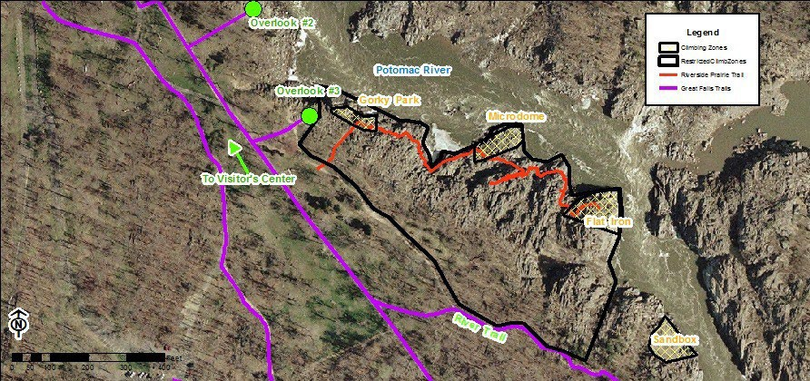
Map shows the area of closure identified in the Record of Determination Closing the Rocky Environments South of Overlook 3 at Great Falls Park, Virginia.

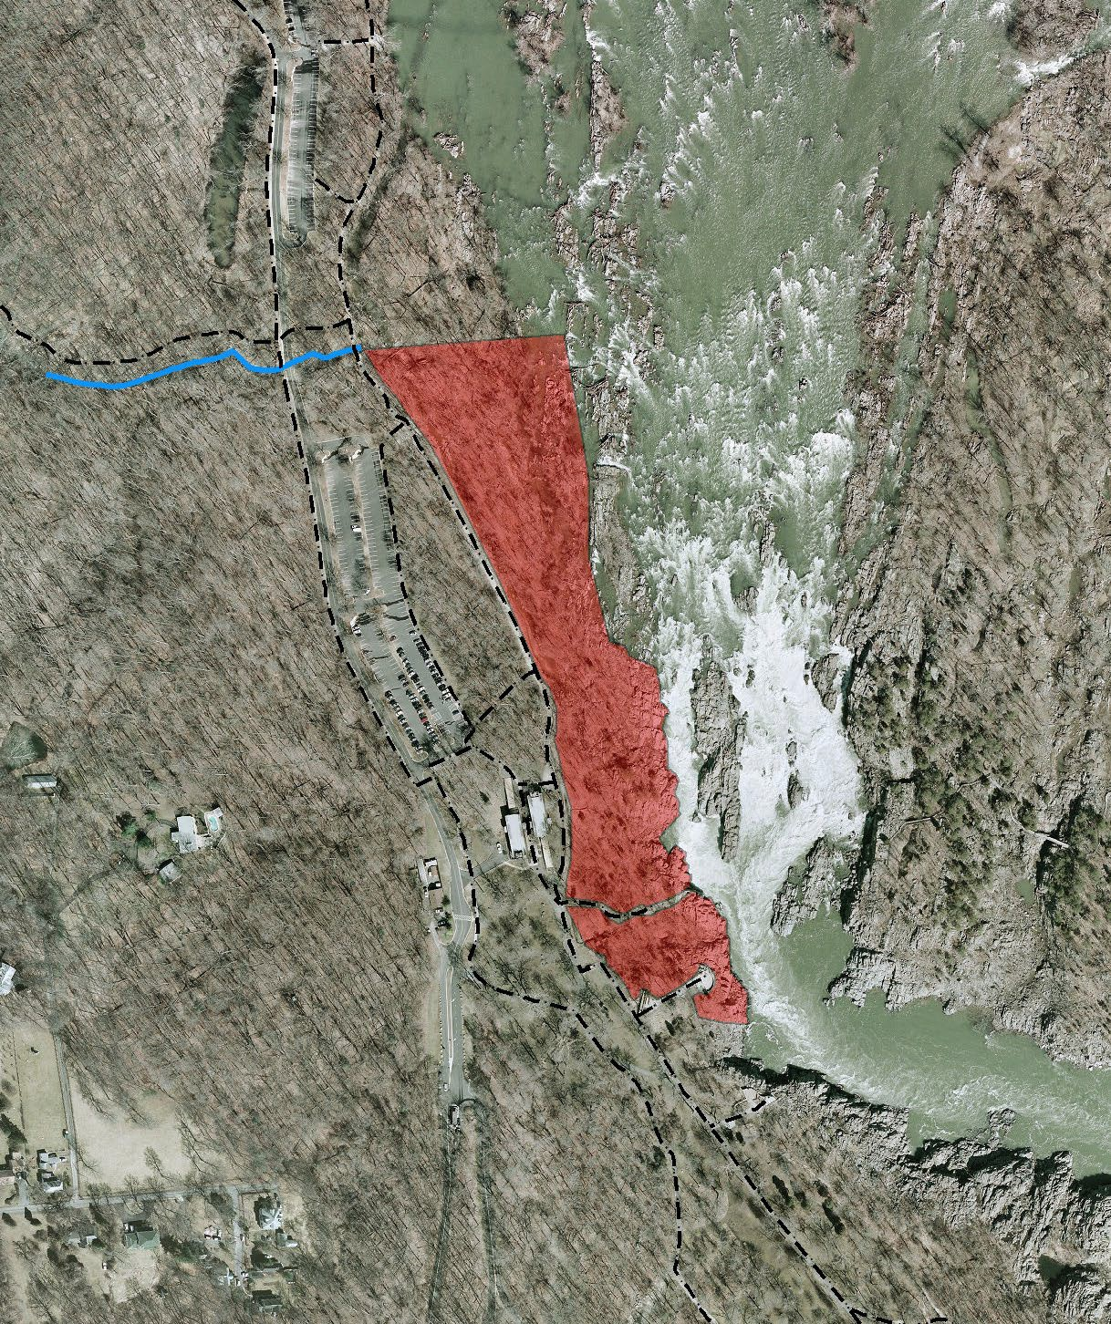



Closed Shoreline Great Falls

Visitor Center

H! Overlook #1
H! Overlook #2

Fisherman's Eddy

0 200 400 800
F
Feet

George Washington Memorial Parkway

First Amendment Area: Great Falls Park
U.S. Department of the Interior National Park Service

Scale: 1:2,000

First Amendment Areas

0 80 Geo1E y6e0, Maxar, Microso3ft20 Feet


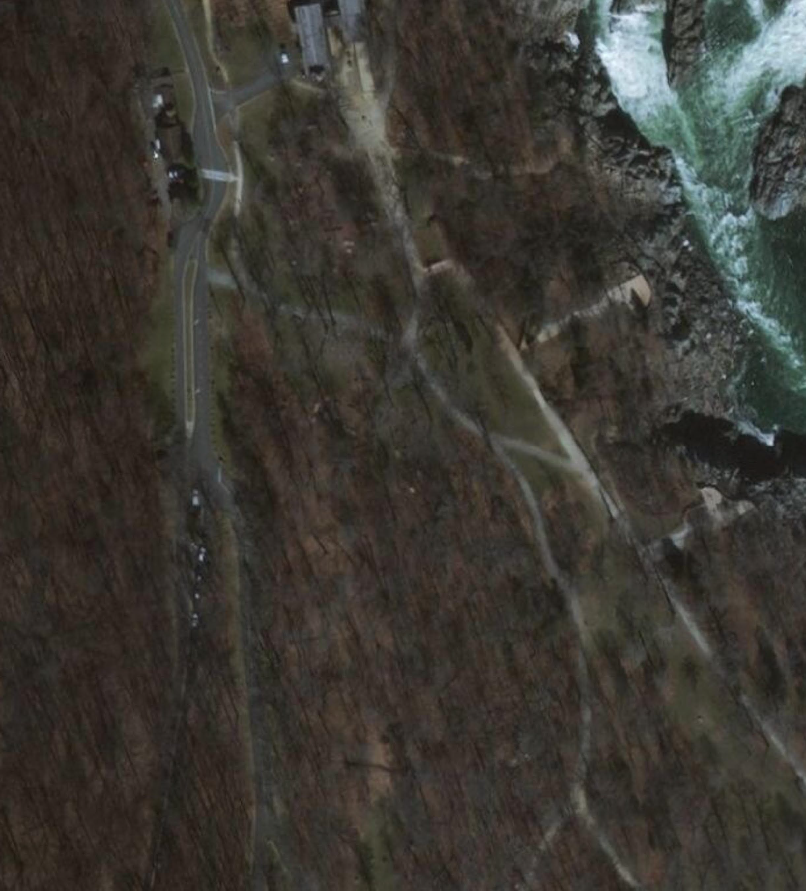
Path: C:
\GIS\Projects\SUP\Amendmentareas\FirstAmendmentAreaMaps.aprx Map:GWMPFirstAmmendAreas
Layout: GWMPFirst Amendment Area

Produced by George Washington Memorial Parkway Christy McManus
The National Park Service does not assume responsibility for information accuracy, precision, or completeness as
displayed on this map.

George Washington Memorial Parkway

First Amendment Area: Memorial Avenue
U.S. Department of the Interior National Park Service

Scale: 1:1,000

First Amendment Areas

0 DC4G0IS, GeoE8ye0, Maxar, Microso1ft60 Feet

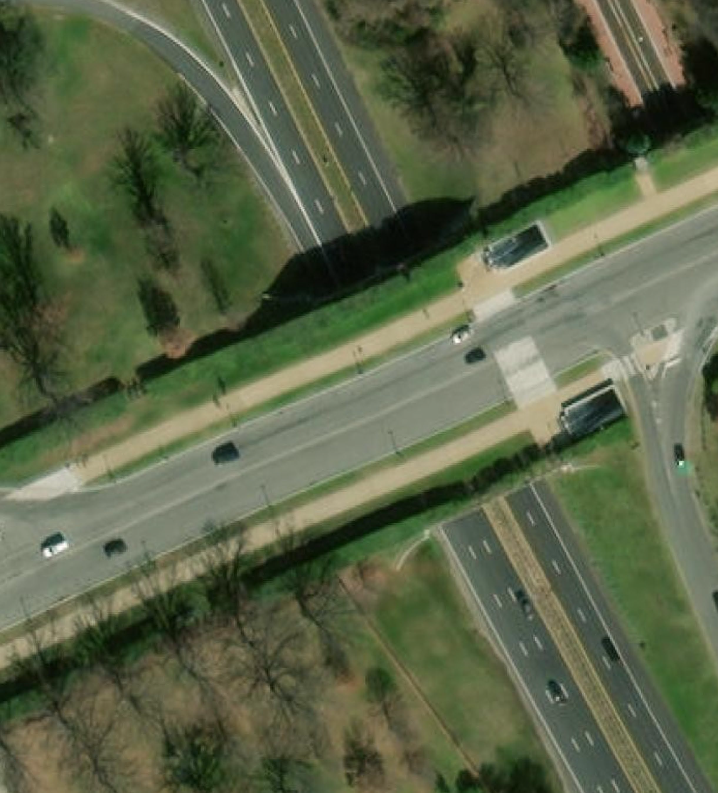
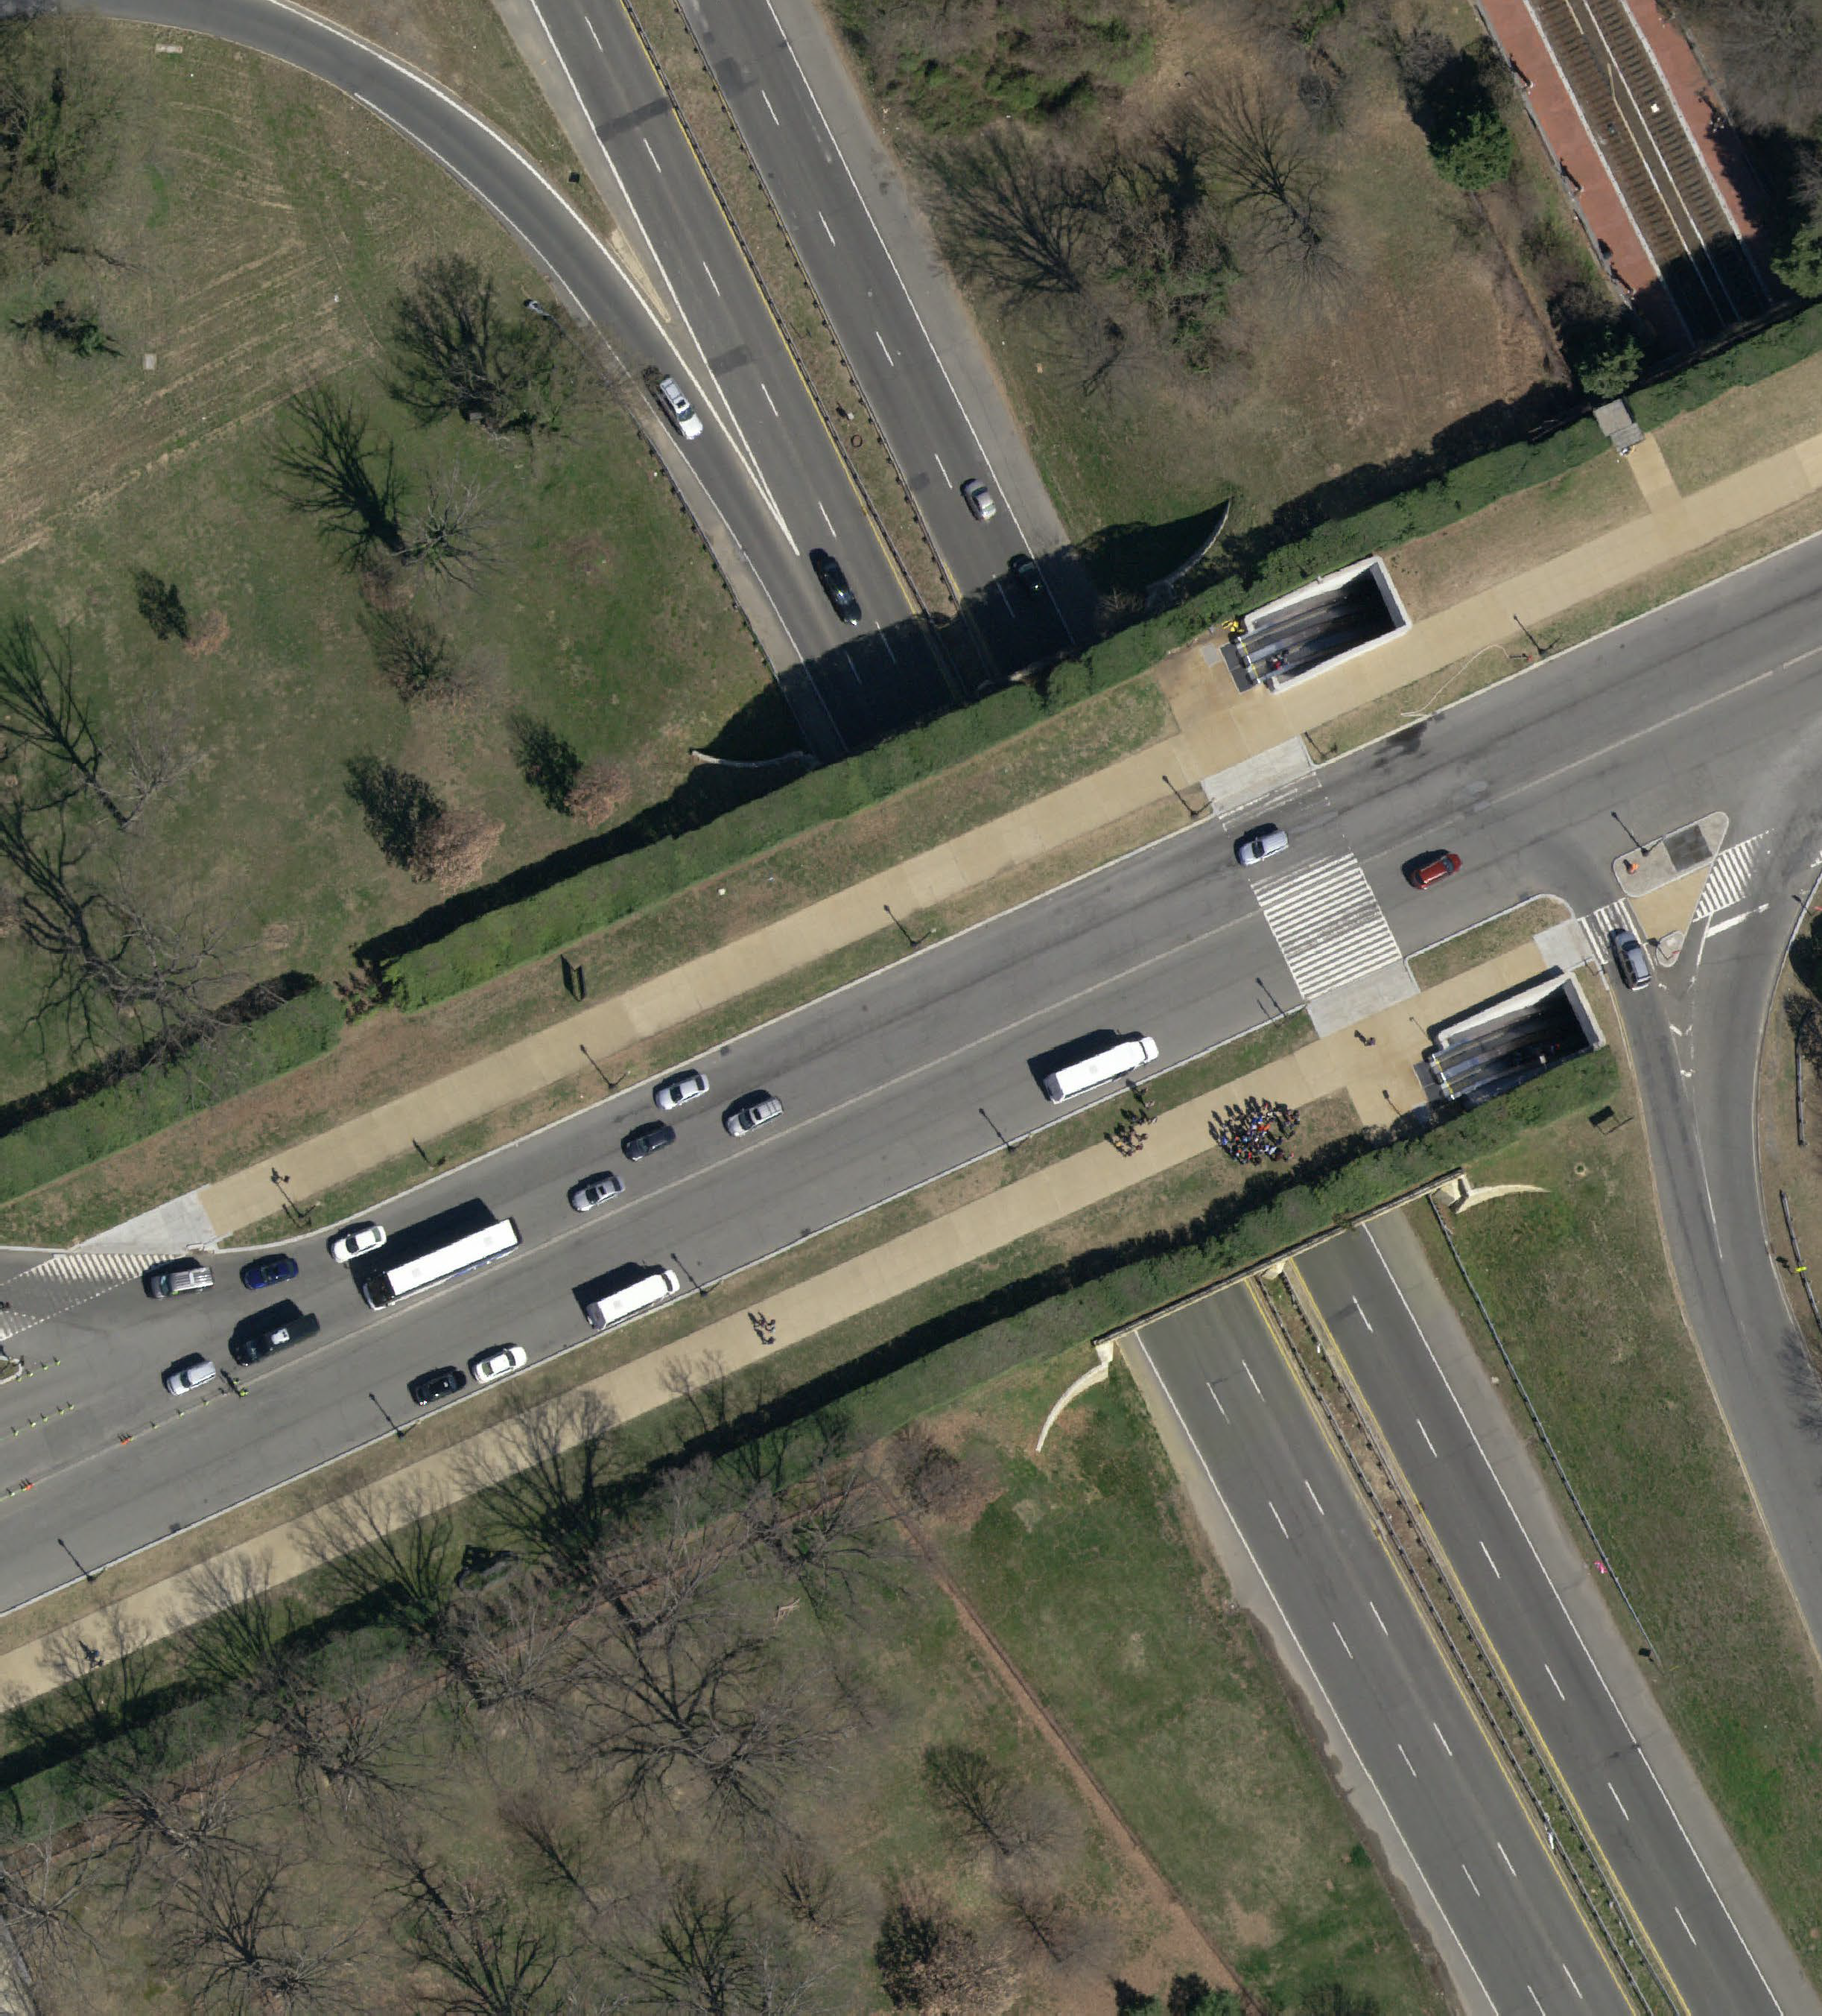
Path: C:
\GIS\Projects\SUP\Amendmentareas\FirstAmendmentAreaMaps.aprx Map:GWMPFirstAmmendAreas
Layout: GWMPFirst Amendment Area

Produced by George Washington Memorial Parkway Christy McManus
The National Park Service does not assume responsibility for information accuracy, precision, or completeness as
displayed on this map.

George Washington Memorial Parkway

First Amendment Area: Mt. Vernon Circle
U.S. Department of the Interior National Park Service

Scale: 1:2,000

First Amendment Areas

0 80 Geo1E y6e0, Maxar, Microso3ft20 Feet

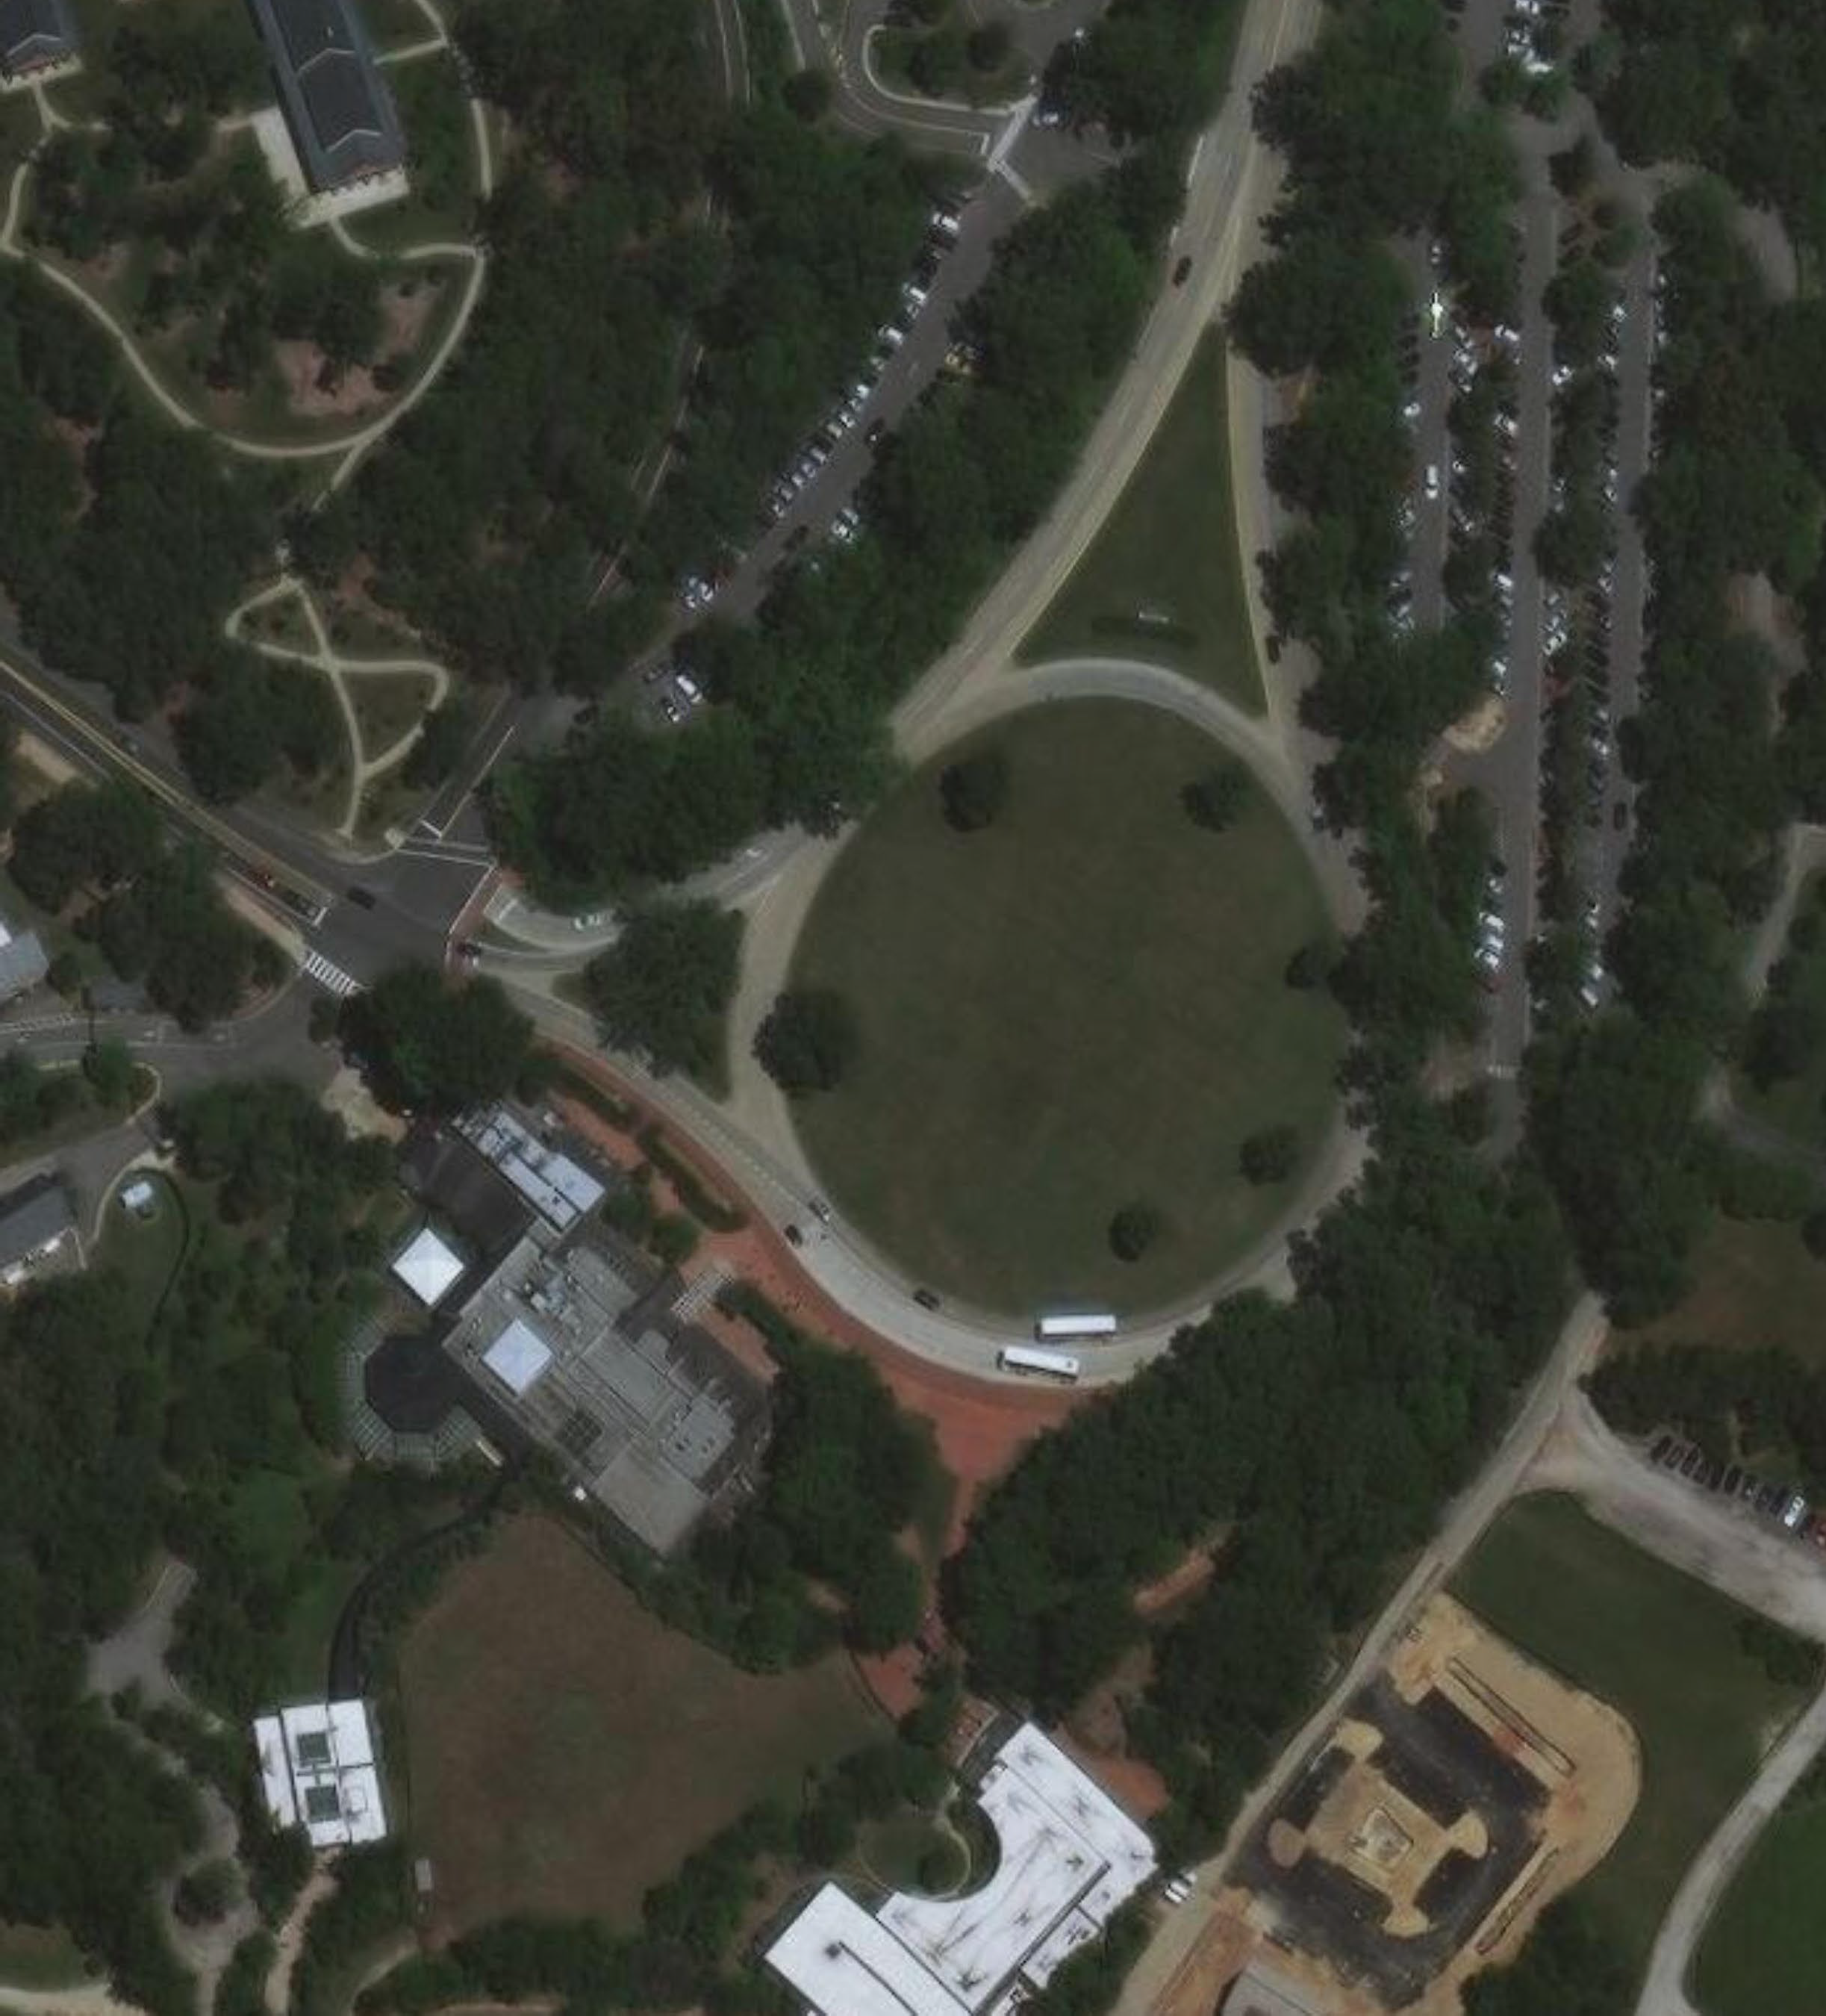

Path: C:
\GIS\Projects\SUP\Amendmentareas\FirstAmendmentAreaMaps.aprx Map:GWMPFirstAmmendAreas
Layout: GWMPFirst Amendment Area

Produced by George Washington Memorial Parkway Christy McManus
The National Park Service does not assume responsibility for information accuracy, precision, or completeness as
displayed on this map.

George Washington Memorial Parkway

First Amendment Area: Netherlands Carillon
U.S. Department of the Interior National Park Service

Scale: 1:3,000

First Amendment Areas

0 125 GeoE2ye5,0Maxar, Microsoft500 Feet

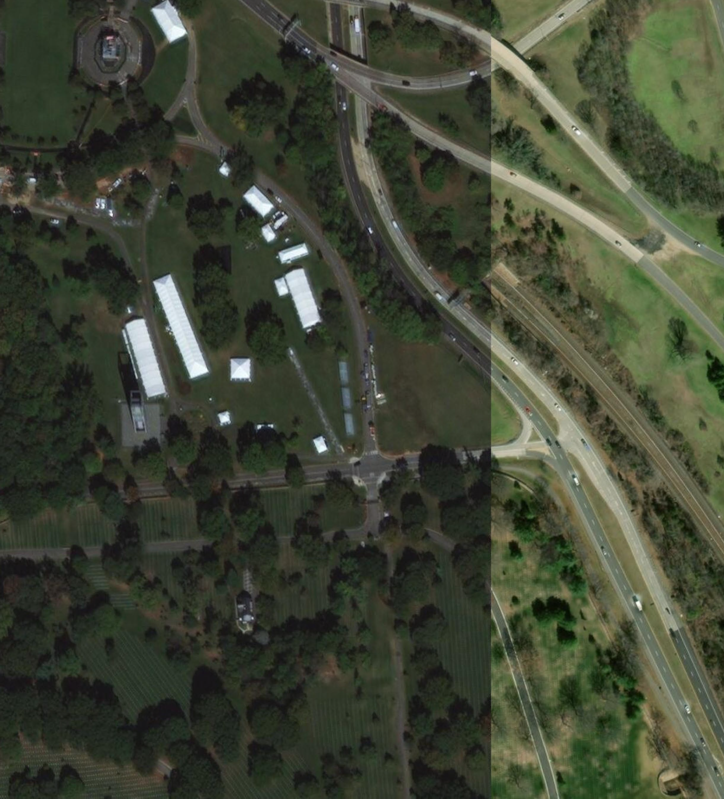
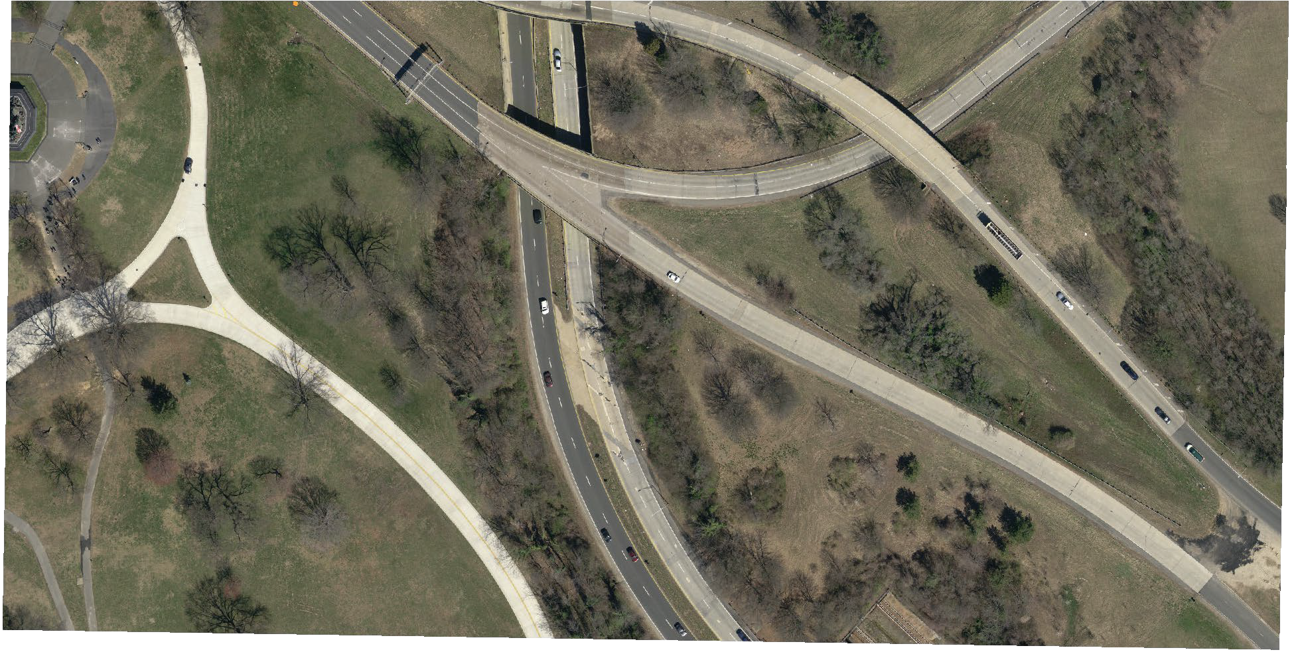
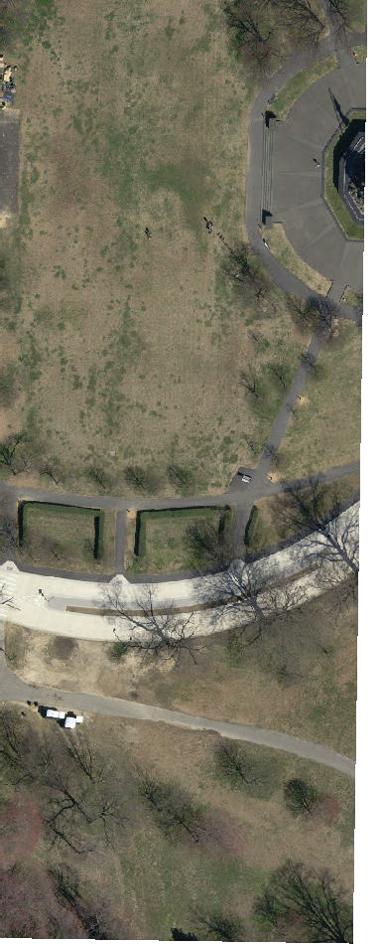
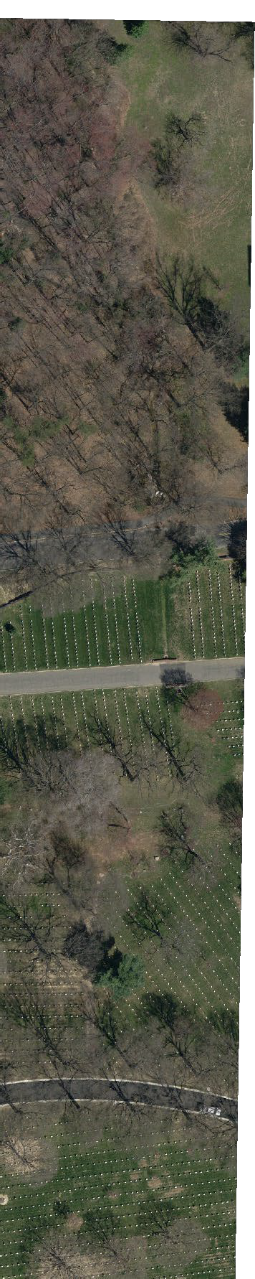
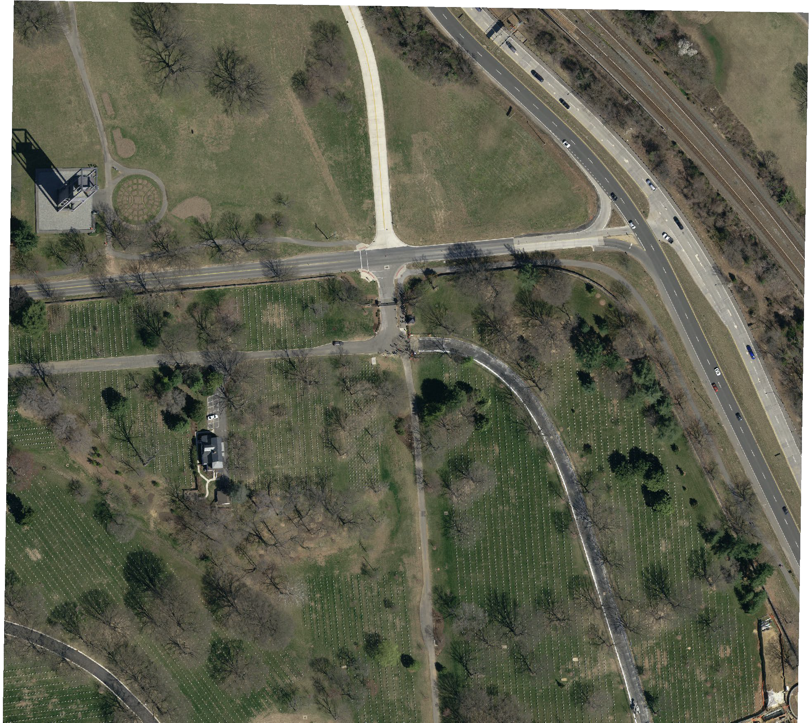
Path: C:
\GIS\Projects\SUP\Amendmentareas\FirstAmendmentAreaMaps.aprx Map:GWMPFirstAmmendAreas
Layout: GWMPFirst Amendment Area

Produced by George Washington Memorial Parkway Christy McManus
The National Park Service does not assume responsibility for information accuracy, precision, or completeness as
displayed on this map.

N 38.775717° W77.046642°
N 38.772836°
W 77.043586°

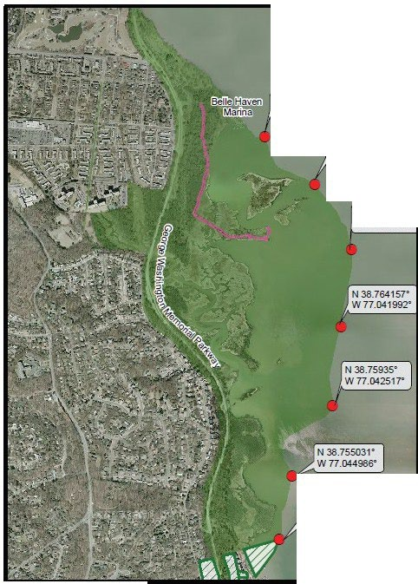

N 38.768861• W77.041711•

N 38.751183• W 77.045761·

8.'GlSl UA:r.m10_1!1J)t.6niCbl'/.m.-,,
w4ft-, Dyke Marsh Wildlife Preserve
•
,
-
Scale:
Feel
0 0.125 0.25 0.5
--c:== Mles
0 0.2 0.4 0.8
- --=== Kilome-ters
703.289.2500.
October 2010.
GPS
1 in= 1.8.88 feet 1:22.657 Map produced by
==== Haul Road Boadwalk 0 660 1,320 2,640 GWMP
12d
SCENIC EASEMENTS/ RIGHTSIN LANDS NATIONAL PARJ< SERVICE
JURISDICTION

