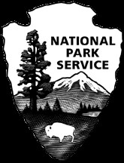
First Amendment Activities

George Washington Carver National Monument

National Park Service
U.S. Department of the Interior
Freedom of speech, press, religion, and assembly are rights protected by the First Amendment of the Constitution of the United States. People may exercise these rights in national parks, but the National Park Service (NPS) still retains its responsibility to protect park resources and prevent conflict among park visitors. Therefore, the NPS establishes guidelines for setting the time, place and manner (number of participants, use of facilities and type of equipment) for the events to occur.
- By law, the NPS has established places in parks where First Amendment activities can be accommodated. These areas are visible to the general visiting public without interfering with the public’s enjoyment of the park. While the NPS regulates aspects of the activity to protect park resources, it never regulates the content of the message.
- The attached map reflects the designated areas for First Amendment activities as a “developed” zone. The authorized First Amendment activities area consists of the from inside the front entrance gate, north to the starting edge of the woodlands zone, west to the starting edge of the parking lot entrance, and south to the starting edge of all Prairie Zones. This area includes all the old administration/housing area of the park, but stops at the starting edge of all Prairie Zones.
- The following areas of the park are closed to First Amendment activities:
- All Cultural Zone Areas
- All Prairie Zone Areas
- All Woodland Areas
- All Persimmon Grove Areas
- The picnic area is included in the designated First Amendment activities area.

- Special Use Permits are issued for First Amendment activities, but there are no fees or costs, and no insurance is required for the activities.
- Groups of 25 or fewer people may demonstrate or distribute or sell printed matter in the designated First Amendment area without obtaining a permit. Small groups may still apply for a permit in order to guarantee the use of a particular area within the designated area.

- All requests for similar activities are treated equally. As long as permit criteria and requirements are met, no group wishing to assemble lawfully will be discriminated against or denied the right of assembly.

Types of First Amendment Activities
- Religious services or ceremonies
- Press conference
- Voter registration
- Collecting signatures on petitions or voter initiatives
- Public demonstration, picketing, assembly or rally for expressing opinion and views
- Sale or distribution of printed material related to free expression of opinion

Type of Activities that are NOT covered by the First Amendment
- Church picnic or social gathering
- Wedding ceremonies or receptions
- Political fund raiser or other invitation-only political activity or event
- Solicitation of donations
- Community parades, athletics, or sporting events
- Scattering of cremated human remains (“cremains”)
Many of the non-First Amendment activities can be accommodated through the Special Use permit system for which a fee may be charged. Liability insurance may be required. Contact the Park Special Use Coordinator for more information.
Locations: The areas available for public assemblies and the sale and distribution of printed materials have been identified above and can also be found in the Superintendent's Compendium in Section 2.51and Section 2.52.

Applications: Complete the attached Application for Special Use Permit. Please review and sign the Terms & Conditions below before submitting the permit application as they outline the specific requirements and restrictions of the permit. Mail the completed application and signed Terms and Conditions to: George Washington Carver National Monument, Attn: Special Park Uses Coordinator, 5646 Carver Road, Diamond, MO 64840. The completed application should be received at least 10 business days prior to the date the permit is needed. There are no fees or charges associated with a First Amendment application or permit.

Permits: If your application is approved, a Special Use Permit will be prepared and mailed to you for signature. Upon receipt, please review, sign and return the permit to our office for the Superintendent’s signature. After the Superintendent signs the permit, a signed copy of the permit will be forwarded to you. The approved, signed permit copy must be in your possession at the time of the activity.

Terms & Conditions: To maintain park natural and cultural resources and quality visitor experiences the following criteria apply to Special Use Permits for First Amendment activities:

- The activity must not conflict with any scheduled NPS function or program.

- The United States Department of the Interior, National Park Service, will in no way be held responsible in the event of any personal injury, and/or loss of, or damage to, personal property during, or occurring from, the use of this area.

- First Amendment activities will be conducted in designated areas as specified in the George Washington Carver National Monument Superintendent’s Compendium.

- Permits are issued for no longer than a 14-day period. A permit is renewable for like periods upon completion of another application, and provided no other application has been received and no prevailing park use has been identified for the area requested.

- The NPS reserves the right to immediately revoke the permit at any time should this become necessary in the interest of public safety, public health and general welfare.

- The person or group will comply with any instructions from a designated official representative from George Washington Carver National Monument.

- Erecting of banners, signs, etc. is prohibited.

- To protect park lands and wildlife, throwing or scattering of rice, bird seed, flowers (to include flower petals, fresh or dried), confetti, streamers or other similar materials is prohibited. The release of animals including birds, butterflies, or other living things is prohibited. In addition, the use of bubble machines is prohibited.

- Helium balloons may not be released within the park nor is the Permittee allowed to use helium balloons as adornments to any park sign, structure, natural or cultural resource.

- Serving of alcohol or any type of bar service is prohibited.

- Fires, candles, tiki torches, and charcoal grills are prohibited. Sterno or gas grills are allowed.

- The area used by the Permittee will be left in the same condition as found and all litter placed in trash receptacles. Any NPS property damaged by, or as a result of the Permittee, will be replaced or repaired at the cost of the Permittee.

- Structures, including tents and portable pavilions may not be erected.

- No items may be attached to NPS property (fences, trees, trash receptacles, etc.). Banners and signs which are hand carried are allowed and must not pose a danger to anyone else in the area.

- Electrical power will not be furnished nor will generators be allowed.

- Any portable public address system being used will be so adjusted as to accommodate only those people in the immediate area.

- Participants are to avoid language which implies any official connections to the NPS and its activities.

- Good order and proper decorum shall be maintained by the person or persons conducting and participating in the event and the person or persons will leave the area at the conclusion time stated on the permit. It is prohibited for anyone engaged in activities covered under the permit to obstruct or impede pedestrians or vehicles, or harass park visitors or misrepresent their purposes. Permittee agrees to maintain public access in the area.

- The Permittee must provide their own equipment, chairs, etc.

- Failure to comply with the provisions of the permit will result in its immediate revocation.

Other stipulations may be added depending on the specific nature of your request.

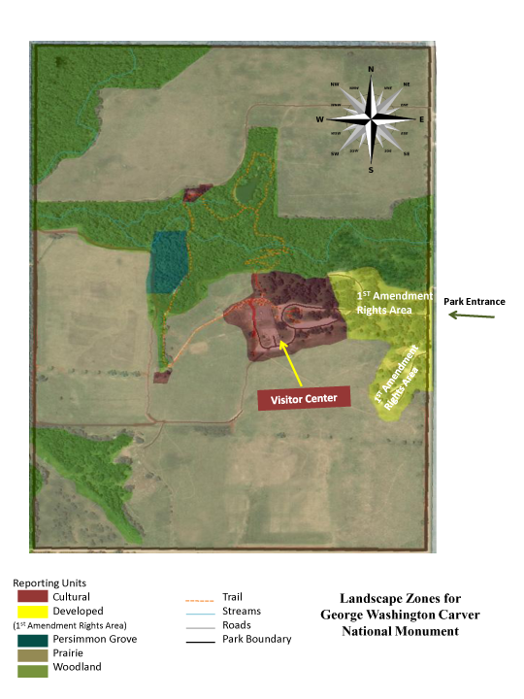
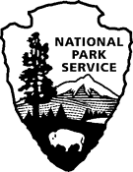
National Park Service
(George Washington Carver National Monument)
(5646 Carver Rd, Diamond, MO 64840)
(417-325-4151)

Application for Special Use Permit

Please supply the information requested below. Attach additional sheets, if necessary, to provide required information. A nonrefundable processing fee of $0.00 must accompany this application unless the requested use is an exercise of a First Amendment right. You must allow sufficient time for the park to process your request; check with the park for guidelines. You will be notified of the status of the application and the necessary steps to secure your final permit. Your permit may require the payment of cost recovery charges and proof of liability insurance naming the United States of America as also insured.

Enter either a social security number OR a tax ID number: we do not require both.
Applicant Name: | Company/Organization Name:
Social Security #: | Tax ID #
Street/Address: | Street/Address:
City/State/Zip Code: | City/State/Zip Code:
Telephone #: | Contact name:
Cell phone #: | Telephone #:
Fax #: | Fax#:
Email: | Email:

Description of Proposed Activity (attach diagram, attach additional pages if necessary):

Requested Location(s): ______________________________________________________________________

DATE(S)
Set up begins:  (date and time) | Activity begins:  (date and time) | Activity ends:  (date and time) | Removal completed  (date and time)

Maximum Number of Participants (Please provide best estimate)
Maximum Number of vehicles: (attach parking plan)
_______Cars _______Vans/lt.trucks _______Utl.vans/trucks _______Buses/oversized vehicles

Support equipment (list all equipment; attach additional pages if necessary)

List support personnel including addresses and telephones; attach additional pages if necessary

Individual in charge of activity on-site (include cell phone number) and authorized to make decisions related to the permitted activity:

Is this an exercise of First Amendment Rights? Y N
Have you visited the requested area? Y N
Have you obtained a permit from the National Park Service in the past? Y N
(If yes, provide a list of permit dates and locations on a separate page.)
Do you plan to advertise or issue a press release before the event? Y N
Will you distribute printed material? Y N
Is there any reason to believe there will be attempts to disrupt, protest or
prevent your event? (If yes, please explain on a separate page.) Y N
Do you intend to solicit donations or offer items for sale?
(These activities may require an additional permit.) Y N

You are encouraged to attach additional pages with information useful in evaluating your permit request including: staging, sound systems, parking plan, security plans, sanitary facilities, crowd control, emergency medical plan, use of any building, site clean-up, etc.

The applicant by his or her signature certifies that all the information given is complete and correct, and that no false or misleading information or statements have been given.

Signature Date ___________________
Printed Name_________________________________ Title_______________________

Note: This is an application only, and does not serve as permission to conduct any special activity in the park. The information provided will be used to determine whether a permit will be issued. Send the completed application along with the application fee in the form of a credit card payment, cashier’s check, money order or personal check made payable to National Park Service to Randall Becker, Supervisory Park Ranger at the Park address found on the first page of this application.

If your request is approved, a permit containing applicable terms and conditions will be sent you. The permit must be signed by the responsible person and returned to the park for final approval by the Park Superintendent before the permitted activity may begin.

NOTICES

Privacy Act Statement: The Privacy Act of 1974 (5 U.S.C. 552a) provides that you be furnished with the following information in connection with information required by this application. This information is being collected to allow the park manager to make a value judgment on whether or not to allow the requested use. Applicants are required to provide their social security or taxpayer identification number for activities subject to collection of fees and charges by the National Park Service (31 U.S.C. 7701). Information from the application may be transferred to appropriate Federal, State, and local agencies, when relevant to civil, criminal or regulatory investigations or prosecutions.

Paperwork Reduction Act Statement: We are collecting this information subject to the Paperwork Reduction Act (44 U.S.C. 3501) to provide the park managers the information needed to decide whether or not to allow the requested use. All applicable parts of the form must be completed in order for your request to be considered. You are not required to respond to this or any other Federal agency-sponsored information collection unless it displays a currently valid OMB control number.

Estimated Burden Statement: Public reporting burden for this form is estimated to average 30 minutes per response including the time it takes to read, gather and maintain data, review instructions and complete the form. Direct comments regarding this burden estimate or any other aspect of this form to the Information Collection Clearance Officer, National Park Service, 1849 C Street NW. (1237), Washington, D.C. 20240

Title 18 U.S.C. Section 1001 makes it a crime for any person to knowingly and willfully make to any department or agency of the United States any false, fictitious, or fraudulent statements or representations as to any mater within its jurisdiction.

