GRAND TETON NATIONAL PARK
BEAR SIGHTING & INCIDENT REPORT To report bear incidents, call 307-739-3301.

Observer’s: Name: ______________________________________________ Telephone number (local if possible): ________________________________
Observation: Date: ____________________ Time: ____________________
Address: _________________________________________________________
Email Address: ___________________________________________________
Type: (circle one) sighting scat track other: _______________________

Location: (describe in detail) ______________________________________________________________________________________________________________
_____________________________________________________________________________ UTME ______________________ UTMN ______________________

TOTAL NUMBER OF BEARS OBSERVED: __________________ For each bear observed, please circle the correct answer in each column
 | BEAR #1 |  |  |  |  |  |  | BEAR #2 |  |  |  |  |  |  | BEAR #3
SPECIES | Unknown |  | Black |  |  |  | Grizzly | Unknown |  | Black |  |  |  | Grizzly | Unknown | Black |  |  |  |  | Grizzly
AGE | Unknown |  |  | Adult: 201- + 400 lbs |  |  |  | Unknown |  |  |  | Adult: 201- + 400 lbs |  |  | Unknown |  |  |  | Adult: 201- + 400 lbs
AGE | Sub-adult/small adult: 101-200 lbs |  |  | 2 year old: ½ to ¾ of female; 101-200 lbs |  |  |  | Sub-adult/small adult: 101-200 lbs |  |  |  | 2 year old: ½ to ¾ of female; 101-200 lbs |  |  | Sub-adult/small adult: 101-200 lbs |  |  |  | 2 year old: ½ to ¾ of female; 101-200 lbs
AGE | Yearling: ¼ to ½ of female size |  |  | Cub-of-year: ¼ of female size |  |  |  | Yearling: ¼ to ½ of female size |  |  |  | Cub-of-year: ¼ of female size |  |  | Yearling: ¼ to ½ of female size |  |  |  | Cub-of-year: ¼ of female size
WEIGHT(lbs) | Unknown  10-50 |  | 51-100  101-200 |  | 201-400  + 400 |  |  | Unknown  10-50 |  |  | 51-100  101-200 |  |  | 201-400  +400 | Unknown  10-50 |  | 51-100  101-200 |  |  |  | 201-400  + 400
COLOR | Unknown |  | Black |  | Blonde |  |  | Unknown |  |  | Black |  |  | Blonde | Unknown |  |  | Black |  |  | Blonde
COLOR | Light  brown |  | Medium  brown |  | Dark  brown |  |  | Light  brown |  |  | Medium brown |  |  | Dark  Brown | Light  brown |  |  | Medium brown |  |  | Dark  brown
COLOR | Cinnamon or reddish |  | Gray/silver |  | Other: |  |  | Cinnamon or reddish |  |  | Gray/silver |  |  | Other: | Cinnamon or reddish |  |  | Gray/silver |  |  | Other:
CHEST MARKINGS | Unknown |  | Girth band |  |  | Chest patch |  | Unknown |  |  | Girth band |  |  | Chest patch | Unknown |  |  | Girth band |  | Chest patch
CHEST MARKINGS | None | Chest patch& band |  |  | Other: |  |  | None | Chest patch& band |  |  |  |  | Other: | None |  | Chest patch& band |  |  |  |  | Other:
MANAGEMENT  IDENTIFYING  MARKERS | Unknown |  | None |  |  | Radio collar |  | Unknown |  | None |  |  | Radio collar |  | Unknown | None |  |  |  | Radio collar
MANAGEMENT  IDENTIFYING  MARKERS | Ear tag |  | Paint |  |  | Other: |  | Ear tag |  | Paint |  |  | Other: |  | Ear tag | Paint |  |  |  | Other:
EAR TAG |  |  | Number |  | Color |  |  |  |  |  | Number |  |  | Color |  |  | Number |  |  |  | Color
EAR TAG | Left:  Right: |  |  |  |  |  |  | Left:  Right: |  |  |  |  |  |  | Left:  Right:

ACTIVITY: a brief description of the primary activity
HOW FAR WERE YOU TO THE BEAR? | _________________ Yards |  |  |  |  |  |  | _________________ Yards |  |  |  |  |  |  | _________________ Yards
BEAR NOTICE  PEOPLE | Unknown |  | Yes |  |  |  | No | Unknown |  |  | Yes |  |  | No | Unknown |  | Yes |  |  |  | No
BEAR’S REACTION TO PEOPLE | Unknown  Walked  away |  | Ran away  Bluff  charged |  |  |  | No reaction  Approached people | Unknown  Walked  away |  |  | Ran away  Bluff  charged |  |  | No reaction  Approached people | Unknown  Walked  away |  | Ran away  Bluff  charged |  |  |  | No reaction  Approached people
**TYPE OF INCIDENT | Sighting |  | Approached people |  |  | Food reward |  | Sighting |  |  | Approached  people |  |  | Food reward | Sighting | Approached  people |  |  |  | Food reward
**TYPE OF INCIDENT | Property damage |  | Dead bear |  |  | Bluff charge |  | Property damage |  |  | Dead bear |  |  | Bluff charge | Property damage | Dead bear |  |  |  | Bluff charge
**TYPE OF INCIDENT | Injured bear |  | Bear Jam |  |  | Other: |  | Injured bear |  |  | Bear Jam |  |  | Other: | Injured bear |  | Bear Jam |  |  | Other:
**If any of the observed bears acted aggressively towards people, approached people, obtained any unnatural foods, or caused property damage (i.e., ripped tent, scratched car), please fill out the Comments section on the backside of this form** S&RM # _________________

Report filled out by: ____________________________________ Place, Date and Time filled out ________________________________

COMMENTS

Describe the nature of any incident including property damage, human injury, or unnatural food the bear obtained. Include the bear’s behavior and people’s reaction to the bear.

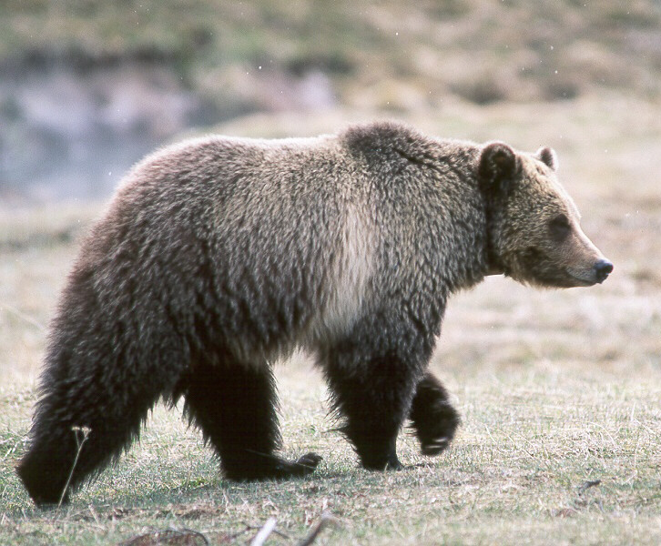
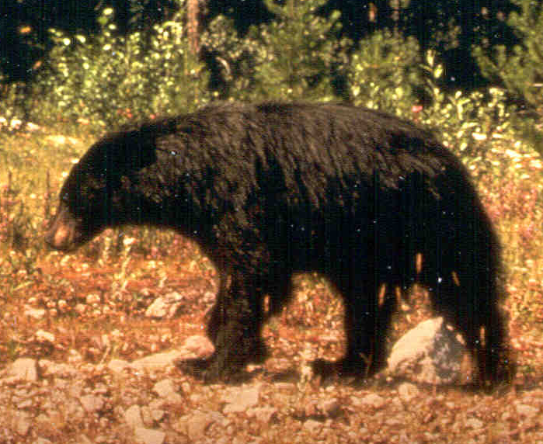
Grizzly Bear:
Black Bear:

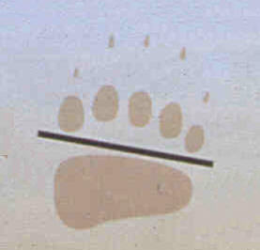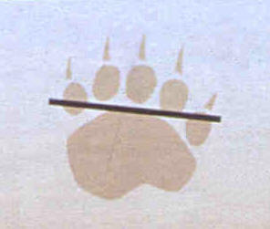
Claws are 1 ½ inches (4 cm) long.

Claw length ______
Pad length ______
Pad width ______
Claws are approximately
4” (10 cm) long.

Claw length ______
Pad length ______
Pad width ______

Color: Grizzly bear colors range from blonde to nearly black, sometimes with silver-tipped guard hairs that give a
“grizzled” appearance.

Physical features: Dished-in face and large hump of heavy muscle above the shoulders.

Color: Black bears may be black, brown, cinnamon, or blonde.
Cubs may not be the same color as their mother.

Physical features: Facial profile is straighter from tip of nose to ears, without the dished-in look. Lack the hump of a grizzly, and have shorter claws.

If Bear Jam: Management Actions

Personnel _________________________ Hours at jam _________

Personnel _________________________ Hours at jam _________

Personnel _________________________ Hours at jam _________

Personnel _________________________ Hours at jam _________

Management Hazing: _________________________________

Area Closure: _______________________________________

Trail/Camp Closure: __________________________________

Bear Warnings Posted: ________________________________

Personnel _________________________ Hours at jam _________ Dead/Injured Bear: ___________________________________

Case Incident Number: _________________________

To report bear incidents, call dispatch at 307-739-3301

