Survival in the Environment

Pre-Visit Activity:

Goal: To assist students in gaining an understanding of ways in which people use the resources of their environment in order to survive by examining the culture of Native American Indians of the Potomac

Objectives: After completing the lesson, students will be able to:
- Define ways in which Native American Indians of the Potomac depended on environmental resources for food, clothing, and shelter.
- Locate and identify major rivers of the Chesapeake Bay system on a map.
- Describe the advantages and disadvantages of a riverside settlement.
- Identify and evaluate potential settlement sites with a view to effectively meeting survival needs.

Introduction: Survival in any region depends upon the ability of the inhabitants to meet their needs for food, clothing, and shelter by using available resources. Culture, or lifestyle, may be defined in part by the ways in which people interact with their environment, establishing hunting and gathering or farming communities. Over time, the culture may become more complex as work becomes specialized and religious and governmental institutions are established.

When native people of our region considered an area for settlement, they searched for the resources which would make survival possible. Today, we will be identifying potential resources, examining maps, locating the Great Falls area in the context of the Chesapeake Bay region, and determining optimal sites for settlement.

Procedure: Students will work with a partner as they brainstorm and record a list of local resources useful for survival, examine maps of the region, identify and support their choice of settlement locations. Duration: 60 – 90 minutes

- Copy and distribute the worksheet, “Resources for Survival – Great Falls Area”. Using available classroom references and drawing on knowledge of the region, students will brainstorm and record a list of potential resources available in the Great Falls area at the time of Native American Indian settlement.
- Circulate and facilitate this pair-share activity as students focus specifically on resources which could be used for food, clothing, and shelter. Through whole group sharing and discussion, refine and record the list of resources. (See “Answer Key 1”)
- Copy and distribute accompanying maps of the “Chesapeake Bay Region” to each student. Using a large classroom map or sharing smaller regional reference maps, students will locate and identify bodies of water, as well as the Great Falls area and Powhatan Indian villages.
- Circulate and check completed maps for accuracy, providing assistance as needed. (See answer sheet for Chesapeake Bay Region map) In whole group discussion, focus on the value of waterside settlement, including access to marine life; river transport; water for drinking and farming; land animals that depend on and frequent these areas. Encourage students to identify negative aspects of a riverside location, such as: flooding, erosion, enemy invasion by water or entrapment by land.
- Copy and distribute maps and site descriptions of the “Great Falls Settlement Sites”. Students will examine and discuss site options, identify and agree on two possible sites for settlement, and record their reasons for selecting each site.
- Circulate and facilitate this pair-share activity as students review the materials, discuss options, and reach consensus. Overhead projection of a transparency map of the area may facilitate discussion as students share and support their settlement choices with classmates. Teachers will want to assist students in identifying the pros and cons of each site. For example, choosing the “Swamp Flats” location affords a sheltered environment with abundant trees for building shelters, crayfish and edible plants for food, visiting deer for food and clothing. However, this site may be subject to flooding, unsuitable for farming, and fail to provide a vantage point for surveillance of the river. Based on this discussion, students may wish to re-examine their choices and select one or two optimal sites as a class.
- The teacher may ask students to place these completed activities in a “Native American Indians of the Potomac” folder to which on-site and post-visit activities and observations may be added.
Resources for Survival – Great Falls Area
Student worksheet

Food * *

* *

* *

Clothing * *

* *

* *

Shelter * *

* *

* *

Answer Key 1
Resources for Survival

Food fish, crayfish, small mammals, rabbits, squirrels,
raccoons, opossum, deer, bear, quail, pheasant,
corn, squash, beans, pumpkins

Clothing skins of deer, bear, rabbit, raccoon, woven reeds,
inner layers of bark, bird feathers, quills, claws
for ornamentation

Shelter saplings, bark, twigs and branches, deer and bear
skins, reeds and grasses, caves, rocks

Answer Key 2

Teacher’s notes (add personal info)

Food

Clothing

Shelter
Chesapeake Bay Region - Student worksheet

- Assisted by a reference map of the Chesapeake Bay region, locate each body of water on your map. Draw a line from the name of each river and bay to its location on the map.

- Locate the “x”, which identifies Great Falls. Draw a line from the place name to the “x”.

- Place a small dot where you believe your school is located and label it drawing a line and writing the school name.

- Locate the small black dots, each of which identifies a Powhatan Indian village circa 1600. What do the sites have in common? ______________________________________________________________________________________________________________________.
Why might the Powhatans have chosen these sites for settlement? 1.) _______________________________
_________________________________________.
2.) __________________________________________
_________________________________________.
3.) _________________________________________
_________________________________________.
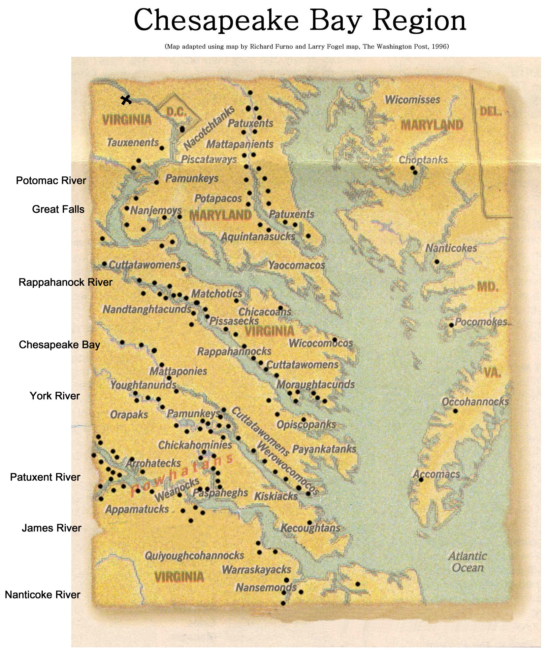
Chesapeake Bay Region
Teacher Answer sheet

1. Assisted by a reference map of the Chesapeake Bay region, locate each body of water on your map. Draw a line from the name of each river and bay to its location on the map.
2. Locate the “x”, which identifies Great Falls. Draw a line from the place name to the “x”.
3. Place a small dot where you believe your school is located and label it drawing a line and writing the school name.
4. Locate the small black dots, each of which identifies a Powhatan Indian village circa 1600. What do the sites have in common? All are located along the river water bodies.
Why might the Powhatans have chosen these sites for settlement?
1.) Means of escape from enemies or access to trade routes.
2.) Transportation up and down the river/access to Bay and its resources.
3.) Access to water for drinking, planting crops (rich soils from river deposits) and food resources such as fish and shellfish as well as the many different kinds of plants that tend to inhabit stream and river environments along its shores versus deep forested areas.

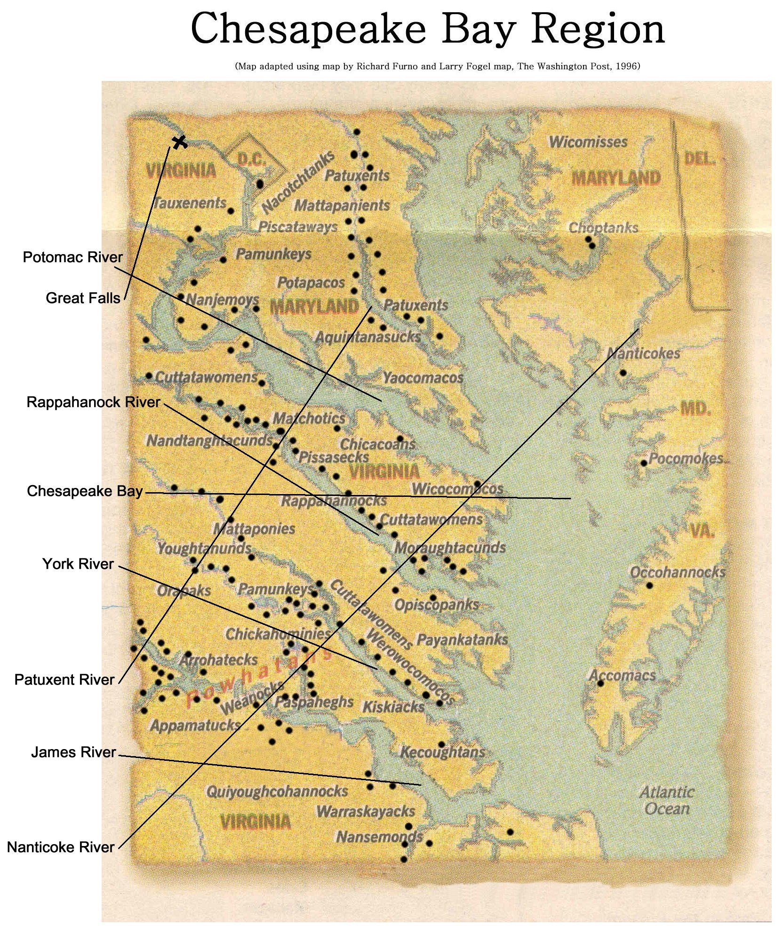
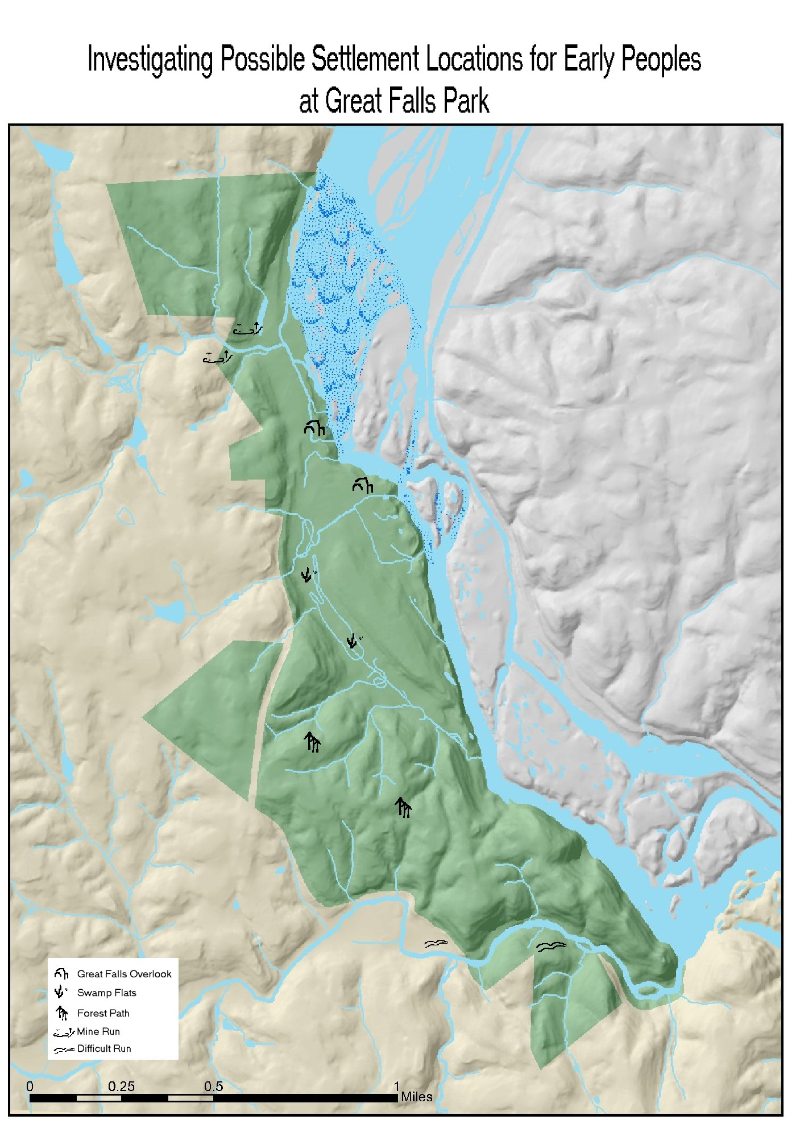
Great Falls Settlement Site Descriptions

Study the following descriptions of five potential settlement sites and the accompanying Great Falls map. Discuss the pros and cons of each site: the availability of resources needed for survival, the natural hazards or potential dangers which settlers might encounter. Record your views on the “Pros and Cons” chart. You and your partner must agree on two areas which would be most favorable for settlement. Circle the names of your choices on the map. Record your sites and list your reasons for choosing these areas in the spaces below.

River Overlook: The rocky terrain is bounded by 30 to 70 foot cliffs which rise from a narrow gorge. There are numerous smooth boulders and thousands of potholes carved out by the river since the last ice age. Vegetation is somewhat sparse, though evergreen and deciduous trees are present. Nearby a large flat area extends toward the steep hillside. While usually dry, occasional rains and the wet season may create soggy conditions. Various medicinal and edible plants grow here as a result of these wet conditions. About every ten years, the Potomac flood waters have been known to overflow the banks.

Swamp Flats: Over 500,000 years ago, the swamp was a major channel of the river. The terrain is mostly flat to the base of a hillside. The swamp is fed by three streams which nourish lowland plants and trees such as ferns, beech trees, and numerous wildflowers. Deer, fox, and raccoons frequent the swamp which is also home to frogs and crayfish. Because of the soil’s high moisture content, insects (such as mosquitoes) find this area suitable for breeding. The swamp’s unique environment contains several plants which are hard to find in other parts of the area.
Difficult Run: The terrain is mostly flat with some steep uphill areas which overlook the stream valley. The stream is flat and wide at the top with calm waters. It picks up speed as it narrows into a steep gorge with a small set of falls. Muskrat and beaver have been seen in the stream, and the area where the stream empties into the river abounds with fish. Approximately ½ mile from the river, there are flat areas. Below is a gorge with steep bluffs; passage is difficult, other than deer trails. The stream has been known to flood the surrounding area after heavy downpours.

Forest Path: While some of the terrain is flat, there are also gently rolling hills. The forest is dense with evergreen and deciduous trees, and the soil is rich and fertile. Owls and hawks prey on small forest creatures, while deer and fox shelter themselves under the forest canopy. Additionally, there are natural springs and a quarry nearby. The Potomac River lies approximately a mile away.

Mine Run: Located ¼ mile above the falls, this location is mostly forested with several flat areas near the hillsides and away from the rocky bluffs. An old growth forest provides abundant tree resources. Within several hundred yards is Clay Pond and a surrounding wetland of medium to small size. Here geese and waterfowl are commonly seen taking refuge and utilizing wetland food resources. On the opposite side is Mine Run, a small stream that empties into the Potomac River at a point not far above the falls. The adjacent steep hillsides are topped by broad ridges. The soil in this area is moderately fertile.
Settlement Site Pros and Cons
Site | Pros | Cons
River Overlook

Swamp Flats

Difficult Run

Forest Path

Mine Run

Reasons for selecting:

1. _____________________ 2. ____________________

* *

* *

* *
Bibliographic Resources

Humphrey, Robert L. and Mary Elizabeth Chambers. Ancient
Washington: American Indian Cultures of the Potomac Valley. Washington, DC: George Washington University Press, 1985.

Hyslop, Stephen G. “Life in America 400 Years Ago: When
Algonquian Culture Ruled our Region”. The Washington Post: Wednesday, June l4, 1995.

Rountree, Helen. The Powhatan Indians of Virginia. Norman,
Oklahoma: University of Oklahoma Press, 1989.

