United States Department of the Interior

NATIONAL PARK SERVICE
National Capital Parks-East 1900 Anacostia Drive, S.E Washington, D.C. 20020

May 29, 2019

Record of Determination for a Temporary Closure of Greenbelt Park Campground and Laurel Picnic Area for Roadway Reconstruction in Greenbelt Park

Pursuant to 36 CFR § 1.5, the National Park Service will temporarily close the Greenbelt Park Campground and Laurel Picnic Area on Monday, July 15, 2019 through Thursday April 30, 2020. The closures during this time period will consist of a temporary closure of the majority of Park Central roadway between the park entrance and the Goodluck Road Parking Area. Specific closures will affect the following areas on these dates;
July 15, 2019: Park Central Road is closed from the Dogwood intersection to the Goodluck Road Parking Lot.
July 18, 2019: Park Central and Loop Road is closed after Sweetgum and Holly picnic areas to Dogwood intersection. Earlier closure on July 15 remains in effect. October 1, 2019: Park Central Road is closed between Sweetgum and Holly picnic areas. Earlier closures on July 15 and July 18 remain in effect.

The temporary closures are required in order to allow work under a contract issued by the NPS for the replacement of Still Creek Bridge, the placement of two box culverts, and the resurfacing of all paved areas from the park entrance to the Ranger Station. These areas include U.S. Park Police Parking, Greenbelt Headquarters Parking, Sweetgum Parking Area, Holly Parking Area, Laurel Parking Area, Dogwood Parking Area, Goodluck Road Parking Area and all road surfaces from the park entrance to the intersection of Park Central Road and the road to the Ranger Station. Roadway reconstruction will largely include the removal and replacement of existing asphalt pavement.

The closures will prohibit all vehicular, bicycle, and pedestrian traffic in the construction work zone. The temporary closures are necessary for the safety of park visitors, National Park Service (NPS) employees, Federal Highway Administration (FHWA) employees, and construction crews while this work is performed. Less restrictive measures will not suffice in ensuring protection of the public, workers, and the resource.

A variety of best management practices for the mitigation of storm water impacts will be installed throughout the construction area, as required by the Maryland Department of Environment. These include the replacement of the Still Creek Bridge, installation of the box culverts and removal of some pavement along the walking trail to Goodluck Road. In consultation with the Maryland State Historic Preservation Office this project has been determined not to adversely affect any historic properties. This project has been determined to be within a National Environmental Protection Act Categorical Exclusion for maintenance

activities on existing infrastructure. All work will be performed consistent with these determinations.

The temporary closures of the Greenbelt Park Campground and Laurel Picnic Area will occur for nine months or less in duration. Due to park planning efforts, no reservations for either area have been impacted. Because of this and the limited time period, the closures are not of a nature, magnitude, or duration that will result in significant alteration in the public use pattern of these park areas. Use of the hiking trail system in Greenbelt Park will remain uninterrupted during this time period. The temporary closure will not require a long-term or significant modification in the resource management objectives of National Capital Parks-East or Greenbelt Park.

Accordingly, pursuant to 36 CFR § 1.5(b), publication as rulemaking in the Federal Register is unnecessary and unwarranted. This determination is consistent with past partial and temporary park closures or public use limitations in the National Capital Region.

Pursuant to 36 CFR § 1.7, notice of the closure will be made via posting, electronic communication, and by park staff direction. This Record of Determination is available upon request. Violation is prohibited.
....... _

Matthew D. Carroll Superintendent
Date

Gr t'i,, ,
1
•••

.,..

1I P11

Road closures enbelt Rd

begin
r. --
.,
r •

t ER W July 15
i E IG r l
- h,. ·

..,.

July 18

....-. -
0
,-.\
;, October 1 9
<

All closures end
I '

late spring 2020
,:J
C
"'t,
-
7

...
'-.ll r-;,
  - '>-
-'f
6
0 ..-,I

,;,
'I.
0-_.,,
;;.
·'::,

0,..-

GREENBELT PARK
5,

- ...

.u . )
•,..;;-
' - ·. ··'·'
§

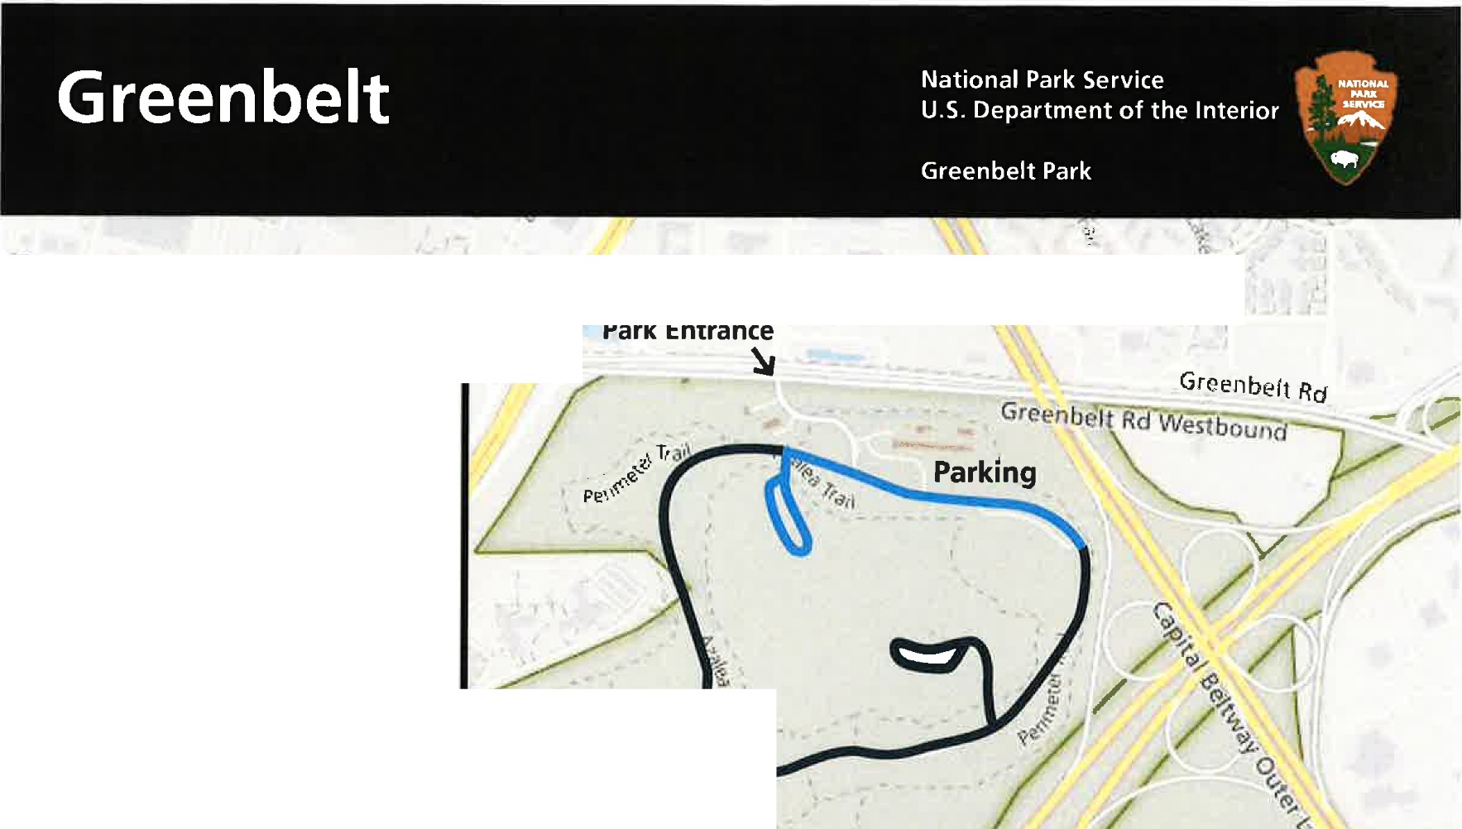
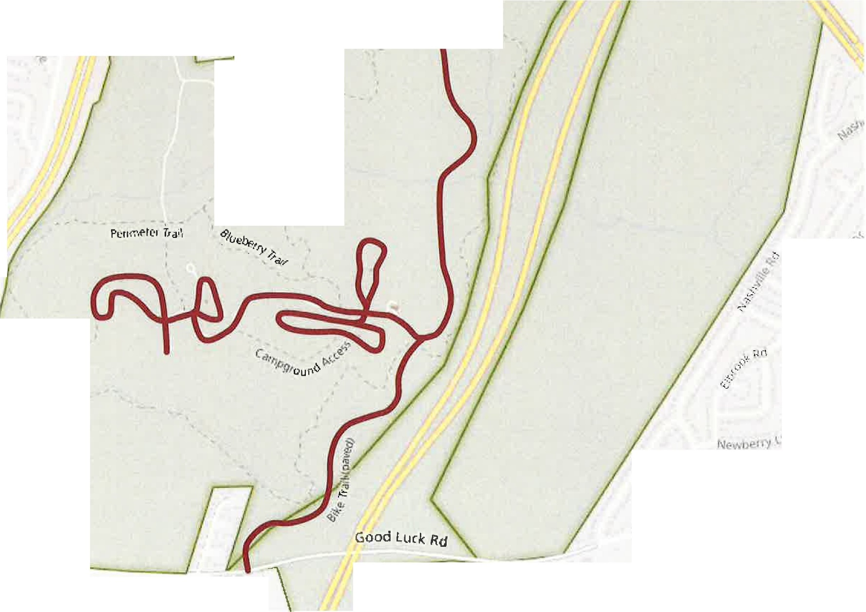
I 5T \FFORD

/,
- );

