The Nature Around You
Grade: 6th – 8th grade
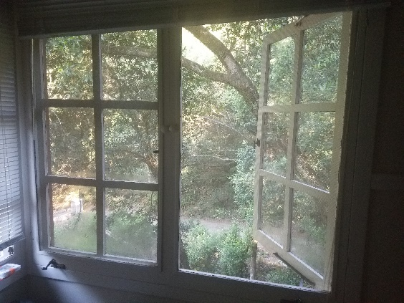
In this lesson, you’ll have a chance to learn about the nature around you and share it with your peers. First, you’ll explore digital content centered around coast redwood trees. Then, you’ll get to create your own content about some of your favorite nature near where you are.
Things you’ll need:
- Pen or pencil
- Writing paper
- Drawing materials
- Choose what kind of redwood content you’d like to explore. You can choose from:
Calming videos:
https://www.savetheredwoods.org/redwoods-recharge/calm-videos/
Redwood music playlists:
https://www.savetheredwoods.org/redwoods-recharge/spotify-playlists/
360 videos:
https://www.savetheredwoods.org/redwoods-recharge/virtual-experiences/
Coast Redwood app – explore a VR coast redwood from wherever you are. Currently only available for iOS, but soon to be available for Android:
https://apps.apple.com/us/app/coast-redwood-canopy/id1511004571
- As you explore your content, think about these questions, and write down any answers you have to them:
- What did you learn? Write down 3-5 things you didn’t know before.
- How does this content make you feel? Write 3-5 emotions you feel while exploring.
- What questions do you have about this content? Write 3 questions you might want to research.
- Now, you’re going to find your own natural space to create your own content. Find a space with some nature in it. Examples: your local park, your garden, the plants in your house, that tree on the sidewalk. Next, pick what kind of content you’d like to create. Examples: a tweet, a short song, a short poem, a drawing. Create content that helps answer the following question:
How would my world change if this nature wasn’t here?
Now, share your content with your teacher, family, and friends.

Standards
MS-LS2-4 Ecosystems are dynamic in nature; their characteristics can vary over time. Disruptions to any physical or biological component of an ecosystem can lead to shifts in all its populations.
Writing 7.2 Write informative/explanatory texts to examine a topic and convey ideas, concepts, and information through the selection, organization, and analysis of relevant content.
Writing 7.7 Conduct short research projects to answer a question, drawing on several sources and generating additional related, focused questions for further research and investigation.

