Mutualism Lesson UBD (Understanding By Design) Framework: Second Grade
Desired Results
Goals of the Lesson
Students will...
- Learn about mutualism in the redwood forest.
- Synthesize information from text.
- Think about their own mutualistic relationships.
- Write about diversity
Transfer
- Understand that organisms in ecosystems are connected
- Understand that diversity makes an ecosystem stronger
- Engage with scientific and personal inquiry
Meaning
Essential Question:

How are members of an ecosystem connected?

Enduring Understandings: Students will understand that...
- There are many examples of different relationships in ecosystems
- They can see similarities in their own relationships
- Diversity exists in ecosystems and their communities
Acquisition
Students will know...
- Examples of mutualism in the redwood forest
- What mutual relationships they have in their lives
- Why diversity is important in a healthy ecosystem
Students will be able to...
- Explain the aspects of mutualistic relationships
- Answer questions that relate to information given in the text
- Write about their own relationships
Evidence
Students will show their learning by…
Filling out the chart on each relationship, answering the questions about their own relationships and writing why diversity is important in ecosystems and communities.

Mutualism Lesson Plan
An inquiry based lesson on representation and botany.
1-2 hour lesson, 2nd grade
Overview
How are members of an ecosystem connected and how are we connected?

Lesson Goals
- Understand that organisms in ecosystems are connected
- Understand that diversity makes an ecosystem stronger
- Engage with scientific and personal inquiry
Lesson Objectives
- Students will be about to explain the aspects of mutualistic relationships
- Students will be able to answer questions that relate to information given in the text
- Students will be able to write about their own relationships
Next Generation Science Standards
2-LS2 Ecosystems: Interactions, Energy, and Dynamics
LS2.A: Interdependent Relationships in Ecosystems: Plants depend on animals for pollination or to move their seeds around.
2-LS4-1. Make observations of plants and animals to compare the diversity of life in different habitats.
LS4.D: Biodiversity and Humans: There are many different kinds of living things in any area, and they exist in different places on land and in water.

CA Common Core Standards
W.2.7 Participate in shared research and writing projects (e.g., read a number of books on a single topic to produce a report; record science observations). (2-LS2-1)
W.2.8 Recall information from experiences or gather information from provided sources to answer a question. (2-LS2-1)

Teacher Note about Procedure:

Using all of the examples of Mutualism given will take longer than 1 hour. Teachers should choose whether it makes sense for their class to do all of the examples or to choose 3 or 4 examples. Teachers can choose mutualism examples based on relevancy, student interest, differentiated instruction potential, etc. The lesson will work with all of the examples or only a few.

Teachers should go over the beginning and end of the Mutualism lesson as a class. The rest of the mutualism lesson can be done as independent work depending on reading level. Please lead classroom discussion in the beginning to go over important terms (organism, ecosystem, mutualism.) and a discussion at the end to go over the important themes of connection and diversity.

Teachers may choose to use the graphic organizer provided below or to use the PowerPoint provided.

Mutualism in the Redwood Forest Ecosystem!
What is an organism:

What is an ecosystem:

What is mutualism:
A mutualistic relationship is when two different organisms work together or depend on each other. They form a relationship that is beneficial to both parties.
What do you think lives in the Redwood Forest? Please draw a picture of it below:

Let's look at Mutualism in the redwood forest!
Banana Slugs and Redwood Trees: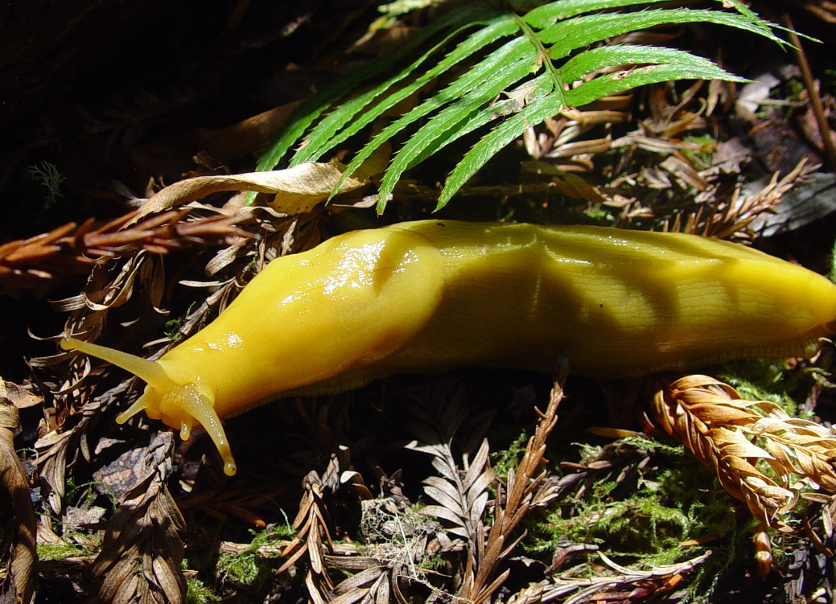
Image Description: A banana slug on the forest floor

Banana slugs live in the redwood forest and have a wonderful relationship with the redwood trees! Banana slugs need their skin to stay wet, so they like to live in wet places away from the sun. Redwood trees give them a damp place to live. The trees give them shade and water from the fog.

Banana slugs help the trees too! Banana slugs are decomposers, which means they break down dead material. This means they eat fallen leaves or animal poop and turn it into a nutrient rich soil for the redwoods to use. This is why they have a mutualistic relationship!

Fill out the chart:

 | What do they give? | What they do get?
Ecosystem Member 1:

Ecosystem Member 2:

Add the new community member to your drawing!

Banana slugs turn what might seem like a negative, like dead material, into a positive, like nutrient rich soil!
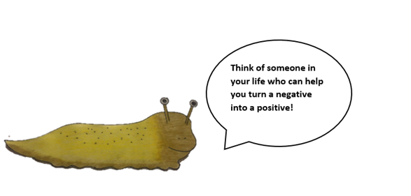Image Description: A drawing of a banana slug saying “Think of someone in your life who can help you turn a negative into a positive.”
Answer the banana slug’s question:

Ladybugs and Horsetails:
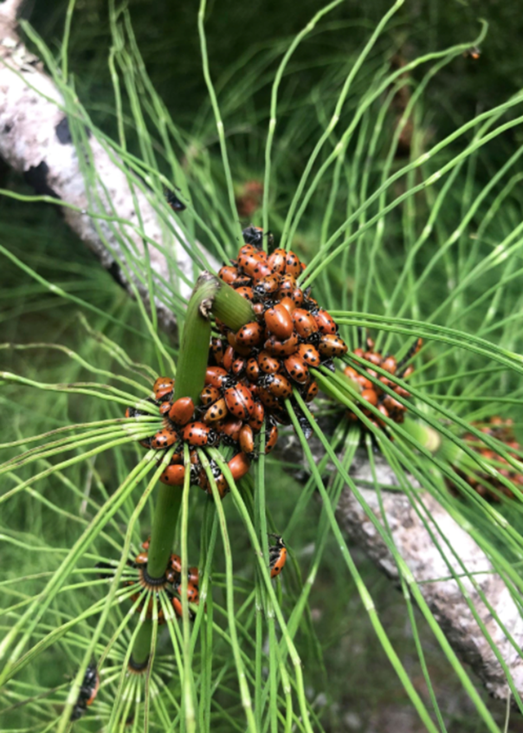
Image Description: A group of ladybugs clustering on a horsetail.

Ladybugs come to Muir Woods to get away from changing weather. They gather on the horsetail. The horsetail gives them shelter, water that can collect on the needles and food. Aphids are small insects that can hurt a horsetail, but luckily ladybugs love to eat aphids. This makes the ladybug and horsetail relationship have benefits for both. They have a mutualistic relationship.

The horsetail is a safe place for the ladybugs to land, and the ladybugs help to relieve the horsetail ferns of their pests. They are there for each other when they need each other.
Fill out the chart:

 | What do they give? | What they do get?
Ecosystem Member 1:

Ecosystem Member 2:

Add the new community member to your drawing!

Horsetail ferns give ladybugs a safe place to be when they migrate.
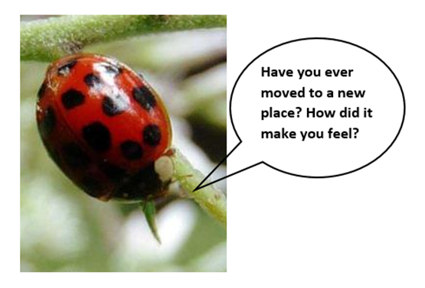

Image Description: A picture of a ladybug saying “Have you ever moved to a new place? How did it make you feel?
Answer the ladybug’s question:
Coho Salmon and The Redwood Trees:

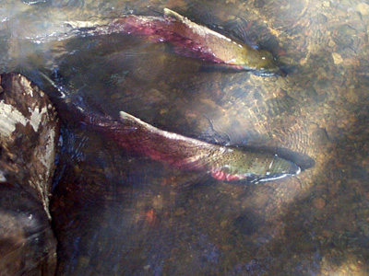

Image Description: Two coho salmon swimming in the creek.

Redwoods often grow along creeks. They will help to shade the creek and keep it cool. They keep soil from going into the creek and muddying the water. When their branches or trunks fall into the creek, it helps to slow the water down and create pools. All these things make for a better habitat for the Coho Salmon.

Coho salmon go from the creek to the ocean and back again. When salmon go out to the ocean, they get a lot of important nutrients from the things they eat. When they come back to lay their eggs, they will die in the creek. After they die they will decompose and the nutrients they brought from the ocean become a part of the redwood forest ecosystem and help the redwoods to grow.

Fill out the chart:

 | What do they give? | What they do get?
Ecosystem Member 1:

Ecosystem Member 2:

Add the new community member to your drawing!

The salmon bring something new to the redwood forest.
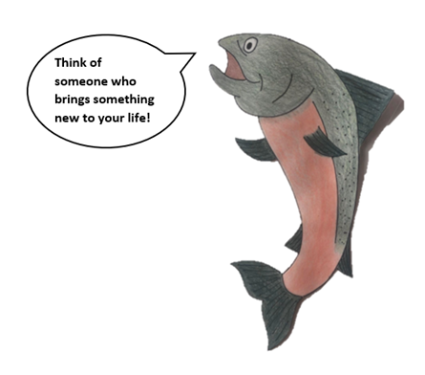
Image Description: A drawing of a coho salmon saying “Think of someone who brings something new to your life!”

Answer the salmon’s question:

Lichen

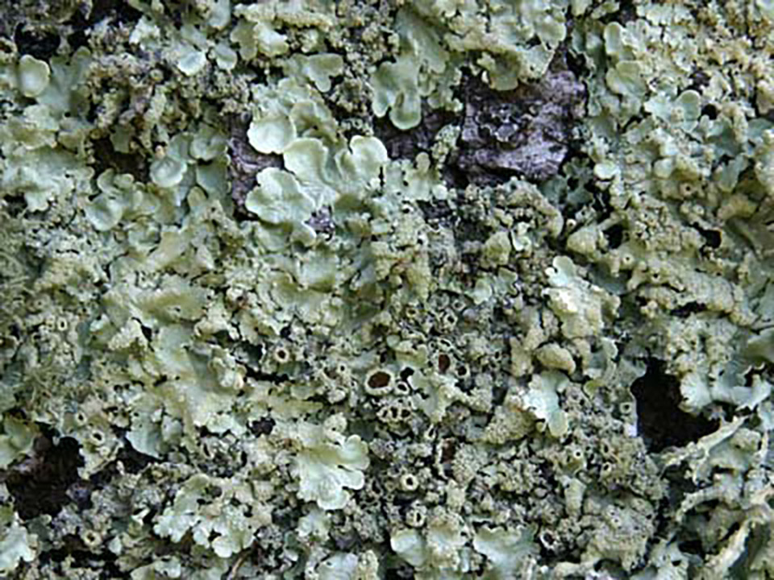
Image Description: Green lichen on a rock

Lichen is not one thing, but many things that exist together!

Lichen is made up of different kinds of fungus and algae. The fungus creates the structure and provides nutrients. The algae makes food and energy from sunlight and water for itself and the fungus. Therefore, they have a mutualistic relationship.

Fill out the chart:

 | What do they give? | What they do get?
Ecosystem Member 1:

Ecosystem Member 2:

Add the new community member to your drawing!

Without all these components, lichen would not exist. All the different organisms are a part of this team.

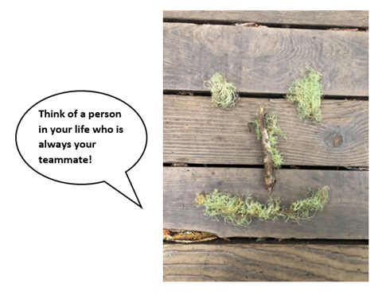
Image Description: Lichen arranged like a smiley face says, “Think of a person in your life who is always your teammate!”
Answer the lichen’s question:

Mushrooms and Trees

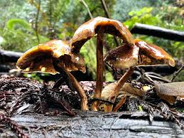
Image Description: Mushrooms grow out of a redwood log

When you see a mushroom, you are only seeing a very small part of it! That is because most of it lives underground, in what’s called the mycelium.

This mycelium plays an important role in how trees talk to each other. Scientists have found that these mushrooms connect to tree roots underground and get important food and energy from the tree roots. In return the mushrooms connect the tree to other trees around them, helping trees to communicate with each other.

Fill out the chart:

 | What do they give? | What they do get?
Ecosystem Member 1:

Ecosystem Member 2:

Add the new community member to your drawing!

The fungi help the tree to communicate to other trees around it.
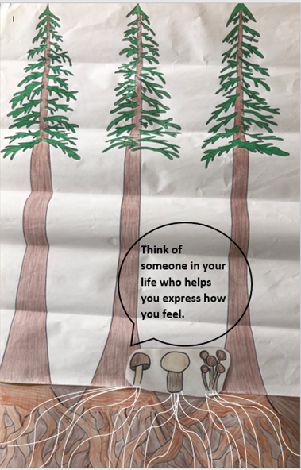Image Description: A drawing of three redwood trees and their roots connected with three mushrooms and their mycelium underground. The mushrooms say “Think of someone in your life who helps you express how you feel.”
Answer the mushroom’s question:
Animals and Berries
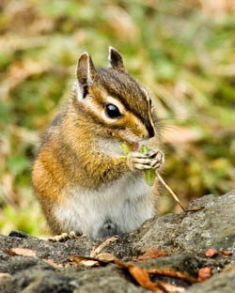

Image Description: A chipmunk eats seeds on a rock

There are different kinds of berries throughout the redwood forest. Some of these berries can be dangerous for us to eat, but are fine for animals like chipmunks, birds and squirrels. These small animals will eat the berries, and then carry their seeds to another place. This is called seed dispersal. This helps everyone, it is food for the small animals and helps the plant to spread its seeds and grow in new places. That is why this is a mutualistic relationship.

Fill out the chart:

 | What do they give? | What they do get?
Ecosystem Member 1:

Ecosystem Member 2:

Add the new community member to your drawing!

When the animals carry the seeds to a new location, they give the plant a chance of growing somewhere else.
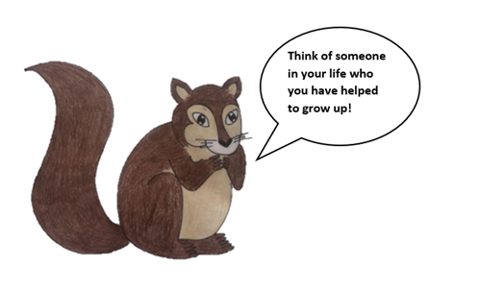
Image Description: A drawing of a squirrel says, “Think of someone in your life who you have helped to grow up!”

Answer the chipmunk’s question:

Sorrel and the Redwood Trees
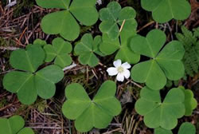
Image Description: Redwood sorrel and flower on the forest floor.

When you look around the redwood forest, you may see what you think is a lot of clover. But it is something different. It’s called redwood sorrel.

Redwood sorrel is a shade loving plant. Redwood trees provide that shade for the sorrel. In return, the sorrel provides cover for the forest floor and helps to make sure that the soil stays in place. One single sorrel by itself can’t keep the soil in place. One redwood by itself can’t provide enough shade. The forest needs every redwood tree and every sorrel.

Fill out the chart:

 | What do they give? | What they do get?
Ecosystem Member 1:

Ecosystem Member 2:

Add the new community member to your drawing!

The trees provide shade for the sorrel and all the small sorrel plants work together to keep the soil on the forest floor.

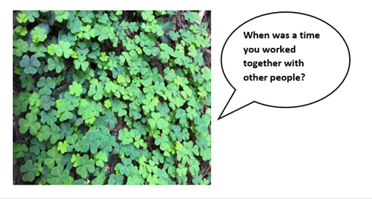
Image Description: A picture of redwood sorrel says, “When was a time you worked together with other people?”

Answer the sorrel’s question:

All the relationships are very different, as are the organisms in the relationships. There is a lot of diversity in redwood forest ecosystems.

What is diversity?
How does diversity make this forest stronger?
How does diversity make your community stronger?

