Alice Eastwood Lesson UBD (Understanding By Design) Framework: Fourth/Fifth Grade
Desired Results
Goals of the Lesson
Students will...
- Read about Alice Eastwood’s role in the preservation of the redwood forest and her career endeavors.
- Practice the use of direct quotations to better understand a person’s objectives.
- Practice plant observing and describing.
Transfer
- Utilize observation to describe things in nature.
- Understand why and how places are preserved
- Engage with historic and scientific inquiry
Meaning
Essential Question:

How do we choose what to preserve and who to remember?

Enduring Understandings: Students will understand that...
- Looking closely at how the environment around us can inspire preservation and interest.
- People dedicate their lives to conservation.
- That many people contributed to the conservation of national park sites.
Acquisition
Students will know...
- The life and career of Alice Eastwood
- How to record observations of plants
- How to write about a historical moment
Students will be able to...
- Look at quotes in an informative article and gather information from this direct source.
- Record observations of a natural object in drawings and writings
- Create questions and further inquiry around relevant subjects
- Write their opinions and ideas.
Evidence
Students will show their learning by…
Filling out the Alice Eastwood Graphic Organizer. Showing their plant observations through drawing and writing. Writing their newspaper article.

Alice Eastwood Lesson Plan
An inquiry based lesson on representation and botany.
2 hour lesson (with optional break in the middle), 4th-5th grade
Overview
How do we choose what to preserve and who to remember?

Lesson Goals
- Utilize observation to describe things in nature.
- Understand why and how places are preserved
- Engage with historic and scientific inquiry
Lesson Objectives
- Students will be able to locate quotes in an informative article and gather information from this direct source.
- Students will be able to record observations of a natural object in drawings and writings
- Students will be able to create questions and further inquiry around relevant subjects
- Students will be able to write their opinions and ideas.
CA History-Social Science Standards
4.3.4 Study the lives of women who helped build early California.
CA Common Core Standards
Reading Standards for Information Text:
4.1 Refer to details and examples in a text when explaining what the text says explicitly and when drawing inferences from the text.
5.1 Quote accurately from a text when explaining what the text says explicitly and when drawing inferences from the text.
Writing Standards:
4.9a Draw evidence from literary or informational texts to support analysis, reflection, and research.
5.2b . Develop the topic with facts, definitions, concrete details, quotations, or other information and examples related to the topic.

Lesson Procedure
Use the provided PowerPoint to start the lesson.
Optional Lesson Break after earthquake questions.
Activities available in slides or graphic organizer below:
Look at Alice Eastwood’s botanical drawing. Now look at these redwood cones and needles. Do your own botanical drawing and notes of the redwood cones and needles. Go outside and find your own thing to draw and observe.
Alice Eastwood’s Drawing and Descriptions:
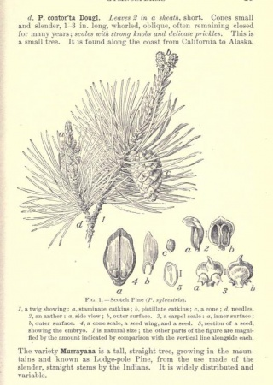
Image Description: Alice Eastwood’s botanical drawings and writing of a douglas fir
A Redwood Cone and Needles:
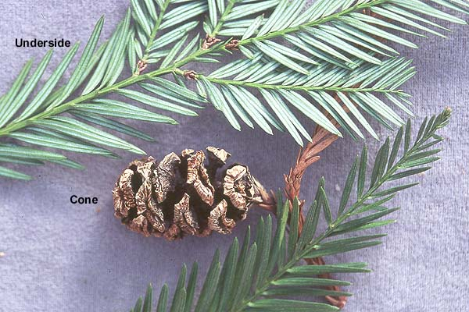
Image Description: A redwood cone and needles
Redwood Drawing and Descriptions:

Your own plant Drawing and Descriptions:
Alice Eastwood ran into a crumbling building to rescue her collections and her friend’s collections. Why do you think she did that?
___________________________________________________________________________________________________________________________________________________
If you were in her situation, what would you run into a crumbling building to get? Why?
___________________________________________________________________________________________________________________________________________________
---------OPTIONAL LESSON BREAK---------------
For more a lesson on writing newspaper articles visit:
https://www.scholastic.com/teachers/articles/teaching-content/writing-newspaper-article/
In this Newspaper article from 1904 Alice Eastwood is mentioned.
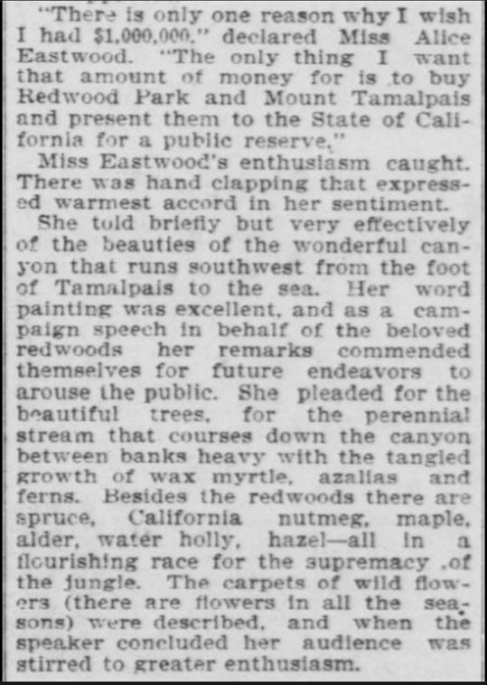

Newspaper clipping reads:

“There is only one reason why I wish I had $1,000,000” declared Miss Alice Eastwood. “The only thing I want that amount of money for is to buy Redwood Park and Mount Tamalpais and present them to the State of California for a public reserve.” Miss Eastwood’s enthusiasm caught. There was hand clapping that expressed warmest accord in her sentiment. She told briefly but very effectively of the beauties of the wonderful canyon that runs southwest from the foot of Tamalpais to the sea. Her word painting was excellent, and as a campaign speech in behalf of the beloved redwoods her remarks commended themselves for future endeavors to arouse the public. She pleased for the stream that courses down the canyon between banks heavy with tangled growths of wax myrtle, azaleas and ferns. Besides the redwood there are spruce, California nutmeg, maple, alder, water holly, hazel - all in a flourishing race for the supremacy of the jungle. The carpets of wild flowers (there are flowers in all the seasons) were described, and when the speaker concluded her audience was stirred to greater enthusiasm.
The journalist talks about why the redwood forest is so important to Alice Eastwood. In 1949 a campground was named after Alice Eastwood in the park that she helped save. Write your own newspaper article about the campground being named after her. Please share in your article why this area was named after her and why you think it is important.
_____________________________________________________________________________________________________________________________________________________________________________________________________________________________________________________________________________________________________________________________________________________________________________________________________________________________________________________________________________________________________________________________________________________________________________________________________________________________________________________________________________________________________________________________________________________________________________________________________________________________________________________________________________________________________________________________________________________________________________________________________________________________________________________________________

