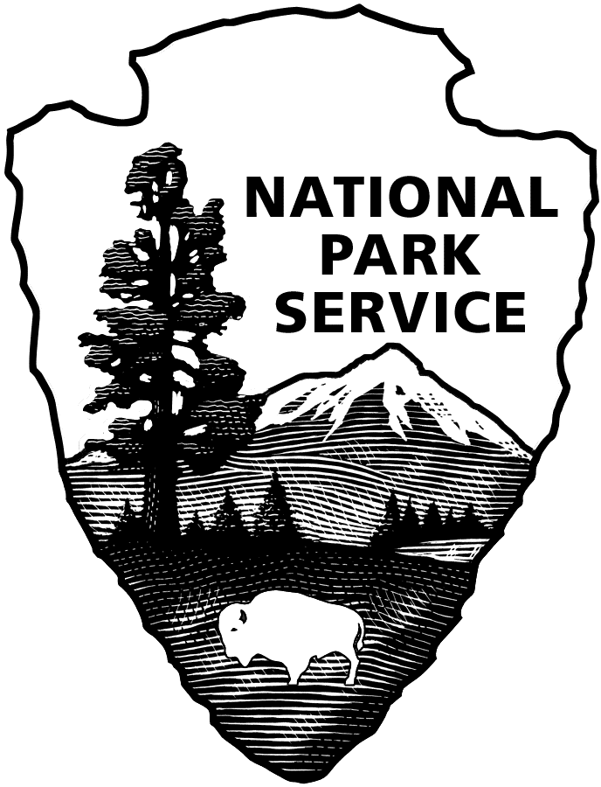
United States Department of the Interior

NATIONAL PARK SERVICE
Glacier Bay National Park & Preserve
P.O. Box 140
Gustavus, Alaska 99826-0140
Tel: (907) 697-2230

RECRUITMENT BULLETIN: GLBA-24-025
ISSUE DATE: April 29, 2024
CLOSING DATE: May 06, 2024

JOBS AVAILABLE THROUGH THE ALASKA LOCAL HIRE PROGRAM--PUBLIC LAW 96-487

Glacier Bay National Park and Preserve is accepting applications for two temporary (not-to-exceed 1039 hours), full-time Park Ranger (General), GS-0025-07 positions. More than one position may be filled via this bulletin.
________________________________________________________________________________

POSITION DUTY LOCATION
Park Ranger, GS-0025-07 Bartlett Cove, AK
$26.53 to $34.50 per hour, plus a 3.21% Cost of Living Allowance (COLA)

APPOINTMENT INFORMATION: Temporary, full-time approximately May to October. The appointment may be extended for an additional period (not to exceed 1039 hours total employment). Persons selected may be eligible for rehire in future years. Schedule may involve weekend work or performance of duties before or after “normal” working hours. Government housing is not available. More than one position may be filled from this posting.

BENEFITS: Temporary, seasonal, and intermittent employees on appointments expected to last at least 90 days, and expected to work a schedule of 130 hours or more a calendar month, will be eligible to enroll in a Federal Employee Health Benefit (FEHB) health plan upon notification from their employing office. Eligible employees will be responsible for the employee share of the premium while on the official agency roles, which will be deducted from bi-weekly earnings.

DUTIES: You will work as a Park Ranger (General), GS-0025-07 at Glacier Bay National Park and Preserve. Duties include but are not limited to the following:

- Lead work tasks independently or with others and report progress of work to the supervisor, make day-to-day adjustments in accordance with established priorities, obtaining assistance from the supervisor on problems that may arise, such as backlogs which cannot be disposed of promptly.
- Estimate and report on expected time of completion of work, and maintain records of work accomplishments and time expended and prepare production reports as requested.
- Instruct lower-level employees in specific tasks and job techniques and make available written instructions, reference materials and supplies.
- Give on the job training to new employees in accordance with established procedures and practices.
- Maintain a current knowledge and answer questions of visitors and other employees on procedures, policies, directives, etc. and obtain needed information or decisions from supervisor on problems that come up.
- Check office work and databases for accuracy to make sure that Visitor Use statistics are being completed and that supervisor's instruction on work sequence, procedures, methods and deadlines are being met daily.
- Resolve simple, informal complaints of visitors and refer others to supervisor.
- Report to supervisor on office performance, progress and training needs.
- Informs visitors about park flora and the life habits and behavior of park fauna, with emphasis on behavior that may be potentially dangerous to visitors.
- Checks on the measures campers and hikers take to avoid attracting or provoking dangerous animals.
- Educates visitors regarding activities that impact upon the preservation of natural and cultural resources, including issues dealing with visitor safety.
- As assigned, performs resource management tasks and duties supporting the mission of the park.
- Presents programs, lectures, multi-media shows, structured and impromptu talks, and various other programs, about park resources and the rules for park usage, employing appropriate interpretive techniques and devices geared to the characteristics and of particular audiences. Duties may be performed on or off-site at locations designated by the park, e.g., visitor centers, campgrounds, auditoriums, etc.
- Suggests new topics, revisions, and other changes or improvements in the overall Visitor Information Station program.
- Participates in operations of special events at the park such as festivals related to the park's resources and programs, annual recreational boat shows, and crafts displays, historical reenactments, etc. Suggests appropriate activities related to the themes of the events. Makes arrangements for transportation of participants to and from the park
- and for reception of dignitaries and carries out other tasks assigned in connection with one-time or annual celebrations related to the programs and themes of the park.
- Performs various administrative duties, e.g., scheduling, gathering routine information for reports, compilation of statistical data, etc.
- Typically serves as a member of all-risk operations, e.g., search and rescue, Wildland and structural fires, etc. Performs emergency medical services as needed.
- Is responsible for the radio communication operations. Handles emergency telephone calls placed to unit headquarters. Constantly monitors radio traffic. Administers and provides communications services and passive tracking for unit operations, all park and visitor vessel captains. Implements established call out procedures for emergency assistance. Notifies local services, cooperators, unit neighbors and others when requested.
- Develops operating guidelines and procedures for the radio communication/tracking operations. Trains unit personnel in subjects related to the radio communication function and proper radio use, including radio operations, resource ordering and tracking, emergency tracking, field reports and procedures, and emergency operation computer system when needed. Maintains and updates logs as required.
- Patrols park areas by foot, motorized skiff, vehicle, and or other park vessels routinely and when called on in an emergency.

PHYSICAL DEMANDS: The work requires regular and recuring physical exertion such as long periods of standing, walking, driving, bending, etc. The work, on a regular and recurring basis, requires physical exertion such as climbing, hiking, and lifting heavy objects. Work may be performed on uneven, steep, rough, slippery, and/or rugged terrain.

WORK CONDITIONS: The work is performed in a setting in which there is regular and recurring exposure to moderate discomforts and unpleasantness, (e.g., high or low temperatures, confined spaces or adverse weather conditions). The work environment may involve high risks with exposure to potentially dangerous situations or unusual environmental stress. In addition, work may be performed in areas of extremely rough terrain with wide annual variations of climatic conditions.

WHO MAY APPLY: Any U.S. citizen who has acquired special knowledge or expertise regarding the natural or cultural resources of Glacier Bay National Park and Preserve, by reason of having either lived or worked in or near the park. To be eligible, applicants must have lived or worked in or near the area long enough to encounter and become familiar with a full range of typical conditions that affect the work to be accomplished. Applicants’ resumes should reflect periods of time having lived or worked in or near the area of consideration.

Areas considered “near” Glacier Bay National Park and Preserve are Icy Bay on the north to Dixon Entrance on the south, Gustavus, Hoonah, Elfin Cove, Pelican, Excursion Inlet, Haines, Skagway, Juneau-Douglas-Auke Bay, Yakutat and Dry Bay.

POSITION REQUIREMENTS: Requirements will be determined by evaluating experience in your resume and /or in the interview and selection process. All position requirements must be met by the closing date of this job posting. Knowledge or expertise concerning the park’s or preserve’s natural and/or cultural resources and the management thereof is required. Local knowledge of the resources and the typical conditions that affect the work to be accomplished will be applied in the performance of the duties. In determining eligibility, applicants' resume must indicate periods of time of having lived and/or worked in or near the above listed areas of consideration. Failure to do so may result in non-referral of your application.

Following are nine competencies identified for this position. Applicants are not required to address these competencies in a separate document but are encouraged to include in their resumes information related to these competencies.

- Thorough knowledge of the natural and cultural resources of the park to which assigned.
- Thorough knowledge of the recreational resources of the park and of the surrounding area, including hiking, camping, fishing, boating and water sports, riding, biking, skiing, mountaineering, snowmobiling, bird watching, and other types of activities. Specific knowledge is required regarding the minimum environmental impact and safety requirements for each permitted activity.
- Knowledge of interpretive and communications techniques necessary to develop informational materials and to prepare and deliver structured and informal presentations to varied audiences.
- Knowledge of the dispatch function and ability to handle a range of unusual or emergency communications with skill and judgment.
- Ability to recognize problems, analyze situations, and develop solutions to problems through application of sound judgment. Ability to independently make rapid decisions based upon available information and handle emergency dispatch situations.
- Knowledge of the NPS mission and its policies, goals, and objectives, as well as knowledge of park operations, procedures, practices and precedents.
- Basic knowledge of the methods, techniques, and operational procedures involved in performing field-level firefighting.
- Basic knowledge and skill in providing emergency medical services.
- Basic knowledge of the Incident Command System, and knowledge of basic skills in carrying out the range of duties involved in all-risk operations teams.

CONDITIONS OF EMPLOYMENT:
- U.S. Citizenship required.
- Appointment subject to background investigation with favorable adjudication before starting work.
- Selectee will be required to participate in the Direct Deposit Electronic Funds Transfer Program.
- Must be 18 years of age or older.
- Males must meet Selective Service Registration Act requirement. Verify registration at sss.gov.
- Government housing is available.
- You will be required to submit to a drug test and receive negative drug test results prior to appointment. In addition, this position is subject to random testing for illegal drug use.
- You will be required to operate a government motor vehicle as part of your official duties; a valid driver’s license is required. After selection, you may be required to submit a GSA Form 3607 and driving record at your own expense.
- You must obtain and maintain a current Department of Interior Motorboat Operator Certification Course (DOI-MOCC) certificate. The DOI-MOCC certificate is not needed at time of hire but must be obtained within the first year of employment. Training course is provided by park for applicant to complete following start of employment.
- You will be required to wear a uniform and comply with the National Park Service uniform standards. A uniform allowance will be provided.
- You may be required to work on-call, evenings, weekends, holidays, overtime and shift work.

HOW TO APPLY:

PLEASE READ THE FOLLOWING INSTRUCTIONS CAREFULLY! Incomplete submissions may result in non-referral of your application. Please note: An application consists of your resume and any other required forms or documents outlined below. There is no application form to complete.

Assistance may be obtained by e-mailing glba_hr@nps.gov.

All applications must be postmarked or received via email by the closing date of the announcement.

If mailed via USPS, your application must be addressed to: Park Headquarters, Glacier Bay National Park and Preserve, P. O. Box 140, Gustavus, AK 99826.

If your application is postmarked on the closing date, it must be received in a sealed envelope at Glacier Bay National Park and Preserve no later than seven calendar days after the closing date. Emailed applications must be received by 11:59 AKST on the closing date of the job posting.
It is the applicant’s responsibility to verify their application has been received via email by the deadline specified above.

You may email your application to: glba_hr@nps.gov. Emailed applications must not be sent (CC) to this position’s supervisor or any other individual staff member.

If you email your application, include the bulletin number in the subject line. If you apply for more than one position, send a separate email with application for each position.

Note: Information provided in the body of the email will not be considered part of your application. Include all information you want to share in your resume or include a cover letter.

Be sure to not include any photographs of yourself or any PII (Personally Identifiable Information), such as your Social Security Number, driver’s license number, or passport number.

Hand-delivered applications cannot be accepted. DO NOT SEND your application via UPS or FedEx. We do not accept faxed applications or applications mailed in postage-paid government envelopes or through an internal government mail system.

REQUIRED FORMS to send via USPS or email:

- Resume that provides detailed information about your work experience. Also include: the recruitment bulletin number of the position for which you are applying; and for each period of employment: the dates worked (for example, June 2009 through August 2010), the position title, employer’s name, phone number and address.
  - Emailed resumes and cover letters need to be sent as attachments.

- DD-214 if claiming points of Veterans’ Preference; if claiming 10 points of Veterans’ Preference, also include the SF-15 and verification documents described on the back of the SF-15. The SF-15 may be obtained through the Internet at www.opm.gov/forms.

It is the applicant’s responsibility to provide documentation/proof of claimed status for veterans’ preference, qualifications, and education. Applicants will not be solicited for further data if that provided is found to be inadequate, illegible, or incomplete.

Application materials will not be returned; therefore, do not submit original documents that you may need in the future, or extra materials such as letters of recommendation, photographs, or award certificates.

If you make a false statement in any part of your application, you may not be hired or you may be fired after you begin work, or you may be subject to fines, imprisonment, or other disciplinary action.

Veterans’ Preference (for qualifying veterans): To receive Veterans’ Preference, your application package must include a legible copy of the DD-214, “Military Discharge,” that shows the type of discharge from service (usually the Member 4 copy), or Report of Separation from Active Duty if separation was prior to July 1, 1979. If claiming 10-point Veterans’ Preference, you also must provide a completed SF-15 (www.opm.gov/forms) and verification documents listed on the SF-15. If you are separated and as yet do not have a DD-214, you may use an official statement of service from your command indicating that you have completed active service and are being discharged under honorable conditions, or provide other official documentation (e.g. documentation of receipt of a campaign badge or expeditionary medal) that proves your military service was performed under honorable conditions. You will not receive Veterans’ Preference if you do not provide this documentation.

Reasonable Accommodations: The agency provides reasonable accommodations to applicants with disabilities where appropriate. If you need a reasonable accommodation for any part of the application and hiring process, please notify the park office listed on this announcement. Determinations on requests for reasonable accommodations will be made on a case-by-case basis.

Privacy Act Information The application you submit for this position contains information subject to the privacy act of 1974 (PL-93-579, 4 USC 552a). We are required to provide you with information regarding our authority and purpose for collecting this data, the routine uses which will be made of it and the effects, if any, of non-disclosure. You are entitled to the same information as it pertains to disclosure of your social security number. Any questions you may have regarding the Privacy Act regulations and the rights it extends can be answered by contacting the park office.

Equal Employment Opportunity Appointments are made without regard to race, color, age, sex, sexual orientation, religion, political affiliation, national origin, marital status, non-disqualifying handicap condition or any non-merit factor.

