“Book-to-Life”
  - The Eternal Soldier
  Who is the author? | Who is the illustrator?
Who is the main character?  What is the setting? | What do you think happens?  (Write or draw your guess.)

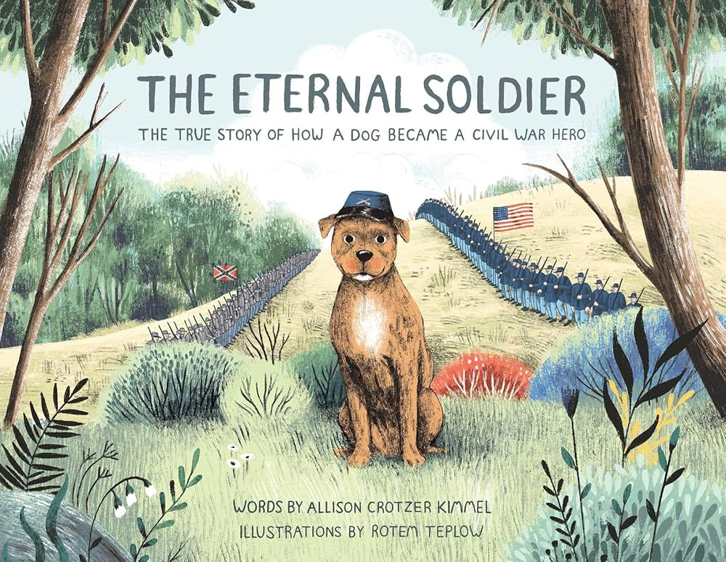
  - New Book Words

AUTHOR  ILLUSTRATOR  SETTING  CHARACTERS  FICTION  NON-FICTION  PLOT  CONFLICT | is the writer of the book.  is the person who created the pictures for the book.  is the time and place of the story.  are the people or creatures in a story that speak and perform the actions. The MAIN character is who the book is about!  is made-up stories from the author’s imagination.  is writing about real people, places and events.  is the series of events that make up the story.  is the main problem or struggle in the story.

