“Book-to-Life”
  - B is for Battle Cry: A Civil War Alphabet
  Who is the author? | Who is the illustrator?
What is the title? | What things do you see on the cover that you might learn about in the book?

Fiction or Non-fiction?

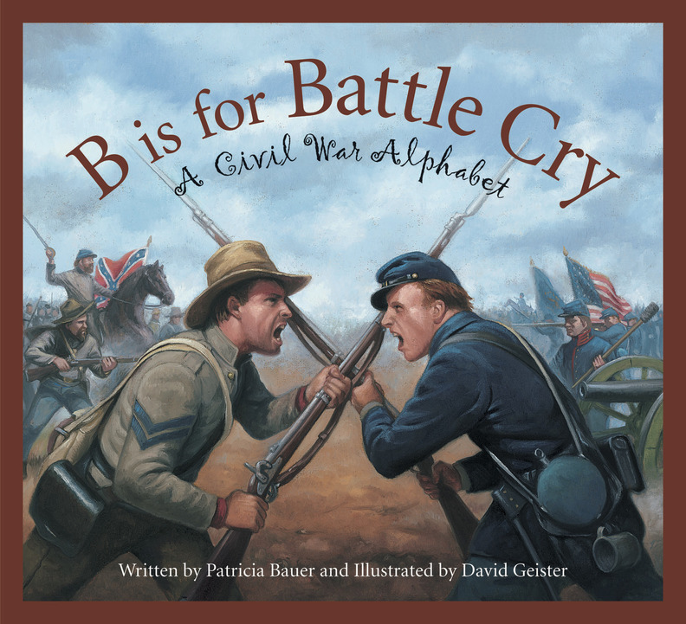
  - New Book Words

AUTHOR  ILLUSTRATOR  ACKNOWLEDGEMENTS  VERSE or POEM  GLOSSARY  FICTION  NON-FICTION  TITLE  SUBTITLE | is the writer of the book.  is the person who created the pictures for the book.  the page where author thanks those who helped with book  is word art that uses rhythm and rhyme to express ideas  are the people or creatures in a story that speak and perform the actions. The MAIN character is who the book is about!  is made-up stories from the author’s imagination.  is writing about real people, places and events.  is the series of events that make up the story.  is the main problem or struggle in the story.

