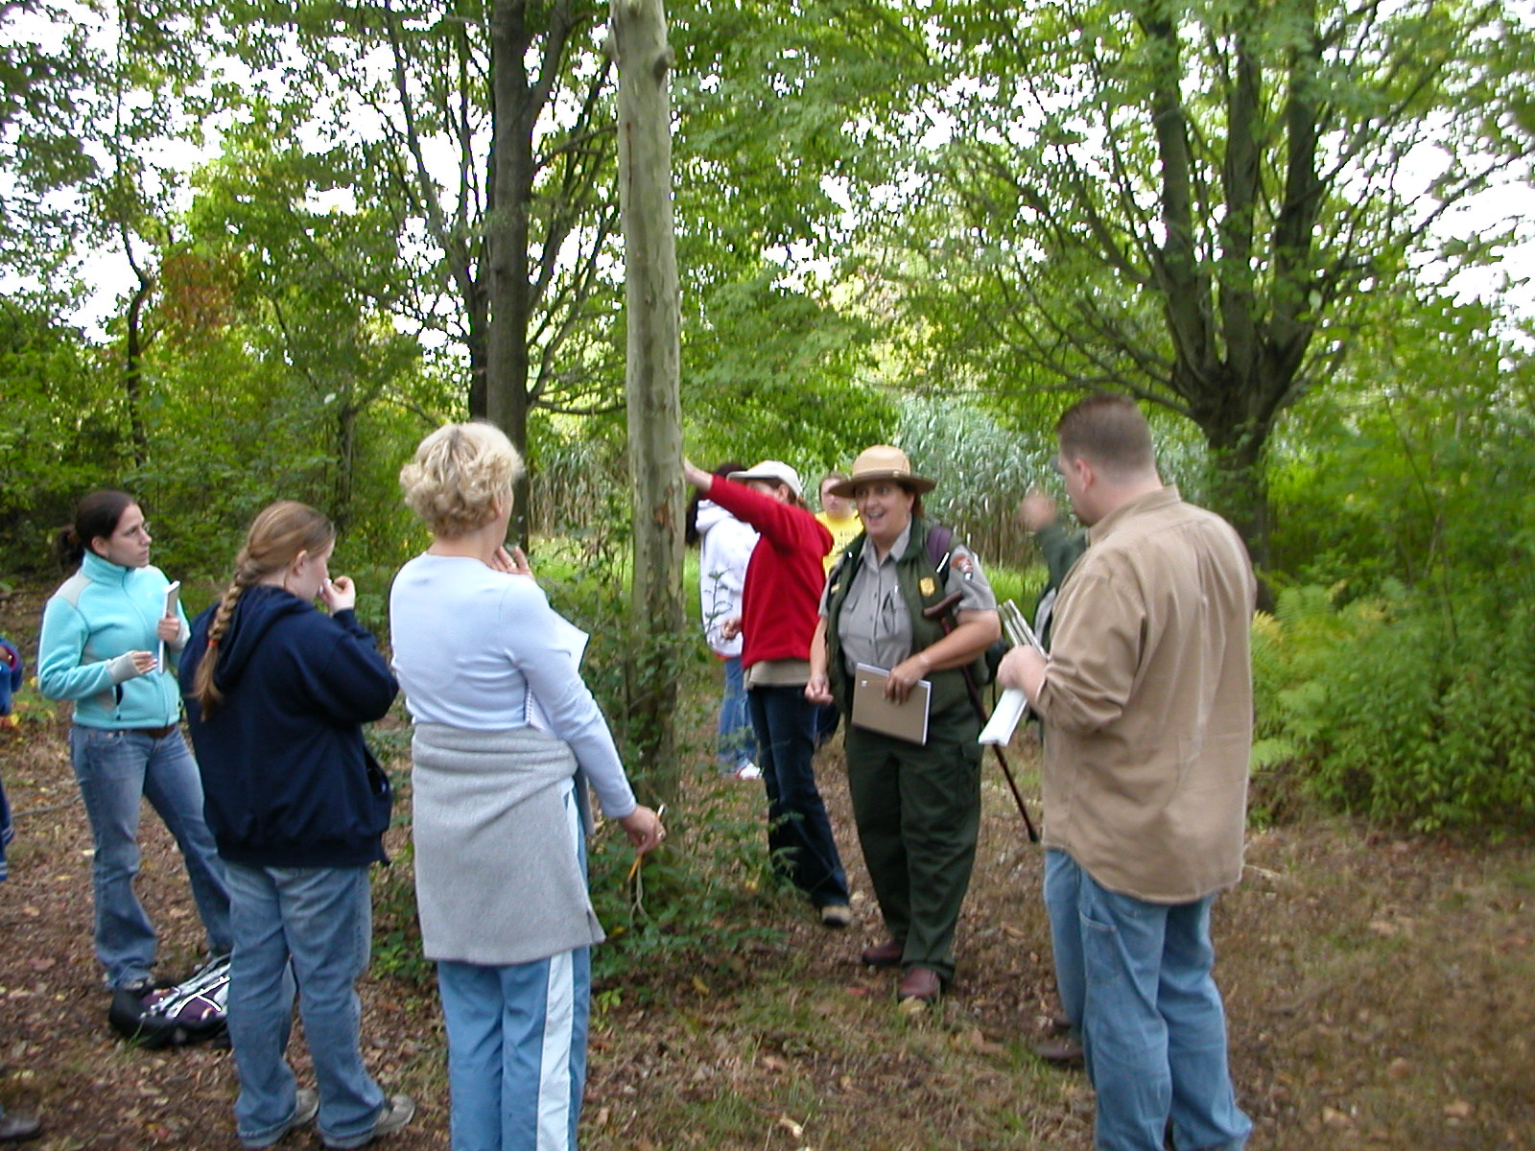

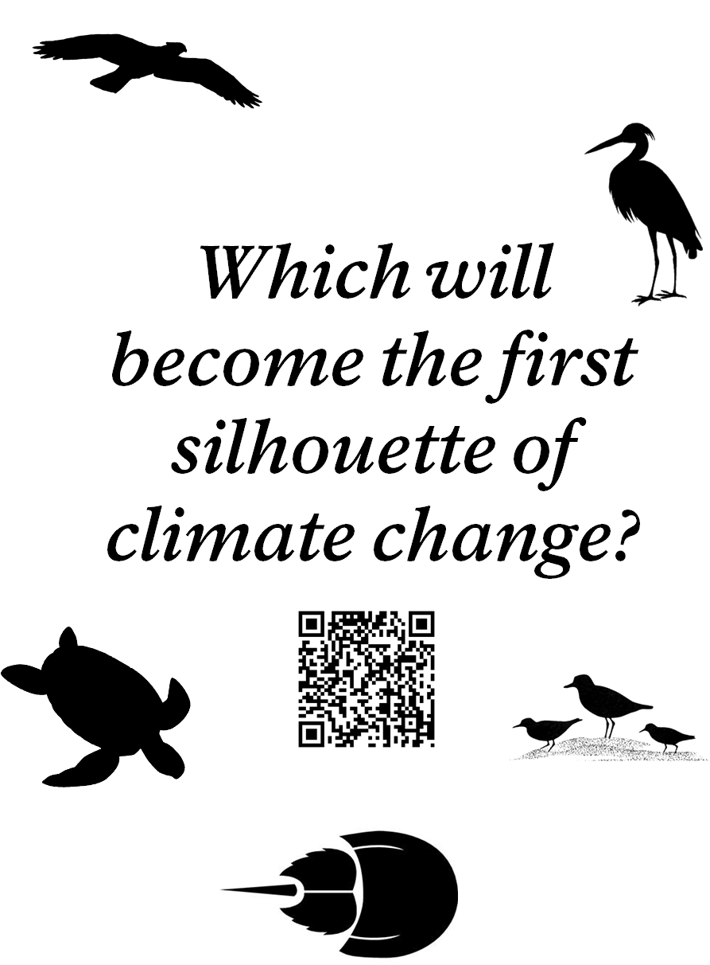

Gateway National Park Service U.S. Department of the Interior

Gateway National Recreation Area
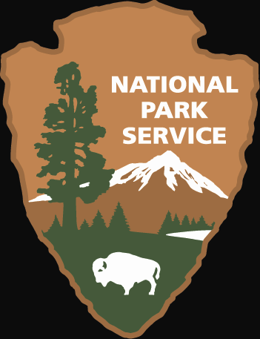
EXPERIENCE YOUR AMERICA™

