National Park Service
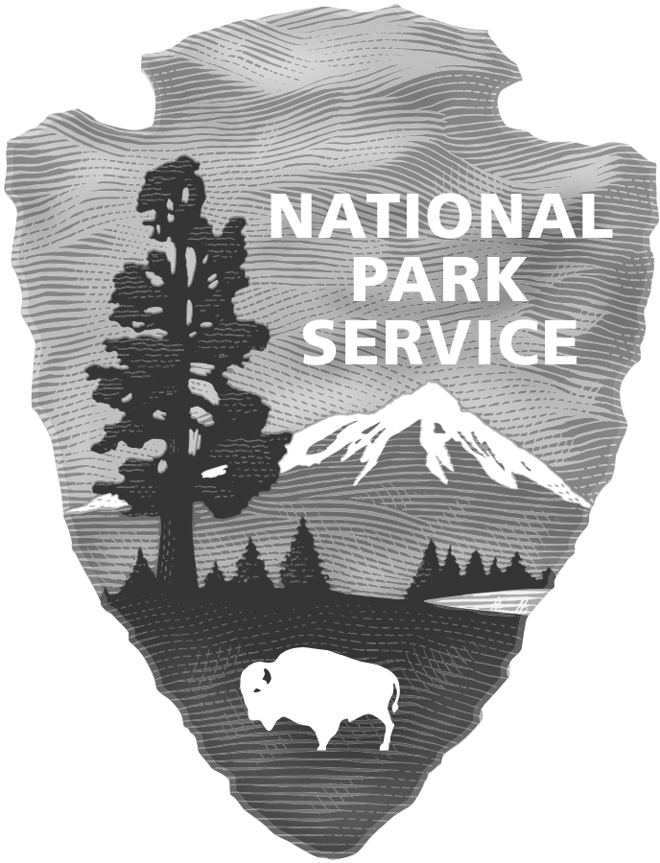
U.S. Department of the Interior

Gateway Research Learning Center
Gateway National Recreation Area

Internship Program
Intern

To be filled out by Student
Intern Name:

Address: Phone:

Email:

School: Degree Program:

GPA: Expected Graduation:

School Liaison Name: Phone:

Liaison Title/Department: Email:

To be filled out by NPS personnel
Park

Park: Unit/District:

Address:

Supervisor: Phone:

Email:

Field Supervisor: Phone:

Email:
Internship Details

Date (begin-end):

Work Schedule (Please fill in hours)

Sunday | Monday | Tuesday | Wednesday | Thursday | Friday | Saturday

Duty
Location
Detail
Products/
Deliverables
Completion
Date
Evaluation
*Justification Attached

Evaluation Sheet

Duty | Evaluation | Justification

Evaluation Scale

The National Park Service employees are rated biannually according to the scale below. In the interest of experience the intern will be rated as thought they were an employee once mid-semester and at the end of the semester.
Exceptional | 4.6 – 5.00 AND No critical element rated lower than “Superior”.
Superior | 3.6 – 4.59 AND No critical element rated lower than “Fully Successful”.
Fully Successful | 3.0 – 3.59 AND No critical element rated lower than “Fully Successful”.
Minimally Successful | 2.0 – 2.99 AND No critical element rated lower than “Minimally Successful”.
Unsatisfactory | One or more critical elements rated “Unsatisfactory”.

Final grades are up to the academic institution and any evaluations from the supervisor are suggestions based on performance. Suggested corresponding grades are as follows:

Letter Grade | NPS rating
A+ | Exceptional (4.6 – 5.00)
A | Superior (3.6 – 4.59)
A- | Fully Successful (3.0 – 3.59)
B | Minimally Successful (2.0 – 2.99)
C | Unsatisfactory (One or more critical elements rated “Unsatisfactory”

Signature Sheet

Notification of Standards: Signatures certify that critical elements/standards were discussed)
Employee: | Field Supervisor: | Supervisor:
Date: | Date: | Date:

Employee Input into Development of Standards: Signatures certify intern involvement was solicited by supervisor:
Employee: | Date: | Field Supervisor: | Date:

Progress Review: Signatures certify that performance was discussed.
Employee: | Date: | Field Supervisor: | Date:

Final Review: Signatures certify that performance was discussed.
Employee: | Field Supervisor: | Supervisor:
Date: | Date: | Date:

