Desired Results
Established Goals:
NGSS:

LS2.A: Interdependent Relationships in Ecosystems
- Organisms, and populations of organisms, are dependent on their environmental interactions both with other living things and with nonliving factors. (MS-LS2-1)

LS2.C: Ecosystem Dynamics, Functioning, and Resilience
- Ecosystems are dynamic in nature; their characteristics can vary over time. Disruptions to any physical or biological component of an ecosystem can lead to shifts in all its populations. (MS-LS2-4)
- Biodiversity describes the variety of species found in Earth’s terrestrial and oceanic ecosystems. The completeness or integrity of an ecosystem’s biodiversity is often used as a measure of its health. (MS-LS2-5)
LS4.D: Biodiversity and Humans
- Changes in biodiversity can influence humans’ resources, such as food, energy, and medicines, as well as ecosystem services that humans rely on—for example, water purification and recycling. (secondary to MS-LS2-5)
ETS1.B: Developing Possible Solutions
- There are systematic processes for evaluating solutions with respect to how well they meet the criteria and constraints of a problem. (secondary to MS-LS2-5)
NYS Core Science Standards:
Living Environment Key Idea 7: Human decisions and activities have had a profound impact on the physical and living environment.
The Physical Setting Key Idea 4: Energy exists in many forms, and when these forms change energy is conserved.
Common Core:
RST1.6-8: Cite specific textual evidence to support analysis of science and technical texts.
WHST1.6-8: Write arguments to support claims in an analysis of substantive topics or texts using valid reasoning and relevant and sufficient evidence.
Major Understandings:  - The environment may contain dangerous levels of substances (pollutants) that are harmful to organisms. Therefore, the good health of environments and individuals requires the monitoring of soil, air, and water, and taking steps to keep them safe.  - Since the Industrial Revolution, human activities have resulted in major pollution of air, water, and soil. Pollution has cumulative ecological effects such as acid rain, global warming, or ozone depletion. The survival of living things on our planet depends on the conservation and protection of Earth’s resources. | Essential ( Questions):  - How does human consumption of resources impact the environment and our health?  - What responsibilities do we have, as individuals, for environmental stewardship?
Students will know:  - The biotic and aboitic factors in an ecosystem  - The different water quality indicators.  - Water is an important resource.  - All water on the planet is constantly moving.  - The area of land that the water flowed through is called the watershed. | Students will be able to:  - Identify the various water sources associated with the NY/NJ Harbor.  - Compare historical and current maps of Jamaica Bay.  - Demonstrate proper use of water collation and testing equipment.
Assessment Evidence
Performance Task(s):  Students will choose one of the following:  - Contact environmental groups currently involved in conservation efforts  - Contact scientist about ongoing research being conducted in Jamaica bay  - Write a article for the school website or newsletter  - Create a visual log about what is happening in Jamaica Bay  - Video  - Still pictures  - Drawings | Other Evidence:  - LaMotte/Stroud Watershed worksheet and Big River Topographic Map  - Crumbled paper watershed model reflection  - Completed data collection sheet  - Field Journal (see ample at Department of Environmental Conservation http://www.dec.ny.gov/education/72444.html)  - Post-trip reflection
Learning Plan
Advanced Preparation:
- Site visit to water testing location
- Gather historical maps and information about Jamaica Bay
- Rewrite the historical focus and natural resource information in the Dead Horse Bay Teacher Packet to make in site specific.
- Divided students into groups of four, assigning each group a water quality test.

Materials:
- Historical maps NY/NJ Estuary
- Current Maps NY/NJ Estuary
- Big River Topographic Map Activity from the LaMotte/Stroud Watershed Tour Kit
- Copy paper
- Water soluble markers
- Spray Bottles
- Data collection sheets
- Water testing equipment (enough for classroom practice and three field tests)
- Water sample for classroom
- Student research material:
  - Water quality test directions
  - Water quality test information
  - History of site
  - Natural resource information
- Cameras (still and video)
- Waders

Pre-trip Activities:
- Do Now/Motivation/Engagement: List as many bodies of water as you can.
  - Working as a class, list the different types of bodies of water with simple definitions.
  - Focus on the types of water students will be visiting (estuary, salt marsh, beach)
- Working in a group of four, give students current map of NY Harbor/Jamaica Bay.
  - Students will identify the different water types
  - Students will locate various points of interest on the map, including the location they will be collecting data
  - Students compare historical maps of location to current map.
    - Identify the changes and the implications to the eco-system
    - Reading about Dead Horse Bay from Gateway Dead Horse Bay Self-Guided Teacher Packet
    - Jamaica Bay Wetlands Area, 1924-1999 graph and questions from NPS Adventures Program 10/20/2006
- Read Aloud – The preface of The Big Oyster, by MarkKurlansky
  - Use the reading as the basis of a class discussion on the human impact on the NY/NJ estuary
    - What information was the author trying to convey?
    - How does the history of the oyster give us clues to the larger picture in the estuary?
    - What were the causes of the decline of the estuary?
    - What role does the oyster play in the ecosystem and what happened once they were gone?
- Understanding the relationship between the watershed and the water.
  - What is a watershed?
    - Discuss the definition of a watershed.
    - Big River Topographic Map Activity from the LaMotte/Stroud Watershed Tour Kit
      - Students will identify the parts of a watershed, the contour interval, highest elevation, the tributaries, and the effect of pollution on the ecosystem
  - Crumpled paper watershed model
    - http://www.omsi.edu/sites/all/FTP/files/expeditionnw/4.E.1.Crumple.pdf
    - Students write a reflection on how their choices effected the water quality
- Water quality testing -(Jigsaw/guided reading)
  - Divide students into testing groups
    - pH
    - Dissolved oxygen & oxygen % saturation
    - Nitrate
    - Phosphate
    - Salinity
    - Turbidity
    - Temperature
  - Each group will get reading about their test
  - On chart paper answer three questions
- What is being tested?
- Why is it important?
- What are the implications if amount are higher or lower than optimal amounts?
  - Students will share out findings to class.
  - Groups will practice using testing equipment

Trip:
- Students explore location, recording observations:
  - Using field guides, students identify different plants and animals
  - Written notes, drawings, still pictures, video
- Teacher enters water for collection
- Students, in assigned groups, conduct water testing (Three trials)
  - Each group will record data on data collection sheet
  - Results will be shared
- Trip reflection
  - What do your results indicate about the current condition of Jamaica bay?
  - What did you observe that could have an impact on the water quality in the Jamaica Bay?
  - What could you do to help conservation efforts?
Post-Trip Assessment
- Students will choose one of the performance Tasks in order to answer the key questions
  - How has urbanization of Brooklyn affected the ecosystem in Jamaica Bay?
  - Why is it important to preserve Jamaica Bay?
  - What could you do to help conservation efforts?
References:
Black, Frederick. Jamaica Bay: A History, Gateway National Recreation Area New York, New Jersey. Division of Cultural Resources North Atlantic Regional Office National Park Service U.S. Department of Interior. Washington, D.C., 1981
East River Estuary Guide, East River Community Recreation and Education on the Water, City Parks Foundation, 2011
Kurlansky, Mark. The Big Oyster History. Random House Trade Paperbacks. New York, NY. 2007
National Parks Services Adventures Program, 10/20/2006
U S Department of the Interior National Park Service, Dead Horse Bay Self-Guided Teacher Packet, Gateway National Recreation Area Jamaica Bay Unit New York

Resources:
www.dec.ny.gov
http://www.cleanoceanaction.org
http://games.noaa.gov/oscar/welcome.html
http://estuaries.noaa.gov/ScienceData/Home.aspx
http://www.harborestuary.org/pdf/teachersguide.pdf
http://nynjbaykeeper.org/

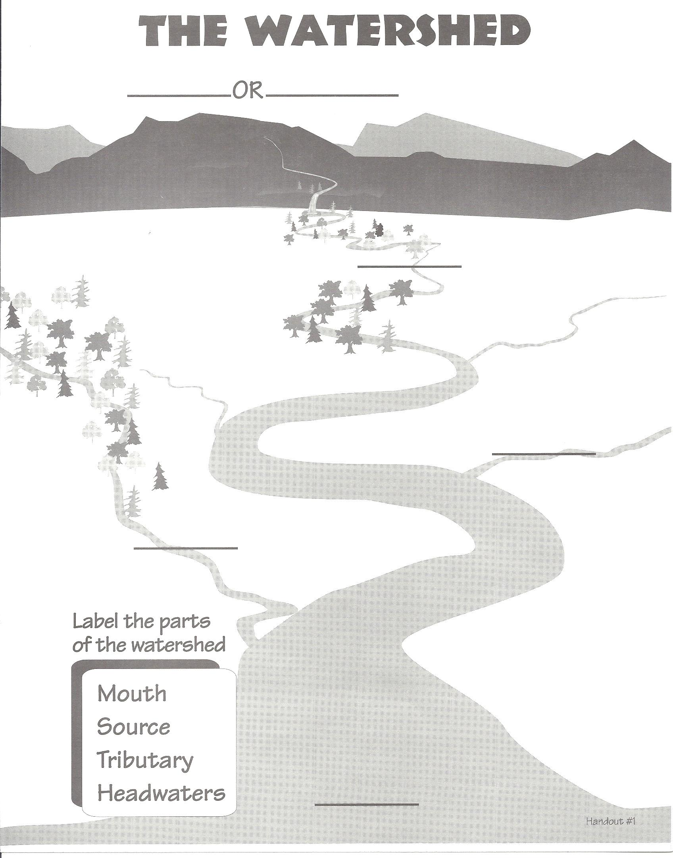

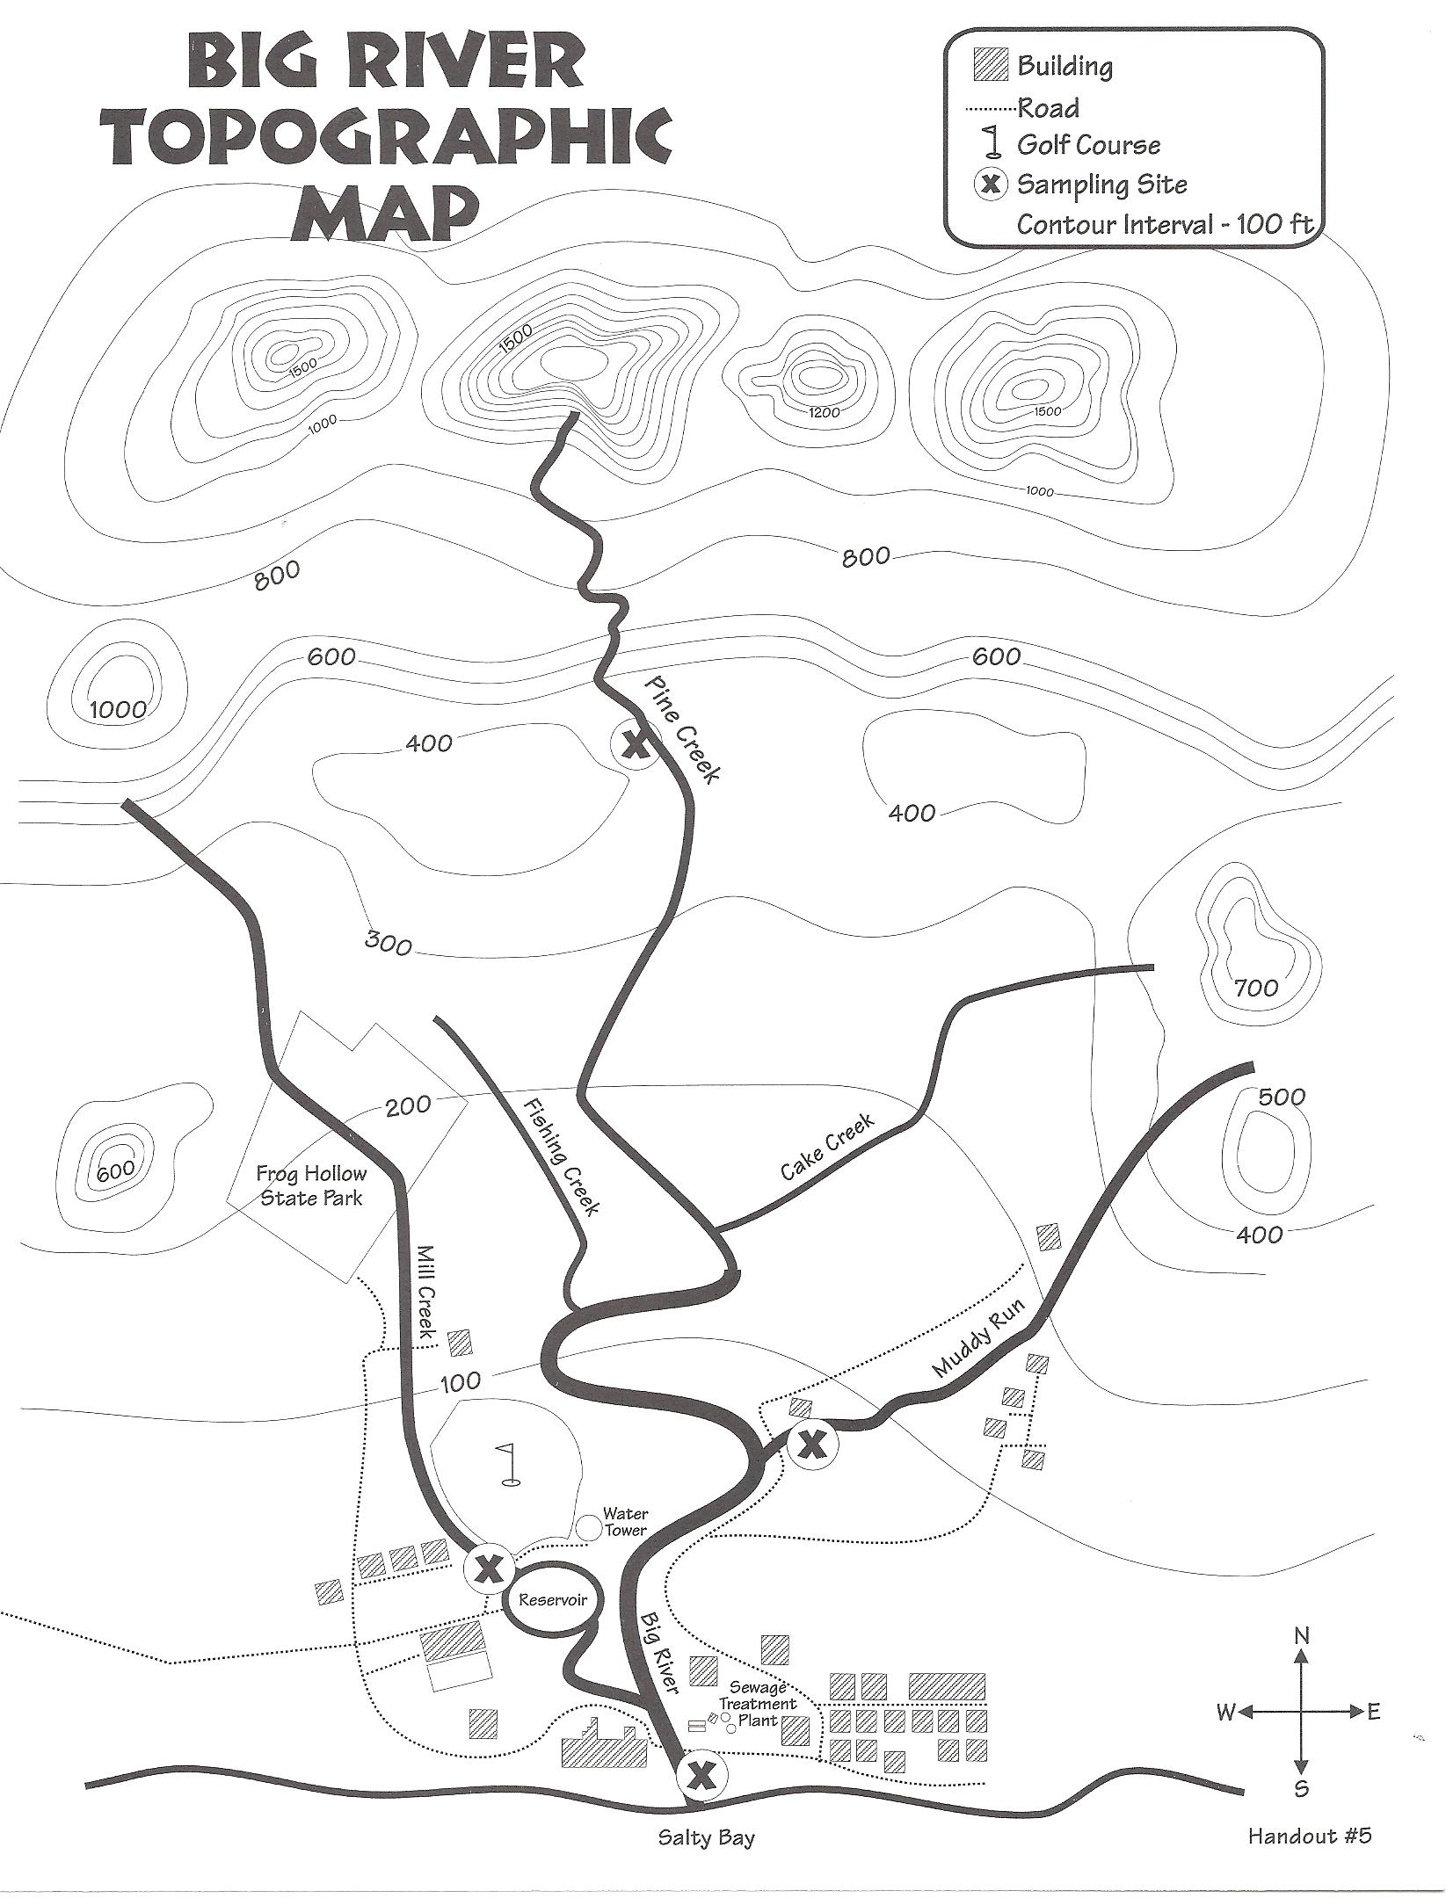

Jamaica Bay Water Quality Data Sheet

Location: ___________________________________ Date: ________________ Time: _________________
Name of Observer: _______________________________________________________________________________
Current Weather Conditions: ______________________________________________________________________________________________________________________________________________________________________________________________________________________________________________________________________________________________________

Current Air Temperature: ______________________ºC

Weather Conditions Last Two Days: ______________________________________________________________________________________________________________________________________________________________________________________________________________________________________________________________________________________________________

Observations:
________________________________________________________________________________________________________________________________________________________________________________________________________________________________________________________________________________________________________________________________________________________________________________________________________

Test | Trial 1 | Trial 2 | Trial 3 | Average
Water Temperature
Dissolve Oxygen
Oxygen % Saturation
pH
Nitrate
Phosphate
Salinity
Turbidity

Jamaica Bay Water Quality Data Sheet

Location: ___________________________________ Date: ________________ Time: _________________

Name of Observer: _______________________________________________________________________________

Current Weather Conditions: ______________________________________________________________________________________________________________________________________________________________________________________________________________________________________________________________________________________________________

Current Air Temperature: ______________________ºC

Weather Conditions Last Two Days: ______________________________________________________________________________________________________________________________________________________________________________________________________________________________________________________________________________________________________

Observations:
________________________________________________________________________________________________________________________________________________________________________________________________________________________________________________________________________________________________________________________________________________________________________________________________________

Test | Trial 1 | Trial 2 | Trial 3 | Average
Water Temperature
Turbidity

Jamaica Bay Water Quality Data Sheet

Location: ___________________________________ Date: ________________ Time: _________________

Name of Observer: _______________________________________________________________________________

Current Weather Conditions: ______________________________________________________________________________________________________________________________________________________________________________________________________________________________________________________________________________________________________

Current Air Temperature: ______________________ºC

Weather Conditions Last Two Days: ______________________________________________________________________________________________________________________________________________________________________________________________________________________________________________________________________________________________________

Observations:
________________________________________________________________________________________________________________________________________________________________________________________________________________________________________________________________________________________________________________________________________________________________________________________________________

Test | Trial 1 | Trial 2 | Trial 3 | Average
Dissolve Oxygen
Oxygen % Saturation

Jamaica Bay Water Quality Data Sheet

Location: ___________________________________ Date: ________________ Time: _________________

Name of Observer: _______________________________________________________________________________

Current Weather Conditions: ______________________________________________________________________________________________________________________________________________________________________________________________________________________________________________________________________________________________________

Current Air Temperature: ______________________ºC

Weather Conditions Last Two Days: ______________________________________________________________________________________________________________________________________________________________________________________________________________________________________________________________________________________________________

Observations:
________________________________________________________________________________________________________________________________________________________________________________________________________________________________________________________________________________________________________________________________________________________________________________________________________

Test | Trial 1 | Trial 2 | Trial 3 | Average
pH

Jamaica Bay Water Quality Data Sheet

Location: ___________________________________ Date: ________________ Time: _________________

Name of Observer: _______________________________________________________________________________

Current Weather Conditions: ______________________________________________________________________________________________________________________________________________________________________________________________________________________________________________________________________________________________________

Current Air Temperature: ______________________ºC

Weather Conditions Last Two Days: ______________________________________________________________________________________________________________________________________________________________________________________________________________________________________________________________________________________________________

Observations:
________________________________________________________________________________________________________________________________________________________________________________________________________________________________________________________________________________________________________________________________________________________________________________________________________

Test | Trial 1 | Trial 2 | Trial 3 | Average
Salinity

Jamaica Bay Identification Chart
Plants:
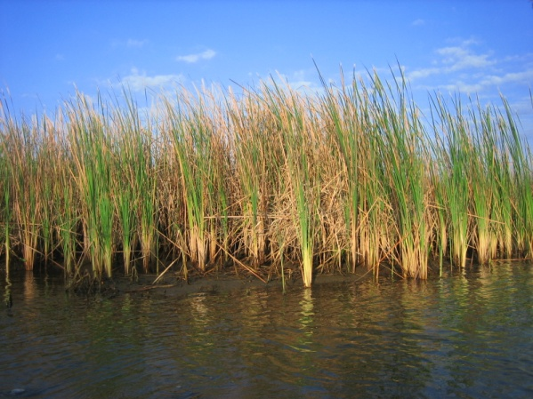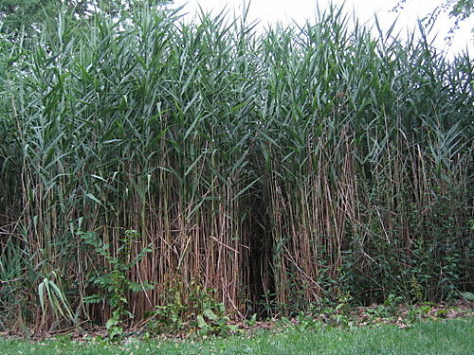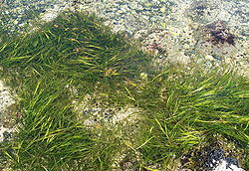
Phragmities Eel Grass
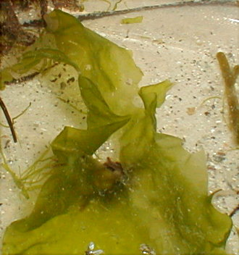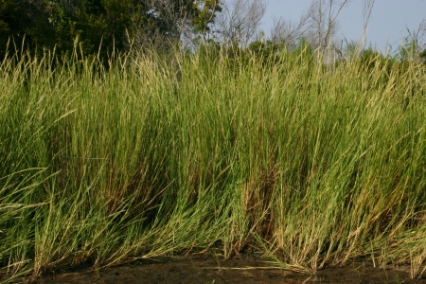
Sea Lettuce Spartina
Shoreline:
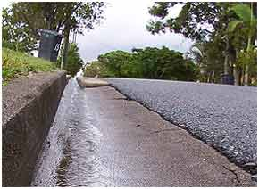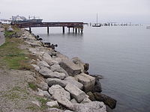
Impervious Surface Rip Rap

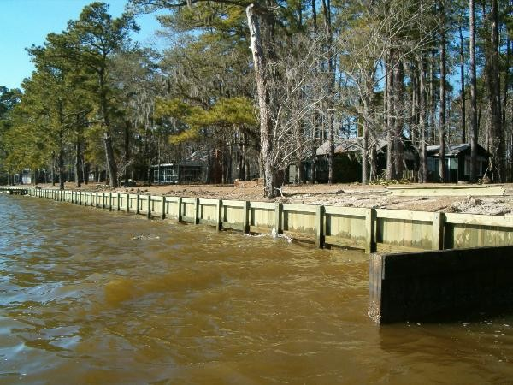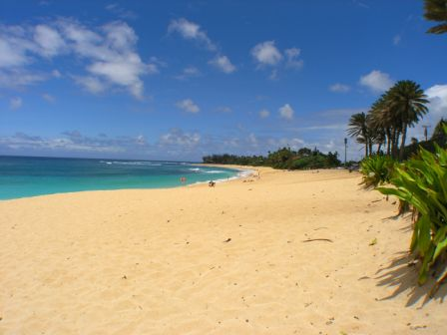
Bulkhead Beach

