Lesson # 2- Great Flights and Flyers of Floyd Bennett Field

Time Frame: 45 minutes

Aim: What role did FBF play in the development of aviation?

Instructional Objectives:

Students Will Be Able To: (SWBAT)

-Give examples of the seminal aviators who flew out of the facilities at FBF.

-List some of the major aviation milestones that were achieved at FBF.

Standards: Common Core (as listed in the NYCDOE websites)
ELA standards for grades 6-12)
College and Career Readiness Anchor Standards for Reading: 1, 2,3,4,7,8,9,11
Reading Standards for Informational Text 6-12: 1,2,3,4, 7,8,9
College and Career Readiness Anchor Standards for Writing: 1,2,3,4,5,6,8,9,10, 11
College and Career Readiness Anchor Standards for Speaking and Listening: 1,2,3,4,5,6
College and Career Readiness Anchor Standards for Language: 1,2,3,4,6
Standards for Literacy in History/Social Studies, Science, and Technical Subjects 6-12
College and Career Readiness Anchor Standards for reading: 1,2,3,4,5,6,7,8,10
College and Career Readiness Anchor Standards for Writing: 1,2,3,4,5,7,8,9
College and Career Readiness Anchor Standards for Speaking and Listening: 1,2,3,4,5,6

Historical Information For Teachers: Floyd Bennett Field was an ideal place for transcontinental flights because of its location in New York City. From its dedication in 1931, up to its commission as a Naval base in 1941, Floyd Bennett Field was on the cutting edge of competitive flying and aviation technology. During this time dozens of record-breaking flights took place there, either commencing or concluding at the site. Aviation pioneers like Wiley Post, Howard Hughes, Roscoe Turner, Jackie Cochran and their contemporaries were regulars at the airfield. This era of history is little known to most Americans. The lesson plan is meant to serve as a bridge to this past, showcasing to young learners the role Floyd Bennett Field played in this important period of aviation history and the relationship these early 20th century American heroes had with the site.

Do Now/Motivation: (5 min) Start out by giving a story about a personal hero(s) from childhood or the present that the students will be able to identify. Explain what this person/people meant to you and why. (Ex. 9-11 First Responders, Jackie Robinson, Derek Jeter, President Obama, Superman) The anecdote should be organic which will make it more interesting to the students. Once you have your students engaged pose the question “What makes somebody a hero?” Elicit examples of their heroes and what makes them special. As they give you answers list them on board. Some of their heroes may not be so heroic in your opinion. Play it by ear and challenge them to defend their answers as you see it fit. Students may give fictitious heroes, which is OK. Give definitions on board, if necessary…(Hero- a person distinguished by their brave deeds and noble qualities, a person of courage and ability.)

Agenda:

Mini-Lesson: (10 min) Explain to children that all of Floyd Bennett Field’s historic flights took place in the decade of the 1930’s. Try and elicit from the students what was going on in the country in this decade (the Depression) and how this external reality may have drawn people toward the events at Floyd Bennett. (Escapism) Give examples of how escapism works today. (No matter how bad your life is, if your favorite team wins the championship, somehow though the circumstances of your life haven’t changed, you feel better. Rooting for your heroes allows you to forget about your problems, or something simpler like going to the movies, watching television, or listening to music)

Once concept is outlined share the below quote with your students from the NY Times to reinforce it.

“In the drab days of the Depression, the words Floyd Bennett Field were magic to millions around the country and the world. The names of the aviators operating from the field-Amelia Earhart, Wrong Way Corrigan, Col. Roscoe Turner, Gen Italo Balbo of Italy and Jacqueline Cochran- conjured up images of daring flights that advanced aviation beyond its infancy and lifted men’s hopes for better days…”

Activity: (30 min) Break students up into groups and hand each group a bio of a famous flyer. They will read them together. Each group should have a (Runner, Recorder, Representative) The runner will pick up the worksheet, the recorder will take notes and the representative will speak on behalf of the group when it is their turn to represent their aviator. The groups will read the bios of their characters and determine, in their minds whether or not they are heroes and if so, what attributes make them heroic? They will have to measure their opinions by the deeds of the flyer and their legacy. Once time is allotted for the groups to review their flyer and debate their flyer’s merits, each group will present their flyer to the class using a small piece of poster board, their flyer’s relationship to Floyd Bennett Field, and their determinations to the rest of the class. Students will make their presentations on simple poster board, which can be worked on at their desks and then brought up to display to their peers. The questions they should be answering are below.

- Who is our aviator?
- What did they accomplish?
- Is my aviator a hero and if so, why or why not?

*The 8 Aviator Biographies are Included in the Forthcoming Pages.

Douglass Corrigan

In October of 1925, Douglass Corrigan paid $2.50, a lot of money at the time, to take a plane ride. The rest is history. After that first thrilling voyage he committed himself to learning aviation. Less than a year later, he took his very first solo flight.
Corrigan never was much for rules or conventional wisdom. When he was born in 1905, very little was known about flight and it was considered foolish, by most, to pursue a career in it. But it turns out they were the fools. Corrigan, through his efforts, was able to participate in the very early stages of aviation history. The man was flying planes before half of the world had ever even seen one, and the technology that he helped develop is still with us today.
What he’s most known for is a historic flight that took place in 1938, and began right here in NYC. Corrigan was scheduled to depart from Floyd Bennett Field in Brooklyn, to California. The problem was he wanted to fly to Dublin, Ireland instead. As it was, however, the government wouldn’t give the clearance to fly across the Atlantic Ocean in his plane. They said his aircraft was too old and dangerous. But he couldn’t be dissuaded. So he announced that he would fly to California, when he had no real intention of doing so. On July 16th, 1938 when Corrigan took off from Floyd Bennett Field, he headed East to Ireland across the Atlantic Ocean instead of West to California. 28 hours and 13 minutes later he landed in Ireland to a huge reception and fanfare. The people called him “Wrong-Way Corrigan,” because he had flown the wrong way. In NYC they had a grand parade for him and the folks in Ireland even wrote him a song. Some people say that his “Wrong-Way” flight is the most distinguished flight to ever come out of Floyd Bennett Field. The famous New York Post even celebrated Corrigan’s wrong way flight, by printing their headline the wrong way.
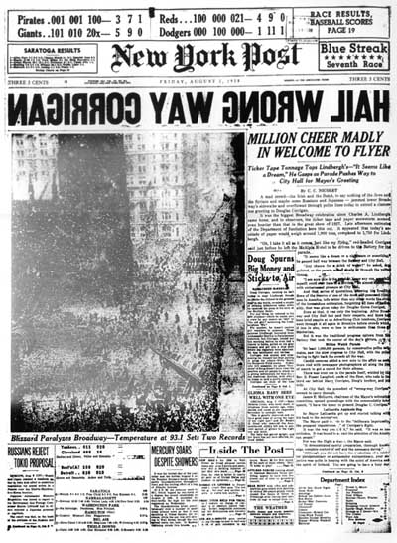

Howard Hughes

Howard Hughes was born into a wealthy Texas family in 1905. His father had owned a major tool manufacturing company, which Hughes inherited at the young age of 19, after his death. The young Hughes could have just sat idle and lived off his inheritance, but he had ambition for more.
Hughes always had a love for mechanics and aviation. At the age of 11, he built his own functioning radio. To top that off, at the age of 12, he built his own personal motorcycle after his father refused to buy him one. It was only natural that when Hughes was presented with the opportunity to participate in the early development of modern aviation, he eagerly participated.
In 1932, using the money he inherited from his father, Hughes founded his own aircraft production company, Hughes Aircraft. This company would eventually become hugely successful supplying aircraft to both the United States military and the commercial travel sectors. Hughes had taken the legacy of his father as a businessman and impressed his own upon it. Hughes aircraft constructed some notable aircraft, the H-4 Hercules, being the most famous, which even when measured with the planes of today, still has the longest wingspan of all time, longer than an NFL football field.
Outside of his achievements as an industrialist and builder, Hughes accomplished much as a flyer. A lot of the aircraft he built and sold, he also flew, including the H-4 Hercules. One of the greatest flights of his life took place right here in Brooklyn at Floyd Bennett Field. On July 10th, 1938 Hughes began a record-breaking historic 3-day journey around the world, returning to Floyd Bennett Field on July 14th to a heroes welcome.

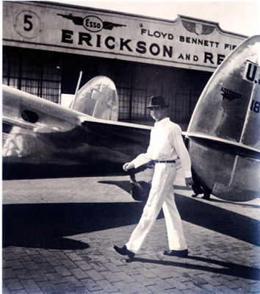

Italo Balbo

When many of us think of Italy, we think of Pizza before we think of pilots. But then again most of us have never heard of Italo Balbo. Italo Balbo was an Italian, and his life story is one of a pilot, a soldier, and a statesman.
Balbo was born in 1896. By the age of 18, he had enlisted in Italy’s army. He saw combat during WWI, which hardened his demeanor and personality. After the war, in recognition of Balbo’s service, the Italian government awarded him distinguished medals for courage under fire. He was a national hero.
When Balbo, returned home from the war, he got involved in politics as a primary supporter of Italian dictator Benito Mussolini. This close relationship with Mussolini made Balbo one of the most powerful men in Italy, a country that would eventually face off with the United States in WWII.
Balbo’s involvement with politics is what eventually led him to aviation.
In 1926, Balbo was appointed Secretary of State for Air, by the Italian government. At this point he had little flying experience so he had to learn fast, and fast he did. Balbo would lead two internationally celebrated trans-Atlantic flights, which brought him to NYC and Chicago. The deeds were carried out in grand fashion, his 1933 flight including 25 planes of which, only 23 would return to Italy. Balbo was considered a hero by the international media after leading his “armada” from the old world to new. Prior to the WWII Balbo was highly respected in the United States. The city of Chicago went as far as to name a street Balbo Avenue, whereas NYC held a large parade in his honor to commemorate his flights. Balbo would lose his life in WWII, when his plane was shot down. He is considered the father of the Italian Air Force. Many people in Chicago think that Balbo Ave’s name, however, should be changed because of Italo Balbo’s legacy as a Nazi ally and enemy of the United States.

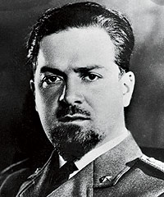

Jimmy Doolittle

In 96 years of life James Harold Doolittle accomplished a lot. He was an aviation pioneer, a four star brigadier general, and a Congressional Medal of Honor recipient. Each one of those achievements, on their own is outstanding, while possessing all three, is miraculous. Doolittle was born in Alameda, California in 1896. His introduction to aviation came during WWI in which he served as a flight instructor. After the war Doolittle would earn his fame as a racer and aviation pioneer. In 1929 Doolittle was the first pilot to successfully complete a “blind” flight. A blind flight is one that is completed solely using instruments with zero visibility, much like pilots do now. Doolittle helped pave the way for those who followed in his footsteps. Blind flying allowed pilots to fly in conditions that they previously could not.
During WWII Doolittle would solidify his legacy as one of the most courageous Americans of the 20th century. He volunteered to lead a top- secret bombing attack on Japan, shortly after the Japanese had struck Pearl Harbor. After successfully bombing their targets Doolittle and his crew ran into a storm over China on their way back to their base. The storm delayed their return flight and Doolittle and his fellow airmen ran out of fuel and were forced to parachute out of their bomber over enemy occupied territory. Eventually Doolittle would escape from Japanese occupied China, finding his way back to the safety of Allied lines. For his heroics, President Franklin Delano Roosevelt presented him with the Medal of Honor. In 1985, President Ronald Reagan would also honor Doolittle by making him a four star general at the age of 88 years old. Doolittle broke the transcontinental speed record, flying from Los Angeles to Floyd Bennett Field in 11 hours and 59 minutes, in 1935, and was a constant presence there during its first decade helping lead an aerial display during its dedication ceremony in 1930.
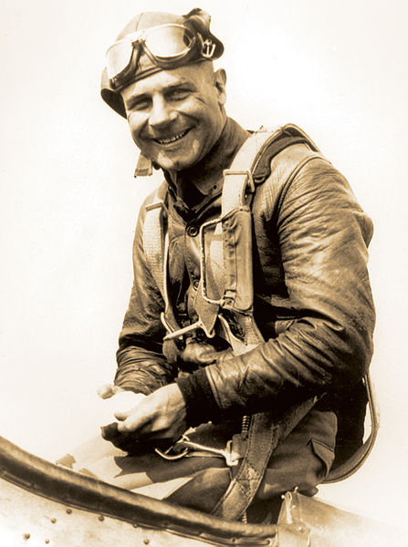

Wiley Post

Wiley Post was born in Northeast Texas in 1898, the year the Spanish- American war ended. His parents were farmers and like father like son, he learned those skills throughout his childhood helping maintain the family property. When he was old enough to go out on his own, he took a job in a flying circus as a parachutist, or what we would call a skydiver today. This was how Post was introduced to aviation.
On October 1st, 1926, something happened to him that forever changed his fate. Post lost his left eye due to an accident at an oil field. He ended up gaining a large settlement of money from the owner of that oil field which he used to buy his first aircraft. From that point forward, Post dedicated his entire personal and professional career to the advancement of flight.
His greatest achievement was being the first person ever to fly solo around the world. Post left Floyd Bennett Field in Brooklyn on July 15th, 1933 and didn’t return until July 22nd. After this flight he was known the world over and used his fame to help aviation science.
In 1934, Post endeavored to create the first pressure suits so that pilots could fly at extremely high altitudes. He ended up as high as 50,000 feet and even discovered the jet stream. These pressure suits were a scientific marvel and were the precursor of the space suits that astronauts wear today.

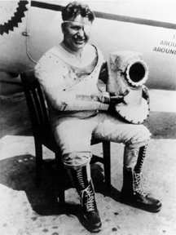

Jackie Cochran

Jackie Cochran was born in Florida by the Alabama border in a very small town. Growing up she didn’t have a lot of money. Her father worked in a sawmill, which provided enough for her family but left very little money for leisure activities.
Cochran married young and divorced young too. The marriage took her away from her family and all the way to NYC, where she ended up being a hairdresser. One might wonder how Cochran went from being a hairdresser to a famous pilot? But the answer is simple. She worked in a hair salon on 5th Ave in Manhattan, where her clientele were some of the richest and most powerful people in the country. Through this job Cochran ended up meeting her second husband, and through this marriage she was able to pursue the one passion, which had been previously out of reach, the passion of flight.
Once she took her first ride in a plane, Cochran knew there was no turning back. She ended up learning to fly in three weeks. By the end of her career Cochran had set multiple speed records, many of them right out of Brooklyn, at Floyd Bennett Field. In fact, at the time of her permanent retirement in 1980, Cochran had set more speed records than any other aviator to date, man or woman. That’s why the media called her the “Speed Queen.” Through her flying and ambassadorship she also helped form the WAAC, Women’s Army Auxiliary Corps and the WASP, Women’s Airforce Service Pilots. Both of these organizations proved integral to the war effort during WWII. They also showed the American public that women are just as capable as men and can be counted on in times of national emergency. Once in an interview about whether or not she was compromising her womanhood by flying in planes, Cochran responded, “I may fly bomber but I’m still feminine.” Cochran was an early advocate for women’s equality through her efforts.

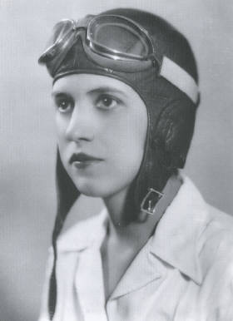

Roscoe Turner

Roscoe Turner was born in Corinth, Mississippi in 1895, the son of a poor farmer. Turner knew early in life that farming was not to be his future. He had a knack for mechanics and liked working with motors. Being from a modest background meant that breaking into flying would not be easy, so as soon as Turner had his chance, he went for it.
Turner joined the military when America entered WWI. His service allowed him to fly and hone his skills as an aviator. After the war ended Turner continued flying as a member of America’s 1st generation of “barnstormers.” Barnstormers were stunt-pilots who toured around the country performing stunts and races for enthralled audiences, with the marvel that was early aviation. Like NASCAR driving of today, airplane racing was a big spectacle in the 1930’s with a large following. Racing is where Turner earned his fame.
Roscoe Turner famously broke 4 major records out of Floyd Bennett Field, in 1932, 33’, and 34’. He set the speed records flying both east to west from NYC to Los Angeles and west to east, from Los Angeles to NYC. Turner was one of the most accomplished racers to fly out of Floyd Bennett and his speedy flying made him a celebrity. He flew in films, such as Howard Hughes’ “Hell’s Angels” and hung out with movie stars. Turner was always very crafty with the media sometimes being accompanied by his pet lion Gilmore when making public appearances. After he ended his racing career Turner went on to become to aid the United States military by training over 3,000 pilots for service during WWII.

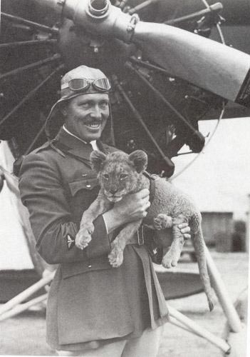

Amelia Earhardt

Amelia Earhardt’s early life, at times, was difficult and her family struggled in money and in health. She watched her father lose her family’s house and his health, and by the young age of twelve, Amelia considered her childhood over. Earhart’s family had split up. She had already lived in Kansas, Iowa, Minnesota, and Illinois. Nowhere seemed like home and all she wanted was things to be normal. But it’s not all a sad story. The benefit of having such an uncertain young life was Amelia sought to find her place outside of it. Earhart wanted to experience the world and seek adventure. So from a young age, this is what she did.
As a young woman, Earhart volunteered to nurse the wounded men during WWI, serving in Canada. The experience was one of the best in her life. It gave her an opportunity to help people in difficult circumstances and the courage to do things she wouldn’t normally do.
This courage, is what brought Earhart to aviation. They called Amelia “The Queen of the Air.” In 1932, she became the 1st female aviator to fly solo across the Atlantic Ocean. This achievement gave her international fame and celebrity. Earhart even got to meet two presidents and was regularly on the cover of newspapers. She used the limelight to promote aviation for woman, helping found “The Ninety-Nines,” an organization to support female pilots and encourage young woman to fly.
With her first major flying achievement completed she set her sights on something bigger, the longest round the world flight to date, following the equator for an incredible 29,000 miles. The aircraft she would use for the flight was the Lockheed Electra. During the flight, somewhere over Howland Island in the Pacific Ocean, her plane went missing and was never recovered. Though she was unable to achieve her intended goal and met an untimely end, her successes in life and aviation paved the way for generations of female flyers that followed. Earhart showed the courage, skill, and determination to do what many men and woman in her era were unwilling to do, test the limits of flight and technology and risk her own life in pursuit of aviation science. Earhardt flew out of Floyd Bennett Field often, regularly taking part in the Bendix Tophy Races, which took place there in the 1930’s.

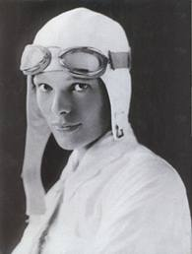
Homework: Students should go home and find a historical artifact relating to one of their contemporary heroes. This could be a baseball card, a pin, a photograph, or anything that relates to someone they admire. Once they determine the artifact of choice, they should answer the following questions in short paragraph or two, to be handed in the following day.

- What is this artifact? Describe it and its value.
- Could this type of artifact relate to one of the flyers we discussed today in class? Why or why not?

Exceeds Expectations | Meet Expectations | Does not meet expectations
Group Work Rubric
Completely addresses all prompts. | Addresses the majority of prompts. | Failed to address the prompts.
Demonstrated excellent teamwork and cooperation. | Generally stayed on task during cooperative work. | Were disruptive and worked poorly together as a team.
Excellent logic and usage of class materials and concepts. | Few errors of logic and some misunderstanding of terminology. | Little understanding of class materials and concepts.
Class Participation Rubric
Asks interesting questions. | Asks an occasional question. | Never asks a question.
Responds to teacher question in a thought provoking way. | Responds to question. | Does not respond to teacher question.

Photo/Image Bibliography

1) NY POST “Hail Wrong Way Corrigan”
(http://upload.wikimedia.org/wikipedia/en/e/eb/Wrong_Way_Corrigan.jpg)

2) Howard Hughes at Floyd Bennett Field
(http://www.deadprogrammer.com/category/person/howard-huges)

3) Italo Balbo
(http://www.chicagomag.com/Chicago-Magazine/August-2008/Dubious-Legacy/)

4) Jimmy Doolittle
(http://www.af.mil/shared/media/photodb/photos/020925-O-9999G-010%5B1%5D.jpg)

5) Wiley Post
(http://3.bp.blogspot.com/_DofLEXUVwIE/RqG7JQuypVI/AAAAAAAAB5U/uv-GsdEurOw/s400/wiley%2Bpost.jpg)

6) Jackie Cochran
(http://womenaviators.org/pictures/jackiecochran1.jpg)

7) Roscoe Turner
(http://www.airfactsjournal.com/wp-content/uploads/2011/03/Roscoe-Turner-and-Gilmore-big.jpg)

8) Amelia Earhardt
(http://acepilots.com/earhart2.html)

Submitted by
Frank Cafarella
Brooklyn College
Graduate Student Intern
Summer 2011

p. 85 Cultural Landscape Report (NY Times)
http://www.chicagomag.com/Chicago-Magazine/August-2008/Dubious-Legacy/
Brooklyn Eagle, June 21st, 1941

