Clean Shore Corps Teacher Guide
Program Goals
The primary goal of the program is designed to introduce students to the human impact on our oceans and environments looks like. Clean Shore Corps is designed as a three step process to engage students in the classroom, in their neighborhoods, and at home. Students look to their schools and neighborhoods to find sources of plastic trash and follow the trail of that debris to the beaches and waters of New York. From there they find ways to solve the issues of plastic litter and where it comes from.
Clean Shore Corps is highly focused on civic action and responsibility by students for the environment; it also emphasizes critical thinking. Evidence-based action is also an important tool in the program, and students learn that data driven proof is necessary for actions that will impact the environment.
Primary Objectives
- Introduce students to the concept of civic action and environmental responsibility
- Identify most prevalent marine debris and trash at beaches and in neighborhoods
- Outline plan of civic action to reduce that form of marine debris
- Students learn data gathering and interpretation techniques
- Raise awareness of marine debris and the issues it causes in our environment
Overview
Plastic marine debris, both micro and macro, have become very big issues in environmental circles in the past decade. Plastic can sicken marine animals that eat it, fill our oceans, and degrade over a period of decades, not years. New York City is in need of better trash practices by its residents, as much of the marine debris on beaches and in the water is produced by litter in the streets. Storms and other precipitation events sweep trash and plastic into storm drains and out into the rivers and harbor.
By taking trash surveys in the streets and on the beaches of New York, students learn to track the debris and use the data to determine the most common litter. From there, students can come to proof-based conclusions on what method of civic action to reduce marine debris would be for their classroom.
Students conducting these surveys learn the importance of making evidence-based decisions and gain a sense of pride in helping to maintain their neighborhood and city.

Part 1 Previsit Activity
Teachers are encouraged to select one of these two curriculum guides when creating pre and post visit lessons for students. The core of the on-site lessons involve following the protocol and completing data sheets for home, street and beach surveys.
https://marinedebris.noaa.gov/sites/default/files/publications-files/HWF_Curriculum_Summary.pdf
https://marinedebris.noaa.gov/educators-guide-marine-debris
These videos are and excellent introduction to the problem:
https://marinedebris.noaa.gov/discover-issue/trash-talk
http://www.cnn.com/interactive/2016/12/world/midway-plastic-island/
https://www.youtube.com/watch?v=Pd_C3YK3kI4
Both of the lesson plans, “An educator’s guide to marine debris” and
“Hawaiʻi Wildlife Fund: Marine Debris Keiki Education and Outreach (MDKEO) Program”, address the following topics:
1) Home and community “plastic awareness”
2) Pacific garbage patch and harm to marine life, nature of plastics
3) How does plastic get from our homes/communities into the water?
a. Watershed
b. Wind
c. Outflow/combined sewer outflow/storm drains/point and non point source pollutions
Use either the NOAA or Hawai’I Wildlife syllabus for in-classroom discussion on marine debris and litter.
Decide, as a class or just yourself, to do a Sidewalk Survey, a Home Trash Survey, or a School Trash Survey.
Conduct the survey and gather data

Part 2 On Site Visit
Coordinate with Gateway and volunteers to visit North Channel Bridge in Queens or a different Jamiaca Bay beach to conduct a Marine Debris Survey
Collate and interpret the data (see example):
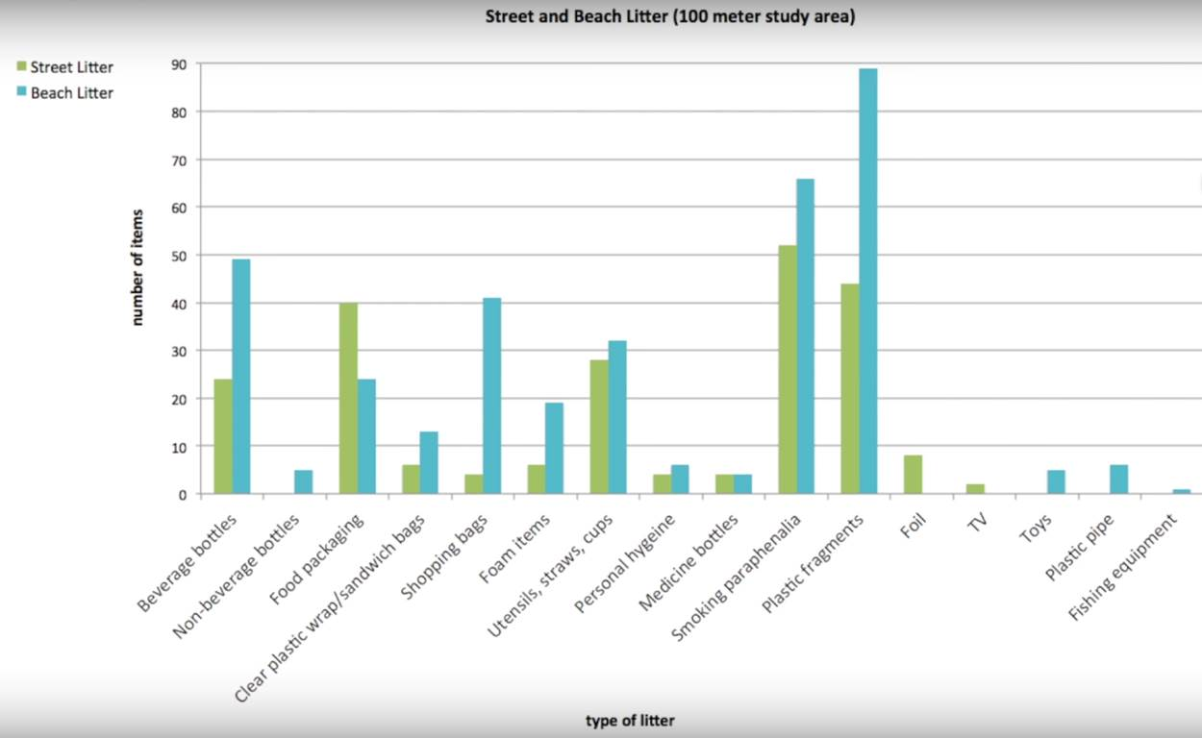
Part 3 Civic Action
Students analyze completed data forms. Identify the three most frequently found litter on streets, and beaches.
Students generate testable question, clean up, and discuss data trends in class. Students will graph, chart or make poster display of findings
- Research orgs (government, environment, industry) in marine debris prevention, report findings, identify project for class to participate in.

- Public education campaign with audience and product identification about the most common plastics found on streets and beaches and its impacts.
- Activities on personal choice of 3Rs; Reusing through arts & crafts

Materials for data collection are available at the Jamaica Bay Wildlife Refuge in Queens for checkout:
Cafeteria Culture datasheet (website)
Measuring Reel (supplied by Gateway)
Trash Grabbers (supplied by Gateway)
Gloves (supplied by Gateway)
Clipboards
Pencils

Beach Survey Set Up
Step 1:
Use the measuring tape to measure out 100 feet along the beach. Mark off ten feet increments. The sections are from the waterline up to either the beach grass or some other determined point.
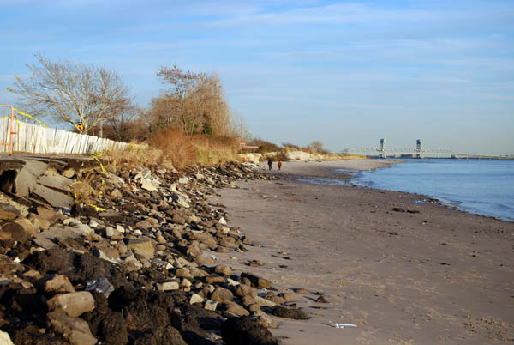
Ten Feet
Divide your students up into groups of two or three per section: one student to record the data, and one or two other students to pick up trash with the grabbers.
It’s a good idea to do a quick demonstration to the students before they break into groups:
- Have an aid use the grabbers to pick up a piece of trash
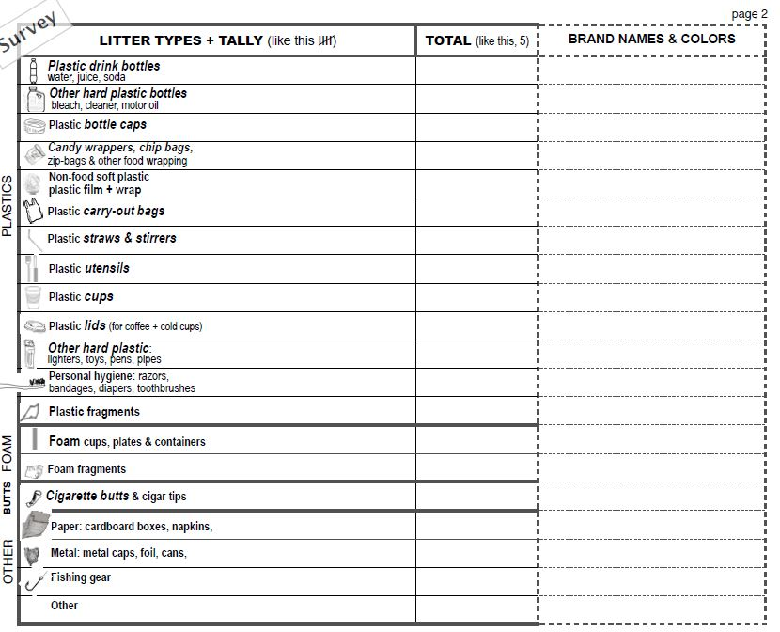
- Have the aid list the attributes of the trash, including brand name and color.

Tallying goes in this column
Total number in this column

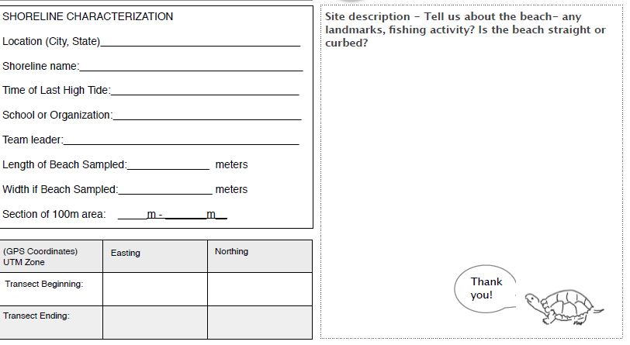
Fill out the first page of the survey together
The assign each group to a section of the beach transect; each group can decide how to conduct the survey, from water to the edge of the beach, or from the beginning of the transect portion to the end:

Caution the students to keep their gloves on and to not to touch any garbage that looks outwardly dangerous, like glass or needles.
After the students finish their sections

