Birds Brains and Binoculars
A citizen science study of bird behavior and bird habitat

Essential question:
How can collected data about bird behavior and habitat help make smart habitat restoration and land management decisions?

Program goals:
- Students gather data and develop recommendations for habitat improvements based on data and proof.

-Observing birds allows students to discover the interdependence between animals and the environment.

- Show students how to make correlations between bird behavior and habitat composition, analyzing data and using it to support their conclusions about land management strategies (vegetation planting, vegetation removal, bird house installation, etc.)

- Introducing students to a community of citizen scientists and becoming advocates for birds and bird habitat.

Key ideas:
- The presence or absence of a bird species is an indicator of environmental health. Birds go where the habitat suits them best.
- Bird behavior shows how the local environment provides for that species. Flying, walking, feeding, or grooming are typical ways birds interact with their environment.
  - Example: Tree swallows flying over wetlands eating flies indicates that the wetland habitat is providing food.
  - Example: Birds gathering nesting material and/or building nests are evidence that the habitat is good for producing offspring.
- Accurate habitat composition data paired with behavioral data can show how an area is being used by different bird species.
- The data gathered forms hypotheses about the habitat and what changing its composition would provide for the birds living there.
- Finding trends in long-term data can show how and why the habitat or bird behavior is changing.
  - Example: At the Jamaica Bay Wildlife Refuge, the West Pond has been a salt water environment from 2012 to 2016. The pond will be closed off from the tides and become a fresh water pond in 2017. Several years of bird behavior data in and around the pond will tell us: how will birds interact with their habitat as the pond freshens? Will bird numbers increase/decrease? Will the species composition change? Will the fresh water environment increase/decrease the biodiversity of the area?
Requirements:
- One to two Team Leaders to identify five common bird species and common vegetation types in the four hectare zones.
- Master data sheet for Team Leader
- Survey Sheets for students in Research Teams
- Two to four, four-hectare zones easily accessible in which to conduct the survey, ideally in different biota such as wetland, forested upland, grassland.

For Classes Interested in doing the Program more than once: Goal of marking 25 observations of individual birds of a single species in one month's time to make the data statistically viable.

Equipment:
- Laminated pictures of bird behaviors and vegetation types.
- Binoculars (1 for each pair of students)
- Clipboards/pencils

Tasks:
- Motivate the group on the task its goals, key ideas and importance of their data collection; especially the concept that the birds will not always be doing interesting things. (See BBB script for more ideas)
- Pair students so one has the binoculars and the other are taking down data.

Student Teacher/Guide Data recorder Using binoculars

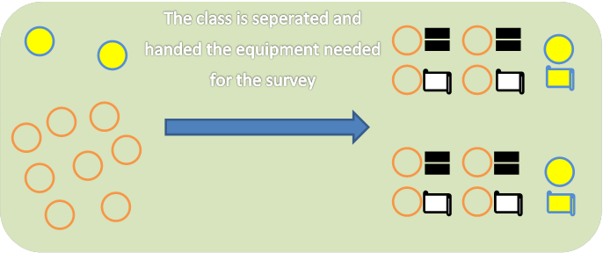

It is also a good idea to have a Guide or Teacher have a pair of binoculars to verify birds/species.

- Upon arrival to the viewing site describe the boundaries of the four hectares viewing area, let students casually and quietly observe the birds and environment for a short time (see BBB script for talking points)
  - Describe the bird behaviors seen.
  - Describe the kinds of space (air or water) or vegetative (trees, grassland) substrate the birds were interacting with.
- Instruct students to prepare to scan the viewing area (see Figure 1).
  - One student will use the binoculars to count all the birds they see from right to left in the viewing area and the other student will record on the data sheet. The team leader will do the same on the Master Data sheet and compare data.
  - The Team Leader will point out a specific bird, list its substrate and give its species name and the entire group will watch that bird for a 30 second period, marking tallies of all of the behaviors observed. The team leader will do the same on the master data sheet. (see Figure 2)
  - Team leader will identify another specific bird and run the tally of behavior again. Repeat for up to ten birds/ substrates.
- The team leader will compare their data with the student data and determine if there is consensus

Figure 1

Scan the four hectare area from right to left, tallying each bird of each species on the datasheet.

Figure 2
Observe behavior one bird at a time

For the Walking Trail Format of the program
The same area, four hectares, of habitat will be covered. 1 hectare= 10,000 square meters; we recommend using Google Earth to calculate area. For assistance with finding an appropriate trail, please contact a Gateway Ranger.

- Instruct the students that they’ll be looking for small woodland birds in front of them, up to four meters on either side of the trail. DO NOT count any birds behind you at any point during the walk; this will make the data collected unviable.

Trail

5 Meters
5 Meters

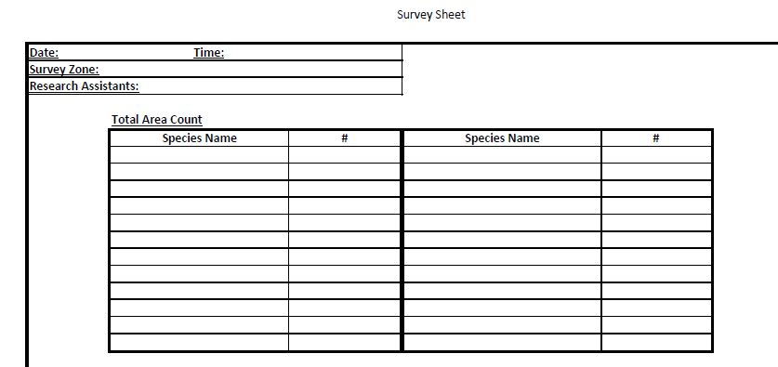
- Once a bird, or multiple birds, is spotted, the group will stop. First the number of birds and the species of the birds will be tallied on the chart.

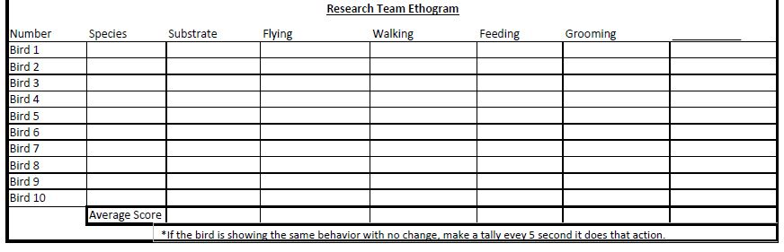
Then each visible bird will be watched for thirty seconds by the student pairs. Guide or teacher will identify the substrate.

- After all the birds are observed, continue walking until the four hectare area has been covered.

Wrap-Up:
At the end of the program, total the tallies of bird behaviors on the survey sheets and draw in the graphs on the bottom of the sheet.
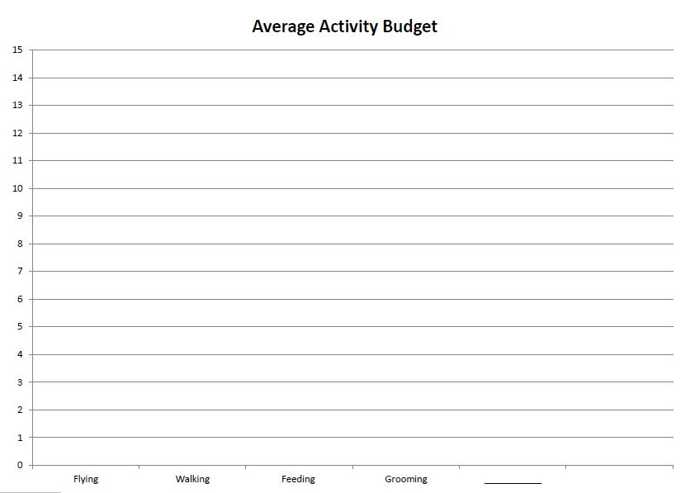

- Review the data and identify some interactions between bird behavior and how the vegetation/ substrate may be assisting with that behavior.
- Ask students how their data collecting is a form of civic action.
- Ask the students to name several bird behaviors they observed and where the behaviors took place.
- Ask students what they think would happen if all the dead trees were taken out of the area; what if more dead trees were added?

If you would like to do an in-class activity with more collected data on bird behavior, contact the Gateway rangers to obtain the data.

