I. THIS LEASE is made and entered on________, 2022 by and between the United States Department of the Interior, acting through the National Park Service, an agency of the United States of America, hereinafter Lessor, and
NAME:

ADDRESS:

E-MAIL:
TELEPHONE NUMBER:
hereinafter, Lessee/s

WITNESSETH: That the Lessor and Lessee, in consideration of their mutual promises set forth herein, agree to enter into a lease of certain real property located within the boundaries of Gateway National Recreation Area (GATE) pursuant to 36 C.F.R. Part 18 and under the following terms and conditions:

1. Term of Lease: | *May XX, 2022 through September 30, 2022, except as otherwise provided in accordance with Section V, Paragraph 17.
- Set Up May Begin: May XX, 2022 (Season 1of 4)
- Authorized Activity May Commence: May XX, 2022
- Authorized Activity Ends: September 30, 2022
- Break Down and Removal Must Be Complete: On or Before October 14, 2022
 | This Lease provides no right of renewal or extension to the Lessee.
2. Description of Premises: | Historic Land located in Floyd Bennett Field, part of the Jamaica Bay Unit  Historic Land located in Fort Wadsworth, part of the Staten Island Unit  of GATE as depicted in Section III below
3. Use of the Premises: | Camping and Camping Related Sale and Rental of Equipment and Sundries
4. Limitations on Use: | Camping and Camping Related Sale and Rental of Equipment and Sundries subject to conditions identified below.
5. Rent: | The Lessee shall pay to the Lessor rent in the following amounts: $ (Minimum of 9% of Gross Revenues)
6. Time & Manner of Payment: | $2,500.00 is due upon signing the lease. The remaining balance for every season of every year this Lease is in effect is due on or before December 15 of that year.
7. Additional Rent: | Unanticipated costs incurred by the Lessor as a result of the use and occupancy of the Premises shall be due and owing immediately upon conclusion of the Lease Term or upon notification from the Lessor, whichever occurs first. Such costs are considered additional rent and may include, but are not limited to, emergency services, clean up, trash removal, and the costs of remedying damage to park resources.

8. Terms and Conditions. This Lease is subject to the Terms and Conditions stated above as well as Terms and Conditions contained in Sections II, III, IV, and V [including any Exhibits or Attachments thereto] of this Lease which are incorporated herein by reference.
IN WITNESS WHEREOF, the below identified official of the National Park Service, in the exercise of authority delegated from the Secretary of the Interior, on behalf of the United States, as Lessor; and the Lessee have executed this Lease on the date(s) set forth below.

LESSOR LESSEE
THE NATIONAL PARK SERVICE

______________________________ ____________________________________
Jennifer T. Nersesian Date
Superintendent
Gateway National Recreation Area

SECTION II. Park Specific Conditions:

- UTILITIES: The Lessee at its sole expense shall make all arrangements with appropriate utility providers (including the Lessor where applicable) for all utilities furnished to the Premises, including, without limitation, gas, electricity, other power, water, cable, telephone and other communication services, sewage, and waste removal. Any utility service provided by Lessor will be subject to the Lessor’s established policies and procedures for provision of utility services to third parties.

- PARKING: The park is prohibited from waiving applicable parking fees. Parking fees in effect during fee collection hours remain in effect and cannot be waived or suspended under any authorized instrument. The National Park Service cannot guarantee parking availability or access into the park during peak times, weather events, or other circumstances beyond the control of park management. Your party may encounter difficulty entering or exiting the park. The Lessee and Lessee’s guests shall comply with parking and traffic determinations made by NPS staff. There are no parking fees in effect at Floyd Bennett Field or Fort Wadsworth, but parking stickers or decals are required.

- PROHIBITED PARKING AREAS: Parking on grass, curbs, or walkways is strictly prohibited and can result in issuance of a U.S. District Court Violation Notice: [26 CFR 1.10(a).

- SMOKING: Smoking is prohibited in any interior space and can result in issuance of a U.S. District Court Violation Notice pursuant to 36 CFR 21.21(a). Discarding cigarettes or cigarette butts on the grounds may result in issuance of a U.S. District Court Violation Notice pursuant to 36 CFR 2.14(a)(1).

- NOISE LEVEL: Sound, audio, or music is prohibited from being broadcast at a level exceeding 60 decibels beyond a distance of 50 feet from the perimeter of the Premises. The Unit Coordinator or her/his designee reserves the right to determine whether sound, audio, or music is broadcast or projected at reasonable level. Lessee must comply with NPS determinations as to same. Noise violations may result in issuance of a U.S. District Court Violation Notice: 36 CFR 2.12 (Audio Disturbance) and / or 36 CFR 2.34 (a)(3) Disorderly Conduct.

- SIGNS: Signs may not be hung or affixed to any park property absent written approval. The Lessee is required to comply with the requirements of any signage plan approved by NPS. Lessees must display signs provided by NPS if any.

- GENERATORS: Generators are prohibited unless specifically authorized in writing by the NPS, in which case a fire and safety inspection will be conducted by NPS Fire Chief or Designee. All generators (gasoline, propane powered stoves, and accessories, including fuel storage) are subject to inspection by NPS and must comply with applicable National Fire Protection Association (NFPA) and NPS fire safety standards.

- HAZARDOUS MATERIAL: Hazardous Materials (which are toxic, explosive, corrosive, flammable, infectious, radioactive, carcinogenic, mutagenic, or otherwise hazardous, asbestos, formaldehyde, radon gas) are strictly prohibited. Other hazardous materials such as gasoline, diesel fuel or other petroleum hydrocarbons must be used in accordance with applicable Regulation.

- CLEAN UP/TRASH REMOVAL, and REPAIR: Lessee is responsible for trash collection and removal of all equipment and trash collected in connection with Lessee’s activities. The Leased Premises and adjacent grounds must be cleaned and left vacant and in broom clean condition upon expiration or termination of the lease. Lessee is prohibited from disposing of its trash within the park. The Lessee shall pay as additional rent the costs of any trash removal, clean up, repair or restoration of the premises which the NPS is required to undertake in connection with Lessee’s use and occupancy of premises. Trash and Waste Removal - Operator should support the park’s carry-in-carry-out policy but is ultimately responsible for all trash removal generated at the site. The park may identify an area to be used in connection with trash collection and removal responsibilities under this Authorization. The park facilities staff will coordinate with the Lessee on trash removal. The Lessee must provide trash and recycling receptacles in the immediate area of operations and remove trash and recycling on a daily basis for the duration of the lease. Trash and recycling must be disposed of in a manner consistent with NPS practices and policies, and as directed by the Jamaica Bay Unit Coordinator or her/his designee. Sanitation and refuse violations may result in issuance of a U.S. District Court Violation Notice pursuant to 36 CFR 2.14(a)(1).

- TRASH MANAGEMENT for PROTECTION OF NATURAL RESOURCES: The Lessee shall take measures to ensure that debris resulting from use of the Leased Premises by the Lessee, Lessee’s invitees or guests, is controlled and collected so as to prevent any resulting scattering of trash and debris in the adjacent grasslands and other natural resource areas.

- ALCOHOL: Sale of Alcohol is prohibited.

- PROPER USE OF THE PREMISES: In addition to the above conditions of the Lease, the Lessee is required to manage the site and undertake or provide the following:
  - Reservation System.
  - Greywater Management. On-site discharge of greywater is prohibited. All greywater must be removed from site at Lessee’s sole expense. Coordination with park staff for truck scheduling will be required.
  - Comfort Stations/Toilets. Except for those assigned under the Lease, if any, comfort stations/toilets must be provided by the Lessee and must be temporary and removable. All comfort stations/toilets must be cleaned, maintained, and pumped out if applicable and carted off-site, at the Lessee’s sole expense on a frequent and consistent basis. NPS reserves the right to make any determinations as to the frequency with which such obligations will be undertaken by the Lessee.
  - Temporary Fire Pits or Rings. If desired, additional temporary fire pits or rings may be provided, subject to limits to be identified by NPS and subject to review and approval by a NPS safety officer and fire protection officer.
  - Trash Removal. The Lessee is responsible for removal of all trash generated at the site. The park may identify an area to be used in connection with trash collection and removal responsibilities under the Lease at the Lessee’s sole expense on a frequent and consistent basis. NPS reserves the right to make any determinations as to the frequency with which such obligations will be undertaken by the Lessee.
  - Lockers. The Lessee must provide Lockers or other secure storage for campers’ belongings. Other on-site storage required by the Lessee is subject to NPS determinations as to availability, if any, and location.
  - On-site Host or Representative. An on-site host or representative must be available for all camper check-ins and must also be available during night hours from 8PM to 8AM, 7 days per week, for the duration of the program.
  - Contact Information. Lease Holder Contact Information must be posted in a visible location at all times.
  - Signage. Signage related to the authorized activities must be approved by NPS.
  - Limitations. No guest may be allowed to book more than fourteen (14) consecutive days at any camp site.
  - Marketing Materials. Marketing materials such as but not limited to brochures, tear sheets, and print advertising, all of which must be approved by NPS.
  - Removal of Amenities. Fire Pits or Rings, picnic tables, and other amenities supporting the proposed use must be removed when any of the locations are not in use/closed for the season.
  - Additional Amenities. Additional amenities such as a camp store for camping related supplies and equipment may be authorized by NPS. Pre-packaged food and non-alcoholic beverage items may be sold by the Lessee. Any prepared foods will require a public health inspection by the NPS Public Health Officer. Lessee notes that a camp store managed by Eastern National is already located on-site at Floyd Bennett Field and Lessee is prohibited from directly competing with Eastern National and may not sell anything that is already carried by Eastern National. This restriction does not apply to the campsites at Fort Wadsworth.
  - Compliance with Park Rules and Regulations. The Lessee will be required to ensure campers comply with park rules and regulations, to revoke permission for campers to remain on site if necessary, and to coordinate with NPS law enforcement as necessary. The Lessee is required to comply with NPS Camping Rules and Regulations: (https://www.nps.gov/gate/learn/management/lawsandpolicies.htm) and the Superintendent’s Compendium (https://www.nps.gov/gate/learn/management/upload/2017-Gateway-Compendium.pdf). A summary of applicable Rules and Regulations for camping, is included below:

  - Glass containers, alcoholic beverages and pets are prohibited in the campground. 36 CFR 1.5
  - Limitations on the number of people permitted per Camping structure must comply with CFR 2.10 (a)
  - Resale, auction, or transfer of campsite reservations is prohibited. 36 CFR 2.3
  - Leaving property unattended for more than 24 hours is prohibited. 36 CFR 2.22(a)(2)
  - Trash may not be left unattended. Trash must be stored in closed animal-proof containers and secured at all times. All trash must be removed from the campsite as directed above. 36 CFR 2.14
  - Food must be stored properly away from wildlife. Food must be stored in closed animal-proof containers and secured at all times. Food cannot be left unattended. 36 CFR 2.10 (d)
  - Fires are only permitted within the campfire ring or similar amenity provided specifically for this use. 36 CFR 2.13 (a) (1)
  - Fires must always be attended and put out completely with water when not attended. Do not let them smolder. 36 CFR 2.13 (a) (4), 36 CFR 2.13 (b)
  - Firewood from outside the park boundary may not be brought into the park or used as fuel for a fire due to invasive species considerations. This includes natural and processed wood, such as lumber. Collecting firewood in the park is not permitted. Firewood will be available for purchase on-site. (36 CFR 1.5)
  - Tying or stringing hammocks, clotheslines or tarps to trees is prohibited. 36 CFR 2.1(a)
  - Children under 18: Reservations at this facility require an adult (18 and older) be present onsite

  - Additional Site-Specific Conditions:

- Lessee’s set up and related activities should avoid excess disturbance to the site as a result of vehicle traffic and other on-site activity.
- In the 2022 season, use of the site is be limited to tent camping and associated support trailers including portable toilets, shower facilities, back of house, related equipment and supply sales, and host accommodations.
- For later season(s), Lessee may propose the introduction of additional camping amenities, including but not limited to glamping and tiny house camping. Lessee will be required to submit to an additional level of compliance review to ensure the proposed activity does not present any unacceptable impacts to natural and cultural resources.
- Temporary fencing, if used around the camping areas, must be driven in. Digging or excavation is prohibited.
- Lessee shall comply with NPS and park lighting guidelines to reduce impacts to the night sky and wildlife. This will include, but is not limited to, low-level lighting, minimized glare, downward focused light fixtures, and energy efficient light sources such as low-pressure sodium lamps.
- Lessee is required to inform campsite occupants that from March 15 through August 31, federally listed shorebirds will be nesting and/or foraging on nearby beaches. Campsite occupants should be mindful of rules and symbolic fencing for protection of piping plover, especially when planning to walk beach areas at night.

  - Oversight Pertaining to Compliance with Park Rules and Regulations. The Lessee will be required to ensure campers comply with park rules and regulations, to revoke permission for campers to remain on site if necessary, and to coordinate with NPS law enforcement as necessary.

SECTION III. Assigned Land and Improvements (Premises):

Floyd Bennett Field. There is currently an array of tent camping and RV sites available at the below described locations. It is not expected that additional camping amenities will be introduced in time for the 2022 season. For later seasons, NPS will consider additional types of camping, including but not limited to glamping and tiny house camping at the below identified locations. Lessee is not required to preserve the existing configuration of campsites at Floyd Bennett Field, although significant changes to the site are not feasible for the 2022 season. All tent camping sites contain a fire ring, barbecue grill and a picnic table.

Location | Area | Notes
Amelia | Approximately 4.0 acres  12 RV Campsites | RV camping site.  Area contains an RV pump out station.
Goldenrod | Approximately 0.2 acres  14 Tent Campsites
Tamarack | Approximately 0.5 acres  13 Tent Campsites | Primitive camping site.
Wiley | Approximately 0.15 acres  5 Tent Campsites | Primitive camping site.

The map below presents the existing campground layout. More information about the locations can be found here: Camp Gateway- Brooklyn NY, Gateway National Recreation Area - Recreation.gov. Campsites are not currently open to the public or otherwise available to be reserved.

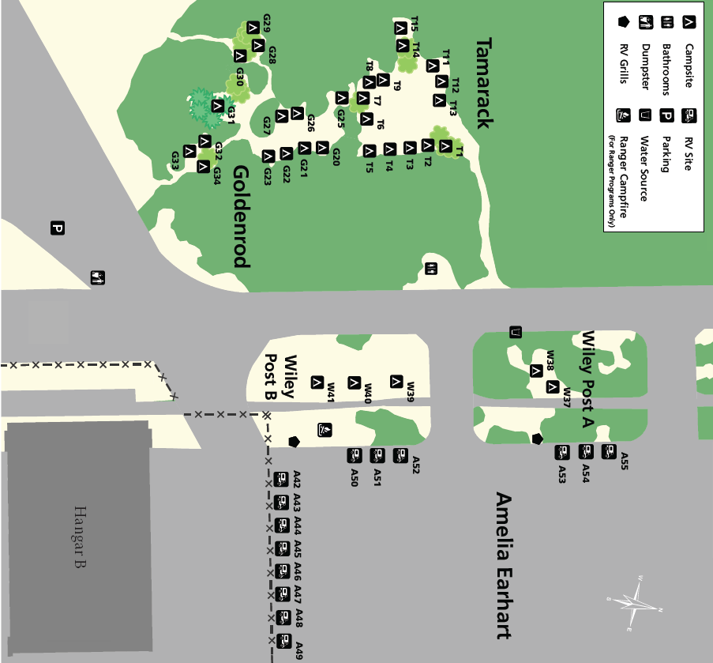

Fort Wadsworth. Camping is authorized in the area of Fort Wadsworth known as Camp Hudson. Camp Hudson contains seven tent sites, restrooms, and hot showers.

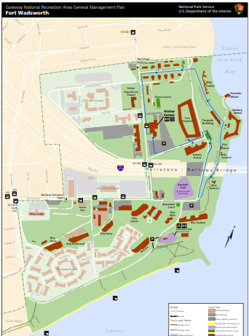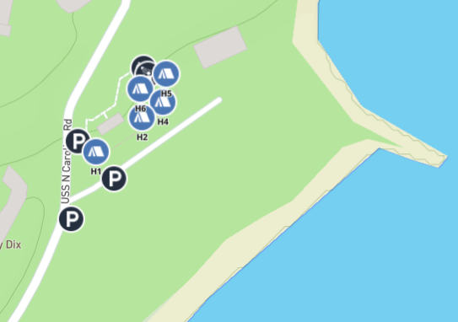

SECTION IV. Insurance Requirements:

The Lessee, or Lessee’s Agent, Contractor or other Representative, as applicable, is required to submit proof of insurance to the NPS as a condition of this Lease. Lessees are prohibited from commencing permitted activities, or set up of activities, until the required proof of insurance has been submitted to and acknowledged by the NPS. The use of facilities authorized under the terms of this Lease may be terminated, delayed, or suspended for failure to provide satisfactory proof of insurance to the NPS. Applicable insurance requirements include:

- Property Insurance - An all risk or special form, including fire, vandalism and malicious mischief insurance. The amount of such insurance shall be the full insurable value of the Premises. All such policies shall specify that proceeds shall be payable whether or not any damaged or destroyed improvements are actually rebuilt. All such policies shall waive any requirement that a building or structure be replaced at its original site.

- General Liability Insurance Requirements – Commercial General Liability through one or more primary and umbrella liability policies against claims for bodily injury and property damage occurring on the Premises, the improvements thereon, or the streets, curbs or sidewalks adjoining the Premises, with such limits as may be required by the NPS, but in any event not less than One Million Dollars ($1,000,000) per incident and Three Million Dollars ($3,000,000) in the aggregate for the Premises.

- Other - All other insurance that the Lessee should maintain to adequately protect the Premises.

- All insurance policies providing the required insurance as described herein shall name the United States of America as an additional insured.

- The Party authorized under this Lease assumes full risk and responsibility for any inadequacy of insurance coverage or any failure of insurers. No approval by the NPS of any insurer, or the terms or conditions of any policy, or any coverage or amount of insurance, or any deductible amount shall be construed as a representation by the NPS of the solvency of the insurer or the sufficiency of any policy or any coverage or amount of insurance or deductible.

- All insurance policies providing the required insurance as described herein shall provide that such policies shall not be cancelled, terminated or altered without thirty (30) days prior written notice to the NPS. The Party authorized under this Lease must provide to the NPS a certificate of insurance executed by a properly qualified representative of the insurance company evidencing that the required insurance coverage is in full force and effect on or before the commencement date of this Lease. The Party authorized under this Lease shall maintain all policies provided throughout the lease term/event and the Party authorized under this Lease shall renew such policies before the expiration of the term of the policy, as applicable.

- The Party authorized under this Lease assumes full risk and responsibility for any inadequacy of insurance coverage or any failure of insurers. No approval by the NPS of any insurer, or the terms or conditions of any policy, or any coverage or amount of insurance, or any deductible amount shall be construed as a representation by the NPS of the solvency of the insurer or the sufficiency of any policy or any coverage or amount of insurance or deductible.

- The Lessee and Lessee’s Agents shall not do anything, or permit anything to be done, in or about the Premises or on adjacent or nearby property that would invalidate or be in conflict with the provisions of any fire or other insurance policies covering the Premises or result in a refusal by insurance companies of good standing to insure the Premises in the amounts required under this section.

The Lessor is not responsible for any theft of, or loss or damage to the Lessee’s property under any circumstance.

SECTION V. General Terms and Conditions:

- In General. This Lease is subject to all present and future laws, regulation, and policy which may be applicable to the Lessee or to all or any portion of the Premises, or to the use, occupancy, possession, operation, maintenance, and repair of the Premises.

- Interests of Other Parties. The Lessee may not assign, sublease or encumber the Lease in whole or in part. Additionally, this Lease shall not, nor be deemed nor construed to, confer upon any person or entity, other than the parties hereto, any right or interest, including, without limiting the generality of the foregoing, any third party beneficiary status or any right to enforce any provision of this Lease. Further, The Lessee warrants that no person or selling agency has been employed or retained to solicit or secure this Lease upon an agreement or understanding for a commission, percentage, brokerage or contingent fee. For breach or violation of this warranty, the Lessor shall have the right to terminate this Lease.

- No Waiver. No failure by the Lessor to insist upon the strict performance of any of the terms and conditions of this Lease or to exercise any right or remedy upon a default, and no acceptance by the Lessor of full or partial rent during the continuance of any default shall constitute a waiver of any default or of such terms and conditions. No terms and conditions of this Lease may be waived or modified except by a written instrument executed by the Lessor. No waiver of any default shall affect or alter this Lease, but each and every term and condition of this Lease shall continue in full force and effect with respect to any other then existing or subsequent default.

- NPS Right of Entry. This Lease excepts to the Lessor the right, at reasonable times to enter upon the Premises as may be necessary for the purposes of the administration of this Lease and/or the Park Area as determined by the Lessor and to close the Premises when immediate danger to life or property is discovered. The Lessor reserves the right to forcefully enter the leased premises in the event of danger, life/safety, or public health concerns. The Lessor shall not be liable to Lessee for any damage resulting from same.

- COVID Safety Measures. Lessee shall implement and enforce COVID safety and mitigation measures acceptable to NPS until such time as the Lessee is notified by NPS in writing that such measures may be relaxed or discontinued. COVID safety and mitigation measures include, but are not limited to the following:
- NPS mask wearing requirements: COVID mask requirement - Office of Communications (U.S. National Park Service) (nps.gov)
- Social distancing requirements
- Related NYC guidance/restrictions

- NPS Action – Safety, Hazard, Public Health. NPS reserves the right to immediately suspend, terminate, or revoke this authorization, or to require the Lessee to immediately suspend, terminate, or revoke this authorization, without penalty if NPS, in its sole discretion, determines the Lessee has failed to comply with life/safety hazards and related requirements; and with public health considerations, which include but are not limited to the NPS-accepted COVID safety and mitigation plan submitted by the Lessee.

- Modifications to the Premises. The Lessee is prohibited from making physical modifications or improvements to the premises except as authorized in writing by the Lessor. The Lessor reserves the absolute right to accept or reject any modifications proposed by the Lessee.

- Surrender of the Premises. Upon expiration or termination of this Lease, the Lessee shall surrender and vacate the Premises, remove Lessee’s personal property, and return the Premises, including its furniture, fixtures and equipment in as good an order and condition as that existing upon the commencement of this Lease.

- Holding Over. This Lease shall end upon its expiration or termination and any holding over by the Lessee or the acceptance by the Lessor of any form of payment of rent or other charges after such date shall not constitute a renewal of this Lease or give the Lessee any rights under this Lease or in the Premises.

- Costs, Fees, and Expenses. Lessee shall pay all costs, fees, expenses, and charges of every kind and nature resulting from its use of the Premises, including but not limited to additional rent, costs incurred by the park for services provided by NPS, emergency services, clean up, trash removal, and the costs to remedy damages to park resources. Such costs, fees, and expenses may include interest based on the current value of funds to the US Treasury. Lessee shall incur additional costs, fees, or charges for failing to vacate Premises upon expiration of the LEASE or NPS authorized use of the Premises for any period of additional time. Lessee shall be obligated to NPS for fees, costs, and charges in the amount of $250 for each day Lessee’s personal property remains on the Premises. In the event Lessee has not removed personal property from the Premises within thirty (30) days of expiration or termination of the Lease, NPS shall have the right to dispose of Lessee’s personal property as NPS determines, in its sole discretion, and Lessee shall be obligated for all costs incurred by NPS in connection therewith.

- Penalties. The Lessor may impose penalties for late payment to the extent authorized by Applicable Laws.

- Loss. Under no circumstances shall Lessor be responsible or obligated for any losses or liabilities of the Lessee.

- Modification of the Lease. This Lease constitutes the entire agreement between the Lessor and Lessee with respect to its subject matter and supersedes all prior offers, negotiations, oral and written. This Lease may not be amended or modified in any respect except by an instrument in writing signed by the Lessor and Lessee.

- Protection of Resources. The Lessee will take no action that will be detrimental to natural or cultural resources of the park or have any adverse impact on the environment.

- Time and Manner. Activities taking place under this Lease shall be prohibited when the park is closed to the public, the Superintendent determines that such activities may not be compatible with authorized Events, or when the authorized activities are determined to be incompatible with NPS official activities or special events.

- Damage to Park Resources. The proposed activity is authorized at the discretion of the park Superintendent. Authorization to conduct the activities addressed herein may be revoked, cancelled, or terminated at the discretion of the Superintendent upon 24 hours’ notice, or without prior notice if damage to resources or facilities occurs or is threatened, notwithstanding any other term or condition of this authorization to the contrary.

- Termination by Lessor. The Lessor may terminate this lease if the Lessee fails to keep and perform any of the terms and conditions of this Lease. The Lessor reserves the right to terminate or suspend the Lease upon 30 days’ notice, or without prior notice if damage to resources or facilities occurs or is threatened, or in the event the Superintendent determines it necessary in the interest of public safety, public health, general welfare, or in the event the Superintendent has determined there has been conduct unbefitting the mission and values of the NPS, notwithstanding any other term or condition of this Lease to the contrary. If the Lessor terminates this Lease as a result thereof, or if this Lease is terminated in accordance with Paragraphs 12, 14, 15, or 16, all of the rights of the Lessee under this Lease and in the Premises shall terminate. The Lessee hereby acknowledges the sovereign right of the Lessor to cancel this Lease at any time to the extent provided by law.

- Termination by Lessee. The Lessee may voluntarily propose to surrender the Premises, and the Lessor agrees to consider the Lessee’s voluntary surrender of the Premises in the event of the following:

- The Lessee no longer requires use of the facility in connection with the authorized use; and
- The Lessee has provided not less than sixty (60) days written notice to the Lessor of the desire to terminate the lease, and
- In the event the Lease is terminated under the terms of this Section 16, the Lessee is obligated for payment of Rent as identified in Section 5 until such time as the Lessee has vacated and surrendered the Premises, the Lessee shall be obligated to remove all personal property, and the Lessee shall be obligated to leave the Premises in as good a condition as they were on the Commencement Date. Any personal property remaining on the Premises beyond the termination date shall be considered “abandoned” and any costs associated with the removal or disposal of same shall be a surviving obligation to be borne by the Lessee. In the event that the Lease is terminated under the terms of this Section 16, the Lessee shall not be entitled to reimbursement for the cost of Improvements or any other Lessee costs associated with the Lease.

- Prohibition on Further Occupancy. In the event of any termination, cancellation, or revocation by NPS, the Lessee shall be prohibited from further occupancy or utilization of the facilities. All costs associated with clean up or damage to resources resulting in the termination or revocation of this authorization shall be borne by the Lessee.

- Removal from the Premises. NPS reserves the right to remove individuals from the Premises, or to require the Lessee to remove individuals from the Premises, in accordance with applicable law, regulation, and policy, upon 24 hours’ notice, or without prior notice if damage to resources or facilities occurs or is threatened, or in the event the Superintendent determines it necessary in the interest of public safety, public health, general welfare, or in the event the Superintendent has determined there has been conduct unbefitting the mission and values of the NPS, notwithstanding any other term or condition of this Lease to the contrary.

- Insurance. At all times during the Lease Term and at the Lessee's sole expense, it shall obtain and keep in force for the benefit of the Lessee and Lessor the insurance coverages set forth in Section IV (Insurance Requirements) of this Lease.

- Indemnity. The Lessee shall indemnify, defend, save and hold the United States of America, its employees, successors, agents and assigns, harmless from and against, and reimburse the United States of America for any and all claims, demands, damages, injuries, losses, penalties, fines, costs, liabilities, causes of action, judgments, and expenses, including without limitation expenses incurred in connection with or arising in any way out of this Lease, the use, occupancy or manner of use or occupancy of the Premises by the Lessee or any other person or entity, the design, construction, maintenance, or condition of any improvements on the Premises, the condition of the Premises, and/or any accident or occurrence on the Premises from any cause whatsoever; provided, however, that the Lessee shall not be liable to the extent that the damages, expenses, claims or suits result from the willful misconduct or negligence of the United States of America, or its employees, contractors, or agents; provided, further, that the United States of America shall be liable only to the extent such claims are covered by the Federal Tort Claims Act (28 USC §§ 2671 et seq.).

- Insurance and Indemnity. The Insurance and Indemnity provisions contained herein shall survive the expiration or termination of this Lease.

- Notice. Except as otherwise provided in this Lease, any notice, consent or other communication required or permitted under this Lease shall be in writing and shall be delivered by hand, sent by courier, sent by prepaid registered or certified mail with return receipt requested and addressed as appropriate to the following addresses (or to such other or further addresses as the parties may designate by notice given in accordance with this section):

If to the Lessor: If to the Lessee:
Superintendent Name:
Gateway National Recreation Area Address:
210 New York Avenue City, State, Zip:
Staten Island, New York 10305 E-mail:

Electronic Notification to the Lessor is permitted though such notification will not have been deemed received until Lessor issues a written response.

- Endorsement. The Lessor is not for any purpose a partner or joint venture participant of the Lessee in the development or operation of the Premises or in any business conducted on the Premises. The Lessee shall not publicize, or otherwise circulate, promotional or other material of any nature that states or implies endorsement of the Lessee or its services or products by the Lessor or any other governmental agency.

- Invalidity. Invalidity of any one or more of the provisions of this Lease shall not affect any other provision of this Lease, and this Lease shall be construed as if the invalid provisions had not been contained in this Lease.

- Expenditures by Lessor. Nothing contained in this Lease shall be construed as binding the Lessor to expend, in any fiscal year, any sum in excess of the appropriation made by Congress for that fiscal year or administratively allocated for the subject matter of this Lease, or to involve the Lessor in any contract or other obligation for the future expenditure of money in excess of such appropriations.

- Emergency. In the event of an emergency Lessee must contact US Park Police at 718 354 4700.

If more than one Lessee is named in this Lease, each Lessee shall be jointly and severally liable for performance of the obligations of this Lease.
All areas must be cleaned and vacated by the expiration time indicated in the Lease.
Use of the premises is only authorized for the use stated herein. The stated use must be consistent with the park missions and values.

