Frequently Asked Questions
Great Kills Marina
Staten Island Unit
Gateway National Recreation Area

Updated April 17, 2019

Notice: The due date for proposals has been extended to May 17, 2019. Proposals must be received by NPS not later than noon.

Q. Can packaged Alcohol for off premise sales be allowed in the ship store ?

- No. Please refer to the “Restrictions on Use” found on page 9 of the RFP.

Q. Does the current 2,500 square foot beach center space proposed for Food and Beverage operations already have equipment and hookups for electric, grease trap, heating, ventilation, and air conditioning systems to facilitate a grill or cantina type restaurant?

- The beach center is offered in “as-is” condition. If the space authorized for Food & Beverage sales has any equipment, prospective Lessees should assume they are non-salvageable and must be removed and replaced. Utilities available at that location include electric service.

Q. Does the current operator provide F&B outlets? Packaged foods?

- No. The current operator provides limited, if any, pre-packaged items for sale at the Marina.

Q. If winter boat storage is relocated to an area farther from the current storage area, and the existing road may not be utilized for transport of boats, is the selected Applicant required to build a new road?

- Applicants are required to bear all costs associated with the long term modification to relocation of the boat storage area. If a new method of access is required, such costs may include any roads which may be required in connection with the transport of boats.

Q. Does the existing travel lift well stay in place if the boat storage area is moved and another travel lift well is constructed with NPS approval?

- The existing travel lift well may remain in place and the proposed Lessee is free to use both travel lift wells. The travel lift itself is the personal property of the current operator and is not included with this opportunity.

Q. What are the Gross Receipts reported for the past three years?

2018 | $1.3 MM
2017 | $1.2MM
2016 | $1.1 MM
Detailed Income and Expense information will not be released

Q. Is the marina office building part of the Leased Premises? Does the marina office have to be replaced?

- Yes, the marina office is part of the Leased Premises. The current office building does not have to be replaced but if the existing structure is removed and replaced with a temporary, removable structure, it must be removed by the Lessee at the end of the Lease term.

Q. If proper facilities and permits are obtained can fuel be sold or is this a permanent prohibition from NPS?

- Fuel sales are prohibited. Please see page 3 of the RFP.

Q. Is the site serviced by public sewer lines?

- Yes. The site is serviced via public sewer consisting of an on-site lift station to a New York City public sewer line. Please see page 3 of the RFP.

Q. Is there a boat pump out system available at this location?

- No.

Q. When will the NPS select the new operator? When will the new governing authorization go into effect?

- The solicitation closes May 1, 2019 at noon. A new lease must be in place by December 31, 2019. Please refer to page 18 of the RFP.

Q. Is the current operator eligible to submit a proposal?

- Yes.

Q. What is current occupancy of marina in the summer ?

- The marina can accommodate up to 250 vessels. NPS does not provide occupancy figures.

Q. Will NPS reimburse Lessees for restrictions on access to the Premises resulting from restoration or similar projects on parklands?

- No. NPS has no mechanism in place to do so. NPS will have to address impacts to the Lessee resulting from restrictions on access if and when such restrictions are in place.
Q. What is the operating status of the marina electrical systems and subsystems after it was rebuilt? Were all Sandy-related repairs successfully completed according to typical marine environment standards?
- The electrical system and subsystems were rebuilt post-Sandy. Please refer to the Great Kills Marina RFP Minimum Investment Cost Estimate in the Request for Proposals which requires the Lessee to “replace 3 failing step down transformers supplying electric to slip pedestals. The transformers are located on the outward dock run of the marina and convert 480v 3 phase to 220v and 110v single phase feeds to the pedestals.” Applicants should feel free to undertake inspections at their own cost and expense. Please coordinate with Gateway_BMD@nps.gov to schedule same.
Q. With respect to the “additional rent for failing to monitor and manage sale and consumption of alcohol" in the park - how will additional rent be calculated?
- Such additional rent will be calculated based on, at a minimum, the costs to the park to manage and monitor related infractions, as well as costs arising in connection with impacts to the park resulting from Lessee’s poor or improper management and failure to manage the sale and consumption of alcohol. NPS reserves the right to withdraw permissions allowing sale and consumption of alcohol under the Terms of the Lease notwithstanding any other condition to the contrary.
Q. Will NPS consider extending the hours of operation of the Beach Center if Lessee were to assume the maintenance and operation of bathroom facilities beyond Park hours at Lessee's own cost?
- No, The NPS is prohibited from entering into a service contract under a Lease that will require the Lessee to assume maintenance and operation of the bathroom facilities. However, the NPS may consider extending the hours of operation if the Lessee will reimburse the NPS for the costs of NPS staff required to maintain and operate the facilities beyond Park hours.

Q. Does NPS have as-built drawings of Great Kills Marina?

- As built drawings will be posted with the Request for Proposal documents located here: https://www.nps.gov/gate/getinvolved/great-kills-marina-request-for-proposals.htm. Please note, approximately 60 pilings were replaced in the Fall/Winter of 2019. The height of the pilings may differ from what is depicted on the as built drawings. Applicants should feel free to undertake inspections at their own cost and expense. Please coordinate with Gateway_BMD@nps.gov to schedule same.

Updated March 18, 2019

Q. What are the exact measurements of the slips?
- The sizes of the slips vary. Please see the dock layout drawing (attached) depicting the sizes and locations of slips.

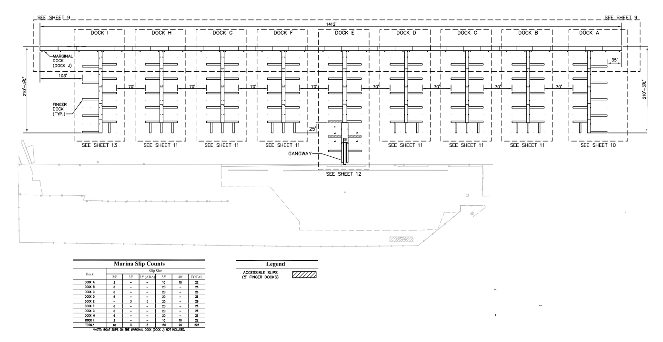2013 Construction Drawings. As Built drawings are not available at this time.

Q. Is there a survey and/or a site plan available that depicts the borders and dimensions of the property?

- Please see the site layout below. There is no formal survey. All drawings and depictions are approximations.

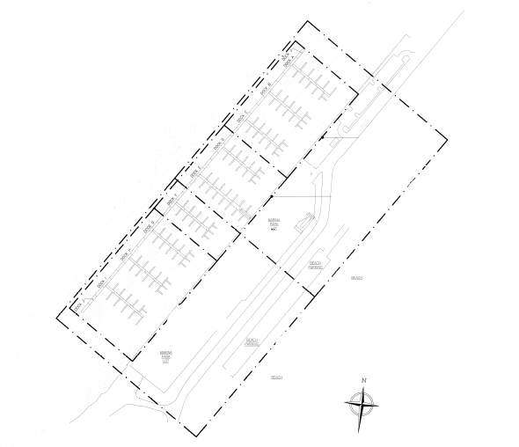As depicted in the 2013 Construction Drawings. As Built drawings are not available at this time.
The proposed Land Assignment is depicted on page 6 of the Request for Proposals:
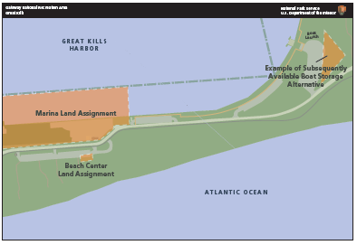
Q. Is there a preferred or suggested area for relocation of the boat storage?

- Applicants are free to propose alternate locations for boat storage but should consult the map on page 4 of the Request for Proposals before doing so. Please see page 7 of the Request for Proposals for an example of an alternate boat storage location.
Q. What is the procedure to schedule a site tour and whom should we contact to do so?

- Please contact gateway_bmd@nps.gov to schedule a site tour. Please provide dates and times which work best for you and we will try to accommodate you.
------------------------
Q. What is required to provide communications services to the Marina?

- In 2015 the park undertook a project to install new conduit and cable from Hylan Blvd. to Great Kills Marina and the Beach Building. The project was not completed due to post-Sandy funding considerations and approximately 1,100 linear feet of conduit and cable (in the area depicted in red in the map below) must still be installed. It is recommended that Applicants conduct their own assessment of current conditions and related requirements. Please contact gateway_bmd@nps.gov to schedule access.

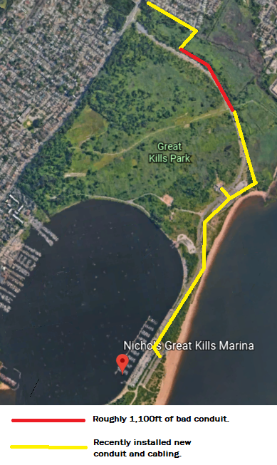

Q. What is the last day on which I may submit a question?

- NPS will continue answering questions received through Wednesday, April 17, 2019.

Q. Is there an estimate of the annual taxes?

- No.

Q. Is there an Application Fee required in order to submit a proposal?

- No.

Q. Are Annual Financial Reports from the current marina operator available?

- No. Annual Financial Reports (AFR’s) are considered confidential business information and are not subject to release.

Q. Utilities: Will water, electric, sewer, and gas have to be relocated?

- There is no current gas or sewer service to the site and there is none anticipated in the future. Water and electric utilities are available on site. Applicants should undertake due diligence to determine whether they will have to relocate the water or electric utilities. Utilities will be billed to the Lessee directly by the utility provider.

Q. What type of security will be required on site?

- Applicants should propose which types of security features and/or services they intend to provide.

Q. What about signage requirements?

- NPS has standard signage requirements. Lessees are required to obtain NPS approval prior to installing signs.
Q. Are Marina facilities open all year? Will boaters have access to boats at all times?

- Yes, marina facilities are open all year but the hours of operation may differ between warm and cold weather seasons. Boaters will have 24-hour access to their vessels when vessels are in the water. Access to boats in storage may require arrangements made ahead of time.

Q. Will boaters have to provide proof of registration and insurance?

- As good operators, we expect the Lessee will require proof of insurance and registration as standard industry practice.

Q. Are pump out facilities or services available?

- No. The Lessee can make arrangements to provide pump out services.

Q. Will I have to pay real estate taxes?

- Lessees will be responsible for the payment to the proper authority, when and as the same become due and payable, all taxes and assessments imposed by federal, state, or local agencies applicable to the Premises or the Lessee’s activities on the Premises. Lessees are not exempt from the payment of local real estate taxes, where applicable, absent any law to the contrary. Please refer to Section 11 of the Sample Lease.

Q. Does the current operator pay real estate taxes?

- The current operator was authorized under a federal contract which is not a real estate interest, therefore not subject to real estate taxes. The proposed Lessee will acquire a leasehold estate, a real estate interest which may be subject to property taxes.

Q. How long is the lease term?

- The lease term may not exceed 60 years. There are no lease renewals.

Q. How is Rent offset?

- The law provides for an offset of Initial Improvements and subsequent Improvements to the Premises over the term of the Lease against Fair Market Value rent subject to NPS approval. For example, if NPS approves $12,000 in capital improvements, that amount will be offset against rent. Therefore, if the hypothetical Fair Market Value rent is $12,000/year (based on percentage of gross) that equates to one year “rent free.”

Q. Does the rent offset carry over if the value of improvements is greater than the rent over the term of the Lease?

- No. NPS may only offset the value of Improvements over the term of Lease not to exceed sixty years.

