**Exhibit D - Maps of Locations**

**LOT B**



Location 1 Location 2

**LOT C**



LOT C- precise location to be assigned by the Sandy Hook Unit within the yellow-bordered area.

**Lot D**



**Lot E**

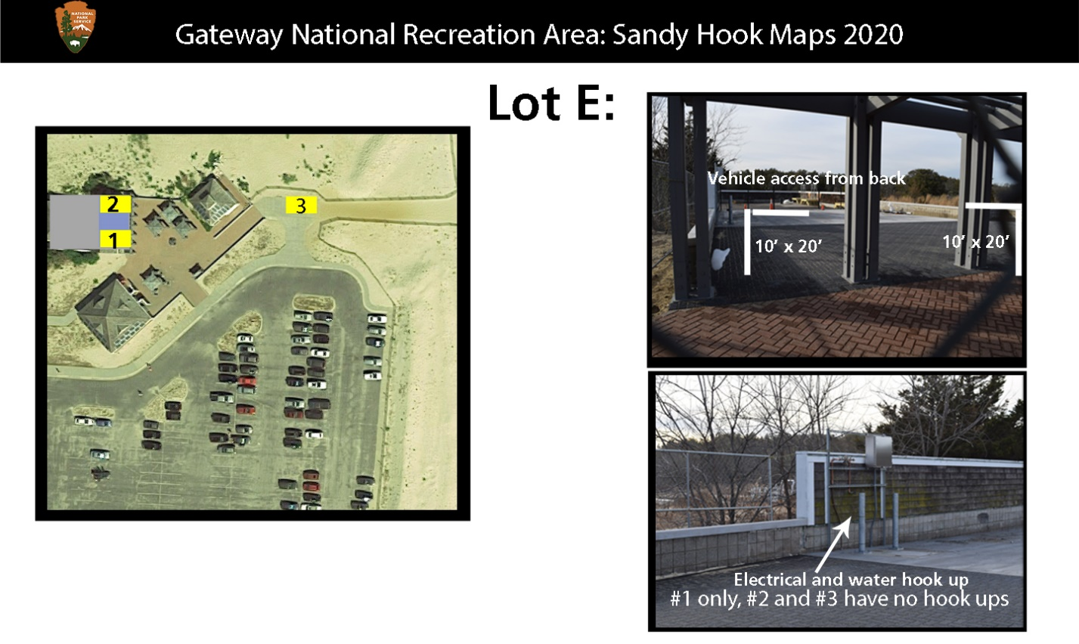

**Lot I**



Precise location to be assigned by the Sandy Hook Unit within the yellow-bordered area.