Speech Historical Context:
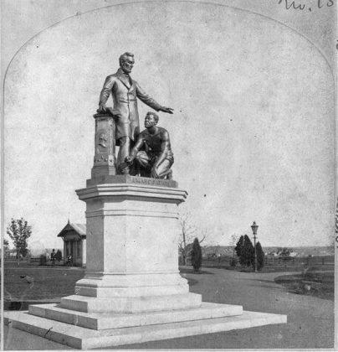
The unveiling of the Freedmen’s Memorial Monument to President Abraham Lincoln in Washington, D.C.’s Lincoln Park took place on April 14, 1876—the 11th anniversary of Lincoln’s assassination. A panoply of federal and civic dignitaries, including President Ulysses S. Grant, the cabinet, justices of the Supreme Court, congressmen, clergymen, and diplomats, joined Frederick Douglass, James E. Yeatman, and John Mercer Langston for the ceremonies. After an opening prayer and the reading of the Emancipation Proclamation—a presidential proclamation and executive order issued by President Lincoln on September 22, 1862 during the Civil War that changed the legal status under federal law of more than 3.5 million enslaved African Americans in the secessionist Confederate states from enslaved to free on January 1, 1863—to an enthusiastic audience, the history of the statue was given (the statue had been funded by the wages of the formerly enslaved—specifically, the first $5 from Charlotte Scott of Virginia and the remaining from Union veterans), and for the actual unveiling of the monument, President Grant pulled the cord that released the flags covering it. “Noisy manifestations of admiration”, cannon fire, and “Hail to the Chief” then sounded. Although Douglass later wrote that he was greatly honored to have been chosen orator of the day, observers heard him remark at the ceremony that the statue “showed the Negro on his knees when a more manly attitude would have been indicative of freedom”.
Speech Read Time ~

Frederick Douglass “Remarks on the Occasion of the Freedmen’s Memorial to Abraham Lincoln in Washington, D.C.” (April 14, 1876)
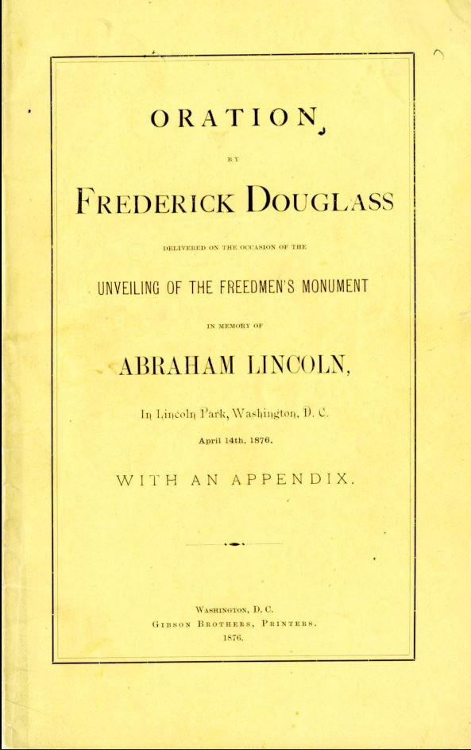
Friends and Fellow-citizens:
I warmly congratulate you upon the highly interesting object which has caused you to assemble in such numbers and spirit as you have today. This occasion is in some respects remarkable. Wise and thoughtful men of our race, who shall come after us, and study the lesson of our history in the United States; who shall survey the long and dreary spaces over which we have traveled; who shall count the links in the great chain of events by which we have reached our present position, will make a note of this occasion; they will think of it and speak of it with a sense of manly pride and complacency.
I congratulate you, also, upon the very favorable circumstances in which we meet today. They are high, inspiring, and uncommon. They lend grace, glory, and significance to the object for which we have met. Nowhere else in this great country, with its uncounted towns and cities, unlimited wealth, and immeasurable territory extending from sea to sea, could conditions be found more favorable to the success of this occasion than here.
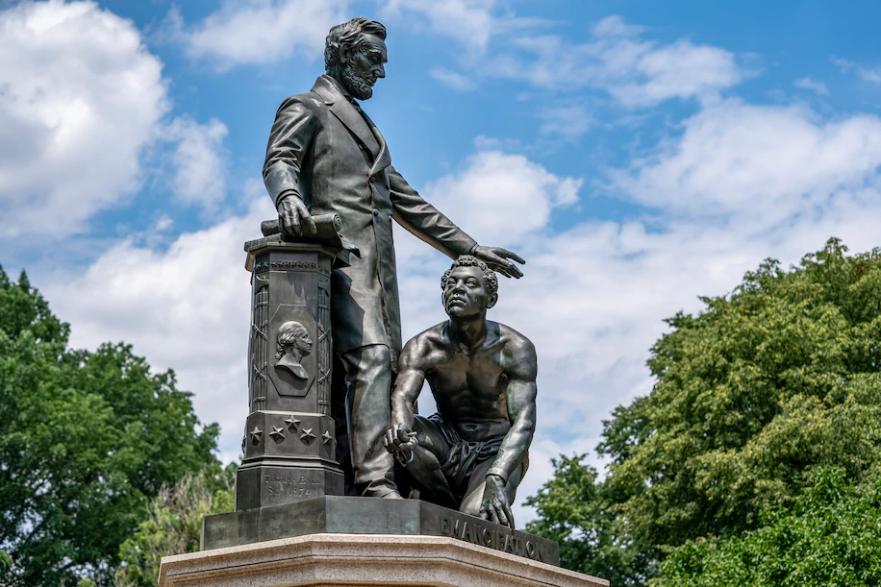
We stand today at the national center to perform something like a national act—an act which is to go into history; and we are here where every pulsation of the national heart can be heard, felt, and reciprocated. A thousand wires, fed with thought and winged with lightning, put us in instantaneous communication with the loyal and true men all over this country.
Few facts could better illustrate the vast and wonderful change which has taken place in our condition as a people than the fact of our assembling here for the purpose we have today. Harmless, beautiful, proper, and praiseworthy as this demonstration is, I cannot forget that no such demonstration would have been tolerated here twenty years ago. The spirit of slavery and barbarism, which still lingers to blight and destroy in some dark and distant parts of our country, would have made our assembling here the signal and excuse for opening upon us all the flood-gates of wrath and violence. That we are here in peace today is a compliment and a credit to American civilization, and a prophecy of still greater national enlightenment and progress in the future. I refer to the past not in malice, for this is no day for malice; but simply to place more distinctly in front the gratifying and glorious change which has come both to our white fellow-citizens and ourselves, and to congratulate all upon the contrast between now and then; the new dispensation of freedom with its thousand blessings to both races, and the old dispensation of slavery with its ten thousand evils to both races—white and black. In view, then, of the past, the present, and the future, with the long and dark history of our bondage behind us, and with liberty, progress, and enlightenment before us, I again congratulate you upon this auspicious day and hour.
Friends and fellow-citizens, the story of our presence here is soon and easily told. We are here in the District of Columbia, here in the city of Washington, the most luminous point of American territory; a city recently transformed and made beautiful in its body and in its spirit; we are here in the place where the ablest and best men of the country are sent to devise the policy, enact the laws, and shape the destiny of the Republic; we are here, with the stately pillars and majestic dome of the Capitol of the nation looking down upon us; we are here, with the broad earth freshly adorned with the foliage and flowers of spring for our church, and all races, colors, and conditions of men for our congregation--in a word, we are here to express, as best we may, by appropriate forms and ceremonies, our grateful sense of the vast, high, and preeminent services rendered to ourselves, to our race, to our country, and to the whole world by Abraham Lincoln.
The sentiment that brings us here to-day is one of the noblest that can stir and thrill the human heart. It has crowned and made glorious the high places of all civilized nations with the grandest and most enduring works of art, designed to illustrate the characters and perpetuate the memories of great public men. It is the sentiment which from year to year adorns with fragrant and beautiful flowers the graves of our loyal, brave, and patriotic soldiers who fell in defense of the Union and liberty. It is the sentiment of gratitude and appreciation, which often, in the presence of many who hear me, has filled yonder heights of Arlington with the eloquence of eulogy and the sublime enthusiasm of poetry and song; a sentiment which can never die while the Republic lives. For the first time in the history of our people, and in the history of the whole American people, we join in this high worship, and march conspicuously in the line of this time-honored custom. First things are always interesting, and this is one of our first things. It is the first time that, in this form and manner, we have sought to do honor to an American great man, however deserving and illustrious. I commend the fact to notice; let it be told in every part of the Republic; let men of all parties and opinions hear it; let those who despise us, not less than those who respect us, know that now and here, in the spirit of liberty, loyalty, and gratitude, let it be known everywhere, and by everybody who takes an interest in human progress and in the amelioration of the condition of mankind, that, in the presence and with the approval of the members of the American House of Representatives, reflecting the general sentiment of the country; that in the presence of that august body, the American Senate, representing the highest intelligence and the calmest judgment of the country; in the presence of the Supreme Court and Chief-Justice of the United States, to whose decisions we all patriotically bow; in the presence and under the steady eye of the honored and trusted President of the United States, with the members of his wise and patriotic Cabinet, we, the colored people, newly emancipated and rejoicing in our blood-bought freedom, near the close of the first century in the life of this Republic, have now and here unveiled, set apart, and dedicated a monument of enduring granite and bronze, in every line, feature, and figure of which the men of this generation may read, and those of aftercoming generations may read, something of the exalted character and great works of Abraham Lincoln, the first martyr President of the United States. Fellow-citizens, in what we have said and done today, and in what we may say and do hereafter, we disclaim everything like arrogance and assumption. We claim for ourselves no superior devotion to the character, history, and memory of the illustrious name whose monument we have here dedicated today. We fully comprehend the relation of Abraham Lincoln both to ourselves and to the white people of the United States. Truth is proper and beautiful at all times and in all places, and it is never more proper and beautiful in any case than when speaking of a great public man whose example is likely to be commended for honor and imitation long after his departure to the solemn shades, the silent continents of eternity. It must be admitted, truth compels me to admit, even here in the presence of the monument we have erected to his memory, Abraham Lincoln was not, in the fullest sense of the word, either our man or our model. In his interests, in his associations, in his habits of thought, and in his prejudices, he was a white man. He was preeminently the white man's President, entirely devoted to the welfare of white men. He was ready and willing at any time during the first years of his administration to deny, postpone, and sacrifice the rights of humanity in the colored people to promote the welfare of the white people of this country. In all his education and feeling he was an American of the Americans. He came into the Presidential chair upon one principle alone, namely, opposition to the extension of slavery. His arguments in furtherance of this policy had their motive and mainspring in his patriotic devotion to the interests of his own race. To protect, defend, and perpetuate slavery in the states where it existed Abraham Lincoln was not less ready than any other President to draw the sword of the nation. He was ready to execute all the supposed guarantees of the United States Constitution in favor of the slave system anywhere inside the slave states. He was willing to pursue, recapture, and send back the fugitive slave to his master, and to suppress a slave rising for liberty, though his guilty master were already in arms against the Government. The race to which we belong were not the special objects of his consideration. Knowing this, I concede to you, my white fellow-citizens, a preeminence in this worship at once full and supreme. First, midst, and last, you and yours were the objects of his deepest affection and his most earnest solicitude. You are the children of Abraham Lincoln. We are at best only his stepchildren; children by adoption, children by forces of circumstances and necessity. To you it especially belongs to sound his praises, to preserve and perpetuate his memory, to multiply his statues, to hang his pictures high upon your walls, and commend his example, for to you he was a great and glorious friend and benefactor. Instead of supplanting you at his altar, we would exhort you to build high his monuments; let them be of the most costly material, of the most cunning workmanship; let their forms be symmetrical, beautiful, and perfect; let their bases be upon solid rocks, and their summits lean against the unchanging blue, overhanging sky, and let them endure forever! But while in the abundance of your wealth, and in the fullness of your just and patriotic devotion, you do all this, we entreat you to despise not the humble offering we this day unveil to view; for while Abraham Lincoln saved for you a country, he delivered us from a bondage, according to Jefferson, one hour of which was worse than ages of the oppression your fathers rose in rebellion to oppose. Fellow-citizens, ours is no new-born zeal and devotion—merely a thing of this moment. The name of Abraham Lincoln was near and dear to our hearts in the darkest and most perilous hours of the Republic. We were no more ashamed of him when shrouded in clouds of darkness, of doubt, and defeat than when we saw him crowned with victory, honor, and glory. Our faith in him was often taxed and strained to the uttermost, but it never failed. When he tarried long in the mountain; when he strangely told us that we were the cause of the war; when he still more strangely told us that we were to leave the land in which we were born; when he refused to employ our arms in defense of the Union; when, after accepting our services as colored
When, therefore, it shall be asked what we have to do with the memory of Abraham Lincoln, or what Abraham Lincoln had to do with us, the answer is ready, full, and complete. Though he loved Caesar less than Rome, though the Union was more to him than our freedom or our future, under his wise and beneficent rule we saw ourselves gradually lifted from the depths of slavery to the heights of liberty and manhood; under his wise and beneficent rule, and by measures approved and vigorously pressed by him, we saw that the handwriting of ages, in the form of prejudice and proscription, was rapidly fading away from the face of our whole country; under his rule, and in due time, about as soon after all as the country could tolerate the strange spectacle, we saw our brave sons and brothers laying off the rags of bondage, and being clothed all over in the blue uniforms of the soldiers of the United States; under his rule we saw two hundred thousand of our dark and dusky people responding to the call of Abraham Lincoln, and with muskets on their shoulders, and eagles on their buttons, timing their high footsteps to liberty and union under the national flag; under his rule we saw the independence of the black republic of Haiti, the special object of slaveholding aversion and horror, fully recognized, and her minister, a colored gentleman, duly received here in the city of Washington; under his rule we saw the internal slave-trade, which so long disgraced the nation, abolished, and slavery abolished in the District of Columbia; under his rule we saw for the first time the law enforced against the foreign slave trade, and the first slave-trader hanged like any other pirate or murderer; under his rule, assisted by the greatest captain of our age, and his inspiration, we saw the Confederate States, based upon the idea that our race must be slaves, and slaves forever, battered to pieces and scattered to the four winds; under his rule, and in the fullness of time, we saw Abraham Lincoln, after giving the slaveholders three months' grace in which to save their hateful slave system, penning the immortal paper, which, though special in its language, was general in its principles and effect, making slavery forever impossible in the United States. Though we waited long, we saw all this and more.
Can any colored man, or any white man friendly to the freedom of all men, ever forget the night which followed the first day of January, 1863, when the world was to see if Abraham Lincoln would prove to be as good as his word? I shall never forget that memorable night, when in a distant city I waited and watched at a public meeting, with three thousand others not less anxious than myself, for the word of deliverance which we have heard read today. Nor shall I ever forget the outburst of joy and thanksgiving that rent the air when the lightning brought to us the emancipation proclamation. In that happy hour we forgot all delay, and forgot all tardiness, forgot that the President had bribed the rebels to lay down their arms by a promise to withhold the bolt which would smite the slave-system with destruction; and we were thenceforward willing to allow the President all the latitude of time, phraseology, and every honorable device that statesmanship might require for the achievement of a great and beneficent measure of liberty and progress.
Fellow-citizens, there is little necessity on this occasion to speak at length and critically of this great and good man, and of his high mission in the world. That ground has been fully occupied and completely covered both here and elsewhere. The whole field of fact and fancy has been gleaned and garnered. Any man can say things that are true of Abraham Lincoln, but no man can say anything that is new of Abraham Lincoln. His personal traits and public acts are better known to the American people than are those of any other man of his age. He was a mystery to no man who saw him and heard him. Though high in position, the humblest could approach him and feel at home in his presence. Though deep, he was transparent; though strong, he was gentle; though decided and pronounced in his convictions, he was tolerant towards those who differed from him, and patient under reproaches. Even those who only knew him through his public utterance obtained a tolerably clear idea of his character and personality. The image of the man went out with his words, and those who read them knew him.
I have said that President Lincoln was a white man, and shared the prejudices common to his countrymen towards the colored race. Looking back to his times and to the condition of his country, we are compelled to admit that this unfriendly feeling on his part may be safely set down as one element of his wonderful success in organizing the loyal American people for the tremendous conflict before them, and bringing them safely through that conflict. His great mission was to accomplish two things: first, to save his country from dismemberment and ruin; and, second, to free his country from the great crime of slavery. To do one or the other, or both, he must have the earnest sympathy and the powerful cooperation of his loyal fellow-countrymen. Without this primary and essential condition to success his efforts must have been vain and utterly fruitless. Had he put the abolition of slavery before the salvation of the Union, he would have inevitably driven from him a powerful class of the American people and rendered resistance to rebellion impossible. Viewed from the genuine abolition ground, Mr. Lincoln seemed tardy, cold, dull, and indifferent; but measuring him by the sentiment of his country, a sentiment he was bound as a statesman to consult, he was swift, zealous, radical, and determined.
Though Mr. Lincoln shared the prejudices of his white fellow-countrymen against the Negro, it is hardly necessary to say that in his heart of hearts he loathed and hated slavery. . . . The man who could say, "Fondly do we hope, fervently do we pray, that this mighty scourge of war shall soon pass away, yet if God wills it continue till all the wealth piled by two hundred years of bondage shall have been wasted, and each drop of blood drawn by the lash shall have been paid for by one drawn by the sword, the judgments of the Lord are true and righteous altogether," gives all needed proof of his feeling on the subject of slavery. He was willing, while the South was loyal, that it should have its pound of flesh, because he thought that it was so nominated in the bond; but farther than this no earthly power could make him go.
Fellow-citizens, whatever else in this world may be partial, unjust, and uncertain, time, time! is impartial, just, and certain in its action. In the realm of mind, as well as in the realm of matter, it is a great worker, and often works wonders. The honest and comprehensive statesman, clearly discerning the needs of his country, and earnestly endeavoring to do his whole duty, though covered and blistered with reproaches, may safely leave his course to the silent judgment of time. Few great public men have ever been the victims of fiercer denunciation than Abraham Lincoln was during his administration. He was often wounded in the house of his friends. Reproaches came thick and fast upon him from within and from without, and from opposite quarters. He was assailed by Abolitionists; he was assailed by slaveholders; he was assailed by the men who were for peace at any price; he was assailed, by those who were for a more vigorous prosecution of the war; he was assailed for not making the war an abolition war; and he was bitterly assailed for making the war an abolition war.
But now behold the change: the judgment of the present hour is, that taking him for all in all, measuring the tremendous magnitude of the work before him, considering the necessary means to ends, and surveying the end from the beginning, infinite wisdom has seldom sent any man into the world better fitted for his mission than Abraham Lincoln. His birth, his training, and his natural endowments, both mental and physical, were strongly in his favor. Born and reared among the lowly, a stranger to wealth and luxury, compelled to grapple single-handed with the flintiest hardships of life, from tender youth to sturdy manhood, he grew strong in the manly and heroic qualities demanded by the great mission to which he was called by the votes of his countrymen. The hard condition of his early life, which would have depressed and broken down weaker men, only gave greater life, vigor, and buoyancy to the heroic spirit of Abraham Lincoln. He was ready for any kind and any quality of work. What other young men dreaded in the shape of toil, he took hold of with the utmost cheerfulness.
"A spade, a rake, a hoe,
A pick-axe, or a bill;
A hook to reap, a scythe to mow,
A flail, or what you will."
All day long he could split heavy rails in the woods, and half the night long he could study his English Grammar by the uncertain flare and glare of the light made by a pine-knot. He was at home on the land with his axe, with his maul, with gluts, and his wedges; and he was equally at home on water, with his oars, with his poles, with his planks, and with his boat-hooks. And whether in his flatboat on the Mississippi River, or at the fireside of his frontier cabin, he was a man of work. A son of toil himself, he was linked in brotherly sympathy with the sons of toil in every loyal part of the Republic. This very fact gave him tremendous power with the American people, and materially contributed not only to selecting him to the Presidency, but in sustaining his administration of the Government.
Upon his inauguration as President of the United States, an office, even when assumed under the most favorable conditions, fitted to tax and strain the largest abilities, Abraham Lincoln was met by a tremendous crisis. He was called upon not merely to administer the Government, but to decide, in the face of terrible odds, the fate of the Republic.
A formidable rebellion rose in his path before him; the Union was already practically dissolved; his country was torn and rent asunder at the center. Hostile armies were already organized against the Republic, armed with the munitions of war which the Republic had provided for its own defense. The tremendous question for him to decide was whether his country should survive the crisis and flourish, or be dismembered and perish. His predecessor in office had already decided the question in favor of national dismemberment, by denying to it the right of self-defense and self-preservation—a right which belongs to the meanest insect.
Happily for the country, happily for you and for me, the judgment of James Buchanan, the patrician, was not the judgment of Abraham Lincoln, the plebeian. He brought his strong common sense, sharpened in the school of adversity, to bear upon the question. He did not hesitate, he did not doubt, he did not falter; but at once resolved that at whatever peril, at whatever cost, the union of the States should be preserved. A patriot himself, his faith was strong and unwavering in the patriotism of his countrymen. Timid men said before Mr. Lincoln's inauguration, that we had seen the last President of the United States. A voice in influential quarters said, "Let the Union slide." Some said that a Union maintained by the sword was worthless. Others said a rebellion of 8,000,000 cannot be suppressed; but in the midst of all this tumult and timidity, and against all this, Abraham Lincoln was clear in his duty, and had an oath in heaven. He calmly and bravely heard the voice of doubt and fear all around him; but he had an oath in heaven, and there was not power enough on earth to make this honest boatman, backwoodsman, and broad-handed splitter of rails evade or violate that sacred oath. He had not been schooled in the ethics of slavery; his plain life had favored his love of truth. He had not been taught that treason and perjury were the proof of honor and honesty. His moral training was against his saying one thing when he meant another. The trust that Abraham Lincoln had in himself and in the people was surprising and grand, but it was also enlightened and well founded. He knew the American people better than they knew themselves, and his truth was based upon this knowledge.
Fellow-citizens, the fourteenth day of April, 1865, of which this is the eleventh anniversary, is now and will ever remain a memorable day in the annals of this Republic. It was on the evening of this day, while a fierce and sanguinary rebellion was in the last stages of its desolating power; while its armies were broken and scattered before the invincible armies of Grant and Sherman; while a great nation, torn and rent by war, was already beginning to raise to the skies loud anthems of joy at the dawn of peace, it was startled, amazed, and overwhelmed by the crowning crime of slavery—the assassination of Abraham Lincoln. It was a new crime, a pure act of malice. No purpose of the rebellion was to be served by it. It was the simple gratification of a hell-black spirit of revenge. But it has done good after all. It has filled the country with a deeper abhorrence of slavery and a deeper love for the great liberator.
Had Abraham Lincoln died from any of the numerous ills to which flesh is heir; had he reached that good old age of which his vigorous constitution and his temperate habits gave promise; had he been permitted to see the end of his great work; had the solemn curtain of death come down but gradually—we should still have been smitten with a heavy grief, and treasured his name lovingly. But dying as he did die, by the red hand of violence, killed, assassinated, taken off without warning, not because of personal hate—for no man who knew Abraham Lincoln could hate him—but because of his fidelity to union and liberty, he is doubly dear to us, and his memory will be precious forever.
Fellow-citizens, I end, as I began, with congratulations. We have done a good work for our race today. In doing honor to the memory of our friend and liberator, we have been doing highest honors to ourselves and those who come after us; we have been fastening ourselves to a name and fame imperishable and immortal; we have also been defending ourselves from a blighting scandal. When now it shall be said that the colored man is soulless, that he has no appreciation of benefits or benefactors; when the foul reproach of ingratitude is hurled at us, and it is attempted to scourge us beyond the range of human brotherhood, we may calmly point to the monument we have this day erected to the memory of Abraham Lincoln.