**“I AM HERE TO SPREAD THE LIGHT ON AMERICAN SLAVERY” Cork, Ireland 14 October 1845**

Description: *A 27-year-old Frederick Douglass arrived in Ireland in late summer 1845. Douglass had recently written his autobiography, “The Narrative of the Life of Frederick Douglass” which revealed his history as being enslaved in Talbot County, Maryland and of his escape to the North. Revealing his past was a brave move, but it also threatened his safety because there were people who would have tried to return Douglass to Maryland and back into enslavement.*

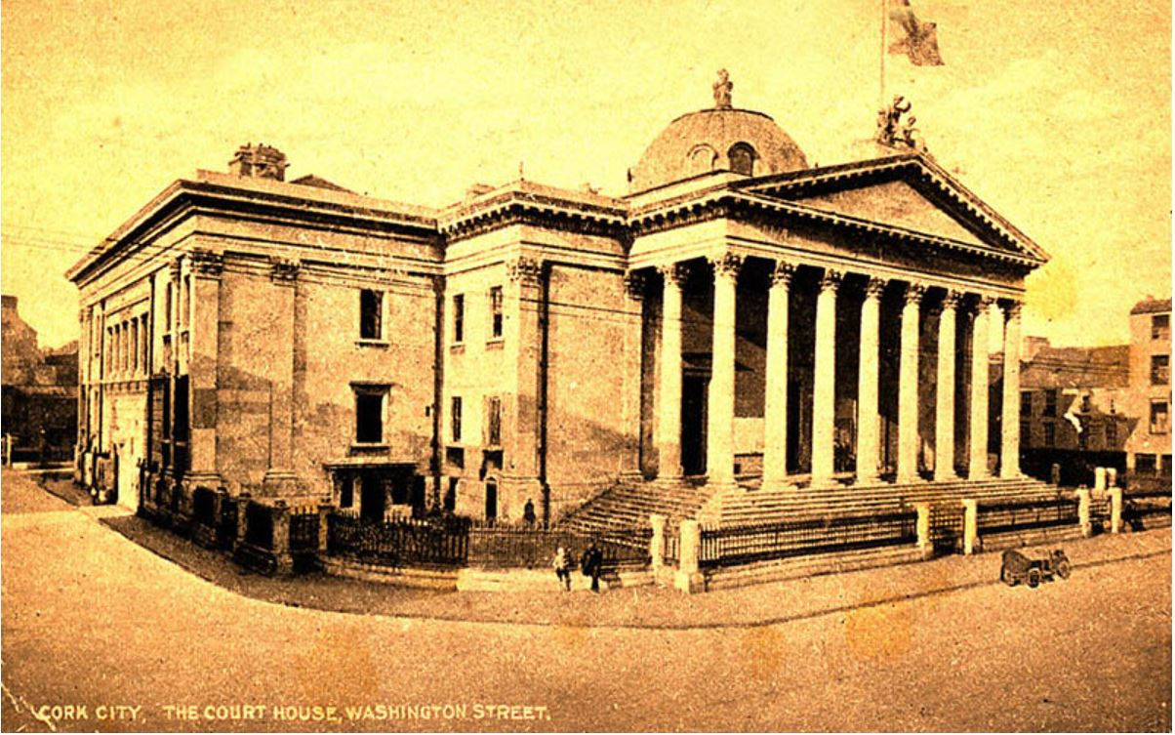*Douglass fled to Europe so he could not be recaptured. He found shelter in Ireland, where he began attending meetings, offering speeches, and working on an Irish edition of his Narrative. On the afternoon of October 14, 1845, Douglass delivered an antislavery lecture in the city courthouse of Cork, Ireland. He had been in the city of Cork for one week. Newspapers covering his speeches observed that long before the meeting’s start time, the building was “densely crowded in every part.” The gallery was “thronged with ladies” who seemed to “take the liveliest interest in the proceedings.” The Cork Examiner reported the presence of “over one hundred ladies” and “a large audience of respectable gentlemen and citizens.” The Mayor of Cork Richard Dawden led the event. Several local residents offered anti-slavery proposals, as did Douglass’s friend and frequent traveling companion James Buffum. Next, Frederick Douglass took the stage. According to a journalist present, Douglass’s oratorical skills were a matter of “admiration” and even “astonishment.” On stage, Douglass joined “facility and power of expression” with “a most impressive and energetic delivery.” In this address, Douglass used a “humorous method” of exposing the “hypocrisy and duplicity” of American enslavers. Those who heard him said he “kept the meeting in a roar [of laughter].”*

**Speech Read Time ~12:30**

Sir, I never more than at present lacked words to express my feelings. The cordial and manly reception I have met with, and the spirit of freedom that seems to animate the bosoms of the entire audience have filled my heart with feelings I am incapable of expressing. I stand before you in the most extraordinary position that one human being ever stood before his race—a slave. A slave not in the ordinary sense of the term, not in a political sense, but in its real and intrinsic meaning. I have not been stripped of one of my rights and privileges, but of all. By the laws of the country whence I came, I was deprived of myself—of my own body, soul, and spirit, and I am free only because I succeeded in escaping the clutches of the man who claimed me as his property. There are fourteen Slave States in America, and I was sold as a slave at a very early age, little more than seven years, in the southern part of Maryland. While there I conceived the idea of escaping into one of the Free States, which I eventually succeeded in accomplishing. On the 3rd Sept., 1838, I made my escape into Massachusetts, a free state, and it is a pleasing coincidence that just seven years after, I stood up in the Royal Exchange in Dublin, to unfold to the people of that good City the wrongs and sufferings to which my race in America were exposed. (Applause.) On escaping into Massachusetts, I went to work on the quays, rolling oil casks, to get a livelihood, and in about three years after having been induced to attend an anti-slavery meeting at Nantucket, it was there announced that I should go from town to town to expose their nefarious system. For four years I was then engaged in discussing the slavery question, and during that time I had opportunities of arranging my thoughts and language. It was at last doubted if I had ever been a slave, and this doubt being used in injure the anti-slavery cause, I was induced to set the matter at rest by publishing the narrative of my life. A person undertaking to write a book without learning will appear rather novel, but such as it was I gave it to the public. (Hear, Hear.) The excitement at last increased so much that it was thought better for me to get out of the way lest my master might use some stratagem to get me back into his clutches. I am here then in order to avoid the scent of the blood hounds of America, and of spreading light on the subject of her slave system. There is nothing slavery dislikes half so much as the light. It is a gigantic system of iniquity, that feeds and lives in darkness, and, like a tree with its roots turned to the sun, it perishes when exposed to the light. (Loud cheering.) we want to arouse public indignation against the system of slavery and to bring the concentrated execrations of the civilized world to bear on it like a thunderbolt. (Loud cheering.) The relation of master and slave in America should be clearly understood. The master is allowed by law to hold his slave as his possession and property, which means the right of one man to hold property in his fellow. The master can buy, sell, bequeath his slave as well as any other property, nay, he shall decide what the poor slave is to eat, what he is to drink, where and when he shall speak. He also decides for his affections, when and whom he is to marry, and, what is more enormous, how long that marriage covenant is to endure. The slaveholder exercises the bloody power of tearing asunder those whom God has joined together—of separating husband from wife, parent from child, and of leaving the hut vacant, and the hearth desolate. (Sensation.) The slaveholders of America resort to every species of cruelty, but they can never reduce the slave to a willing obedience. The natural elasticity of the human soul repels the slightest attempt to enslave it. The black slaves of America are not wholly without that elasticity; they are men, and, being so, they do not submit readily to the yoke. (Great cheering.) It is easy to keep a brute in the position of a brute, but when you undertake to place a man in the same state, believe me you must build your fences higher, and your doors firmer than before. A brute you may molest sometimes with impunity, but never a man. Men—the black slaves of America—are capable or resenting an insult, of revenging an outrage, and of looking defiance at their masters. (Applause.) Oftentimes, when the poor slave, after recovering from the application of the scourge and the branding iron, looks at his master with a face indicating dissatisfaction, he is subject to fresh punishment. That cross look must be at once repulsed, and the master whips, as he says, “the devil out of him;” for when a slave looks dissatisfied with his condition, according to his cruel taskmaster’s idea, it looks as if he had the devil in him, and it must be whipped out. (Oh, oh.) The state of slavery is one of perpetual cruelty. When very young, as I stated, I was sold into slavery, and was placed under the control of a little boy who had orders to kick me when he liked, whenever the little boy got cross, his mother used to say, “Go and whip Freddy.” I however, soon began to reason upon the matter, and found that I had as good a right to kick Tommy, as Tommy had me. (Loud laughter and cheering.) My dissatisfaction with my condition soon appeared, and I was most brutally treated. I stand before you with the marks of the slave-driver’s whip, that will go down with me to my grave; but, what is worse, I feel the scourge of slavery itself piercing into my heart, crushing my feelings, and sinking me into the depths of moral and intellectual degradation. (Loud cheering.) In the South, the laws are exceedingly cruel, more so than in the Northern States. The most cruel feature of the system in the Northern States is the slave Trade. The domestic slave trade of America is now in the height of its prosperity from the Annexation of Texas to our Union. In the Northern States they actually breed slaves, and rear them for the Southern markets; and the constant dread of being sold is often more terrible than the reality itself. (Here the speaker proceeded to comment upon the law of America relative to the punishment of slaves, and read the following):—

“If more than seven slaves are found together in any road, without a white person—twenty lashes a piece. For visiting a plantation without a written pass—ten lashes. For letting loose a boat from where it is made fast—thirty nine lashes; and for the second offence, shall have his ear cut off. For having an article for sale without a ticket from his master—ten lashes. For being on horseback without the written permission of his master—twenty five lashes.”

I saw one poor woman who had her ear nailed to a post, for attempting to run away, but the agony she endured was so great, that she tore away, and left her ear behind. (Great sensation.) This is the law of America after her Declaration of Independence—the land in which are millions of professed Christians, and which supports their religion at a cost of 20 million dollars annually, and yet she has three millions of human beings the subjects of the hellish laws I have read. We would not ask you to interfere with the politics of America, or invoke your military aid to put down American slavery. No, we only demand your moral and religious influence on the slave (holder) in question, and believe me the effects of that influence will be overwhelming. (Cheers.) We want to awaken the slave holder to a sense of the iniquity of his position, and to draw him from his nefarious habits. We want to encircle America with a girdle of Anti-slavery fire, that will reflect light upon the darkness of the slave institutions, and alarm their guilty upholders—(great applause). It must also be stated that the American pulpit is on the side of slavery, and the Bible is blasphemously quoted in support of it. The Ministers of religion actually quoted scripture in support of the most cruel and bloody outrages on the slaves. My own master was a Methodist class leader (Laughter, and “Oh”), and he bared the neck of a young woman, in my presence, and he cut her with a cow skin. He then went away, and when he returned to complete the castigation, he quoted the passage, “He that knoweth his master’s will and doeth it not, shall be beaten with many stripes.” (Laughter.) The preachers say to the slaves they should obey their masters, because God commands it, and because their happiness depended on it. (A laugh.) (Here the Speaker assumed the attitude and drawling manner so characteristic of the American preachers, amid the laughter of all present, and continued)—Thus do these hypocrites cant. They also tell the slaves there is no happiness but in obedience, and wherever you see poverty and misery, be sure it results from disobedience. (Laughter.) In order to illustrate this they tell a story of a slave having been sent to work, and when his master came up, he found poor Sambo asleep. Picture the feelings, they say, of that pious master, his authority thrown off, and his work not done. The master then goes to the law and the testimony, and he there read the passage I have already quoted, and Sambo is lashed so that he cannot work for a week after. “You servants,” continued the preacher, “To what was this whipping traceable, to disobedience, and if you would not be whipped, and if you would bask in the sunshine of your master’s favour, let me exhort you to obedience. You should also be grateful that God in his mercy brought you from Africa to this Christian land.” (Great laughter.) They also tell the wretched slaves that God made them to do the working, and the white men the thinking. And such is the ignorance in which the slaves are held that some of them go home and say, “Me hear a good sermon to day, de Minister make ebery thing so clear, white man above a Nigger any day.” (Roars of laughter.) It is punishable with death for the second attempt to teach a slave his letters in America (Loud expression of disgust), and in that Protestant country the slave is denied the privilege of learning the name of the God that made him. Slavery with all its bloody paraphernalia is upheld by the church of the country. We want them to have the Methodists of Ireland speak to those of America, and say, “While your hands are red with blood, while the thumb screws and gags and whips are wrapped up in the pontifical robes of your Church, we will have no fellowship with you, or acknowledge you (as) Christians.” (Great applause.) There are men who come here and preach, whose robes are yet red with blood, but these things should not be.—Let these American Christians know their hands are too red to be grasped by Irishmen. Presbyterians, Episcopalians, Congregationalists, and Roman Catholics, stand forth to the world and declare to the American Church, that until she puts away slavery, you can have no sympathy or fellowship with them—(Applause). For myself I believe in Christianity. I love it. I love that religion which is from above, without partiality or hypocrisy—that religion based upon that broad, that world-embracing principle, “That whatever you would that men should do to you, do ye even so to them.” (Loud cheering).—In America Bibles and slave-holders go hand in hand. The Church and the slave prison stand together, and while you hear the chanting of psalms in one, you hear the clanking of chains in the other. The man who wields the cow hide during the week, fills the pulpit on Sunday—here we have robbery and religion united—devils dressed in angels’ garments. The man who whipped me in the week used to attend to show me the way of life on the Sabbath, I cannot proceed without alluding to a man who did much to abolish slavery, I mean Daniel O’Connell. (Tremendous cheers.) I feel grateful to him, for his voice has made American slavery shake to its centre.—I am determined wherever I go, and whatever position I may fill, to speak with grateful emotions of Mr. O’Connell’s labours. (Cheering.) I heard his denunciation of slavery, I heard my master curse him, and therefore I loved him. (Great cheering.) In London, Mr. O’Connell tore off the mask of hypocrisy from the slave-holders, and branded them as the vilest of the vile, and the most execrable of the execrable, for no man can put words together stronger than Mr. O’Connell. (Laughter and cheering.)