Frederick Douglass

National Park Service

U.S. Department of the Interior

Frederick Douglass

National Historic Site

National Capital Parks-East



1411 W Street SE

Washington, DC 20020

**2019 Frederick Douglass**

2019 Application

**Oratorical Contest**

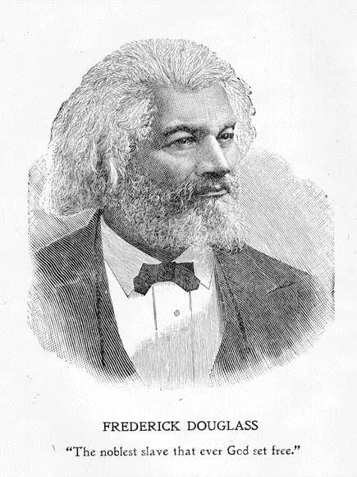

EXPERIENCE YOUR AMERICA™

# updated oratorical watermark.JPGFrederick Douglass Annual Oratorical Contest Guidelines

SPONSOR: Frederick Douglass National Historic Site

THEME: Frederick Douglass: America's Great Orator

The goal of the contest is for students to undergo the same empowering transformation as Frederick Douglass

RESPOND BY: **Friday, November 22, 2019 4:00 pm**

ELIGIBILITY: Students in grades 1 – 12

GUIDELINES: Contestants should memorize and deliver an **excerpt of any speech by Frederick Douglass.** A bibliography of Frederick Douglass speeches can be found in the Oratorical Contest section of the website: www.nps.gov/frdo

LENGTH OF PRESENTATION:

|  |  |  |
| --- | --- | --- |
| *Division* | *Grades* | *Time* |
| Elementary | **1 – 3** | **1 -3 minutes** |
| Junior | **4 – 5** | **2 -5 minutes** |
| Junior High | **6 – 8** | **5 -8 minutes** |
| Senior High | **9 – 12** | **6 -12 minutes** |

JUDGING: Refer to guidelines.

All decisions by the judges are FINAL.

DATES: Students will deliver their oration in competition with other students on the following dates:

* **Friday, December 6, 2019**
* **Saturday, December 7, 2019**

Contest applicants will be notified of their scheduled appointment time.

LOCATION Frederick Douglass National Historic Site’s Visitor Center

TIMES Approximately 9:00 a.m. - 4:00 p.m. (may vary)

SUBMISSION: **By Friday, November 22, 2019 4:00 pm**

Email (preferred): FrederickDouglassNPS@gmail.com

Mail: Frederick Douglass National Historic Site

Attn: Oratorical Contest

1411 W Street SE

Washington, D.C. 20020

Fax: 202-426-0880 (please call the site to confirm receipt)

If you do not receive conformation that your application has been received within one week for emailed and two weeks for mail applications, please contact the Frederick Douglass National Historic Site at (202)-426-5961.

**Frederick Douglass National Historic Site Oratorical Contest Rules**

* The contest is open to students in grades 1- 12.
* Each school will be limited to bring no more than 3 students from each grade level, plus alternates.
* All alternates must be identified at the beginning of the contest. Alternates perform in place of a contestant, not in addition to the school’s contestants.
* Contestants are expected to compete in one of the four divisions:

|  |  |
| --- | --- |
| Elementary (grades 1-3) | 1-3 minutes |
| Junior (grades 4-5) | 2- 5 minutes |
| Junior High (grades 6-8) | 5-8 minutes |
| Senior High (grades 9-12) | 6 -12 minutes |

* Time begins when contestants begin speaking. Time includes introduction.
* 1 point deduction will be taken for every 30 seconds or fraction of time over or under the time limit.
* During the contest, the contestant may request a 30 second timeout for a penalty of 2.5 points to regain composure or recover part of his/her speech.
* In the event that a contestant may forget part of his or her speech the contestant has up to the maximum time limit of each category to recall the speech. After this time the contestant will be judged on the performance as given.
* Contestants should memorize and deliver an excerpt of any speech by Frederick Douglass. A bibliography of Frederick Douglass speeches can be found in the Oratorical Contest section of the website: [www.nps.gov/frdo](http://www.nps.gov/frdo) **Contestants may not present a portion of one of a Frederick Douglass’ books or articles.**
* The use of props and costumes is permitted. Students are permitted to dress up in costume appropriate to the time period or the role. Students are also allowed the limited use of props in their presentation. However, this is a speech competition. The emphasis of the contest is on the delivery, accuracy and emotional appeal to the audience. Contestants **may not** act out their speech, for example (recreate the scene of Frederick Douglass’ escape and/ or bring furniture or set pieces to make the stage look like a specific environment.)

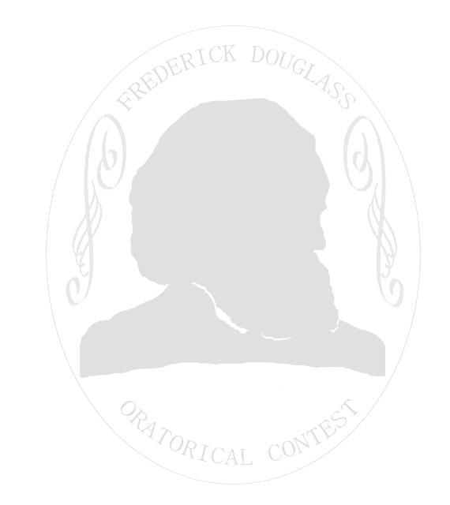

* A contestant who reads their speech from note cards, paper, etc…will be disqualified
* Contestants must be accompanied by an adult chaperone, parent, teacher, or principal.
* Contestants, parents and chaperones are expected to be respectful of other contestants and conduct themselves professionally. All contestants and chaperones are expected to represent the morals and values of Frederick Douglass and act accordingly. Any contestant or chaperone that willfully or maliciously harasses, intimidates, and/or disrespects fellow contestants; chaperones, or contest officials will be disqualified. Contestants will be disqualified from contest if their parents, guardians, teachers, or chaperones violate this stipulation.
* Contestants must be on time. Failure to arrive within fifteen minutes of the appointment or without contacting the site in anticipation of a late arrival will result in disqualification.
* Contestants’ supporters may videotape competition. Personal videos **may not** be used to dispute or challenge judges’ rulings.
* The National Park Service will determine when and how the winners will be notified.
* All judges’ rulings are final.
* National Park Service retains the right to amend the rules without notice.

**Frederick Douglass National Historic Site Oratorical Contest Entry Form**

PLEASE TYPE OR PRINT AND COMPLETE THE ENTRY FORM IN ITS ENTIRETY.

To complete electronically simply type information in the grey boxes and return by email.

Name      Age      Grade  

Home Address     __________________________ Phone     ______

City      ______________________________ State     ___ Zip Code     ____

Preferred point of contact:  Parent  Teacher

Parent/Guardian’s Name     ________________________________________________

Email:      ______________________________________________________________

School     _______________________________________________________________

School Address     ________________________________________________________

School Telephone     ______________________________________________________

Teacher Name     ________________________________________________________ Email     _______________________________________________________________

Title of Speech, Date, Location, Source     ______________________________________________________

____________________________________________________________________________________________________________________________________________________________________________________

**Appointment preference:** *(Please note your first and second choice)*

|  |  |
| --- | --- |
| Fri. Dec. 6, 2019 | AM  PM |
| Sat. Dec. 7, 2019 | AM PM |

###### Please submit completed form and any attachments by:

##### **Friday, November 22, 2019 4:00 pm**

To:

Frederick Douglass NHS

1411 W Street SE

Washington, D.C. 20020

Or

FrederickDouglassNPS@gmail.com

or

Fax: 202-426-0880 (MUST call site to confirm receipt)

**LATE & INCOMPLETE APPLICATIONS WILL NOT BE ACCEPTED.**