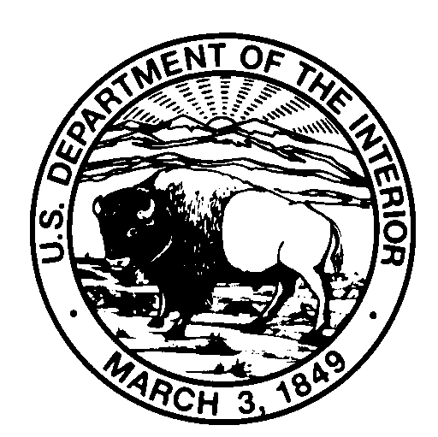
United States Department of the Interior
NATIONAL PARK SERVICE
Fort Sumter and Fort Moultrie National Historical Park
1214 Middle Street
Sullivan’s Island, South Carolina 29482
(843) 883-3123

FORT MOULTRIE FEE WAIVER APPLICATION INSTRUCTIONS

Dear Educator,

Thank you for your interest in Fort Moultrie, part of Fort Sumter and Fort Moultrie National Historical Park. Fort Moultrie is a year-round entry fee park. The park commonly receives requests to waive entry fees for visiting groups. When possible, the park may issue fee waivers to educational or scientific institutions. The procedures for obtaining a fee waiver are outlined below. The park requires fee waiver applications two weeks in advance of the planned visit to ensure sufficient time for processing. Incomplete applications, or applications submitted without sufficient information may experience delayed processing or denial. If you need to cancel or reschedule the visit, please call the park before the group’s planned arrival date so your place may be made available to others.

One chaperone is required for every ten students. One chaperone per ten students will be covered under an approved fee waiver. All Additional chaperones will be charged the usual park entrance fee. The entrance fee is currently $7.00 per person. Effective January 1, 2020 admission fees increase to $10.00 per person. Payment can be made in advance or upon group’s arrival.

Groups must not exceed 110 visitors in total. Additional rules of behavior are listed on page 3 of this packet.

APPLYING FOR A FEE WAIVER
To qualify, applications must contain the following:

1. Provide current, official documentation of recognition as a bona fide educational institution by submitting one of the following types of documentation.

- Documentation confirming educational or scientific tax exemption from the Internal Revenue Service (IRS) or the applicant’s national, state, or local tax authority; or

- A statement from a bona fide academic institution meeting one of these eligibility standards, confirming that the group is visiting for the purpose of providing transferable academic credit based on a curriculum; or

- Documentation confirming accreditation or recognition as an educational institution from a legitimate international, national, regional, state, or local authority for the applicant’s location. Chartered, licensed, registered, recognized, authorized, associated with, approved by, or affiliated with are not synonymous with accreditation. Confirmation of accreditation is required.

2. Copy and paste the application form on the reverse side of this page onto your institutional letterhead. Complete the application and mail or email it along with your official recognition as a bona fide educational institution.

3. Demonstrate the field trip is for educational purposes and that park resources or facilities are directly relevant to the educational purpose. A general statement to the effect that the visit is for “educational purposes” is insufficient by itself.

Application for Academic Fee Waiver

Copy onto institutional letterhead and complete. Mail or email application to:
Fort Sumter and Fort Moultrie National Historical Park
Attn: Academic Fee Waiver Applications
1214 Middle Street, Sullivan’s Island, SC 29482

Fosu_Commercial_Services@nps.gov Subject Line: Academic Fee Waiver Application

Name of Institution:

Institution Address:

Name of Official Group Contact:

Phone: Email:

Number and Grade Level of Students: Number of Faculty/Chaperones:

Date of Arrival: Time of Arrival: Time of Departure:

1. Educational Purpose: List specific curriculum being met and what academic credit is being given:

2. Relevance of Park Resources or Facilities: Identify the park resources and/or facilities that will be used to support the educational purpose of the visit listed above and address how they are relevant to that purpose. Include a field trip itinerary and copies of relevant lesson plans, handouts, or assignments.

3. I understand that the Code of Federal Regulations allows Academic Fee Waivers only for educational and/or scientific institutions that are using the park for educational purposes. I hereby certify that the above detailed trip meets these requirements and therefore request that fees be waived. Current official documentation of recognition of affiliation as an educational institution by a Federal, State, or local government entity, or other evidence attesting to educational status is attached. (e.g., accreditation letter, educational or scientific tax exemption letter).

Print name: Title/Position:

Signature: Date:

Fort Moultrie
Fort Sumter and Fort Moultrie National Historical Park

National Park Service
U.S. Department of the Interior

Field Trip Rules and Regulations – Protecting You and the Park!

The following rules and regulations are in place for your safety, the safety of others, and the safety and preservation of the historic site.

For Your Safety

- Be aware of and stay back from large drop offs on top of gun batteries
- Uneven and slippery walking surfaces exist. Watch your step to avoid trips and falls
- Climbing is not permitted to prevent injuries from falls
- Do not cross areas that are closed with chains or other barriers to avoid risk of injury
- Bring and drink water, especially during hot summer months
- Call 9-1-1 in an emergency, then notify a ranger. First Aid and an AED are located in the visitor center

Respect the park
As a unit of the National Park Service, everything here is protected.

- Leave all plants, rocks, shells, bricks, or other natural and historic objects in the park
- Place litter where it belongs
- Sitting, standing, and climbing on fort walls and cannons is strictly prohibited
- Loud noises are discouraged
- Feeding and/or harassing any wildlife is strictly prohibited

Respect the right of others to enjoy the park
Loud noises and other disruptive behavior can spoil the experience for others. To ensure everyone in your group and other park visitors can enjoy their experience, please…

- No running
- No pushing
- No yelling
- No smoking inside the fort
- No music or other media playing out loud from phones or other devices inside the fort or visitor center

Group Rules

- Chaperones must stay with and in control of their group for the duration of the visit. No students are to be left unattended, regardless of age
- Students will be broken into groups no larger than 30 during the visit. Groups are expected to follow the itinerary provided during the application process
- No more than 60 group members can view the film at one time. For groups exceeding 60 they must be divided into two separate showings of the film. The film is shown every half hour
- No more than 30 group members are allowed in the museum at the same time
- No more than 10 students are allowed in the gift shop at one time. Students must be accompanied by a chaperone

