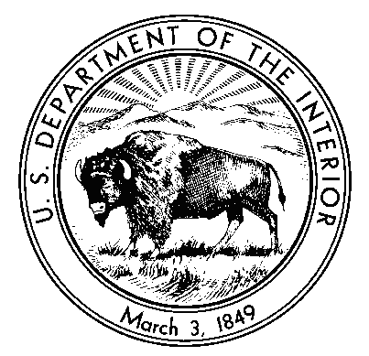

IN REPLY REFER TO:

United States Department of the Interior

NATIONAL PARK SERVICE

FORT McHENRY NM&HS
2400 E. Fort Ave.
BALTIMORE, MARYLAND 21230-5393
www.nps.gov/fomc

Dear Fee Waiver Applicant:

The National Park Service regulations allow school groups and other bona fide national and international academic institutions to obtain a waiver for park entrance fees, provided that the visit is for educational purposes, and the resources or facilities the group proposes to use support those purposes.

The following information has been taken directly from National Park Service Regulations (NPS-22). Your application must contain all of the following:

- Current official documentation of recognition of affiliation as an educational institution by a Federal, State or local government entity, or other evidence attesting to educational status is attached (e.g. ACCREDITATION LETTER or an EDUCATIONAL TAX EXEMPT LETTER). It is insufficient to merely state or imply this on official letterhead.
  - For a Maryland school, simply stating the County on the application will be sufficient to show eligibility, as lists are retained of all Maryland schools.

- The visit shall not be primarily for recreation purposes. This requirement can be met for K-12 with an outline of required student work, or for college courses by stating the course number, description and/or a copy of the catalog description. Number of Fee Waived chaperone/teachers allowed will be: 1 chaperone/teacher – 5 students. Considerations will be made for schools with special circumstances. Additional visitors will need to pay the $10/person daily admission fee upon arrival.

- The visit must be to study some aspect/resource specific to Fort McHenry. A general statement to the effect that the visit is for "educational purposes" is insufficient by itself. An explanation of what the educational purpose entails and how is related to Park resources is required.

Applications must be received in the Group Arrangements Office two (2) weeks in advance of the anticipated visit. REFUNDS WILL NOT BE GRANTED. FEE WAIVERS WILL NOT BE GIVEN AT THE VISITOR CENTER. After your application has been processed, you will receive notification of approval or denial.

Email/mail the following form, along with required documentation, to:
Email: FOMC_Groups@nps.gov or mail: Group Arrangement Office 2400 E. Fort Ave, Baltimore, MD 21230. Please allow additional time for mail. Email is preferred.

United States Department of the Interior
National Park Service

Fort McHenry NM&HS
2400 E. Fort Ave. Baltimore, MD 21230
FOMC_Groups@nps.gov

APPLICATION FOR WAIVER OF FEES FOR EDUCATIONAL STUDY

Contact Name ___________________________________________________________

Name of Institution _______________________________________________________
School phone________________ School Email____________________

Address ________________________________________________________________

City/State/Zip/County______________________________________________________

Date of Scheduled Visit _______________Approximate Time of Arrival ______________

Number of Students:_____Number of adults: _____(Up to 5:1 ratio)
1. Outline of Required Student work for K-12 or Course Title, Catalog Number, and Description of Subject matter:
2. Explain the educational purpose of the trip. What aspect/resource of Fort McHenry National Monument and Historic Shrine will be studied?
3. TO BE ELIGIBLE FOR AN EDUCATIONAL FEE WAIVER, YOU MUST ATTACH CURRENT OFFICIAL DOCUMENTATION OF RECOGNITION OF AFFILIATION AS AN EDUCATIONAL INSTITUTION. FOR EXAMPLE: AN ACCREDITATION LETTER OR TAX-EXEMPT LETTER. SIMPLY STATING OR IMPLYING THIS ON OFFICAL LETTERHEAD IS INSUFFICIENT.
4. I understand that the Code of Federal Regulations allows Fee Waivers only for educational and/or scientific institutions that are using the park for educational purposes. I hereby certify that the above detailed trip meets these requirements and therefore request that fees be waived. I understand that additional visitors above the 5:1 ratio will need to pay the $10/person daily entrance fee upon arrival.

Signature of Official in Charge of Group (please include title and date)

_____________________________________ _______________
Signature of Park Official Date

