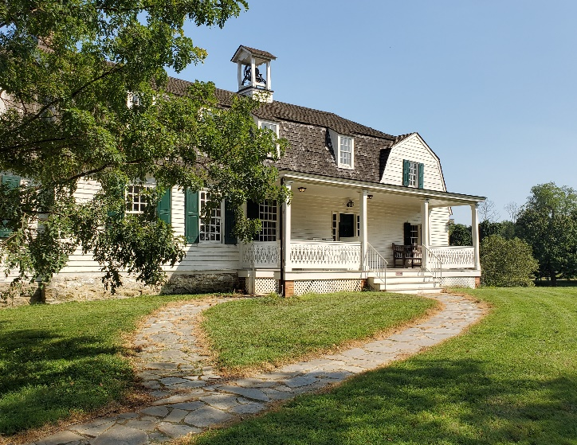 | Enslaved person: Someone forced into working for others with virtually no rights or payment. Laws determined if enslaved persons could worship together, could be taught to read, could earn money doing work outside of a plantation or “master’s” house or could use any laws in their own defense. Enslaved persons in America were of African descent, but not all enslaved persons came directly from Africa.  Slavery existed in all 13 of the original colonies. In Maryland slavery was not made illegal until 1864, a year before it was ended nationally by the 13th amendment.  Enslaved persons might be bought and sold several times throughout their lives, often separated from their families in the process.
Indentured servant: Someone who signed a contract with a “master” to serve that person for a specific number of years, with freedom promised at the end of the contract. Indentured servants at Hampton were typically European, often threatened with jail time in their home countries. In colonial times, “term slavery” worked in much the same way, with a contract for a certain number of years of forced labor for African enslaved persons.  Contracts were not always honored and sometimes even passed on to family members if the contract signer became ill or injured. | Freedom seeking: Describes how people worked to escape bondage, seeking the basic human right of freedom. At Hampton, enslaved persons and white indentured servants both sought their freedom: sometimes they sought their freedom together.  Indentured freedom seekers often went to port towns to return to Europe. Enslaved freedom seekers often went to Baltimore City to become part of a large free black community or to Pennsylvania, a free state with laws making it difficult for slave takers and owners to recapture them. Over 80 enslaved persons sought their freedom from Hampton.

Primary Source Documents: Read these real newspaper advertisements about freedom seekers, written and paid for by overseers and Ridgely family members from Hampton plantation. As you read these ads, ask yourself: Why would it be so important to include descriptions of clothing? What do you think many freedom seekers did before they even set out on their journey—what supplies might they take? Would they choose to change their appearance? What evidence do you find of cruel or harsh treatment at Hampton? What do you think the amount of each reward means? How might the skills mentioned in the ads help them in a new life? Use the graphic organizer on the following pages to compare and learn more about the experiences of these freedom seekers.

Escape Ad #1:

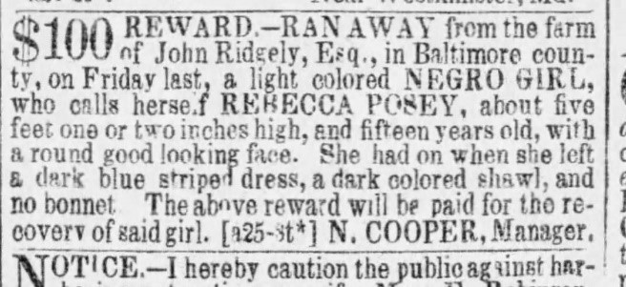
Baltimore Sun, Aug 26, 1852, Maryland Gazette
Rebecca was the daughter of Headwaiter Mark Posey, and her mother and sister were also enslaved at Hampton. Rebecca did make it to freedom in Baltimore City.

Escape Ad #2:

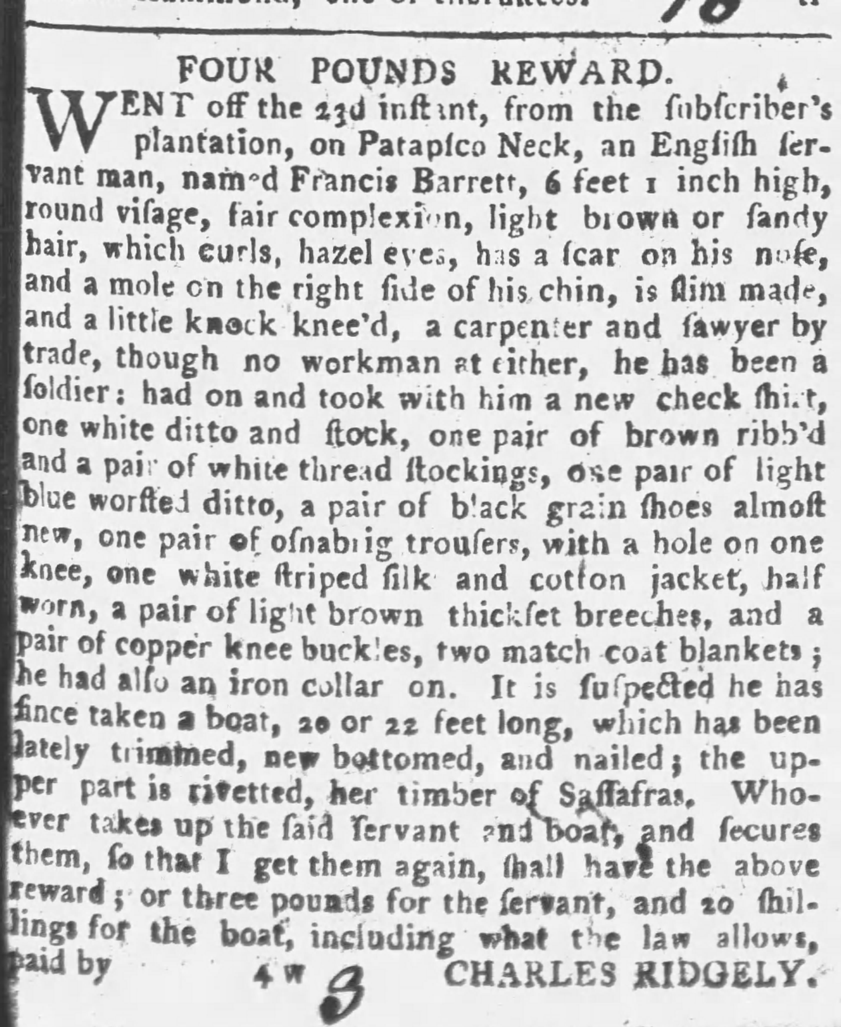
Maryland Gazette, June 29, 1775 Maryland Gazette, Sept 15, 1766
Francis ran away several times and multiple ads were printed about him.

Escape Ad #3:

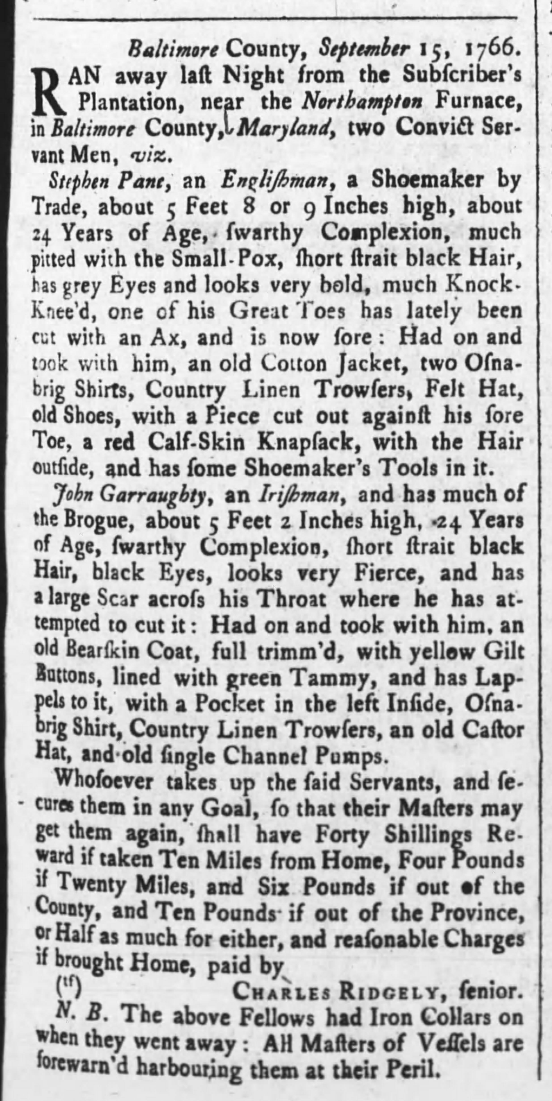
Maryland Gazette, Sept 15, 1766
Notes:
“Convict servant men” were indentured servants, who had the choice between going to prison and becoming indentured servants.
Notice how the letter “s” in these documents look like “f”s.
A “brogue” is an Irish accent.
“Osnabrig” is a coarse cotton.
“Masters of Vessels” are ship captains.

Graphic Organizer

Name of Person/s and Date of Advertisement
Indentured or enslaved?
Where is the person from?
Age
How does the person look, sound, what is the person wearing?

Possessions (what did they take with them?)

Skills/Job

Has the freedom seeker taken anything to help him or her escape?

Are there warnings to people who would try to help the freedom seeker?

Do you see evidence of cruel treatment in the advertisement?

