Comic Book and Quilt Image Gallery

For Grace Wisher’s Story:
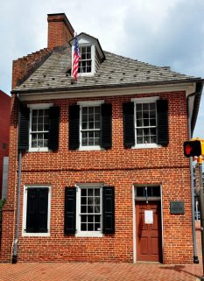 | 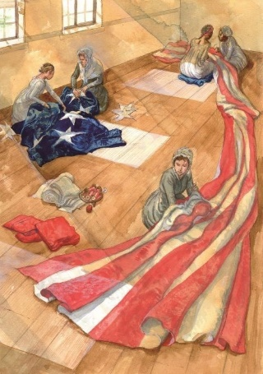 | 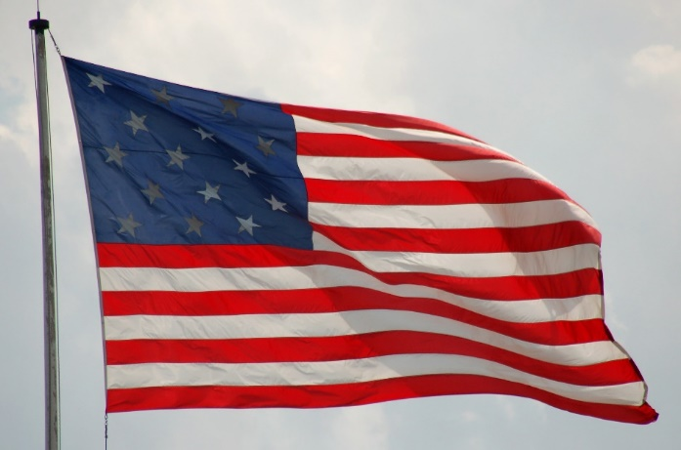
Star Spangled Banner House where Mary and Grace lived and sewed the flag. | Mary Pickersgill, her relatives, Grace Wisher, and an unnamed enslaved woman sewing the United States flag for Fort McHenry. | Garrison Flag, Fort McHenry, with 15 stars and 15 stripes.
 | 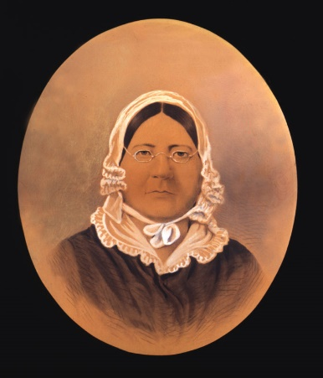 | 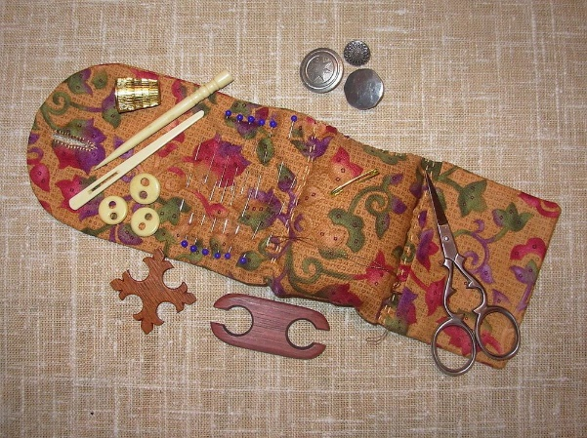
 | Mary Pickersgill, Smithsonian | Nineteenth-Century Sewing Kit

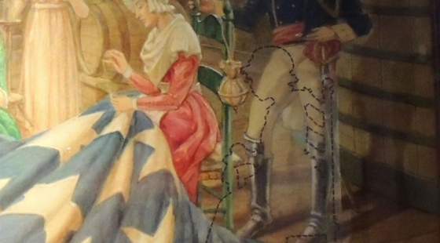
Baltimore artist Robert McGill Mackall painted a picture of the Pickersgill family and army officials who commissioned the flag. The Star-Spangled Banner Flag House has since drawn in the ghost figure of Grace Wisher, who had not been included in the picture. How will Grace appear in your comic book or quilt?
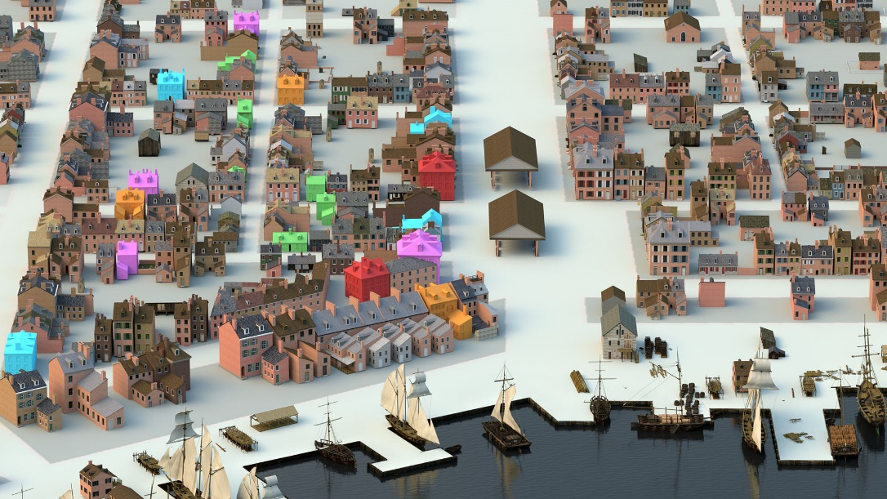
Rendering of Fells Point in 1814.

For John Willis’s Story:
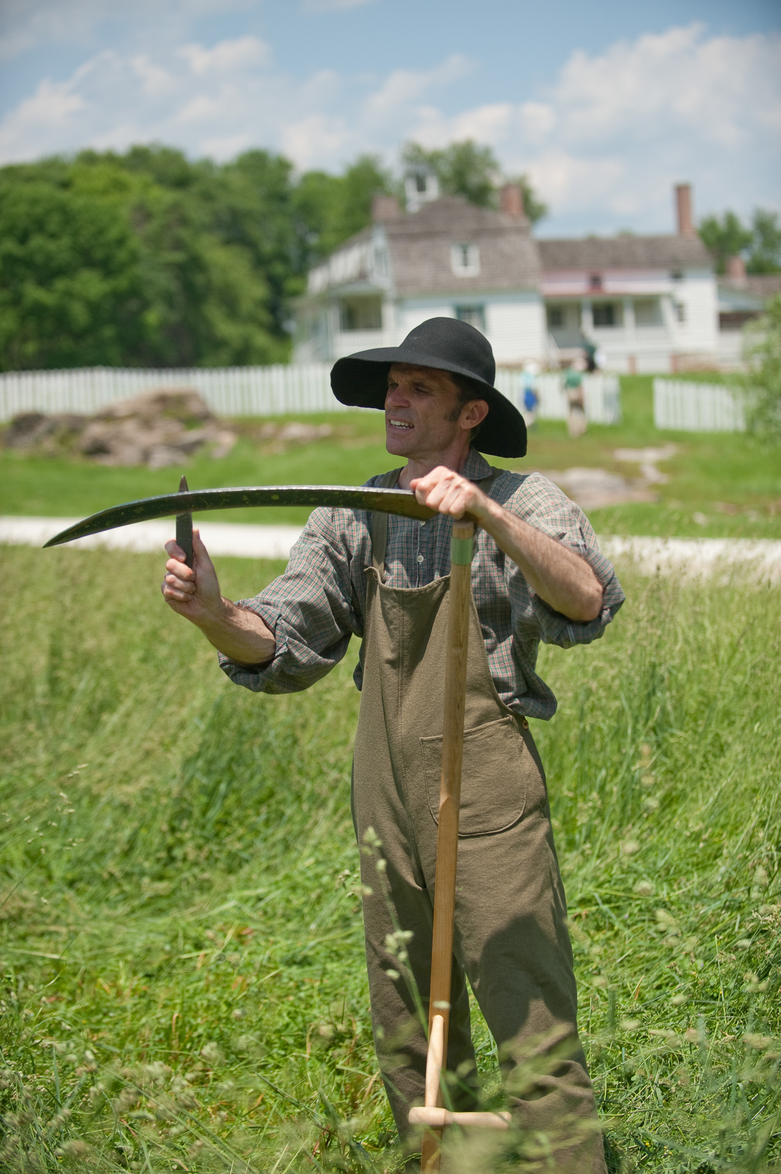 | 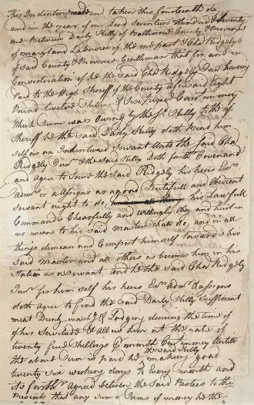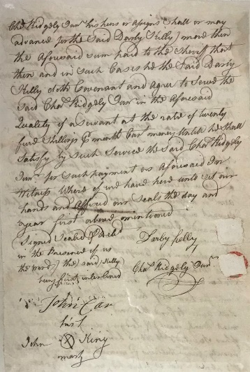
Interpreter demonstrates farming techniques employed by indentured servants, Harvest Day, Hampton | Indenture Contract for Captain Charles Ridgely and Convict Laborer Darby Kelly, 1770.
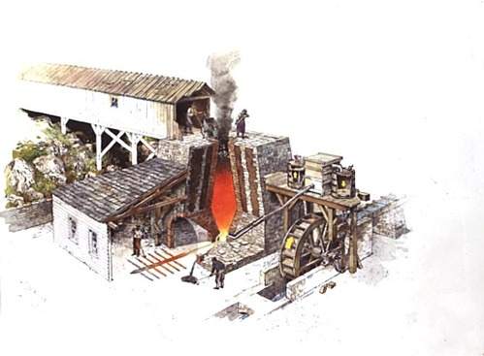 | 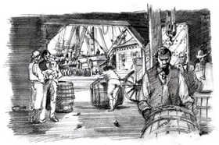
Richard Schlecht’s rendering of a cutaway of an iron furnace | Richard Schlecht’s rendering of a scene of activity at a warehouse and dock.

For both: clothing styles of the late 1700s-early 1800s
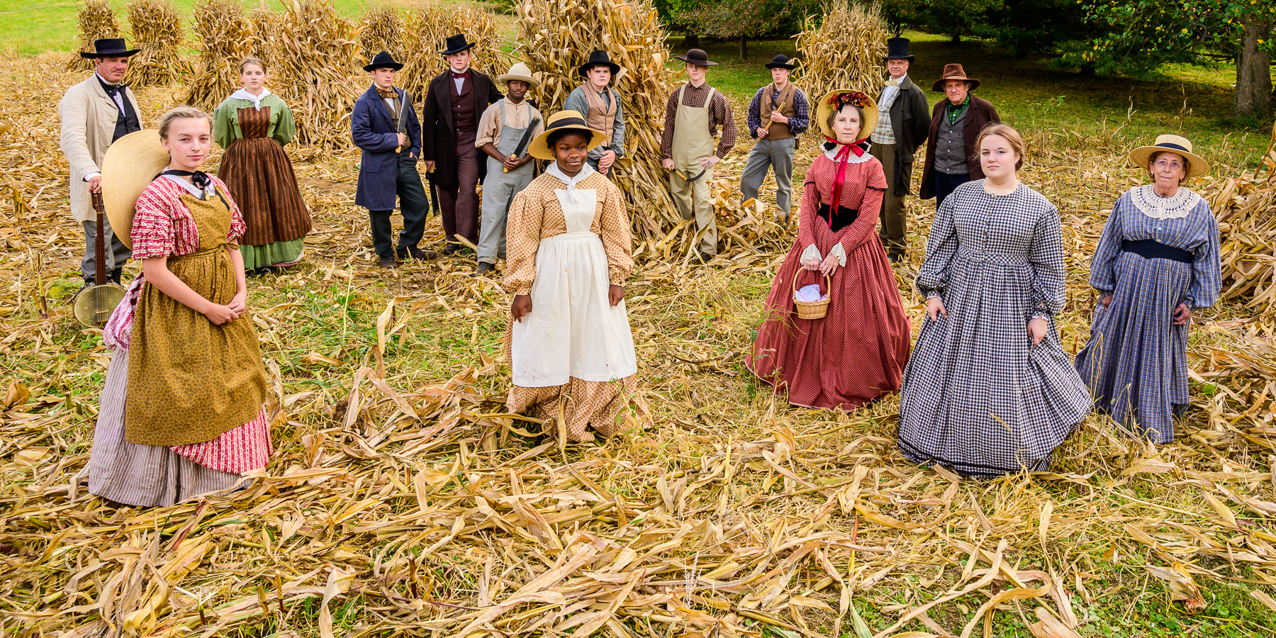
Costumed Interpreters, Harvest Day, Hampton

The next two pages include a Comic Book template and a Quilt Outline template for the project.

