A Brief History of the Santa Fe Trail & Fort Larned

From 1821 to 1880, the Santa Fe Trail was used for hauling and selling trade goods and eventually army supplies. A few families did travel the Trail looking for a new place to live, but that was not the main purpose.

The Trail first began in Franklin, Missouri. As the steamboats traveled further west along the Missouri River, the jumping-off points or starting points also moved west. Eventually railroads began to push westward from Missouri, which also changed the course of the Santa Fe Trail.

Between Missouri and southwestern Kansas, the Trail was one route. Near present-day Dodge City, Kansas, the Trail split into two routes. One branch went south crossing the Arkansas River, traveling through very dry country referred to as the “Jornada”. This Spanish word means “single day’s journey of the dead man” because of all the hardships travelers along the Trail would face. This part of the trail was called the **Dry Route** or the Cimarron Route. The other branch went west to the Rocky Mountains and then turned south. This branch was called the **Mountain Route**. Eventually the two joined near Fort Union in present-day New Mexico and proceeded to Santa Fe. There was also the **Wet Route**, which followed the Arkansas River.

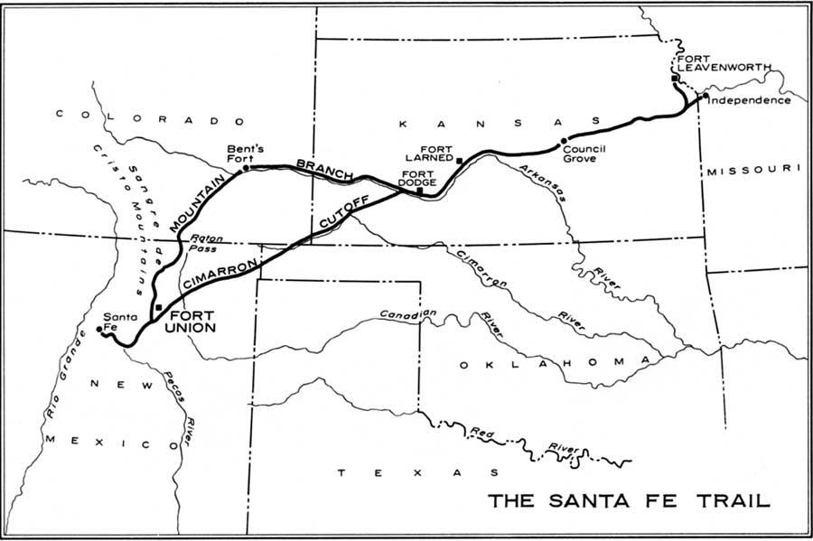



In 1859, Fort Larned, Kansas was opened. Its main purpose was to protect western mail routes, the Santa Fe Trail freighters, and the settlers that were moving into the area. For years many American Indian tribes had lived along the route of the Santa Fe Trail. These included the Kiowa, Apache, Comanche, Arapaho, and Cheyenne. Once the traders began moving through their lands and settlers followed, the fighting between the two increased. Not only were the tribes losing their homelands, but also their main source of life was being killed, the buffalo.

The freighters (large wagons) heavily loaded with trade goods became easy prey. Often they had large herds of horses with them, which were valued prizes for the Indians. After many requests from the freighters, the United States government responded by building a series of forts along the trail to offer protection. Fort Larned was one of these.

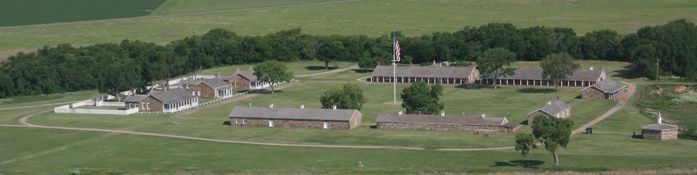

The buildings at Fort Larned were constructed from sandstone blocks. Unlike some other forts, no wall surrounded it for protection. The fort was located on the Dry Route. Fort Larned’s troops patrolled the Santa Fe Trail for seventy miles in either direction from the fort. Sometimes, the soldiers escorted wagon trains down the Trail to try to prevent attacks. As the railroad crossed Kansas, the fort was no longer needed. It was closed in 1878. Today, Fort Larned is a National Historic Site and a unit of the National Park System.