♦ Educational Programs ♦

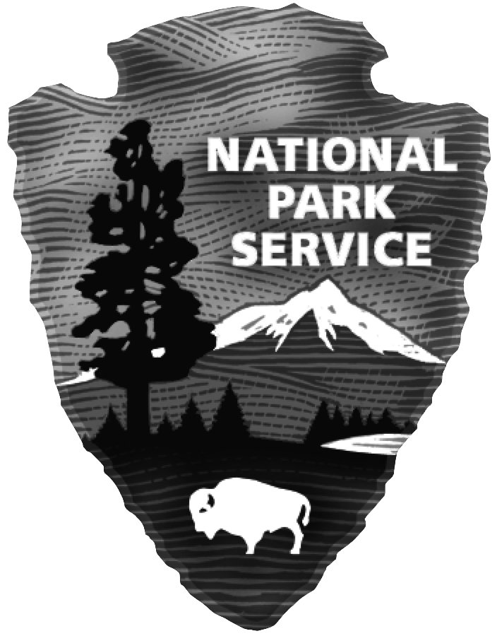



Fort Davis National Historic Site

### P.O. Box 1379

### Fort Davis, Texas 79734

**Phone 432-426-3224 ext.220 FAX 432-426-3122**

**HOURS 8:00 a.m. to 5:00 p.m.**

**→** **TEACHERS! Visit the Fort and have your students do an education program.** **Check out our website at**

[**www.nps.gov/foda**](http://www.nps.gov/foda)**. At the link “For Teachers,” download lessons for the classroom. Find out how to get a**

**fee waiver for your class. Schools visit free! Teachers get a 20% discount in the park bookstore on purchases.**

**All activity-based education programs comply with state standards and promote critical thinking skills.**

**ACTIVITY-BASED EDUCATION PROGRAMS AT THE PARK**

Grades 3-6 **Footsteps Through the Fort** (2 hrs) Students in small groups with sponsors experience an

Grades 6-12 interdisciplinary Social Studies - Math - Science adventure. Emphasizes map reading skills. At each stop, students answer color-coded questions. Can help improve TAKS/STAAR scores

in a fun, hands-on, real-world way! Program for Grades 6-12 has Algebra & more involved

Math, and it includes a “Mystery Photo” that requires clues and deductive reasoning to identify.

Grades K-12**Scavenger Hunt** (1 hour) Visit the historic structures looking for specific items like an 1800s mouse trap or bathtub. Could you identify a cistern? Not as easy as you think.

Grades K-5**Touch the Past!** (1½ hours) An Apache cradleboard…a pen that’s a *feather…*a button hook

for shoes? This bag is just *full* of the strangest things! They must be leftovers from olden days at

Fort Davis. Handle an object. Imagine it’s yours. But who did it *really* belong to? Students

are challenged to locate similar objects in the refurbished buildings as they explore the Fort with

a sponsor who carries objects in a haversack like the soldiers used. This multi-disciplinary

program is hands-on learning at its best.

Grades 4-6**Historic Native Plants – An Outdoor Scavenger Hunt** (2 hours) In this lesson, students will identify and research historical uses for plants indigenous to Fort Davis National Historic Site. The lesson will weave history and science together to incorporate medicinal and economical uses by both native and other settled inhabitants on or around the fort. The study will culminate in a challenging and competitive scavenger hunt of native plants. Evaluation will include students recognizing the physical appearances and characteristics of native plants found on the fort grounds, and presenting their historical uses to the group. This lesson could be used on or off site. Indoor adaptations are included.

**PARK VIDEO**

15-minute video shows in the auditorium every ½ hour or upon special request.

A short history of Fort Davis.

Teachers who prefer to maximize their time at the park can purchase this video at 20%

discount (approx. $20 total) and show it ahead of time to students or on the bus.

**RETREAT PARADE SOUND PROGRAM**

Plays outdoors on loudspeakers at 11:00, 2:00, and 4:00; length 18 minutes.

This audio program is based on a historic ceremony performed at Fort Davis in 1875

to honor former U.S. President, Andrew Johnson, who died that year.

## FOR YOUR CLASSROOM: Traveling Trunks

To bring history into your classroom, the traveling trunks are loaned out for one or two weeks

to schools within 100 miles of the park. The “Buffalo Soldiers in the 19th Century” and

“Frontier Women in the American West” trunks contain lesson plans,

as well as soldiers’ uniforms, military equipment, and period women’s clothes.

The TEKS-compliant trunks for grades 4 – 9 are delivered and picked up by the park.

