**Exploring Fort Bowie**

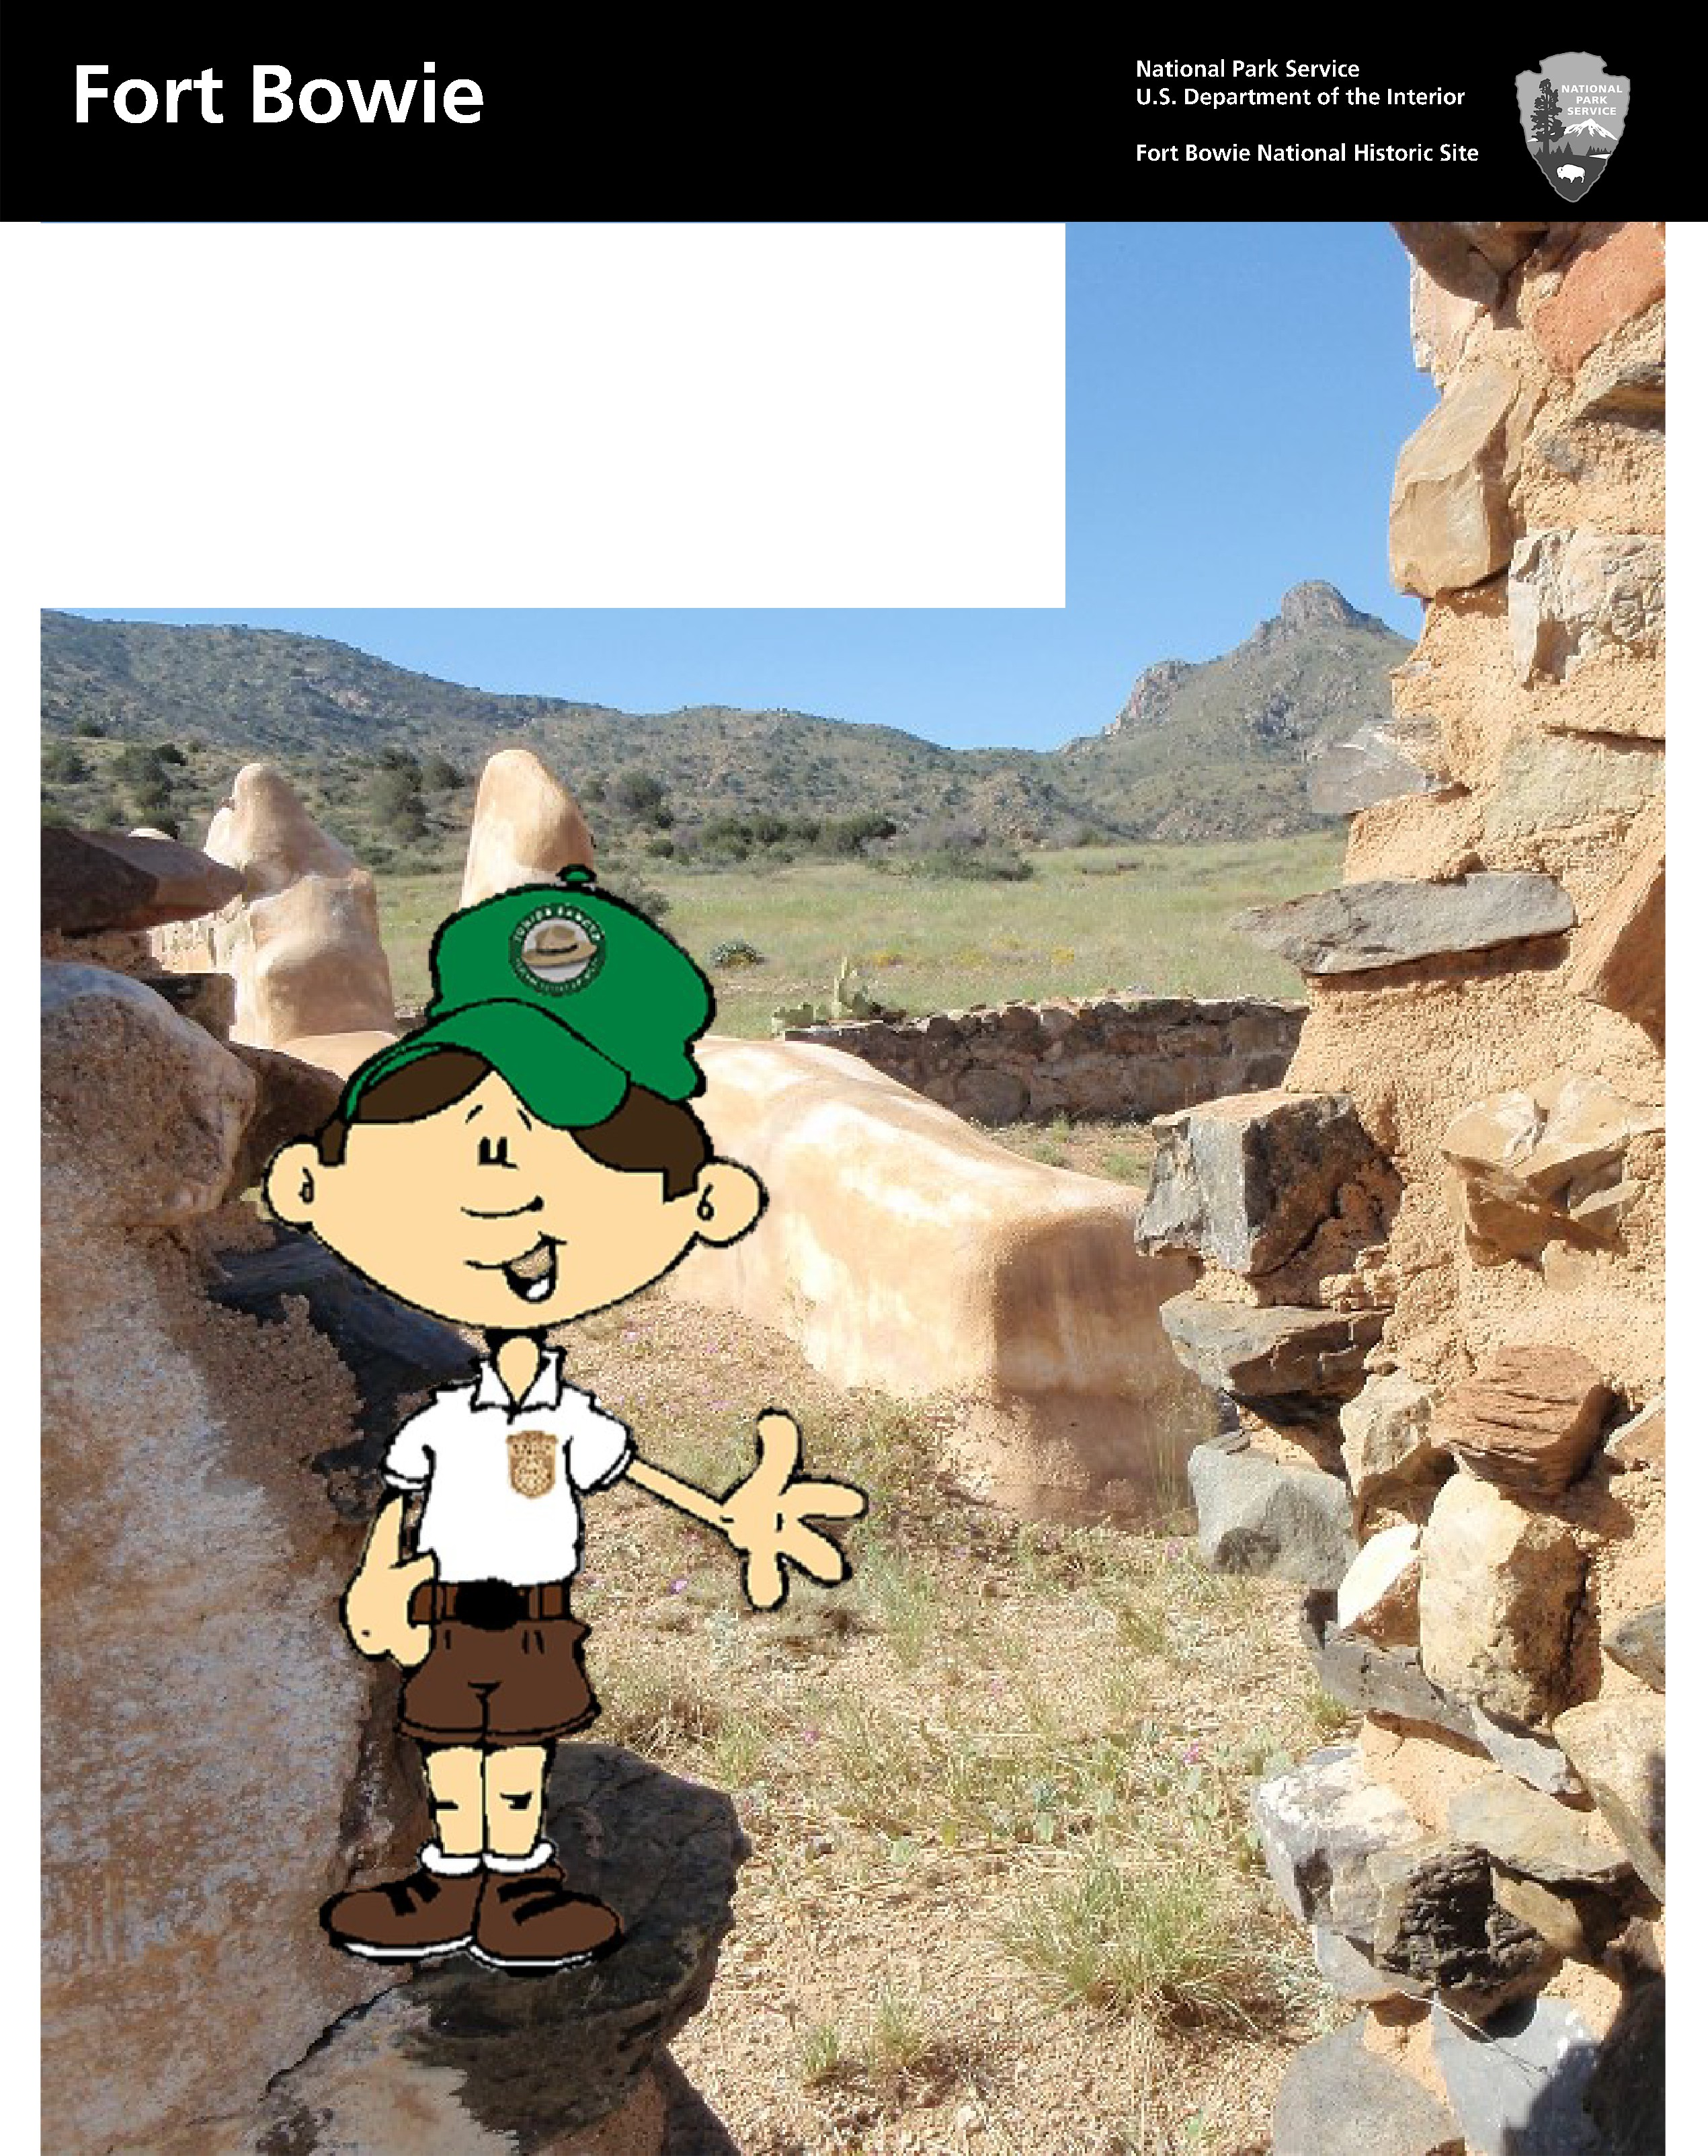

Junior Ranger Activity Book

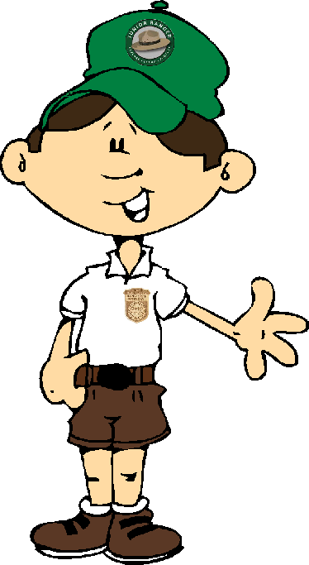

Welcome to Fort Bowie National Historic Site. I’m excited that you’re here and that you want to become a Junior

Ranger like me! Please follow the instructions on the next page to complete this book and receive your badge.

Have fun exploring Fort Bowie!

*Exciting to discover, Interesting to hold,*

*But taken from its historic spot Its story can’t be told.*

*-Anonymous-*

Please help the National Park Service protect Fort Bowie. Please don’t climb on the ruins or disturb any artifacts on the property.

# Instructions

This book is designed for Junior Rangers of all ages. Please complete all of the activities assigned to your age group to earn your badge and certificate. When you have completed the book, return it to a ranger or a volunteer to get sworn in as an official Fort Bowie Junior Ranger.

Instructions: Find your age below and complete all of the activities with the color star(s) next to your age group. *Hint: 11 and older will complete the entire book.*

Ages 4 and below

Ages 5-7

Ages 8-10

Ages 11 and older

*Junior Rangers and Parents: Look at the bottom of each page to find the “Did You Know” section and learn interesting and fun facts about Fort Bowie National Historic Site.*

# Heading West



Traveling into the western frontier in the 1800’s was a long, hard journey. People had to bring many different supplies to survive the trip. What do you think people took on their journey? Circle each of the items you think people brought with them.

Did You Know: Horses have become an iconic symbol of the American West but they are not native to this country. Horses were brought to the Americas by Spanish explorers in the 1500’s. The

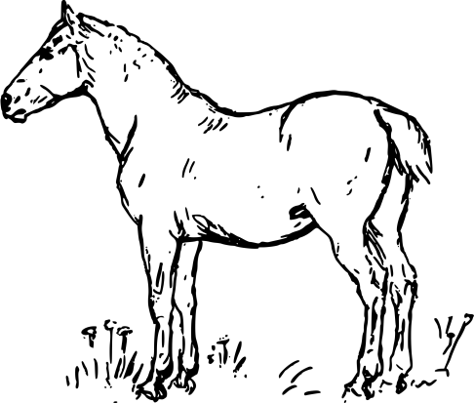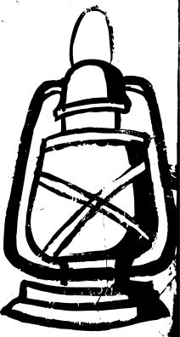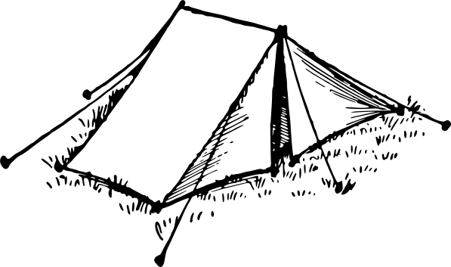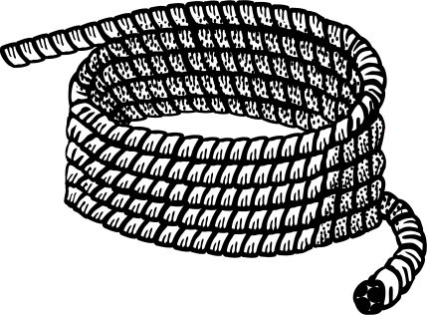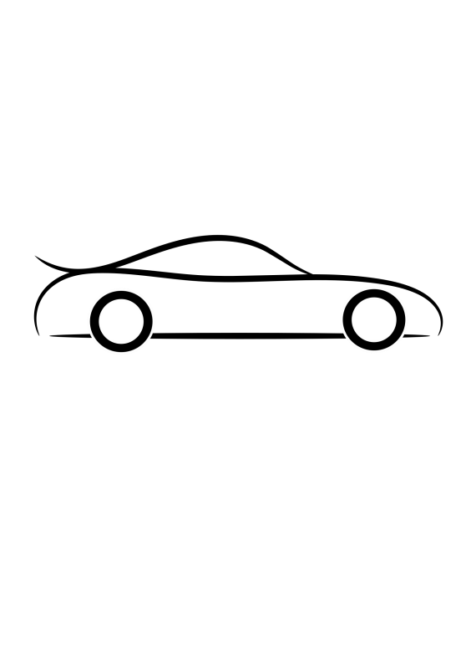

introduction of horses drastically changed how people lived on this continent.

# I Spy...



While visiting Fort Bowie NHS, you will see many different plants, animals, insects, and manmade structures. Take a look around the park. What do you see? Draw something that you find really interesting.

Did You Know: Fort Bowie NHS sits on 1,000 acres and within those boundaries, there are nearly 500 different plants, trees, and cacti!



On the Trail

Fort Bowie NHS is home to many different animals. Often, you will see clues that these animals live in the park. Sometimes you will find its tracks and sometimes you will find its scat (poop!).

Can you match each track to the right animal?

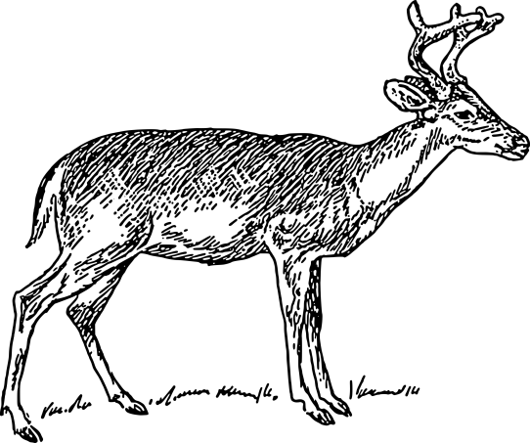

Mule Deer

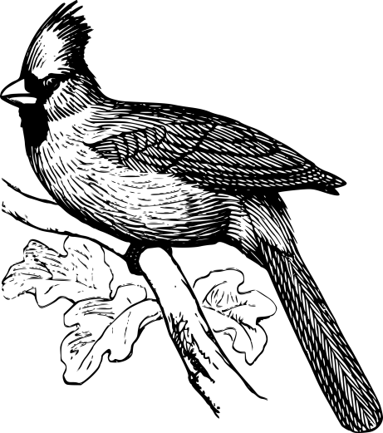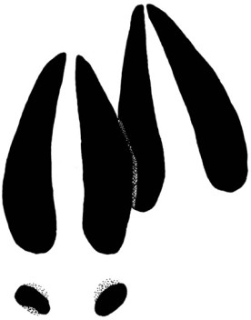

Cardinal

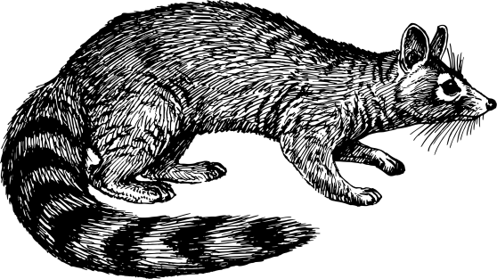

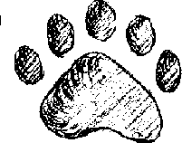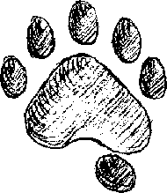

Ringtail

Did You Know: In 1986, the Ringtail became the state mammal of Arizona. They are nocturnal, so you are unlikely to see them during your visit to the park. But you can often find their scat on the trail and sometimes, their tracks as well.

# Bowie Bingo



**B** is for Bowie! Lets explore Fort Bowie and the letter B. Walk in and

around the visitor center and look for the different objects, plants, and animals that start with the letter B. When you find the item, draw a picture of it. Try to get 4 in row for Bingo or challenge your- self to fill in all of the boxes.

|  |  |  |  |
| --- | --- | --- | --- |
| Bell | Bird | Burro Shoe | Bullet |
| Black Bear | Bayonet | Bugle | Beads |
| Basket | Button | Bonnet | Buckskin Pouch |
| Bottle | Butcher Knife | Bobcat | Buckle |

Did You Know: The name Bowie is pronounced “Boo-eee” (not “Bow-eee” like the singer). The fort was named for Colonel George Washington Bowie. General Bowie shared a name with the famous American General who served as the first president of the United States.

# Mirror Messages

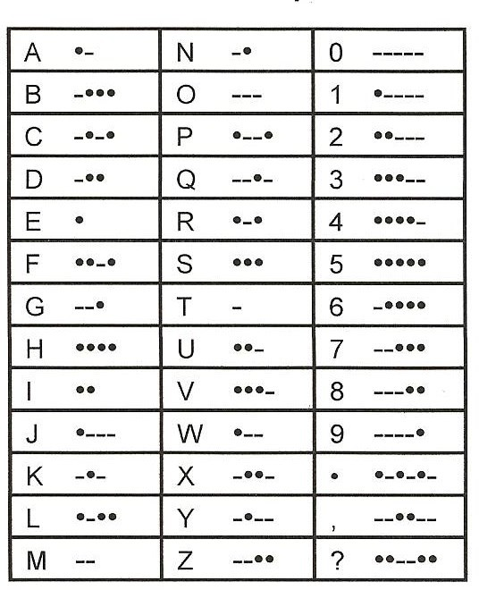

In the 1800’s information was usually communicated by letter or telegraph. But forts, like Fort Bowie, could also send messages by heliograph. A heliograph is a tool that creates flashes of light by reflecting sunlight. Using a Morse Code alphabet, soldiers at Fort Bowie could send messages to other nearby forts. A long flash of light represented a dash (-) in the Morse Code alphabet while a

short flash of light represented a dot (•). Can you help me figure out the messages below?

## Use the Morse Code alphabet to discover the message below.

••-•/---/•-•/- -•••/---/•--/••/•

## Now translate the following message into Morse Code.

A P A C H E P A S S

/ / / / /

/ / /

What do you have to say? Create a Morse Code message in the space below.

**Did You Know**: Fort Bowie had a heliograph located on Bowie Peak, just south of the fort.

This heliograph could communicate with Fort Huachuca, 90 miles away!

# Digging in the Past

The word **archaeology** describes the science of how we learn about the past. Archaeologists study the things people have left behind to learn about human history and activity. Archaeology is a bit like

solving a mystery.

Test your skills as an archaeologist. Look at the artifacts below to see what you can learn about the fort. Circle the answer you think best tells the story about what happened in each place.

## You find the following artifacts:

* The barrel of a rifle
* Bullets
* A round cannon shell

## You find the following artifacts:

* A stone axe
* Beads
* A stone arrowhead

## You find the following artifacts:

* Marbles
* A mule shoe
* False teeth
* A medicine bottle

## What do you think happened?

1. Someone lost a rifle and bullets
2. Soldiers fought here
3. This area was a gun range

## What do you think happened?

1. Soldiers camped here
2. Emigrants traded with Apaches
3. Pre-historic Native Americans

## What do you think happened?

1. Men, women, and children lived, worked, and played here
2. This was once the site of a store
3. Someone lost their luggage

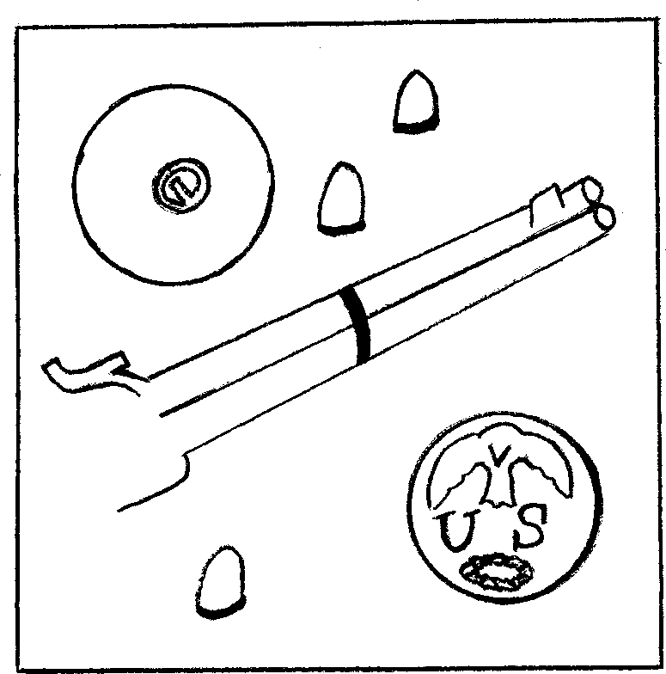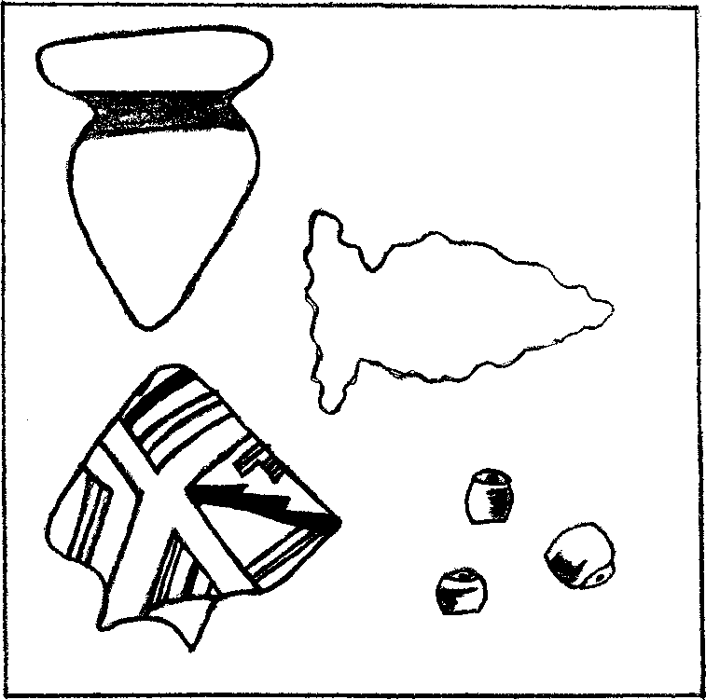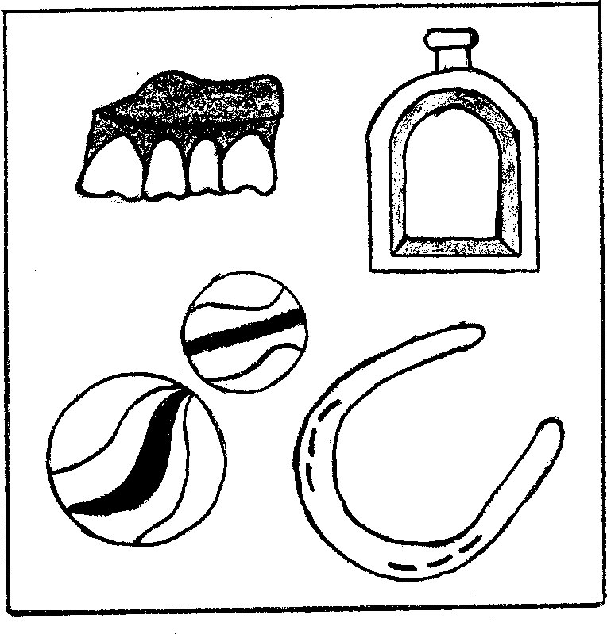

**Did You Know:** Captain Roberts claimed that packrats carried away his false teeth while he was stationed at Fort Bowie. His teeth were found over100 years later in the fort ruins. The teeth are archeological evidence that supports an historical story.

# Living Off the Land



Historically, the Native American inhabitants of the Apache Pass area were hunters and gatherers. The **Chiricahua Apache** who lived in the Chiricahua Mountains had to rely on what nature provided for them in order to survive.

Using information from signs along the trail, and displays located in the visitor center, name at least three natural materials the Chiricahua Apache used in their daily lives. What were these natural materials used for? Then, at the bottom, match each of the Native American

terms to their correct use or function.

Natural Objects Uses

|  |  |
| --- | --- |
|  |  |
|  |  |
|  |  |

Mano & Metate Wikiup

Burden Basket

Cradleboard

A dome-shaped shelter made from willow branches and beargrass.

A cone shaped basket used for gathering foods such as seeds, nuts, and corn.

A pack used for carrying babies.

Stones used for grinding seeds, nuts, and mesquite beans.

Did You Know: The word Apache is a Zuni term meaning “enemy”. The Apache originally called themselves Nde or Ndee, meaning “the people.”

# Fort Report



Western forts were often located in isolated locations and Commanding Officers relied on letters and reports to communicate with their superiors and officials in Washington DC. Major Eugene Beaumont was the Commanding Officer at Fort Bowie 1884-1888. Can you help him compile a final report before he assumes a new command? Explore the fort ruins to help you complete the report.

Sir:

The following information relates to the conditions of Fort Bowie upon my departure November,1888.

Since the surrender of in 1886, hostilities have ceased in this area. As a result, there has been more time for improvements at Fort Bowie. Construction continues on the Post

. This is a much needed improvement since the old facility was unsafe and unfit for housing the sick. This is a much better use of money than has been previously exercised. I still protest

the $ amount that was spent on an extravagant Commanding Officer residence.

Cavalrymen continue their patrols of the area and are responsible for caring for their , though these patrols are not really necessary since the Chiricahua Apaches have been removed from the area.

Quarters are provided for Cavalry units and Infantry units, though conditions in the infantry barracks are decidedly crowded. and bunk in a main room together,

while the occupy small adjoining rooms. Officers occupy homes on the south side of the parade ground. Though housing is limited and often families are forced to when a higher ranking officer arrives. Much to the dismay of the officer’s wife. The

store carries a selection of canned goods, as well as other types of domestic supplies. And in accordance with new Army policies, a post school is located at the fort. However, at this time, there are no students to attend classes. But the building is also used for and .

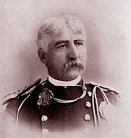

It has been a privilege to serve at Fort Bowie, Major Eugene B. Beaumont, Commanding Officer

United States Army, Arizona Territory

Did You Know: When Major Beaumont arrived at Fort Bowie, construction of a new Commanding

Officers Quarters was underway. After seeing the plans for the Victorian home, he complained that it was “useless ornamentation and an absurd plan.”

CERTIFICATE



Junior Ranger Pledge:

As a Junior Ranger, I pledge to explore our National Parks, protect these important places, and help preserve our parks for future

generations.

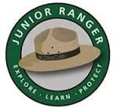

**Congratulations!**

This certifies that

has achieved the rank of a Junior Ranger at Fort Bowie National Historic Site.

Ranger/Date