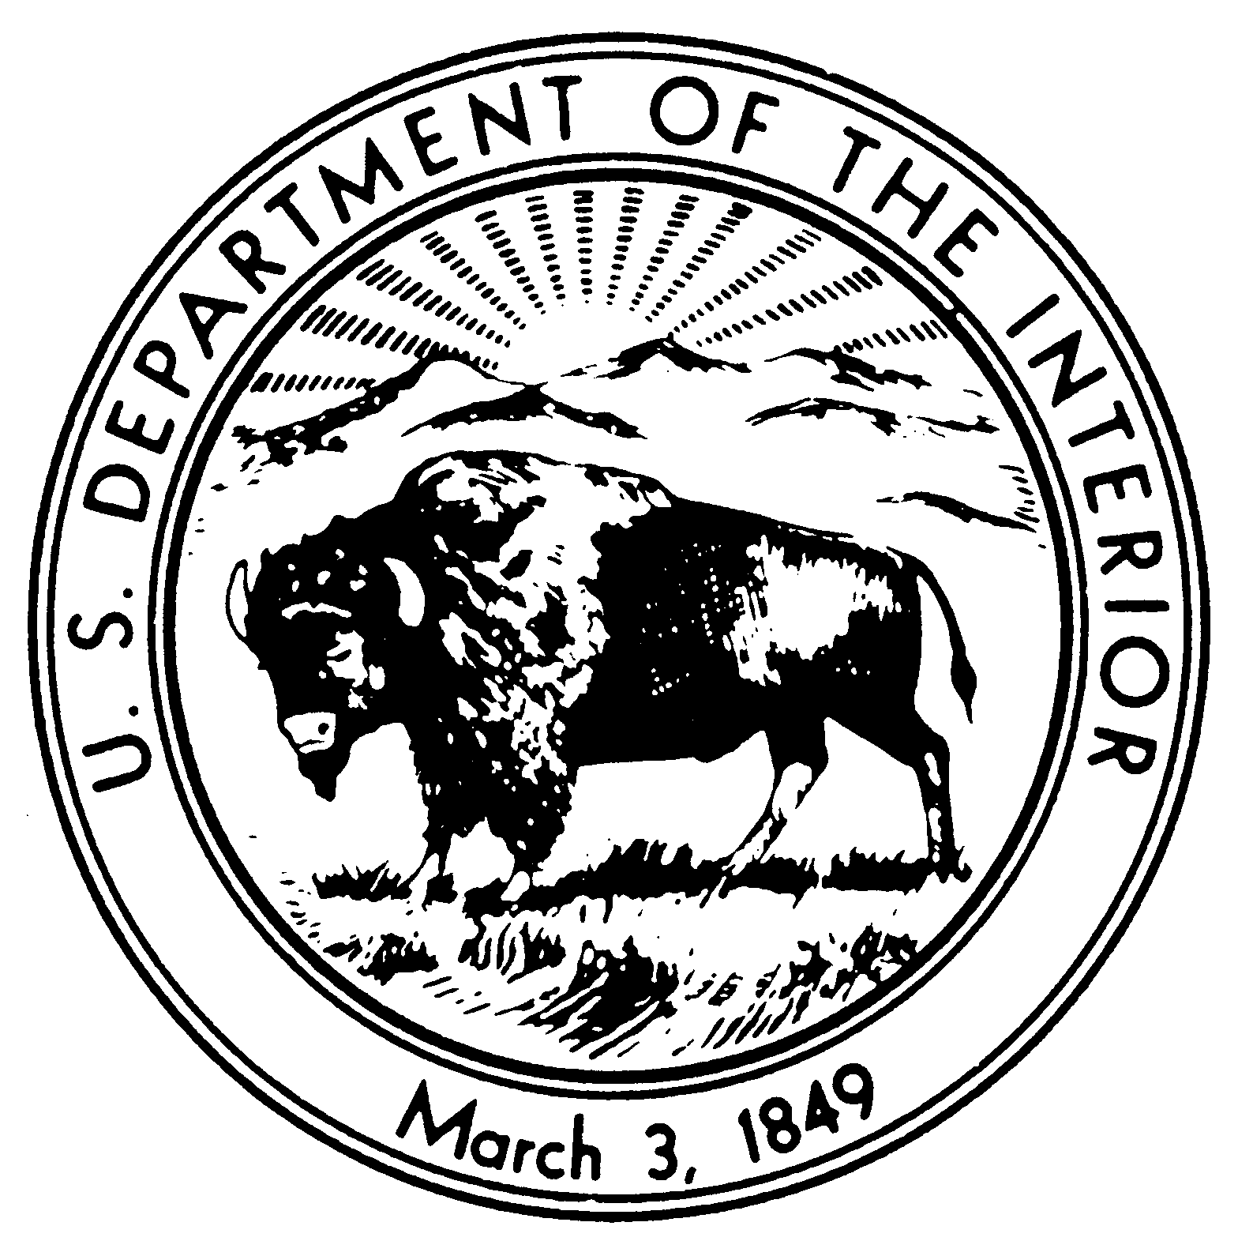
United States Department of the Interior

NATIONAL PARK SERVICE
Eugene O’Neill National Historic Site
P.O. Box 280
Danville, CA 94526

IN REPLY REFER TO:
10D (EUON-VRP)

Closure Order #20-002

9/17/2020

Closures, restrictions and public use limits:

Closure Order – Portion of a Park Area: Under the authority provided to the Superintendent in 36 CFR 1.5, the follow park areas and facilities are closed, effective on September 30, until further notice:
- Shuttle service to the site
- Tours of the house and grounds
- Tao House, including the visitor center
Authority: 36 CFR 1.5(a)(1)
Notice: This administrative order applies to all individuals subject to the regulatory authority of the National Park Service (NPS) within the boundaries of EUON including park visitors, government employees, concession employees, park residents and stakeholders, except as follows: employees working in their designated government workspace on assigned activities may access facilities at the site. Employees working in Tao House in accordance with established social distancing protocols may access these facilities to ensure they are maintained and secure. Care of museum collections in Tao House may also continue.

Finding: The NPS issues this administrative order for the purposes of maintaining public health and safety during the COVID-19 pandemic emergency. This order is consistent with the following Contra Costa County public health directives:

- All individuals currently living within Contra Costa County (the “County”) are ordered to shelter at their place of residence. To the extent individuals are using shared or outdoor spaces, they must at all times as reasonably possible maintain social distancing of at least six feet from any other person when they are outside their residence. All persons may leave their residences only for Essential Activities, Essential Governmental Functions, or to operate Essential Businesses, all as defined in Section 10.
- All public and private gatherings of any number of people occurring outside a household or living unit are prohibited, except for the limited purposes as expressly permitted in Section 10.

These directives require the NPS to take the actions identified above because:

- Public health directives require social distancing to slow the spread of COVID-19. Allowing visitors on the shuttle to the site and tours of the house would violate the requirement that persons stay at least 6 feet from each other.
- Public health directors prohibit gatherings of any number of people who are not living together. Allowing individuals to participate in tours and at events within the park increases the risk of disease introduction and spread, putting employees and visitors at undue risk.
This order is effective immediately and will remain in effect until further notice. The effectiveness of this order will be assessed on an ongoing basis, and the order will be modified or rescinded when conditions warrant.

Approval: ______________________________ _____________
Superintendent Date

