National Park Service  U.S. Department of the Interior | Thomas Edison  National Historical Park |  | 211 Main Street  West Orange, NJ 07052  973 736-0550 phone  973 736-6567 fax
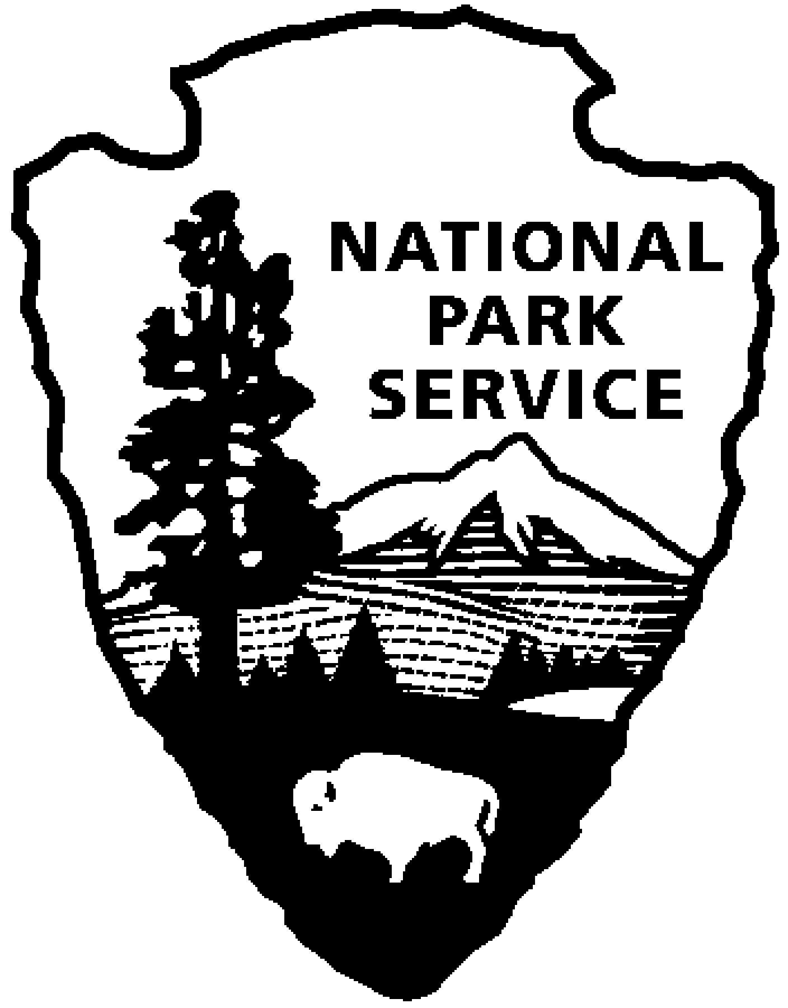
Thomas Edison NHP News Release
For Release: March 16, 2012
Contact: Beth Miller
Phone: 973 324-9974 x2

Mina Edison honored as part of New Jersey Women’s Heritage Trail
West Orange, N.J. – A Women’s Heritage Trail marker that honors Mina Edison’s contribution to the local community was today erected at Thomas Edison National Historical Park. The trail marker is located at Mina and Thomas Edison’s home, Glenmont.
Mina is recognized for her “exemplary commitment to her community, which made significant contributions to the health and recreation of New Jersey residents”. Mina’s passion for gardening led her to support organizations that developed children’s gardens in underprivileged neighborhoods, and delivered flowers to people who were unable to leave their homes due to illness or disability. Additionally, her work with Eleanor Roosevelt and the National Recreation Association furthered her involvement in public recreation and beautification.

“Mina’s role in supporting her husband is widely known but what is often overlooked is that she was a remarkable woman in her own right”, commented Jill A. Hawk, superintendent of Thomas Edison National Historical Park, “Mina was very active in charity work within her community and it is fitting that this work has been recognized through her inclusion in the Women’s Heritage Trail”.

Glenmont, a 29-room Queen Anne style house, became the domain of Mina Miller Edison, Thomas Edison’s second wife, when they married in 1886. Mina preferred the title of “home executive” and she ran Glenmont efficiently like a small business. All aspects of care and maintenance of Glenmont were her responsibility and she hosted many visiting dignitaries, including Henry Ford, the King of Siam, Orville Wright and Helen Keller at the house.

The Women’s Heritage Trail includes parks, historic houses, factories and educational institutions where women played a pivotal role. Nearly 100 sites have been designated in the project which resulted from the first comprehensive statewide survey in the nation of historic sites related to the significant contributions females made to the history of the state. The New Jersey Women’s Heritage Trail is funded through a grant from the NJ Historic Trust and administered through the Historic Preservation Office of the state Department of Environmental Protection. A downloadable guide describing all the sites on the trail is available at: www.nj.gov/dep/hpo/WHTrail_Book.pdf

Thomas Edison National Historical Park is a National Park Service site dedicated to promoting an international understanding and appreciation of the life and extraordinary achievements of Thomas Alva Edison by preserving, protecting, and interpreting the Park’s extensive historic artifact and archive collections at the Edison Laboratory Complex and Glenmont, the Edison family estate. The entrance fee is $7.00. Children under age 16 are free. The Visitor Center is located at 211 Main Street in West Orange, New Jersey. For more information or directions call 973-736-0550 ext. 11 or visit: www.nps.gov/edis
- NPS -

