National Park Service  U.S. Department of the Interior | Thomas Edison  National Historical Park |  | 211 Main Street  West Orange, NJ 07052  973 736-0550 phone  973 736-6567 fax
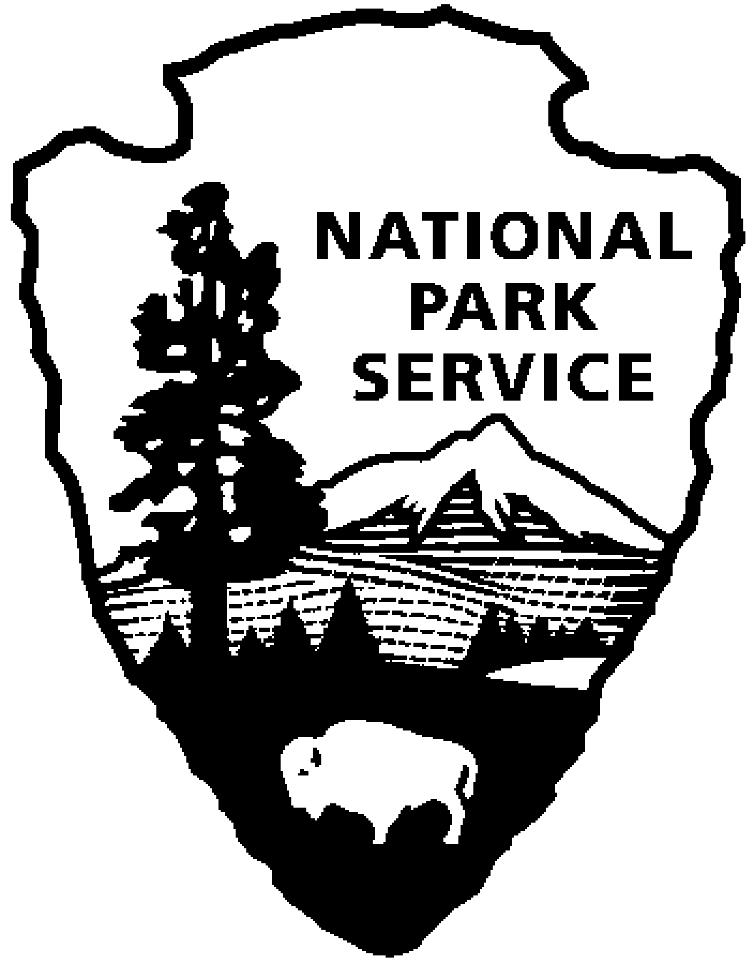
Thomas Edison NHP News Release
For Release: March 17, 2010
Contact: Jerry Fabris
Phone: 973 736-0550 x48

HISTORIAN TIM BROOKS PRESENTATION AND BOOK SIGNING
On The First African-American Recording Artists

WEST ORANGE, NJ - On Sunday, April 18, 2010, at 2:00 pm, Thomas Edison National Historical Park welcomes award-winning historian Tim Brooks who will give a 50-minute illustrated presentation on the very earliest African-American recording artists. The program will be held at the Laboratory Complex on Main Street. Admission to the park is $7, children under 16 are free. There is no additional fee for the program. Seating is limited and reservations are required. Reservations can be made by calling 973-736-0550 ext.89.
Among the audio pioneers who committed their voices and music to cylinders and discs in the years prior to and during World War I were Broadway star Bert Williams, "St. Louis Blues" composer W.C. Handy, jazz pioneers James Reese Europe and Wilbur Sweatman, the Fisk Jubilee Singers, Noble Sissle and Eubie Blake, concert artists Roland Hayes and Harry T. Burleigh, Paul Laurence Dunbar interpreter Edward Sterling Wright, boxing champ Jack Johnson and many others. Rarely heard recordings dating from the 1890s to 1919 are heard, providing a tapestry of evolving black culture during one of the most racially tumultuous periods in American history. Despite towering racial barriers and rampant discrimination, these pioneers from many fields of black music and art made themselves heard and profoundly changed the course of American culture in the years to come.

Tim Brooks is a former television executive and a researcher of early recording artists and phonograph history. After the program, Brooks will sign copies of both his ground-breaking book "Lost Sounds: Blacks and the Birth of the Recording Industry, 1890-1919," and the companion audio compact disc “Lost Sounds,” which won the 2007 Grammy award for “Best Historical Release.”

The Laboratory Complex is open Wednesday through Sunday from 9:00am to 5:00pm. Glenmont, Edison’s home, is open Friday through Sunday from 11:30am to 5:00pm. Tickets for Glenmont must first be obtained at the Laboratory Complex visitor center before going to Glenmont. For more information or directions please call 973-736-0550 ext. 11 or visit our website at www.nps.gov/edis.

-NPS-

