National Park Service  U.S. Department of the Interior | Thomas Edison  National Historical Park |  | 211 Main Street  West Orange, NJ 07052  973 736-0550 phone  973 736-6567 fax
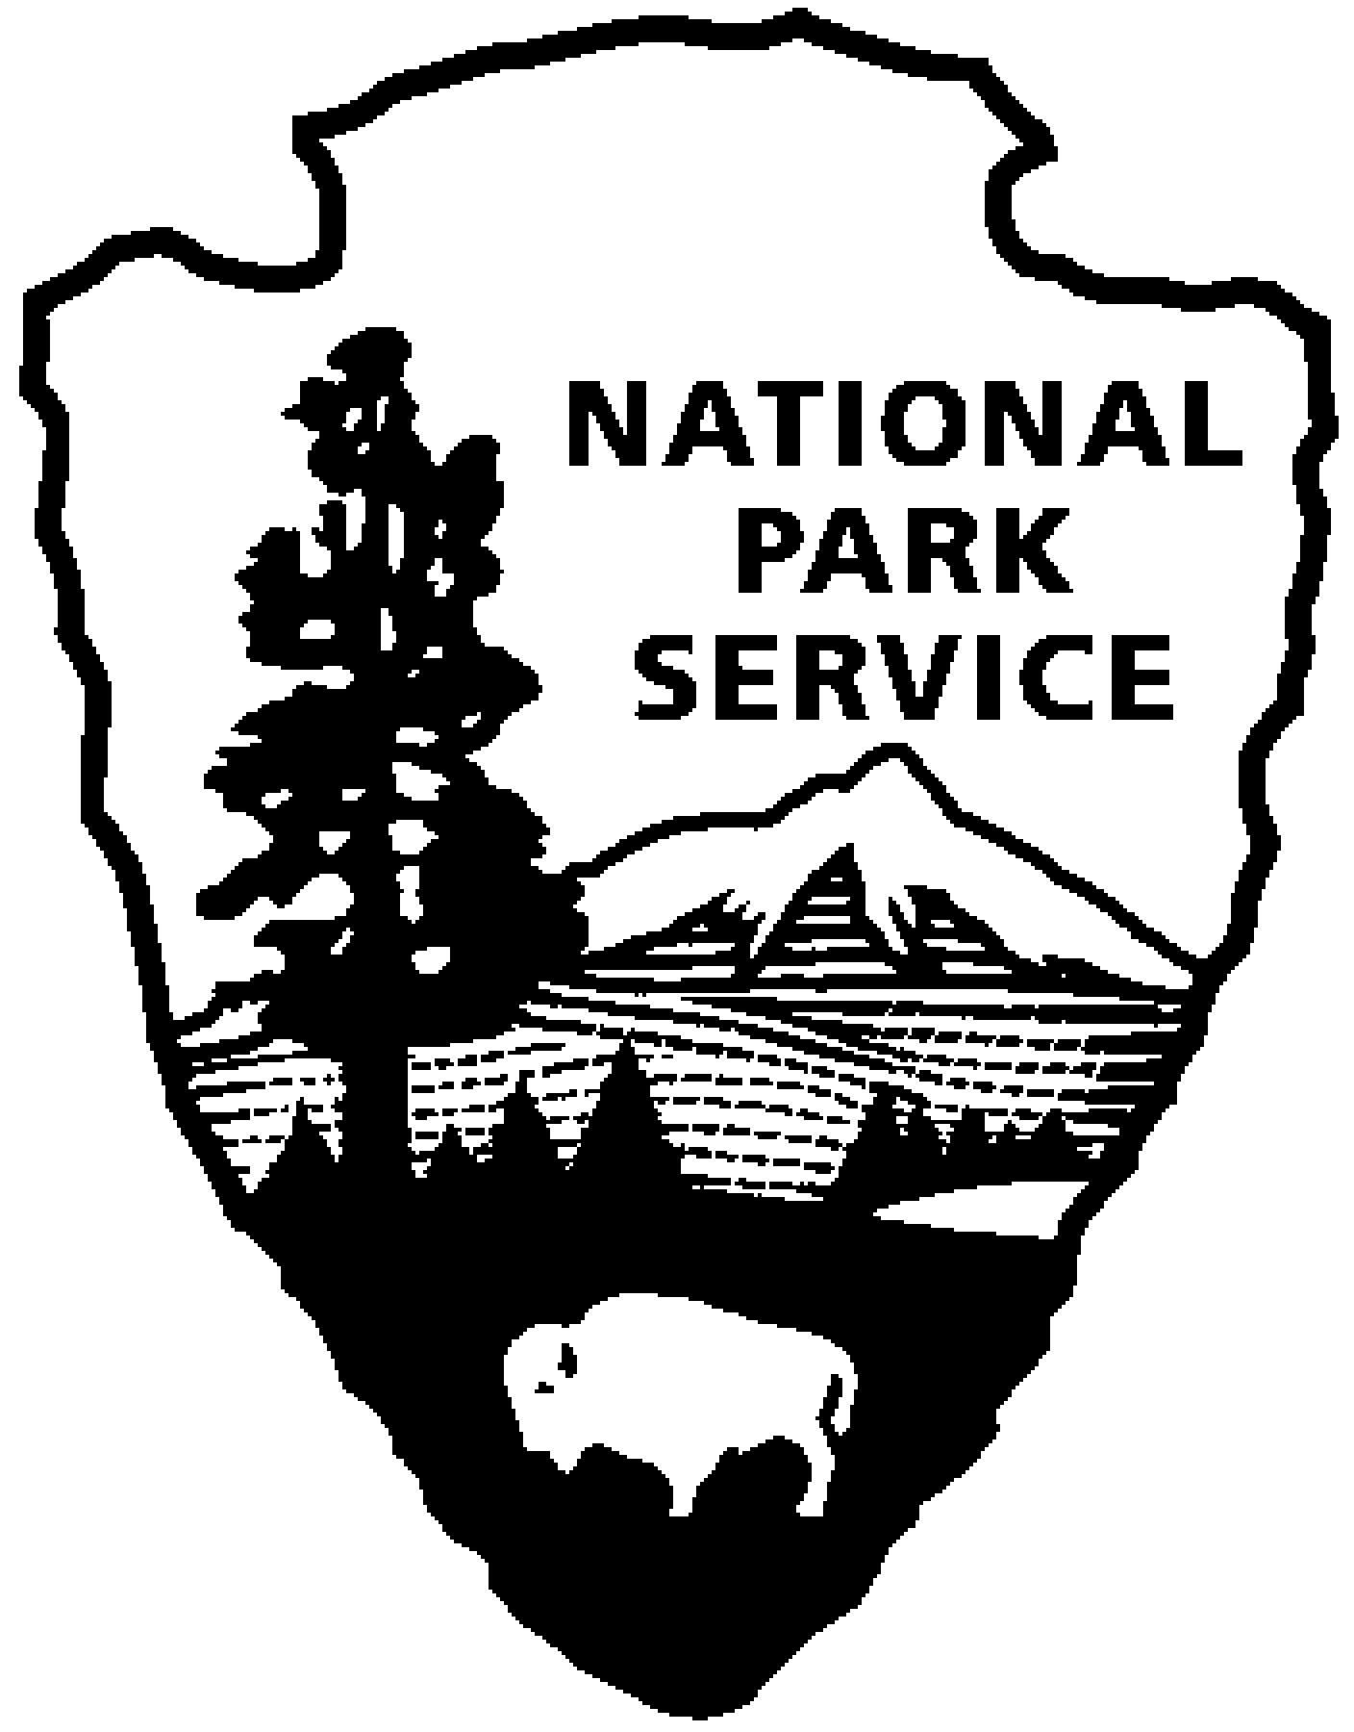
Thomas Edison NHP News Release
For Immediate Release
Contact: Theresa Jung
Phone: 973 736-0550 x50

YEAR OF INNOVATION SERIES:
February 2014 – Thomas Edison: From Menlo Park to West Orange

WEST ORANGE, NJ – The 1880s were years of transition for Thomas Edison - the death of his first wife Mary, the purchase of his Fort Myers, Florida winter home, his marriage to Mina Miller and his move to West Orange. Explore these events, Edison’s relationship with his family and the construction of the West Orange Laboratory during the month of February at Thomas Edison National Historical Park. The programs are free and will be held at the Thomas Edison National Historical Park (NHP) Laboratory Complex at 211 Main Street in West Orange unless otherwise noted.

1st Friday – February 7th at 2:30 p.m.
An Update from Dr. Paul Israel, Director of the Thomas Edison Papers
Dr. Paul Israel, director and general editor of the Thomas A. Edison Papers at Rutgers University will provide an update on the project, which is publishing online and in its book edition the most significant materials in the archive at Thomas Edison National Historical Park as well as providing access to important documents from other repositories. He will focus much of his talk on the what has been learned about the period between Edison's major work at the Menlo Park Laboratory and the opening of the West Orange Laboratory, with special attention to the period 1885-1887 covered by Volume 8, New Beginnings, which will be submitted for publication this spring. Especially significant is new insight into Edison's relationships with his first wife Mary, who died in 1884, and his second wife, Mina, whom he married in 1886. The period 1885 is also when Edison moved his family to Glenmont, built his winter home in Fort Myers, and built the West Orange Laboratory. The Edison Papers staff has gained new insight into Edison's personal life as gleaned from the personal diary he kept in the summer of 1885 while courting Mina, correspondence from Mina's family, and the surprising role Mina plays in the notebooks.

2nd Saturday - February 8th at 10:00 a.m. (especially for children)
Downton Abbey Comes to Glenmont
Join rangers for a Downton Abbey themed children’s tour of the Edison family home. Learn more about the lifestyles of the Edwardian era and the Edison family. Hear stories about life as a servant as we tour the servants’ wing of the estate. See what it was like to grow up at Glenmont as we tour the rooms where the Edison children took their dance and music lessons. The house tour will be followed by paper doll crafts and history trivia games. This program is designed for children ages 7 through 10, but all are welcome and must be accompanied by a parent. Reservations are required and space is limited.

3rd Thursday – February 20th at 7:00 p.m. at the West Orange Public Library
Edison and the Rise of Innovation, talk and book signing
Join NPS Archivist and author Leonard DeGraaf as he talks about his new book. Edison and the Rise of Innovation chronicles Edison’s life and work, making lively and lavish use of rarely-seen historic photographs, lab notebooks and advertising material. Before joining the National Park Service in 1991, DeGraaf was on the staff of the Thomas A. Edison Papers at Rutgers University. He is the author of Historic Photos of Thomas Edison (Turner Publishing, 2008), and his articles have appeared in Business History Review and other publications. He received an MA in history from Rutgers University. Books will be available for purchase and signing.

Special programs in February:

Sunday, February 9th
Tour of the Edison Center at Menlo Park at 10:00 a.m.
- Join us for a private tour of the museum where we will explore Thomas Edison's time of immense creativity at Menlo Park, leading up to the opening of the West Orange Laboratory.
- In addition to touring the museum, you will be able to view the 1937 Art Deco Edison Memorial Tower (which is currently being restored), see the foundations of Edison's office and library building, see the Menlo Park Tablet and Memorial and explore the 36-acre Edison State Park, including a nature trail adjacent to the museum.
- At 11:00 a.m., join the mayor and local dignitaries for an unveiling and re-dedication of the Centennial plaque. The original Centennial plaque was dedicated to honor the 100th anniversary of Edison’s birthday, on February 11, 1947. Every year the first volunteer Edison Fire Department No. 1, of then-Raritan Township, would lay a wreath at the site in honor of Thomas Edison. The plaque was stolen in 2008 and a replacement has finally been completed.
- We will meet at the Edison Center at 37 Christie Street in Edison, NJ at 9:45 a.m. There is a suggested donation of $5.00 to the Edison Center.
- Reservations are required for this event. Please call Karen Sloat-Olsen at 973-736-0550 extension 17 by Friday, February 7th for more information or to confirm your reservation.

Sunday, February 9th at 2:00 p.m.
Black Maria Film and Video Festival at AMC Dine-In Theatre, Essex Green Shopping Center, Prospect Avenue, West Orange
Join the West Orange Film Society and the Friends of Thomas Edison National Historical Park for the annual Edison Birthday showing of the Black Maria Film and Video Festival. The program will feature a mix of captivating independent films by NY/NJ filmmakers curated by Jane Steuerwald, new executive director of the Thomas A. Edison Media Arts Consortium and Black Maria Film and Video Festival. Tickets are $10.00 ($7.50 for members of the W.O. Arts Council only if purchased at the box office.) For more information visit www.wofilmsociety.org or www.blackmariafilmfestival.org

These programs are part of THE YEAR OF INNOVATION celebrating the New Jersey 350th Anniversary in 2014. Since 1664 New Jersey has provided a welcome home for inventors and entrepreneurs like Thomas Edison and there is no better place to learn about the history of innovation than Thomas Edison National Historical Park in West Orange. Special programs each month will explore the themes in EDISON AND THE RISE OF INNOVATION a recent book written by National Park Service archivist Leonard DeGraaf and published by Sterling Signature in October 2013. Another famous innovator – Bill Gates – has written the foreword to this fresh look at Thomas Edison. New programs for all ages will be offered monthly. For more information and updates about THE YEAR OF INNOVATION - First Friday, Second Saturday and Third Thursday events, please visit www.nps.gov/edis monthly. Follow us on Twitter and Facebook.
-NPS-

