National Park Service  U.S. Department of the Interior | Thomas Edison  National Historical Park |  | 211 Main Street  West Orange, NJ 07052  973 736-0550 phone  973 736-6567 fax
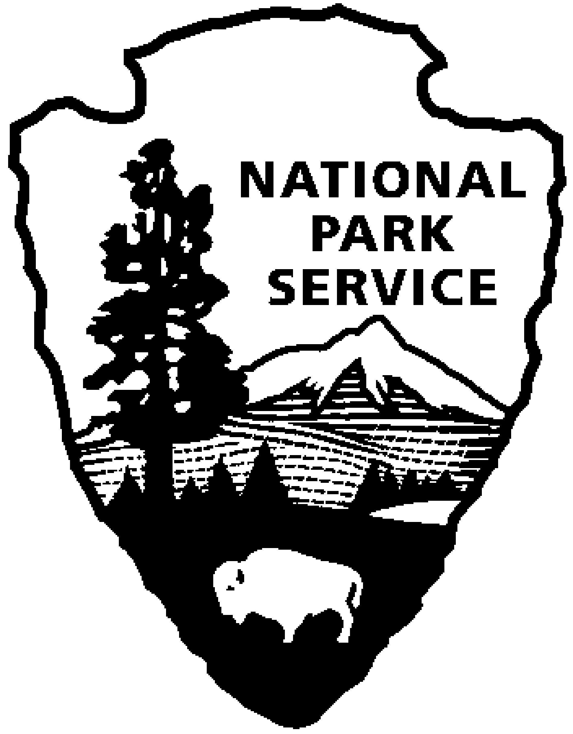
Thomas Edison NHP News Release
For Immediate Release
Contact: Theresa Jung
Phone: 973 736-0550 x50
EDISON FAMILY AND FRIENDS
December 2014

WEST ORANGE, NJ – The Year of Innovation ends with a look at Thomas Edison’s family and friends. Explore these ideas, attend a program, and see a special exhibit of original artifacts, documents and historic photos during the month of December at Thomas Edison National Historical Park (NHP). The programs are free with admission and will be held at the Laboratory Complex at 211 Main Street unless noted.
1st Friday – December 5th at 2:30 p.m.
The Edisons of Fort Myers
Tom Smoot, Trustee, Charles Edison Fund
See this wonderful personal collection of images of Thomas and Mina Edison, their children and grandchildren along with family friends Henry Ford, Harvey Firestone and John Burroughs.
Tom Smoot is a lifelong resident of Ft. Myers Florida. For eighteen years he was the chairman of the Edison Winter Home Board and one of the founders of the Edison Ford Winter Estates Foundation. He is also the Florida trustee of the Charles Edison Fund of Newark, New Jersey. He is the author of The Edisons of Fort Myers, Discoveries of the Heart, 2004.

2nd Saturday – December 13th at 10:00 a.m. (especially for families)
Mrs. Edison’s Scrapbooks
Mina Miller Edison had three children, three step children and a very famous husband. How do we know about the family? One way is through her scrapbooks. Join a ranger for a special walk through the laboratory while learning about the family. See if you can name all six children. Have fun making a scrapbook page of your visit to the park. Reservations are required for this program. Please call 973-736-0550 extension 89.

3rd Thursday – December 18th at 2:30 p.m.
Mina Edison's Cooking Culture at Glenmont
What is your cooking culture? What are your family's favorite foods, when are they served, and what do they say about your values? Join us as we explore Mina Edison's cooking culture while she juggled a household "to do" list that included everything from intimate family dinners to formal parties on the lawn. Historic recipes will be available as a take away for you to try at home. Reservations and special car passes are required for this program. Please call 973-736-0550 extension 89.

Special programs in December:

Fridays, Saturdays and Sundays, November 28th through January 4th
HOLIDAYS AT GLENMONT
The sights and sounds of the season will greet you when you come on a tour of Thomas Edison’s home during “Holidays at Glenmont,” starting on November 28, 2014 and continuing through January 4, 2015. Glenmont will be decorated much as it was while the Edison family lived there. Favorite musical pieces will be playing and greenery and red poinsettias will deck the mantles above the fireplaces. Staircases will be ringed with boughs and red ribbon bows and wreaths will hang in every window. A majestic 10 foot tree will be lit and the presents underneath will be waiting as if the Edison children Madeleine, Theodore and Charles, will soon come running down the stairs from their rooms - after they’ve checked their stockings in the upstairs Living Room!

Harry’s Magic Invention Bag
Sunday December 14 and 28, 1:00 p.m. – 4:00 p.m.
Learn about invention and the important role Edison played in taking invention from a cottage/hobby activity to a full commercial activity- practiced by all major corporations. Hear Harry Roman as he discusses the major role NJ plays in the national invention scene-and all the great inventions NJ inventors have brought into our world.
Harry, a nationally known inventor, was a critical player in establishing the NJ Inventors Hall of Fame in 1989, and later went on to chair the organization from 1996-2004. The Hall of Fame honored him with an Inventor of the Year award in 2005 for his pioneering work in robotics, and honored him again in 2012 with a special achievement award for his dedication to the organization.

These programs were part of THE YEAR OF INNOVATION celebrating the New Jersey 350th Anniversary in 2014. Since 1664 New Jersey has provided a welcome home for inventors and entrepreneurs like Thomas Edison and there is no better place to learn about the history of innovation than Thomas Edison National Historical Park in West Orange. Special programs each month explore the themes in EDISON AND THE RISE OF INNOVATION a book written by National Park Service archivist Leonard DeGraaf and published by Sterling Signature in October 2013. Another famous innovator – Bill Gates – has written the foreword to this fresh look at Thomas Edison. For more information and updates about THE YEAR OF INNOVATION - First Friday, Second Saturday and Third Thursday events, please visit www.nps.gov/edis monthly. Follow us on Twitter and Facebook. Visit the website for information about next years programs.

-NPS-

