National Park Service  U.S. Department of the Interior | Thomas Edison  National Historical Park |  | 211 Main Street  West Orange, NJ 07052  973 736-0550 phone  973 736-6567 fax
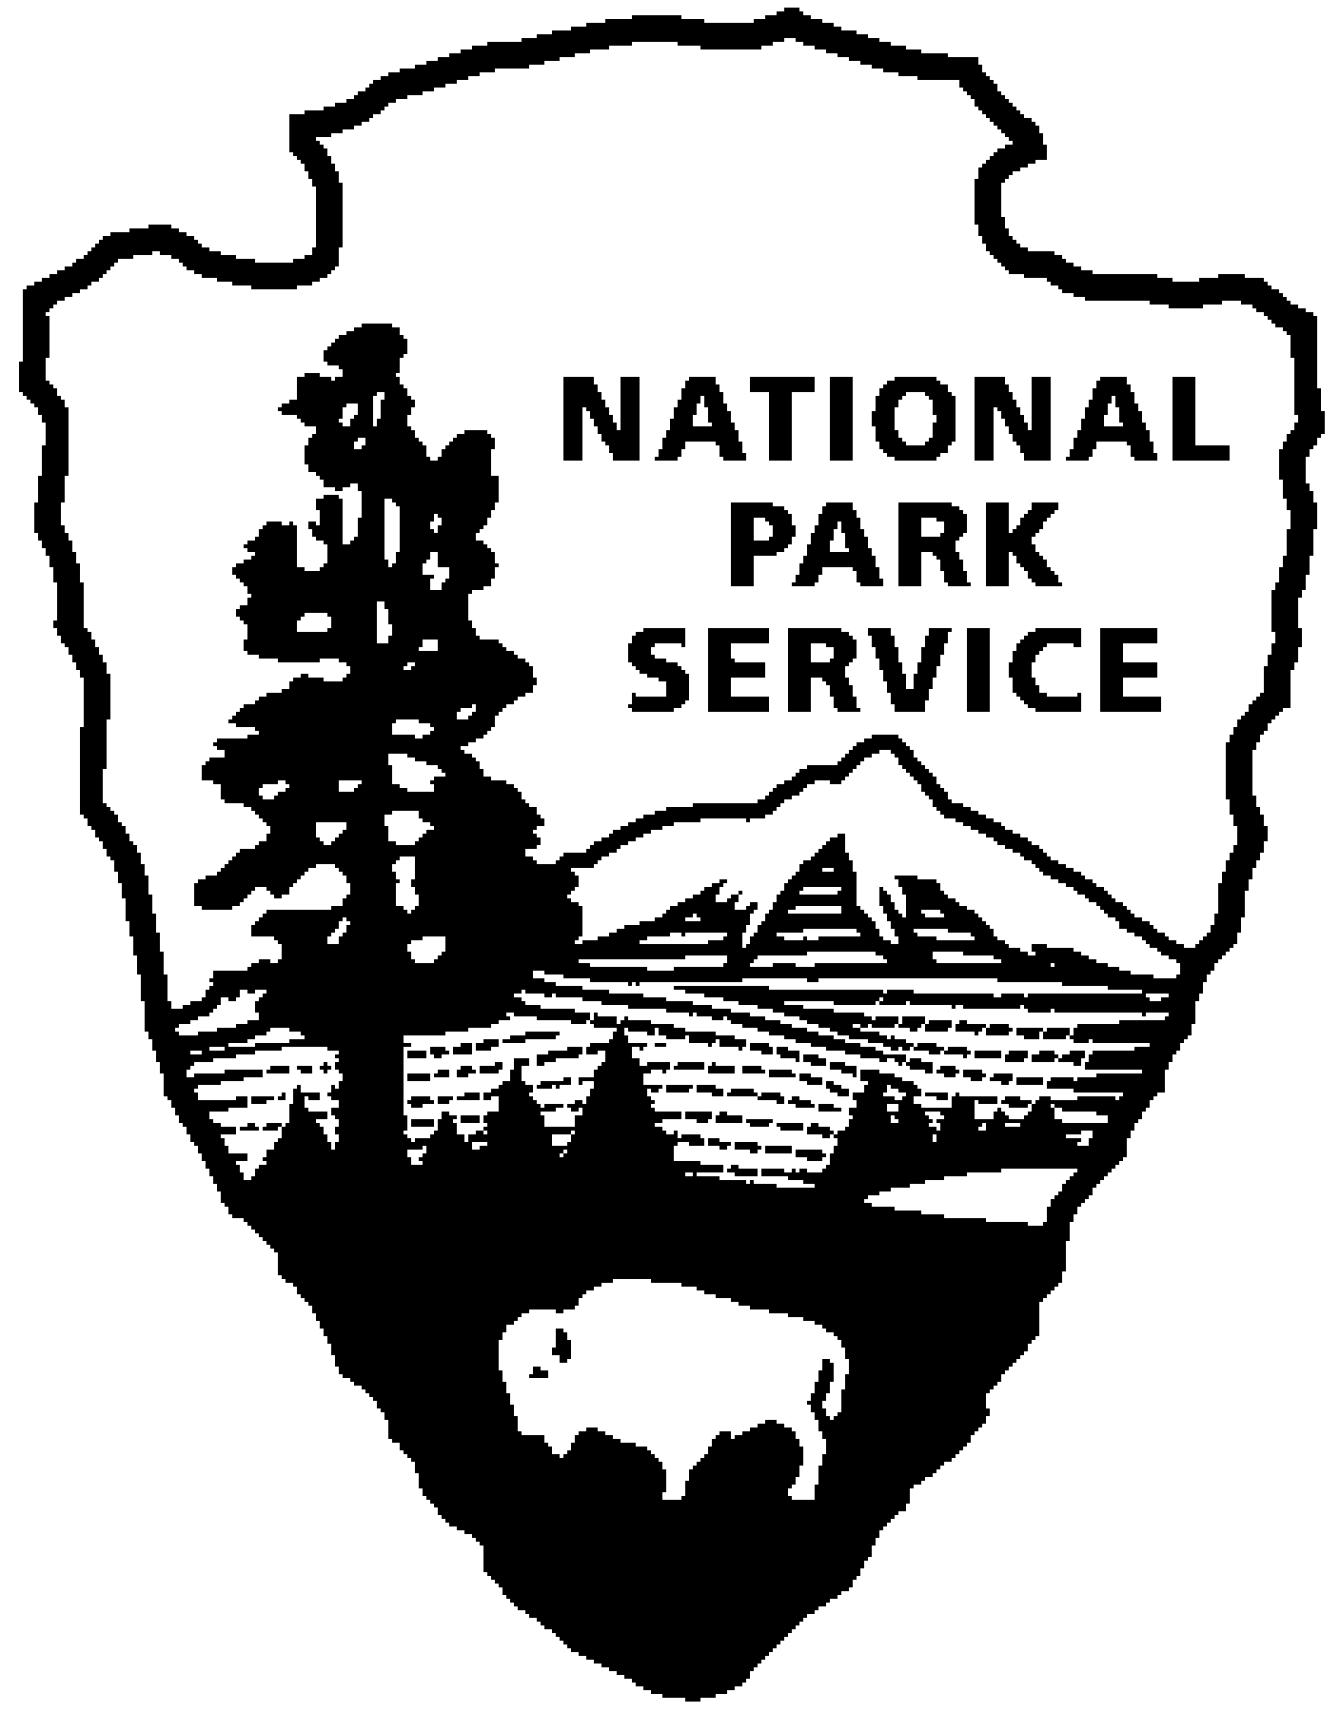

Thomas Edison NHP News Release
For Release: Wednesday July 6, 2011, 2:00pm Eastern Time
Contact: Jerry Fabris
Phone: 973-736-0550 x48

Early Thomas Edison Talking Doll Recording Discovered

WEST ORANGE, NJ – Today the National Park Service (NPS) released online what historians believe is the earliest surviving talking doll recording, available at http://www.nps.gov/edis/photosmultimedia/early-talking-doll-recording-discovered.htm. Phonograph inventor Thomas Edison made the recording during the fall or winter of 1888, capturing the sound of a woman’s voice on a ring-shaped cylinder phonograph record made of solid metal. On May 11, 2011, scientists at the Lawrence Berkeley National Laboratory in Berkeley, California recovered sound from the 123-year-old artifact which has been preserved at Thomas Edison National Historical Park. On the recording, an unidentified woman recites one verse of the nursery rhyme “Twinkle, twinkle, little star”. “This recording has not been heard since Edison’s lifetime. It represents a significant milestone in the early history of recorded sound technology,” says NPS Superintendent Greg Marshall.

NPS museum curators first cataloged the record in 1967, found among items left in the desk of Edison’s secretary. The metal record is significantly bent out of its original round, cylindrical shape. For this reason, curators were unable to play the recording using conventional methods. At the Lawrence Berkeley National Laboratory, Senior Scientist Carl Haber and Computer Systems Engineer Earl Cornell used a three-dimensional optical scanning technology developed during 2007–2009, in collaboration with the Library of Congress, to create a digital model of the surface of the record and reproduce the audio.

The artifact is the only example of a talking doll record from 1888 known to survive today. Edison had begun to make some talking dolls during the fall of 1888 but plans for their sale were put on hold. This model was distinctive for using a record made of solid tin. In November 1888, the New York Evening Sun announced that Edison’s talking dolls had just been “perfected,” and that “nothing remains but to manufacture them in large quantities.” Edison hired women with suitable voices to make as many records as he thought would be needed once his talking dolls were put on the market. According to historian Patrick Feaster, this New York Evening Sun report marks the first time anyone is known to have been employed specifically to perform for the phonograph, so these women were arguably the world’s first professional recording artists. If the goal was to stockpile these tin records “in large quantities” to supply the eventual demand for talking dolls, as the New York Evening Sun suggests, then they may also have been the first phonograph recordings ever manufactured for sale to the public, even though they were never actually sold. By 1890 Edison had switched the design to records made of wax rather than tin. The wax-record dolls failed to sell because they broke too easily – due in large part to the fragility of the records.

-more-

The research and development at Lawrence Berkeley National Laboratory was supported by the federal Institute of Museum and Library Services (IMLS). Lawrence Berkeley National Laboratory addresses the world’s most urgent scientific challenges by advancing sustainable energy, protecting human health, creating new materials, and revealing the origin and fate of the universe. Founded in 1931, Berkeley Lab’s scientific expertise has been recognized with 12 Nobel prizes. The University of California manages Berkeley Lab for the U.S. Department of Energy’s Office of Science. For more, visit www.lbl.gov.

Thomas Edison National Historical Park is a National Park Service site dedicated to promoting an international understanding and appreciation of the life and extraordinary achievements of Thomas Alva Edison by preserving, protecting, and interpreting the Park’s extensive historic artifact and archive collections at the Edison Laboratory Complex and Glenmont, the Edison family estate. The Visitor Center is located at 211 Main Street in West Orange, New Jersey. The Laboratory Complex is open Wednesday through Sunday from 9:00am to 5:00pm. For more information or directions please call 973-736-0550 ext. 11 or visit our website at www.nps.gov/edis .

-NPS-

