National Park Service  U.S. Department of the Interior | Thomas Edison  National Historical Park |  | 211 Main Street  West Orange, NJ 07052  973 736-0550 phone  973 736-6567 fax
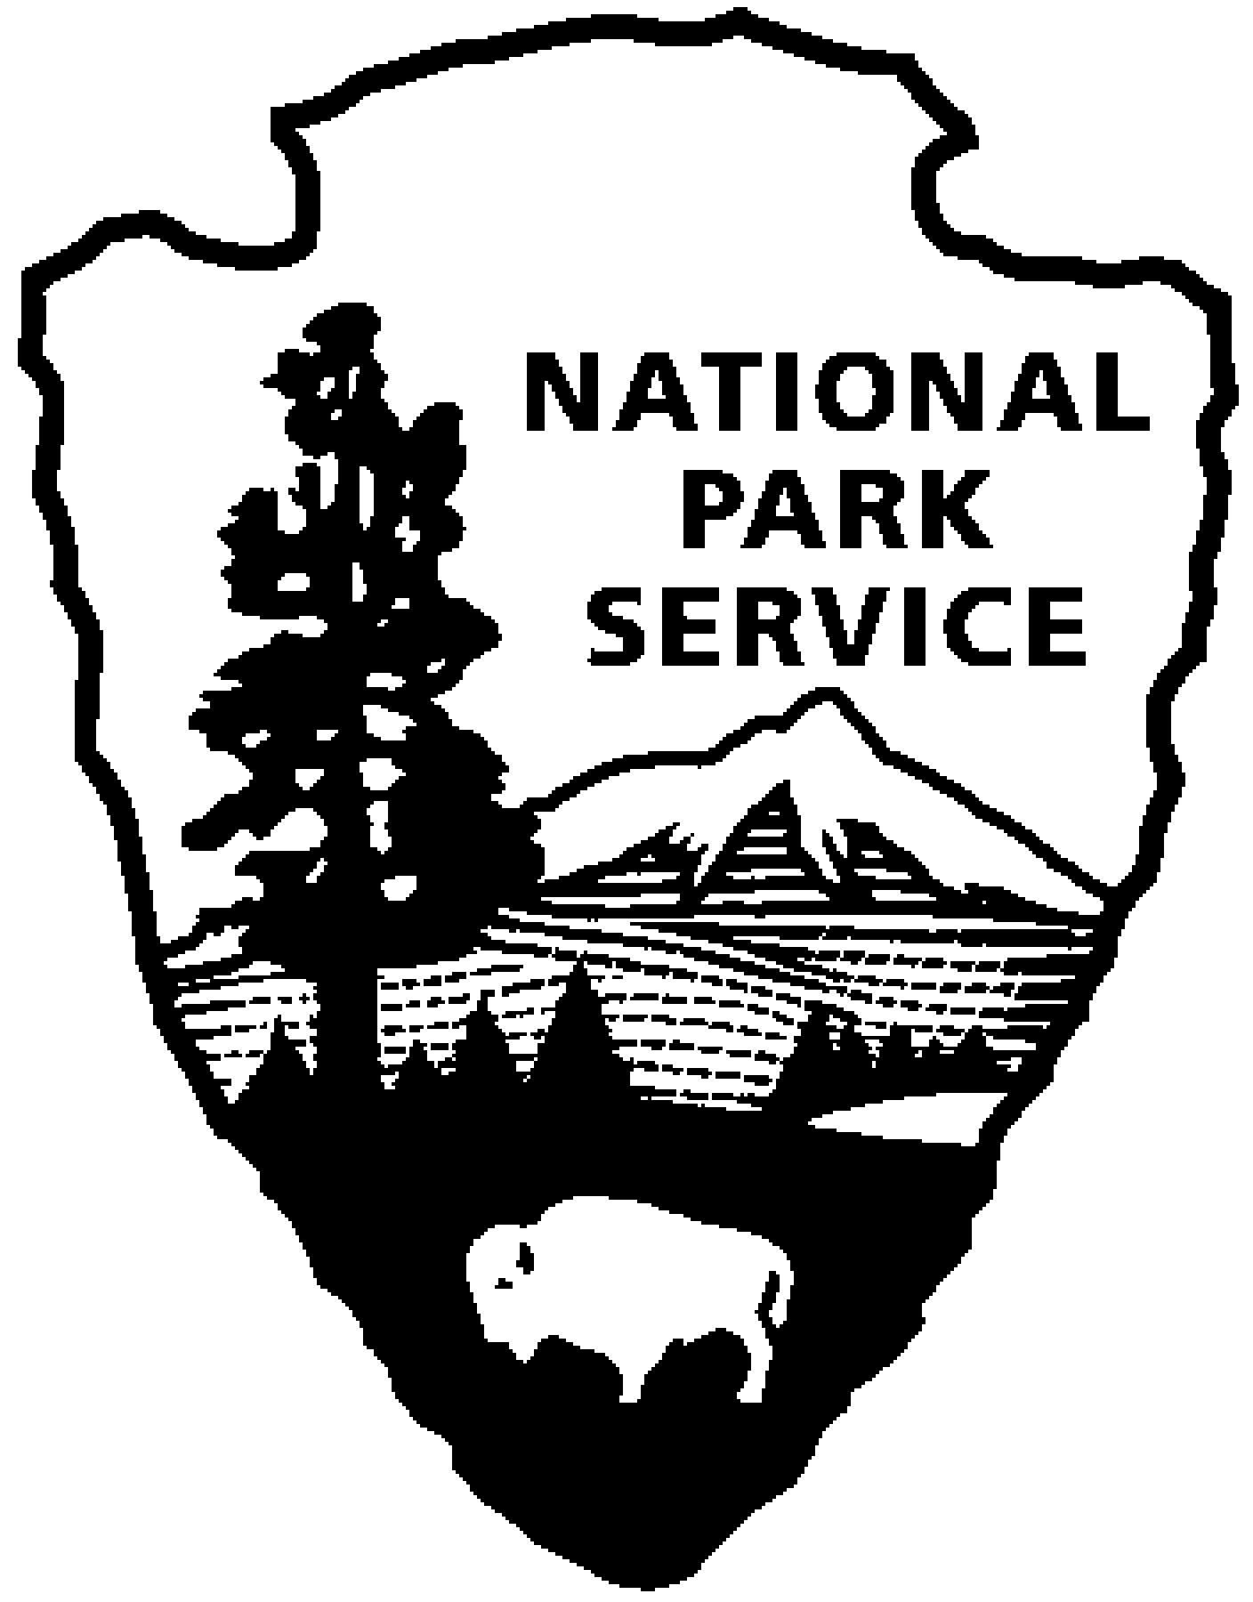
Thomas Edison NHP News Release
For Release: October 2, 2012
Contact: Jerry Fabris
Email: gerald_fabris@nps.gov
Phone: 973 736-0550 x48

In Search of Thomas Edison's Columbia Street Studio

and the 125-foot Recording Horn

West Orange, N.J. – Join Thomas Edison National Historical Park’s audio curator, Jerry Fabris, to revisit one of Edison’s final research projects on the phonograph. This 30-minute illustrated talk and 15-minute walking tour will be presented on Saturday, October 13, 2012 at 2:30 pm at the Laboratory Complex on Main Street. There is no additional fee for this program and reservations are not required.

Until the mid-1920s, sound recordings were made without electricity, using an acoustical horn to gather sound and focus it onto a recorder. A typical recording horn was three or four feet long, with an open end of about six inches diameter. Around 1919, attempting to record a full-size symphony orchestra, Edison began experimenting with very large recording horns. At his recording studio on Columbia Street in West Orange, New Jersey, he constructed the largest-ever recording horn. 125 feet in length and about five feet diameter at the large end, it stretched between two buildings.

This 30-minute presentation will feature historic photographs and oral history recordings about the Columbia Street Studio. Attendees will hear actual sound recording experiments made with the 125 foot horn. Following the presentation, attendees are invited to walk with the curator three blocks down Main Street and Babcock Place to view the former location of the experimental studio and horn.

Thomas Edison National Historical Park is a National Park Service site dedicated to promoting an international understanding and appreciation of the life and extraordinary achievements of Thomas Alva Edison by preserving, protecting, and interpreting the Park’s extensive historic artifact and archive collections at the Edison Laboratory Complex and Glenmont, the Edison family estate. The entrance fee is $7.00. Children under age 16 are free. The Visitor Center is located at 211 Main Street in West Orange, New Jersey. For more information or directions call 973-736-0550 ext. 11 or visit: www.nps.gov/edis
- NPS -

