Junior Ranger
EXPLORE LEARN PROTECT
Thomas Edison National Historical Park
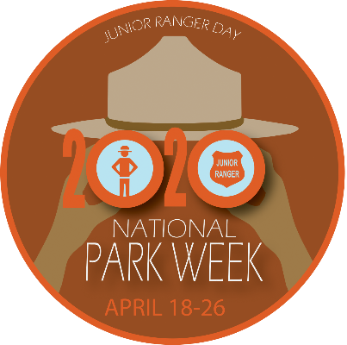
Junior Ranger Pledge:
I promise to learn all that I can about Thomas Edison National Historical Park and to share my knowledge with others. I also promise to enjoy and protect all National Parks
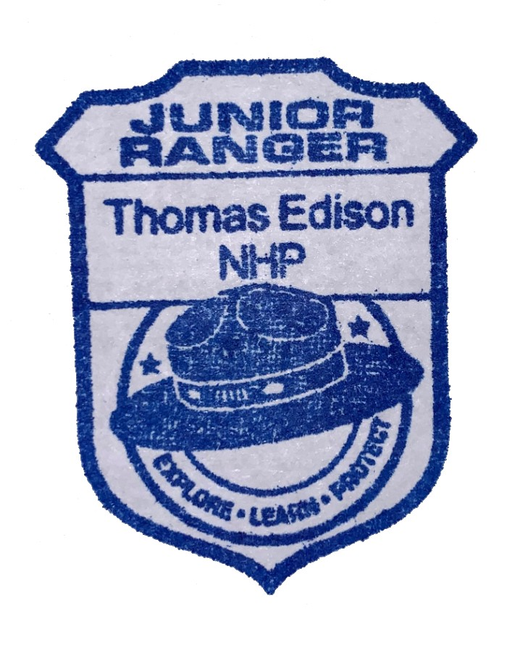

_________________________ _______________
Junior Ranger Name Date

