United States Department of the Interior
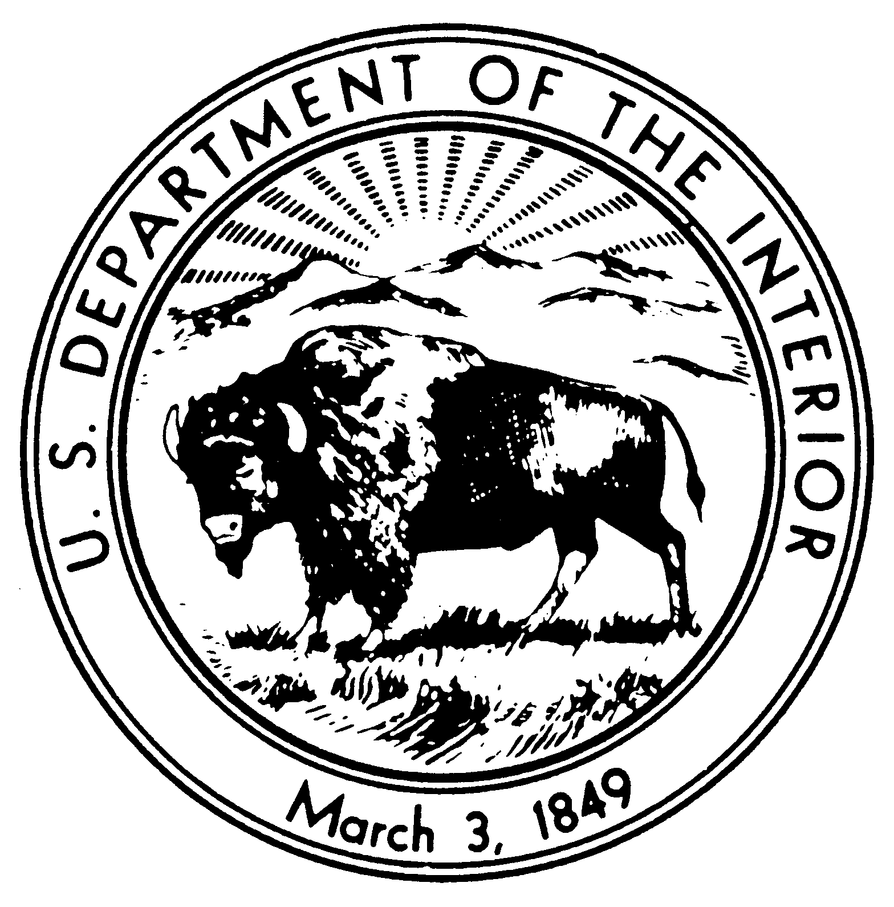
NATIONAL PARK SERVICE
DENVER SERVICE CENTER
12795 W. Alameda Parkway
P.O. Box 25287
Denver, Colorado 80225-0287
IN REPLY REFER TO:
D5217 (DSC-DC)
PARK-PMIS
1443CX_____

Memorandum

To: Superintendent, Park

From: Name, Project Manager, Denver Service Center

Reference: Park, _____ County, State, Contract No. 1443CX_____, Developed Area, Project Title, Package No. PARK-PMIS

Subject: Draft Completion Report

Enclosed is the Draft Completion Report for the above referenced project. Please sign one copy of the letter and return it as an acknowledgement of receipt.

The park is responsible for completing the “Cost From Maintenance Office” section of the report, signing the document, and forwarding the report to the appropriate office.

COR Name
Contracting Officers Representative

Attachments

RECEIVED By: _________________________________________

Title: ________________________________________

Date: ________________________________________

cc:
Reg. Dir., _____ Region
Supt., _____ SO
bcc:
DSC-CS, Contract Files

