Hard Copy Submittal Review Process Guideline with Flowchart
National Park Service (NPS) - Denver Service Center (DSC) | 8-18-17
Use this guideline to ensure a timely review of submittals. A flowchart followed with step-by-step details are provided.
ACRONYMS used in this guideline: A/E: Architect/Engineer, CMR: Construction Management Representative, CO: Contracting Officer (DSC), COR: Contracting Officer Representative (DSC)
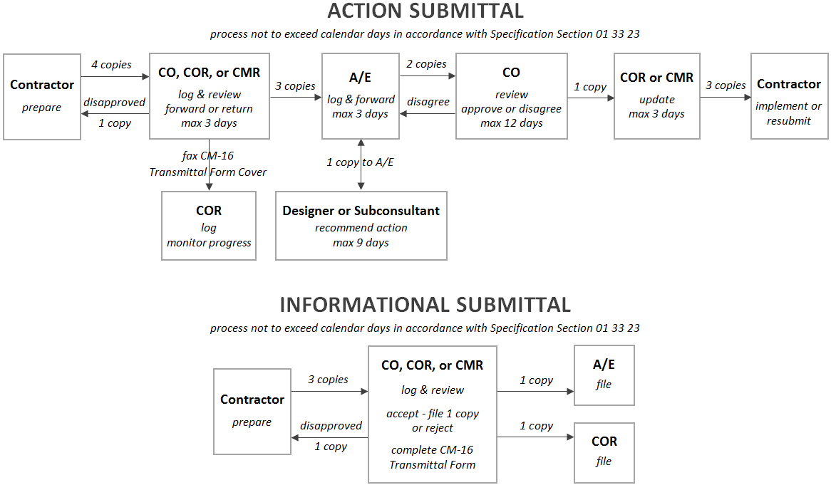
Responsible  Party | Hard Copy Submittal Review Process  Steps and Description of Tasks | Time Schedule
Contractor | - As specified in Specification Section 01 33 23, use CM-16 Transmittal Form. Keep an interim copy until comments are returned. Complete and submit each specification section. Do not combine different specification sections on same CM-16 Transmittal Form. Within a specification section, list each item requiring approval separately; specify action or informational submittal; assign sequential item number; and reference applicable paragraph in Part 2 of specifications. Use CM-16 Transmittal Form Continuation sheet as necessary. Number each CM-16 Transmittal Form in accordance with the pre-assigned submittal numbers separately furnished. The procedure below will return at least 1 set of shop drawings, manufacturer’s data, or sample, along with completed CM-16 Transmittal Form containing original signatures and any attached comments to the Contractor. In some cases, samples will be reviewed in field.  Shop Drawings: Submit 4 sets.  Manufacturers’ Catalog Cut Sheets, Data Sheets, and Similar: Submit 4 copies.  Samples: Submit 4.  Identification Information: Submittals must have identification (examples in parenthesis) including Park Name (BIBE), PMIS Number (014820), Project Title (Chisos Basin Water System), Contract Number (1443N1211050903), Transmittal Number (pre-assigned), Date Submitted, Contractor’s Name, and Subcontractor’s or Supplier’s Name.  Certification: Sign and date CM-16 Transmittal Form to certify submittal is accurate, complete, and in compliance with contract requirements (Far 52.236-21.)  Error or Incomplete/Disapproved Transmittal: Correct and complete. Resubmit and use the same transmittal number with an added alpha suffix (e.g. 12A). | Contract Specification Section 01 33 23 states Contractor provides transmittals a specific number of calendar days before materials or equipment are ordered, delivered, or installed.
CO, COR,  or CMR | - Review CM-16 Transmittal Form and data.  Error or Incomplete/Disapproved Transmittal: Return entire transmittal for correction.  Complete Transmittal: Enter dates transmittal received and forwarded to A/E Designer. Record these dates on the CM-17 Submittal Tracking Form.  Keep copy of CM-16 Transmittal Form and data, shop drawing, or sample for interim use until receipt of review comments.  To A/E Designer: Forward original CM-16 Transmittal Form; 3 copies of manufacturer’s data sheets and/or shop drawings; and 2 samples for technical review and recommendation. Expedite CM-16 Transmittal Form to arrive timely and safely.  To COR: Fax or email scanned copy of CM-16 Transmittal Form if necessary. Track status on submittals. Work with project team to expedite processing. Submittals on critical path go through accelerated review process to accommodate project schedule. | Maximum 3 days
A/E | - Receive submittal and log. Route to appropriate Designer or Subconsultant for technical review.  - Technical Review and Analysis: Ensures equipment and/or materials satisfy contract and perform as intended. Designer makes notes during review process. Preferred method for review comments: Consolidate 8½ by 11 sheets and attach to CM-16 Transmittal Form and cross-reference review comments with sequential item number listed on CM-16 Transmittal Form. If more efficient, make notations directly on each set of submitted data. In Review Comments, cross-reference attached review comments sheet or reference notations made directly on the submittal data, as applicable. Select appropriate NPS Submittal Action for each item submitted. Sign Recommended By field and enter job title and date.  - If Subconsultant reviewing, proceed to C. Otherwise proceed to D.  - Subconsultant: Return original CM-16 Transmittal Form, comment sheets, and submittal data to Prime Consultant.  - Prime Consultant: Perform quality control check. Make copy of CM-16 Transmittal Form with attached review comment sheets and retain 1 set of submittal data. Send remaining 2 copies of submittal data and completed CM-16 Transmittal Forms with comment sheets to DSC. Expedite to arrive timely and safely. | Maximum 3 days
CO | - Receive submittal and log. CO and COR reviews concurs, signs, and dates in the Action By section. Keep completed CM-16 Transmittal Form, comment sheets, and complete set of submittal data/sample for DSC file.  If not in concurrence, contact A/E Designer and discuss resolution. If agreement is reached, edit review comments, sign, and date CM-16 Transmittal Form. Coordinate with A/E to add additional notations made on the submittal data or shop drawings to A/E’s record copy. A/E is responsible for coordinating with Subconsultants. Return original completed CM-16 Transmittal Form with attached comments and remaining submittal sets/samples to CMR. Transmittal logged out of office. Expedite Transmittal to arrive timely and safely. | Maximum 12 days
COR or CMR | - Enter submittal log date at bottom of CM-16 Transmittal Form and on CM-17 Submittal Tracking Form. Transfer notations on submittal data/shop drawings to set of data retained at beginning of process or make 1 copy of completed CM-16 Transmittal Form with comments.  Distribute as follows:  - Fax A/E Designer final, with edits by COR, completed and signed CM-16 Transmittal Form and comments sheets. A/E Designer is responsible for coordinating with Subconsultants.  - Send (or hand carry) original final CM-16 Transmittal Form, comment sheets, and submittal data/sample to Contractor. Log date submittal returned to Contractor.  - Utilize copy of submittal data/sample retained by CMR at beginning of process and CM-16 Transmittal Form with comments sheets as a working set during construction.  - Provide file set to Park Maintenance Division at completion. | Maximum 3 days
Contractor | - Make appropriate number of copies of submittal data and/or shop drawings and CM-16 Transmittal Form with comment sheets and distribute to Contractor, Subcontractor, and Suppliers.  If the submittal is not approved, return to step 1 above. | Maximum 3 days

