Electronic Submittal Review Process Guideline with Flowchart (SharePoint)
National Park Service (NPS) - Denver Service Center (DSC) | 10-13-17
Use this guideline to ensure a timely review of submittals. A flowchart followed with step-by-step details are provided.
ACRONYMS used in this guideline: A/E: Architect/Engineer, CMR: Construction Management Representative, CO: Contracting Officer (DSC), COR: Contracting Officer Representative (DSC)
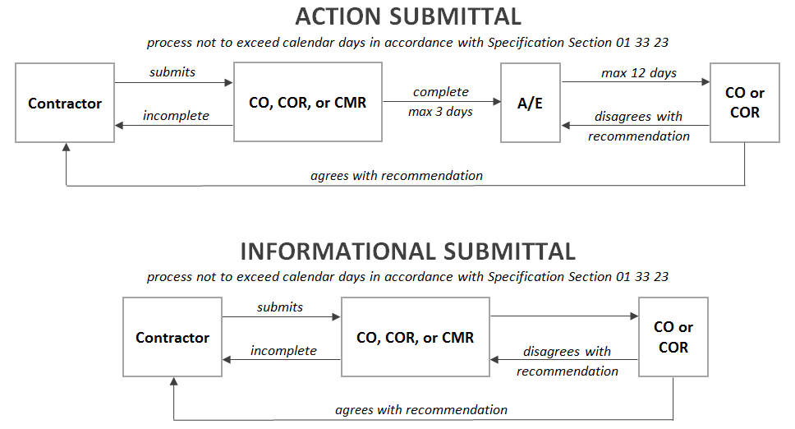
Responsible  Party | Electronic Submittal Review Process (SharePoint)  Steps and Description of Tasks | Time Schedule
Contractor | - Prepare submittal package.  - Attach all related documents in Portable Document Format (PDF).  - SharePoint Project website:  - Upload completed submittal package.  - Hover over Construction to view its menu, then hover over Submittals.  - Under Uploads/Forms, click Submittals to create a new electronic submittal review form.  - Submittal Type drop down menu - choose Action or Information.  - Complete required fields shown with a red asterisk.  - Much of the top fields will be filled in automatically upon submitting the form.  - Attach files as needed following these file requirements:  - File size must be smaller than 50 megabytes.  - Do not include special characters in file name. For details, view Microsoft Support’s Information about the characters that you cannot use in site names, folder names, and file names in SharePoint and scroll to the File names section.  - Update Responsible Party drop-down menu - select CMR or COR per COR.  - Add comments as needed.  - Contractor Sign field - add your username. Click outside the field. Click Sign button.  - Click Submit button. An automatic notification is e-mailed to the responsible party listed on the workflow notification list. | Not Applicable
CO, COR,  or CMR | ACTION SUBMITTAL  - Review submittal for completeness.  - SharePoint Project website:  - If incomplete:  - Does not require a new submittal number.  - CMR Submission Complete drop-down menu - change option to Rejected.  - Update Responsible Party drop-down menu - change option to Contractor.  - Add notification comments providing reasons for incomplete submittal.  - Click Save button. An automatic notification is e-mailed to Contractor listed on the workflow notification list.  - If complete:  - Update Responsible Party drop-down menu - change option to A/E or COR per COR.  - CMR Submission Complete drop-down menu - select Accepted.  - Add comments as needed.  - Click Save button. An automatic notification is e-mailed to A/E or COR listed on the workflow notification list.  INFORMATIONAL SUBMITTAL  - Review submittal for completeness.  - Add comments as needed and attach in PDF.  - SharePoint Project website:  - If rejected:  - Update Responsible Party drop-down menu - change option to Contractor.  - Add notification comments as needed.  - Click Save button. An automatic notification is e-mailed to Contractor listed on the workflow notification list.  - If accepted:  - Update Responsible Party drop-down menu - change option to COR.  - Add notification comments as needed.  - Click Save button. An automatic notification is e-mailed to COR listed on the workflow notification list. | Maximum 3 days
A/E | - Review submittal.  - Add comments as needed in PDF.  - SharePoint Project website:  - Attach PDF comments.  - Update Responsible Party drop-down menu - change option to COR.  - Add additional comments as needed.  - Recommended Submittal Status drop-down menu - select appropriate option.  - Recommended Sign field - add your username. Click outside the field. Click Sign button.  - Click Save button. An automatic notification is e-mailed to COR listed on the workflow notification list. | Maximum 12 days
CO or COR | - Review submittal, A/E comments, and recommended status.  Add comments as needed and attach in PDF.  - SharePoint Project website:  - Attach PDF comments as needed.  - Update Responsible Party drop-down menu - change option to Contractor.  - Add notification comments as needed.  - Permission drop-down menu(s), located left of comments to Contractor - change option to Project Team.  - Action Sign field - add your username. Click outside the field. Click Sign button.  - Click Save button. An automatic notification is e-mailed to Contractor listed on the workflow notification list informing submittal is processed. | Not applicable
Contractor | IF APPROVED OR APPROVED WITH NOTATION  - Reconcile all review comments and implement.  IF DISAPPROVED  - If COR disapproves, a new electronic submittal review form is automatically created. Append submittal number by adding A, B, C, etc. Examples: 1A, 1B, 1C  - Attach additional information to appended electronic submittal review form and process using same steps. | Not applicable

