Addressing Climate Change

and

Natural Hazards
Facility Planning and Design Considerations
January 2015

Stop 1: Natural Hazard Checklist
Excerpt: Level 3 Handbook

STOP 1. Natural Hazard Checklist

The checklist below is a screening tool to be used at the earliest stages of facility planning to determine the most likely natural hazards a project may confront. This general information may help project teams assess which natural hazards may be applicable for a particular project early in the facility planning and design process. As the effort continues site specific information may be required to make a determination for any of the hazards.
The checklist should be completed with input from appropriate Park personnel and specialists. If considerable questions remain about the applicability of specific hazard, contact the appropriate Region or WASO specialist.
For each of the natural hazards listed below, the person(s) completing the checklist should indicate whether the hazard:
- Is applicable and could pose a risk to the project and/or needs more information for a determination.
- Is not applicable to the project for the following reason(s)
- Hazard does not occur due to geologic setting (e.g., no volcanoes or permafrost are present in Florida).
- A previous hazard assessment concluded this hazard was not applicable at this location.
The project’s checklist can be updated at various project milestones as more information is developed. By the time a team completes the schematic design phase the natural hazards applicable to the project should be identified and the checklist should no longer reflect uncertainty associated with any of the hazards listed. To achieve this level of understanding natural hazard assessment(s) may be needed for the project site.
Future versions of this handbook may address additional hazards.
Natural Hazard Checklist
Potential Natural Hazard | Risk or secondary hazard | Sources of General Non-site specific Data | Sources for Site Specific Data |  | Best Professional Judgment
Earthquake | - Falling objects.  - Collapsing structures.  - Inoperability of major building systems e.g. power, sewer, water.  - Liquefaction; loss of strength to foundations, silt deposition, standing water.  - Trigger to other hazards e.g. landslides, debris flows. | 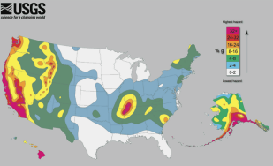  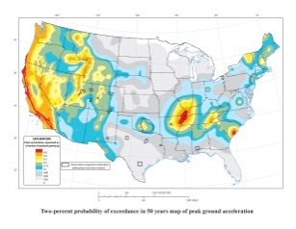  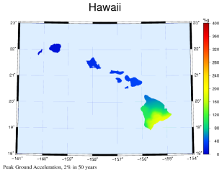  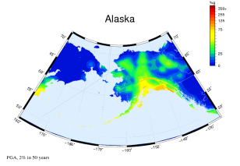 | - International Building Code  - USGS: 2009 Earthquake Probability Mapping  - State based mapping e.g. WA liquefaction susceptibility and site class maps.  - NPS Technical Support |  | Potential Hazard  Not applicable
Landslide/  Avalanche | - Rockfall.  - Mud or debris slides or flows onto structures.  - Mud or debris slides or flows from under structures.  - Snow avalanche. | 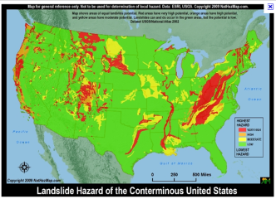 | - State geological surveys e.g. CA landslide mapping.  - NPS Technical Support |  | Potential Hazard  Not applicable
Permafrost | - Melting.  - Surface collapse.  - Increased landslide susceptibility. | 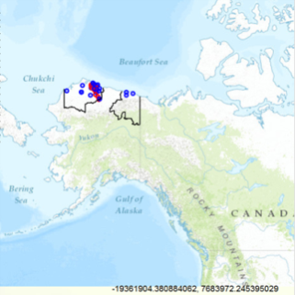  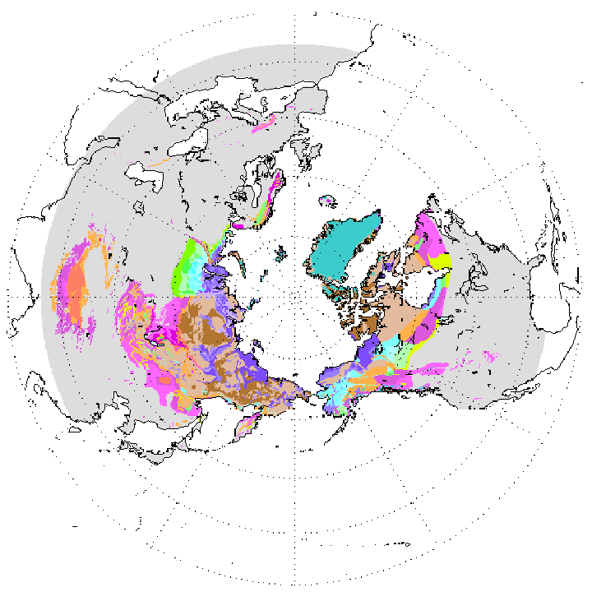 | - Global Permafrost Zonation Index Map  - NPS Technical Support |  | Potential Hazard  Not applicable
Cave/Karst (sinkholes) | - Surface collapse  - Contamination  - Abandoned Mineral Lands (AML) features | 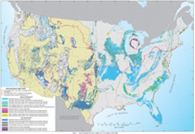  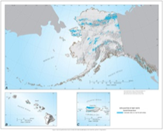 | - State geological hazards maps.  - AML features  - NPS Technical Support – Cave and Karst; Abandoned Mineral Lands |  | Potential Hazard  Not applicable
Shrink/ Swell soils | - Damage to structure  - “heaving” of ground beneath structure  - Increased landslide susceptibility | 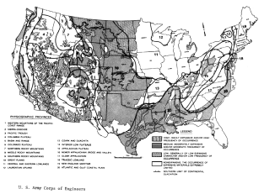 | - State geological survey  site-specific information  - NPS Soil Resources Inventory  - NPS Technical Support |  | Potential Hazard  Not applicable
Coastal Storm Surge | - Rising Sea Levels  - Rising Water – Wind Driven (i.e. hurricane, nor’easter) | 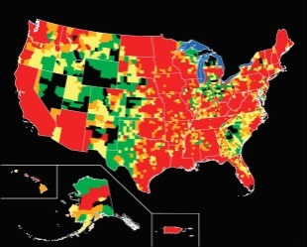 | - FEMA Map Service Center  - NPS Technical Support |  | Potential Hazard  Not applicable
Tsunami | - Coastal area inundation associated with earthquakes or undersea landslides. | 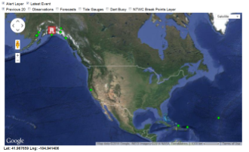 | - State Tsunami Inundation Mapping e.g. OR Tsunami Clearinghouse  - National Tsunami Watch Center  - NPS Technical Support |  | Potential Hazard  Not applicable
Riverine Flood | - Flooding (i.e. snowmelt, rainfall, etc.)  - Destruction of infrastructure.  - Stream channel migration.  - Stream bank erosion. |  | - FEMA Map Service Center  - NPS Technical Support |  | Potential Hazard  Not applicable
Flash Flood | - Sudden rising water (i.e. dry wash)  - Loss of life due to unexpected flooding. |  | - May require a special flood study  - NPS Technical Support |  | Potential Hazard  Not applicable
Hurricane | - High wind speed.  - Flying debris.  - Storm Surge. | 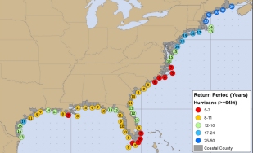 | - Wind Speed data – from local codes  - International Building Code  - FEMA Map Service Center  - NPS Technical Support |  | Potential Hazard  Not applicable
Tornado | - Extreme wind speed  - Flying debris | 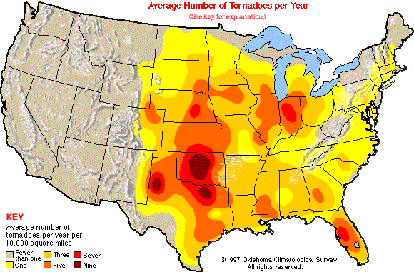 | - International Building Code  - Limited Data for Local Application  - NPS Technical Support |  | Potential Hazard  Not applicable
Wildfire | - Fire and Heat.  - Smoke. | 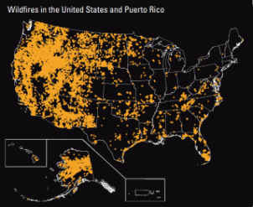 |  | - International Wildland-Urban Interface Code  - Limited Data for Local Application  - NPS Technical Support  Note: This link routes to an NPS intranet site which is only accessible within the NPS network. | Potential Hazard  Not applicable
Volcanic Eruption | - Lava Flows  - Fire  - Volcanic Secondary Hazards  Note: This link routes to an NPS intranet site which is only accessible within the NPS network.  - Toxic gas releases | 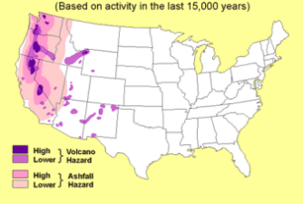 |  | - USGS Volcano Hazards Program  - NPS Technical Support | Potential Hazard  Not applicable
Hydro-thermal Activity (e.g., geysers | - Toxic gas release.  - Explosion.  - Boiling water  - Steam.  - Surface collapse into void. | TBD |  | - Air quality issues and monitoring, including real-time for select locations.  - NPS Technical support | Potential Hazard  Not applicable
Pest Infestation | - Historic/ Facility Fabric Loss  - Vegetation Loss  - Fauna Impacts  - Infection  - Injury | TBD |  | - Integrated Pest Management  - NPS Technical Support | Potential Hazard  Not applicable

