NPS DSC Electronic Drawing Standards (EDS) 2021
National Park Service (NPS) - Denver Service Center (DSC) | 10-19-21
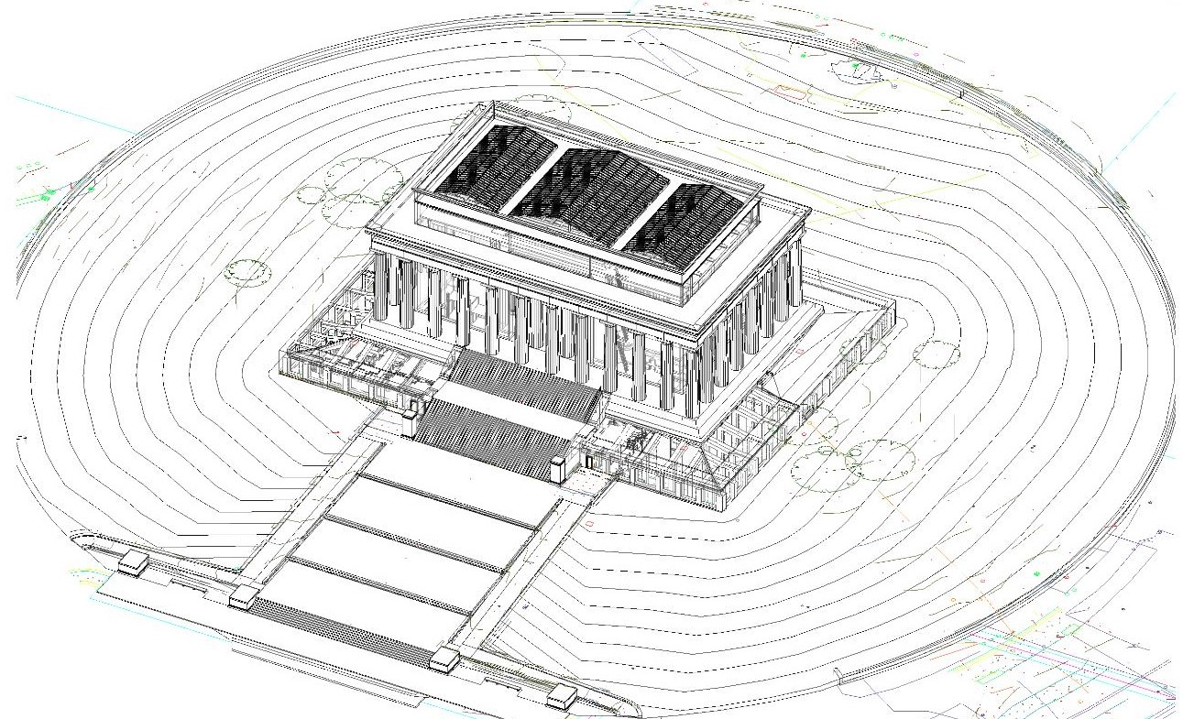
CAD 3D Wire frame drawing of the Lincoln Memorial
Electronic Drawing Requirements for
Design and Construction Drawings

Table of Contents
Acronyms and Abbreviations 4
Introduction 5
Chapter 1 - General Standards 5
Chapter 2 - Drawing Management 6
Folder and File Naming Conventions 6
Folder Naming Conventions 7
File Naming 7
Electronic Drawing File Management and Naming Conventions 7
Amendments or Modifications 8
File Naming of Xrefs in Drawing Base Folders 8
Relative Xref Paths 8
Layering 9
Layer Formats 9
Drawing Templates 9
Chapter 3 Drawing Format 10
Standard Sheets 10
Standard Cover Sheets 10
Second Sheets 11
Title Blocks 12
Approval and Revision Blocks 15
Date Stamp 16
Drawings Reissued for Bid 17
Drawings for Contract Modifications 17
North Arrows 17
Specific View Titles 18
Scales 19
Chapter 4 Drafting Practices 27
General 27
Actual Elevation Versus Reference Building Elevation 28
Abbreviations 28
Colors Used In The Review And Updating Of Drawings 28
Enlarged Detail 28
Layout Lines 28
New Work and Existing Conditions 28
Drawings versus Specifications 28
Lettering - Sizes and Line Weights 29
Symbols 29
Use of Colored Ink or Pencil 29
Line Weights 29
Pen Colors 29
Lettering 30
Text Styles 30
Leaders 30
Dimensions 30
Dimension Format 30
Discipline Specific Guidelines 31
Site Work Drawings (Landscape Architecture, Civil, and Survey) 31
Architectural Drawings 31
Structural Drawings 32
Standard Details 34
Drafting and Detailing References 35
Customization 35
NPS AutoCAD Tools 35
Printing AutoCAD Drawings for DSC 36
CTB Files 36
Deliverables and Data Exchange 36
General 36
Delivery Media 37
Archival Quality 37
General 37
Wet Ink Printer and Ink Jet Printers 37
Use Of Photographic Reproduction 37
Chapter 5 Construction Drawings 37
Construction Drawings 37
Sheet Order 37
Sub-sheet Designation and Numbering 38
Alternative Sub-sheet Designation and Numbering 38
Appendix A 42
General Materials Symbols 42
Appendix B 43
Sample Survey Sheets 43
Appendix C 47
Standard Abbreviations, Standard Symbols, and Sample Construction Drawings 47
Appendix D 50
Sample Amendment or Modification 50
Appendix E 53
Sample As Constructed Drawing Cover Sheet 53
Appendix F 55
Text Height versus Printing Height (Relative to Model Space) 55

Acronyms and Abbreviations
A/E or A&E Architect/Engineer
ACI American Concrete Institute
AIA American Institute of Architects
AISC American Institute of Steel Construction
AITC American Institute of Timber Construction
AMEND Amendment
ANSI American National Standards Institute
ARCH Architectural
ASHRAE American Society of Heaing, Refrigerating and Air Conditioning
ASPE American Society of Plubming Engineers
ASTM American Society for Testing and Materials
AWS American Welding Society
BIM Building Information Modeling
CAD Computer Aided Design
CC Carbon Copy
CD Compact Disc
COR Contracting Officer Representative
CTB Color-dependent plot style tables
DSC Denver Service Center
DWIZ Dimension Wizard (NPS AutoCAD Tools command)
EDS Electronic Drawing Standards
ELEC Electrical
ELEV Elevation
eTIC Electronic Technical Information Center
Floorpl Floorplan
HVAC Heating, Ventilation, and Air Conditioning
in Inch/Inches
INT Interior
IRB Investment Review Board
ISO International Organization for Standardization
JELA Jean Lafitte National Historic Park and Preserve
LA Landscape Architecture
MECH Mechanical
MOD Modification
mm Millimeter/Millimeters
NCS National CAD Standard
NFPA National Fire Protection Association
NPS National Park Service
O.C. On Center
PCI Prestressed Concrete Institute
PDF Portable Document Format
PMIS Project Management Information System
PMIS NO Project PMIS Number
REVIT 3D software
STRUC Structural
TIC Technical Information Center
TWIZ Text Wizard (NPS AutoCAD Tools command)
U.S. United States
v Version
V6 Version 6
Xrefs External References
YELL Yellowstone National Park

Introduction
The Denver Service Center's NPS DSC Electronic Drawing Standards (EDS) 2021 captures the intent of the original National Park Service Director's Order 10A Guideline for Design and Construction Drawings while offering flexibility to utilize new CAD (Computer Aided Design) and BIM (Building Information Modeling) approaches to design and drafting.
DSC Workflows > CAD/BIM & Drafting Standards and the EDS focus on electronic drawing requirements. Electronic customization for Autodesk AutoCAD or BIM software is at the Construction Contractor's discretion but must comply with the EDS.
NPS AutoCAD Tools are now discontinued. These tools were previously developed to incorporate established standards into the electronic environment for creating drawing files in AutoCAD.
Questions related to drawing standards, including detailed descriptions and explanations of Figures, addressed in this NPS DSC Electronic Drawing Standards 2021 can be directed to dsccadsupport@nps.gov.

Chapter 1 - General Standards
These general standards include the fundamental requirements for efficient generation, archival, and retrieval of electronic drawings prepared for NPS DSC. Some of these standards will be explained more specifically in other sections of this document.
- Prepare design and construction drawings using Autodesk AutoCAD software or 3D-BIM (3 dimensional) equivalent of products.
- Produce drawings according to the Electronic Drawing Standards (EDS).
- Produce drawings at true scale and true coordinates in model space. Insert NPS borders sheets in paper space at 0,0,0.
- Print drawings using paper space at 1:1 scale for full-size prints or 1:2 scale for half-size prints.
- For external reference drawings (base files), use relative xref paths.
  - Attach (or overlay) external referenced (xref) drawings into the sub-sheet at 0,0,0.
  - Do not bind external references at completion of drawing.
- Construction Contractors shall use their own appropriate print configurations (.ctb files if using AutoCAD) to produce legible drawings and text.
  - Submit these files with electronic file deliverables (native files).
  - Design teams can create their own files to conform to the line weights as specified for each element (i.e. walls, doors, etc.).
- Colors used in drawing files will be at the Construction Contractor’s discretion, however line weights and text will comply with the EDS and be fully legible at required scales.
- Drawings will contain:
  - date stamp with the CAD/BIM software release number
  - drawing path name
  - file name
  - latest date worked on
- Conform layer names to industry standard best practices following current version of AIA U.S. NCS (American Institute of Architects United States National CAD Standards) and with drawing elements on the appropriate layer.
- Create each sub-sheet as an individual CAD file using external references for base sheet information.
  - One single drawing file containing multiple sub-sheets is not acceptable.
- For drawing path names, follow the DSC folder structure and file naming conventions.
- For site plan drawings, utilize the same coordinate system as on the original base data.
  - The original base data remains constant throughout each phase of the project.
  - Site plans shall be at their true geo-referenced locations and capable of overlaying on the same coordinate system of the original topographic survey and/or base data.
- The digital data delivered shall be able to be integrated with the base data by inserting or overlaying at an origin of 0,0 and rotation angle 0.
Also reference the CAD/BIM & Drafting Quality Assurance (QA) Review Checklist to assist in meeting our electronic drawing requirements.
For standards regarding drawing and map numbers, Reference Manual 10B is still applicable. Where discrepancies between the EDS and RM Manual 10B arise, the requirements set forth in the EDS shall take precedence.

Chapter 2 - Drawing Management
To ensure accessibility of drawing files and external references during the design and construction process, and for archival and retrieval purposes, it is imperative to maintain a standard folder structure. In addition, relative path names will be used for drawings that are to be accessible as an external reference.

Folder and File Naming Conventions
File organization is necessary in managing electronic drawings. By stacking folders, the user can distinguish between Park, PMIS number, discipline the drawing is associated with, and the specific file name. Follow the specified folder structure and file naming conventions when preparing electronic drawings for the DSC.

Folder Naming Conventions
To assure file sharing and accessibility of drawings, use the folder structure below:
\PARK\ 4 Letter Park Designation
\PMIS NO.\ Project PMIS Number
\(CAD, REVIT, BIM, or PDF) DRAWINGS\
\DISCIPLINE or BASES\ Arch, Civil, LA, Mech, Elec, Bases*, etc.
\FILE NAME (.DWG) Drawing Name
Examples: C:\JELA\543210\CAD v2020 DRAWINGS\ARCH\A1 Floorpl.dwg
C:\JELA\543210\PDF DRAWINGS\ARCH\A1 Floorpl.pdf
C:\JELA\543210\PDF DRAWINGS\Combined Drawings.pdf
*The bases folder is the designated location for storing drawings created to be used as a "base" drawing and accessed as an external reference (xref). Use this folder to locate base sheets needed by discipline(s), i.e. mechanical designers may need to xref the architectural floor plan which will be used as the base for their mechanical design. All base drawings will be located in one folder, with the file name indicating the specific type of base. Additionally, the root folders should contain software type and version such as CAD v2020, Revit v2020, BIM 360 v2020, etc., as shown in the example. PDF files may also be combined drawings in a single file, unless the file size becomes too large.

File Naming
To assure file sharing, accessibility and compatibility of drawings, file names will be a maximum of eighteen (18) characters, including spaces and the file extension. The file name shall begin with the sub-sheet number and followed with the design content of each specific drawing sheet.
Examples: L1 SITE PLAN.dwg
S3ROOF FRAMING.dwg
M2 1st HVAC.dwg
E4 POWER PLAN.dwg
See Figure 2-2 below for an expanded version of the folder structure with file naming examples.

Electronic Drawing File Management and Naming Conventions
Example: C:\YELL\123450\DRAWINGS\ARCH\A2 INT ELEV.dwg
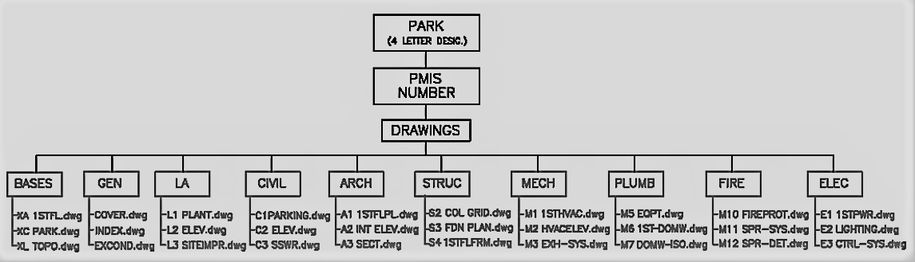
Figure 2-1 - Example of file management and naming conventions.

Amendments or Modifications
If amendments or modifications are part of the project, create an additional folder beneath the DRAWINGS folder, then place amended or modified drawings in the correct discipline folders.
Examples: C:\YELL\123450\DRAWINGS\AMEND1\ARCH\A2 INT ELEV.dwg C:\YELL\123450\DRAWINGS\MOD1\ARCH\A2 INT ELEV.dwg

File Naming of Xrefs in Drawing Base Folders
In naming base drawings to be used as external references (xrefs), files should begin with X, to distinguish it as an xref. Architectural base sheets shall begin with XA, civil base sheets shall begin with XC, landscape base sheets shall begin with XL, etc. The remaining file name should be as descriptive as possible describing the content of the base sheet. Naming base drawings this way will generate consistency and organization within the final drawing set.
Examples: XA-FLRPL.dwg
XC-SITE.dwg
XL-LAYOUT.dwg

Relative Xref Paths
To ensure xrefs load when opening drawings, xrefs will use relative paths. This eliminates problems associated with accessing xrefs when drawings are shared, created or stored on different drives, or written to CDs (compact disc).
To change an xref from an absolute path (the default), to a relative path, use the Xref Manager. In the Xref Manager window, highlight the xref name, and in the Xref Found At field, change the path to ..\bases\[filename].dwg. Then click Save Path.
Note that in the figure below, that the two dots (..\bases\ in the Xref Found At field) indicate backing up one folder from the current folder.
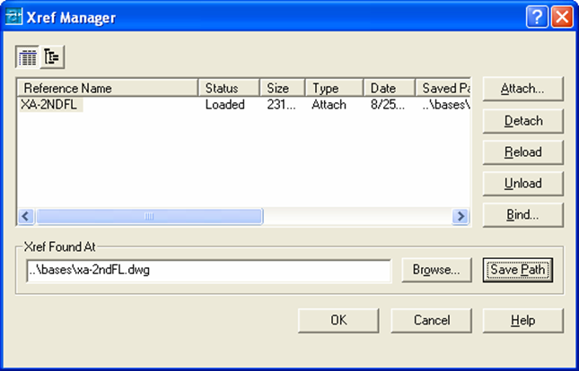
Figure 2-2 - Xref Manager window

Layering
The Denver Service Center uses AIA NCS v6 Layer Guidelines. The Layer Guidelines give two methods for sharing graphic information:
- Single File: Drawings are created by turning layers on and off.
  - Do not use on DSC drawings.
- Multiple File: Drawings are created by using reference files (xrefs). Allows for a total team approach and easier file sharing.
  - Use on DSC drawings.
Save drawings to be used as external reference drawings, or base sheets, to the bases directory for availability as needed for all disciplines. Base drawings should contain only the necessary information needed for use by other disciplines, but not the information specific to the original discipline. This way, base drawings can be utilized immediately, without the need to analyze and manipulate. This is not relevant for BIM software.
Any base drawing to be used as an xref shall have objects created color by layer only. This allows for easier line weight modification, when necessary.

Layer Formats
The layering formats used should follow AIA NCS v6 Layer Guidelines and may include user defined layers as necessary.

Drawing Templates
The NPS standard drawing templates, previously provided, are no longer available or supported by Denver Service Center. Construction Contractors can develop their own templates from previously created electronic drawing files. Construction Contractors are responsible for maintaining the required formats presented in the Drawing Format section of the Standards. This includes utilizing appropriate fonts, layers, and line weights, etc.

Chapter 3 - Drawing Format

Standard Sheets
Standard 22 inches by 34 inches NPS drawing sheets are used for design, construction and as- constructed drawings. See Figure 3-1 for the standard cover sheet border, which also shows the location of approval and revision blocks. See Figure 3-2 for the standard second sheet border.
Standard sheets include:
Cover Sheet: Standard cover sheet with vicinity, park map, and project index.
Second Sheet: Standard border sheet.
Plan and Profile Sheets: Standard second sheet borders, with grids for a plan and profile sheet or a full profile sheet.

Standard Cover Sheets
Electronic Cover sheets for parks and Electronic Drawings sheets are no longer available or supported. It is the Architect/Engineer's (A/E) responsibility to create a cover sheet for each project. Each cover sheet should contain the following items:
- Vicinity map
- Park map showing project site location - obtained from the Park
- Basic data (source of information and date of cover sheet base preparation)
- NPS Arrowhead - obtain from Harper's Ferry Center:
  - email: npsbrand@nps.gov
  - cc: DSC Contracting Officer Representative (COR)
  - subject: NPS arrowhead for DSC drawings
- Graphic bar scale(s)
- Required approval and revision blocks
- PMIS number, if applicable
- Drawing number - obtained from the Technical Information Center (TIC)
- Construction contract number on as-constructed drawings
- A&E block with the A/E firm name, Subcontractors’ names and address (city and state only)
A/E logos are not permitted. The format for presenting A/E firm and Subcontractor information is shown on Figure 3-7. If a set of drawings is prepared in part by the DSC and in part by an A/E, then the A/E information block should be placed only on those drawings for which they are responsible.
The final construction document record set plans shall have professional stamp(s) and signatures from the State(s) where the project is located. Each plan sheet shall have professional stamp(s) by the appropriate discipline responsible for the drawing. Professional stamp(s) shall be placed to the left side of the A/E information block.
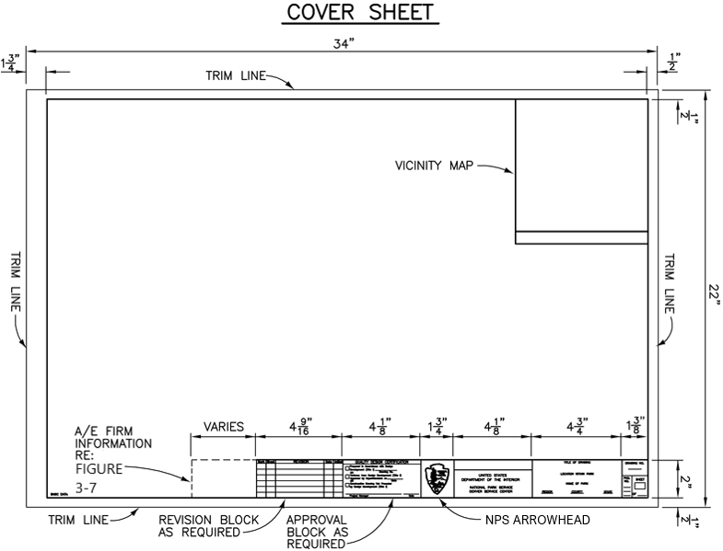
Figure 3-1 - Standard Cover Sheet Border
If possible, place an index to the sheets on the cover sheet. Otherwise, place the index on a separate second sheet.

Second Sheets
These sheets are to be used for all subsequent drawings.
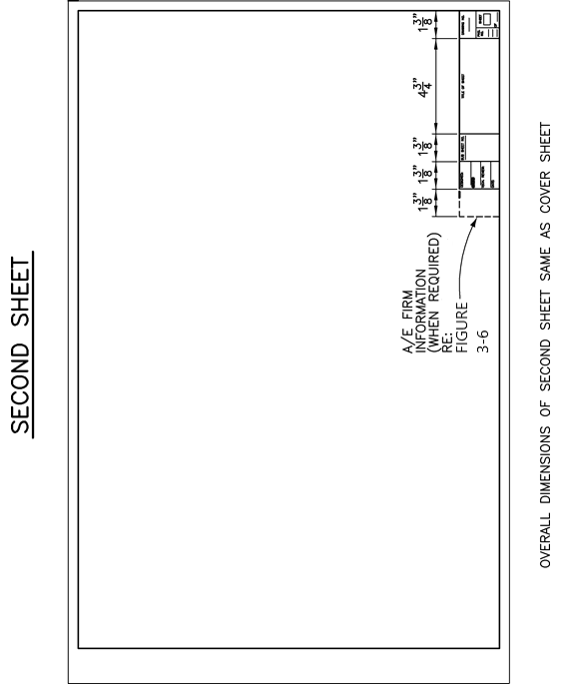
Figure 3-2 - Standard Second Sheet Border

Title Blocks
As shown in Figure 3-3, title blocks on cover sheets include:
- project title
- specific location within the park
- park name
- region
- county
  - If the park is in more than one county, show only the county in which the subject project is located.
- state
As shown in Figure 3-4, title blocks on second sheets contain:
- title of the sheet (sheet contents)
- park name
Every title block will also include:
- drawing number
- PMIS number
- sheet numbering
Each second sheet title block will also include:
- sub-sheet number
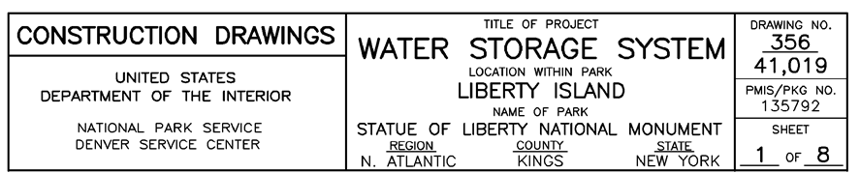
Figure 3-3 - Cover Sheet Title Block
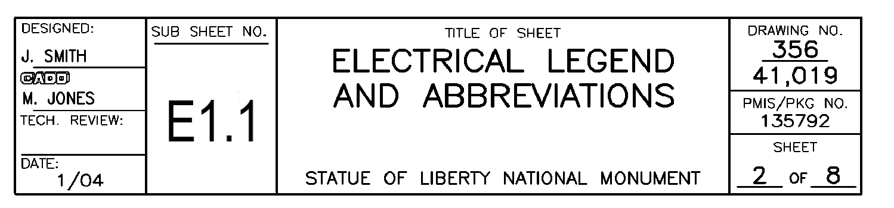
Figure 3-4 - Second Sheet Title Block
The samples in Figures 3-5 through 3-7 show how to prepare the title blocks for cover and second sheets. The text sizes and dimensions in the figures are to provide guidance to maximize consistency between sets.
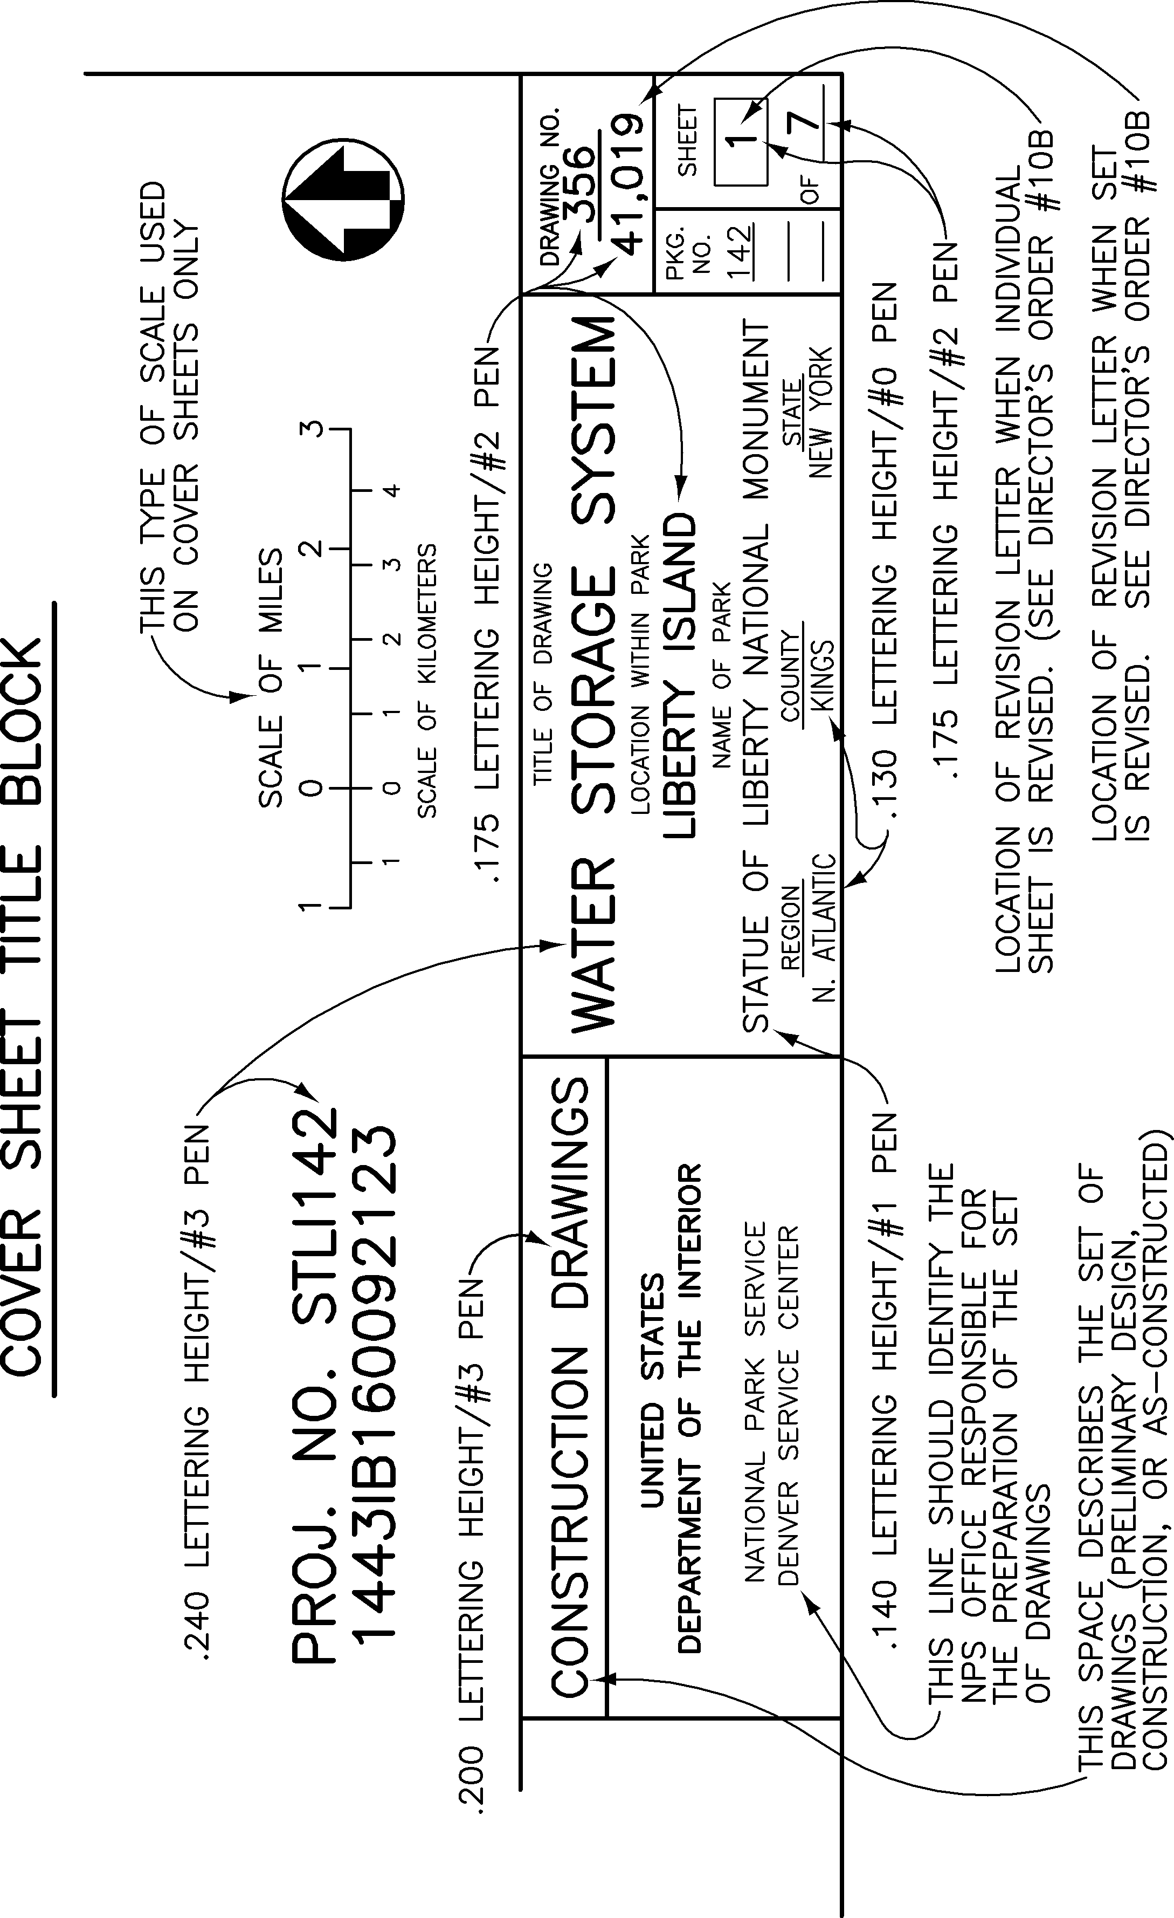
Figure 3-5 - Cover Sheet Block
Pen Line Weight Equivalents
for Figure 3-5 (above) & Figure 3-6 (below)
pen number inches millimeters
1 .021 .53
2 .026 .66
3 .035 .89
4 .043 1.1
5 .055 1.4
6 .013 .33
7 .017 .43

In the sub-sheet numbers:
- As shown in Figure 3-4, A/Es can use decimal point separators to allow for more sheets.
- A/Es may adjust lettering height, width, and line width to accommodate this for legibility.

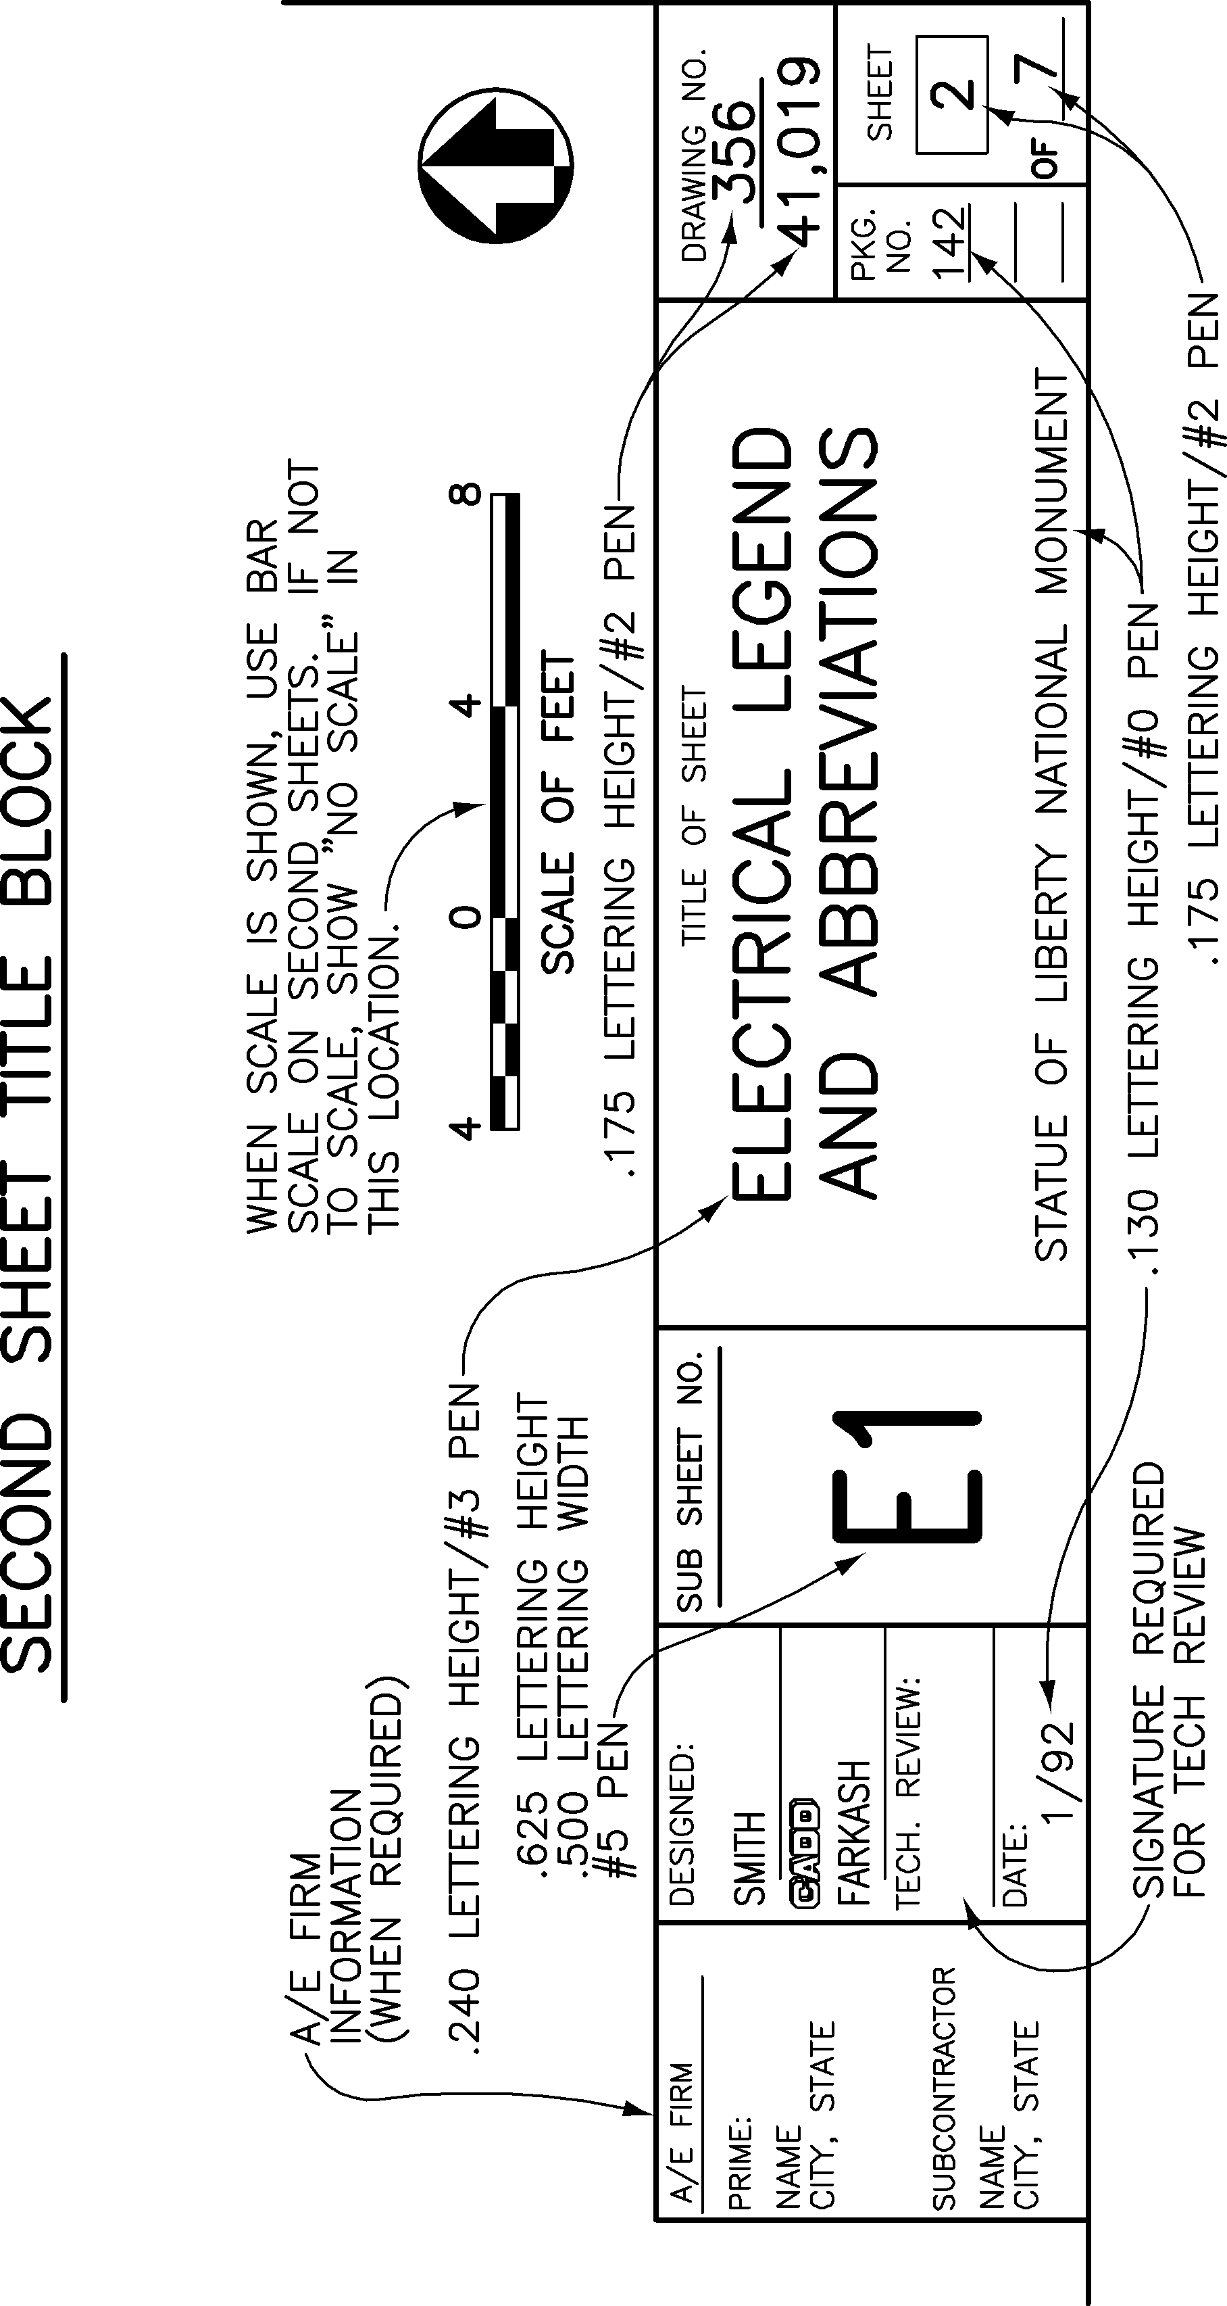
Figure 3-6 - Second Sheet Block
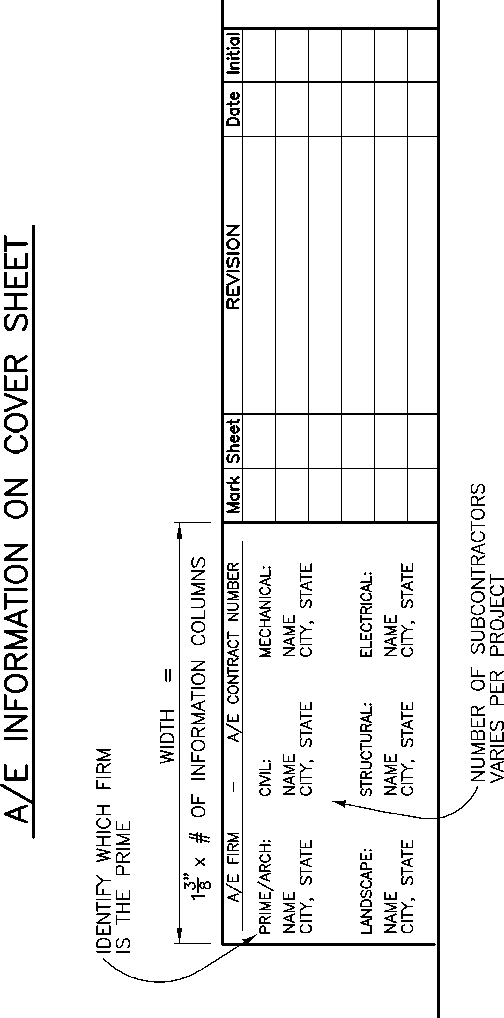
Figure 3-7- A/E Title Block Information

Approval and Revision Blocks
Approval Block - An approval block is required on the cover sheet of all design and construction drawing sets, see Figure 3-8. The approval block states the superintendent of the park has reviewed and approved the plans. The project manager will sign and date the block. Signatures are required at the Schematic Design (SD) phase prior to the Investment Review Board (IRB) presentation, and again at the completion of the Construction Drawing set.
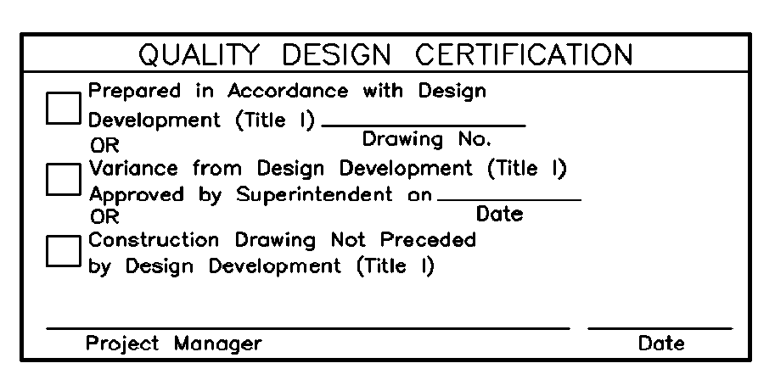
Figure 3-8 - Approval Block
Revision Block - Information should be added to the revision block when changes are made to construction drawings after they have been issued for bid and therefore are official contract documents. See Figure 3-9 for a example of a completed revision block. Revision blocks are placed on the cover sheet only.
Revision blocks are required for changes to construction drawings which have been issued for bid and therefore are official contract documents. Revision blocks shall include:
- identifying mark (a triangle with a number or letter, used to key information in the revision block to the part of the drawing it pertains to)
- sheet number(s) of the sheets with changes or additions
- brief description of the revision
- date of the revision
- initials of person approving the revision
Refer to Reference Manual 10B beginning at page 27 for guidance on revision numbers as listed on sheets. See Figure 3-9 for a completed block. The information in the revision block is keyed to the drawings by clouding the affected part of each drawing and placing a revision mark on or within the clouding.
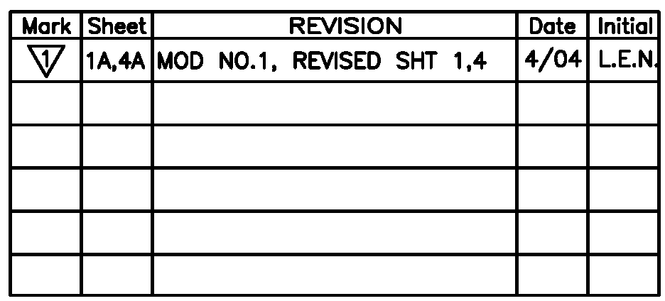
Figure 3-9 - Revision Block

Date Stamp
Each drawing must contain a date stamp that includes:
- latest date the file was worked on
- software release number
- drawing path name
- file name (including any external references).
Place the date stamp vertically, on the left side of the border sheet, outside the border.
Example: 10/15/21 16:24 PWOODRUFF R15 P:\JELA\123456\DRAWINGS\ARCH\1STFLOOR.DWG
Standard border sheets, approval and revision blocks, and date stamp are no longer available through the NPS AutoCAD Tools. NPS AutoCAD tools have been discontinued and are no longer supported. The Construction Contractor is responsible for providing electronic drawings according to the drawing format requirements in this chapter.

Drawings Reissued for Bid
Reissued Bid Packages - Drawings and specifications that did not make it through a successful first bid and are rebid.
Drawings - Whether or not changes are made to the drawings, a revision letter is added to the drawing number to show that drawings are being reissued. On the cover sheet, an alpha A is added to the drawing number.
If no changes are made to the drawings, add to the Revision Block:
- "Reissued for bid, no changes to the drawings"
- date
If changes are made to the drawings, add to the Revision Block:
- "Reissued for bid"
- sheet numbers of the revised drawings
- date
Refer to Chapter 3 in Reference Manual10B for further information.

Drawings for Contract Modifications
Drawings prepared to accompany a construction contract modification shall follow the EDS. The Contracting Officer Representative (COR) is responsible for submitting drawings or sketches to include in the contract modification package, as appropriate. In most cases, the Project Designer will prepare the drawings or sketches. The drawings or sketches will be furnished to TIC (by whomever initially prepares these documents) to process and archive immediately after preparation, to avoid loss. If changes are made to the design during the modification negotiation process, or if the modification is not executed, the COR is responsible for advising TIC of the changes. The COR is also responsible for incorporating the changes into the as-built drawings.
When sketches are used rather than standard drawing sheets, the sketches must include:
- PMIS number
- drawing number
- project title
- person responsible for drawing
- date prepared
Refer to Chapter 3 in Reference Manual10B for further information.

North Arrows
When possible, drawings should be laid out so north is toward the top or left of the sheet. The orientation of north should be maintained throughout a set of drawings, if possible. When a north arrow is required, it is normally placed in the lower right-hand corner above the title block. See Figure 3-5 and Figure 3-6. Recommended style for north arrows appears in Figure 3-10. When more than one north arrow is used on the same sheet, each arrow should be placed near the title of the specific view it orients. See Specific View Titles section below.

Specific View Titles
For the following figures which pens are identified, the following comparison chart applies. Since pens associated with colors are not generally used now, this chart identifies the required line weights in both inches and millimeters for reference.
Pen Line Weight Equivalents
for the following Figures
pen number inches millimeters
1 .021 .53
2 .026 .66
3 .035 .89
4 .043 1.1
5 .055 1.4
6 .013 .33
7 .017 .43
0 .017 .43
00 .013 .33

Instructions for drawing section or detail symbols are provided in Figure 3-15 and 3-16.
Instructions for drawing typical titles are provided in Figure 3-17.
Instructions for drawing building lines are provided in Figure 3-18.

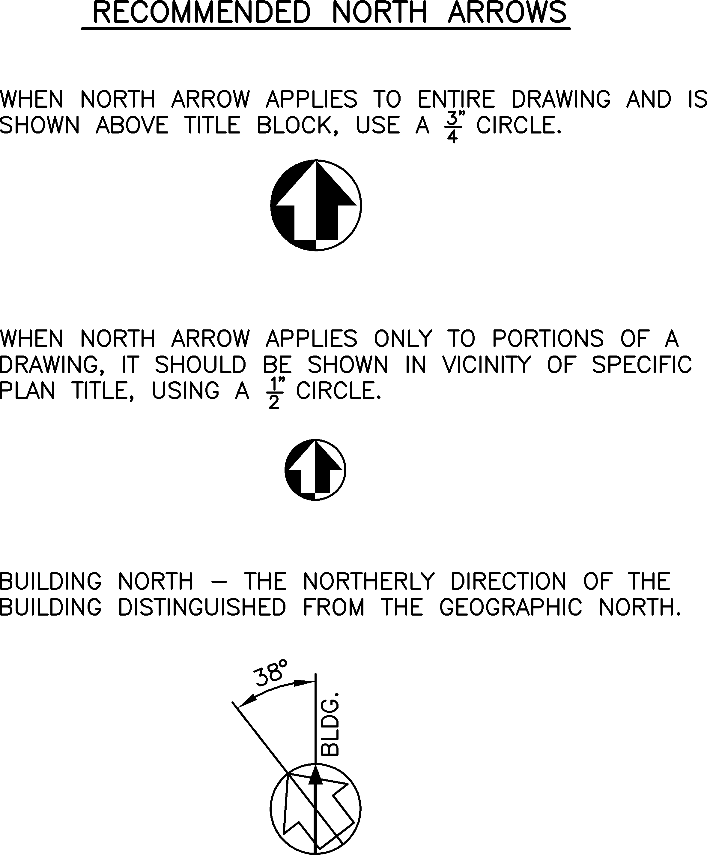
Figure 3-10 - Recommended North Arrows

Scales
Scales must be graphic scale. Recommended styles for scales appear in Figure 3-11.
- If a single scale applies to an entire sheet, place scale above the title block.
- If an entire drawing sheet is not to scale, the term NO SCALE should appear above the title block.
- If more than one scale is used on a sheet, place scales below the title of each section or detail.
- If a specific section or detail is not drawn to scale, the term NO SCALE should appear below the title of that section or detail.
- If more than one scale is used on a sheet, but one or more of them is used repetitively, group all scales above the title block, and reference each section or detail to the corresponding scale. See Figure 3-14.
Scales of associated drawings should be the same for all disciplines.

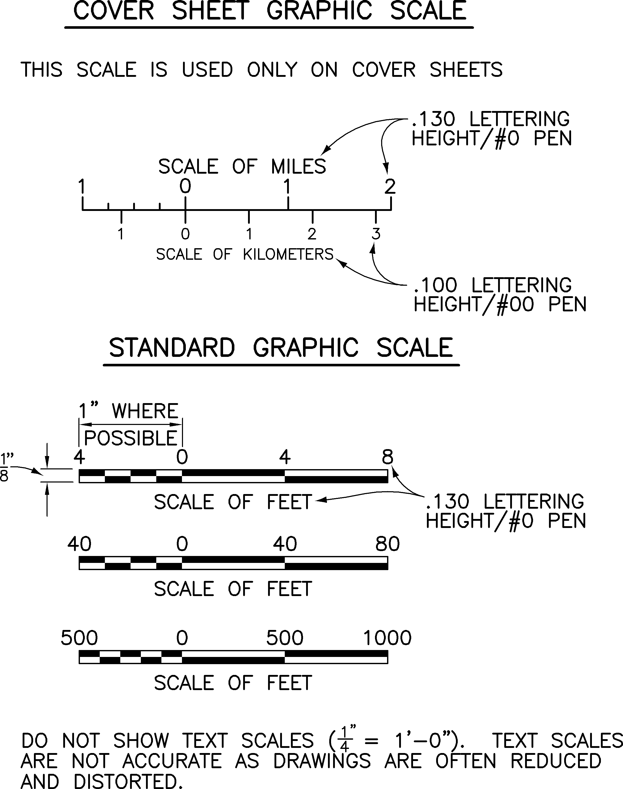
Figure 3-11 - Graphic Drawing Scales
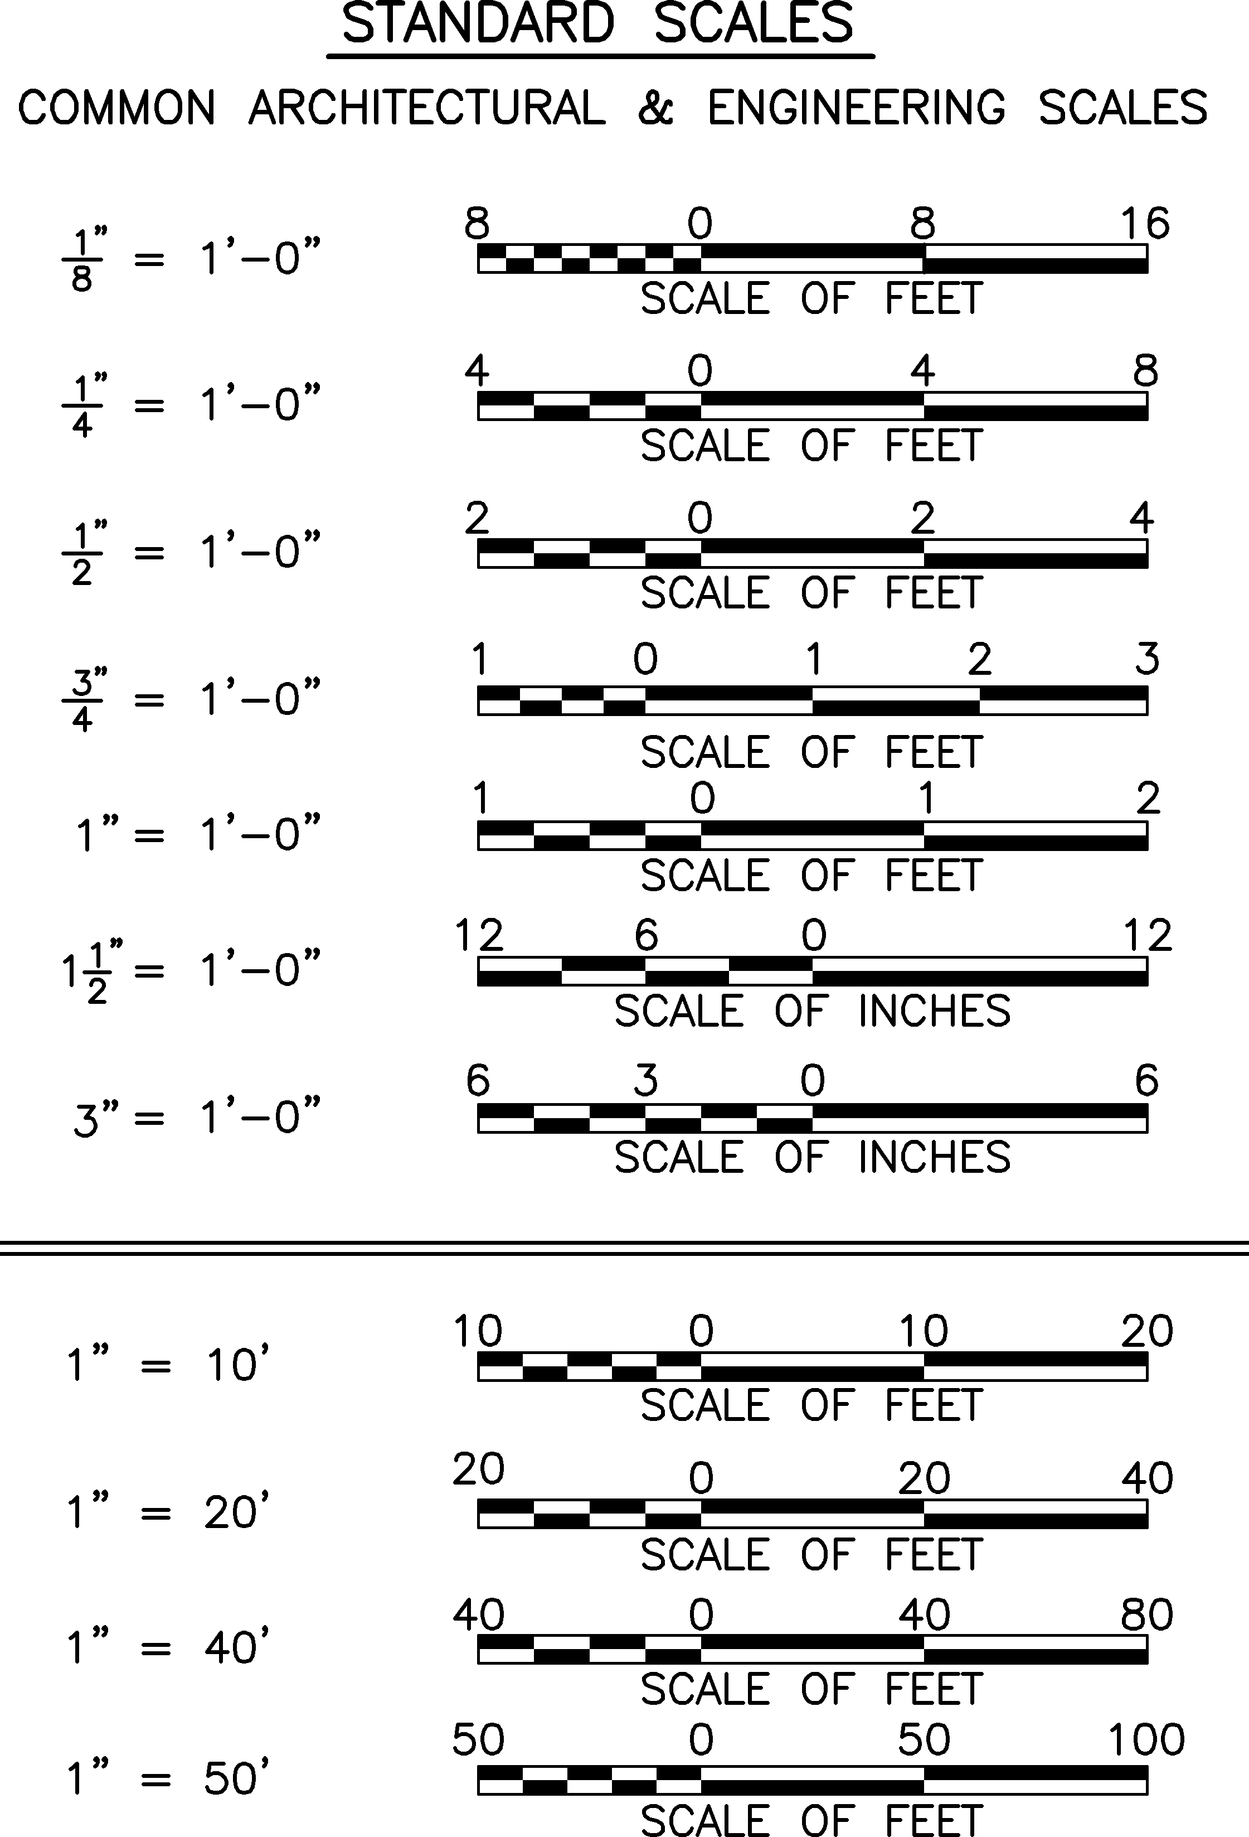
Figure 3-12 - Standard Scales
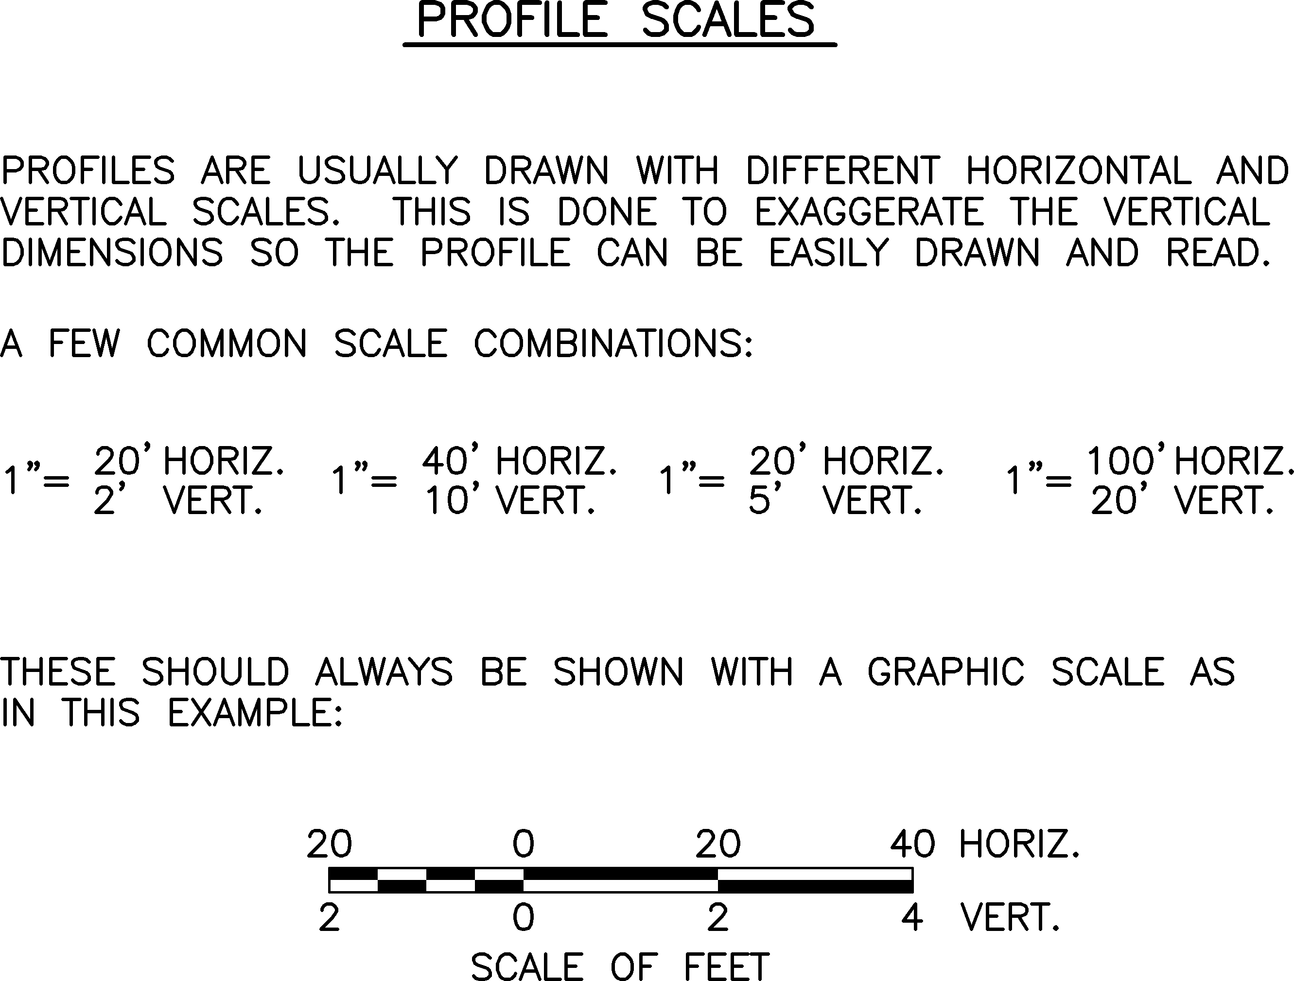
Figure 3-13 - Profile Scales
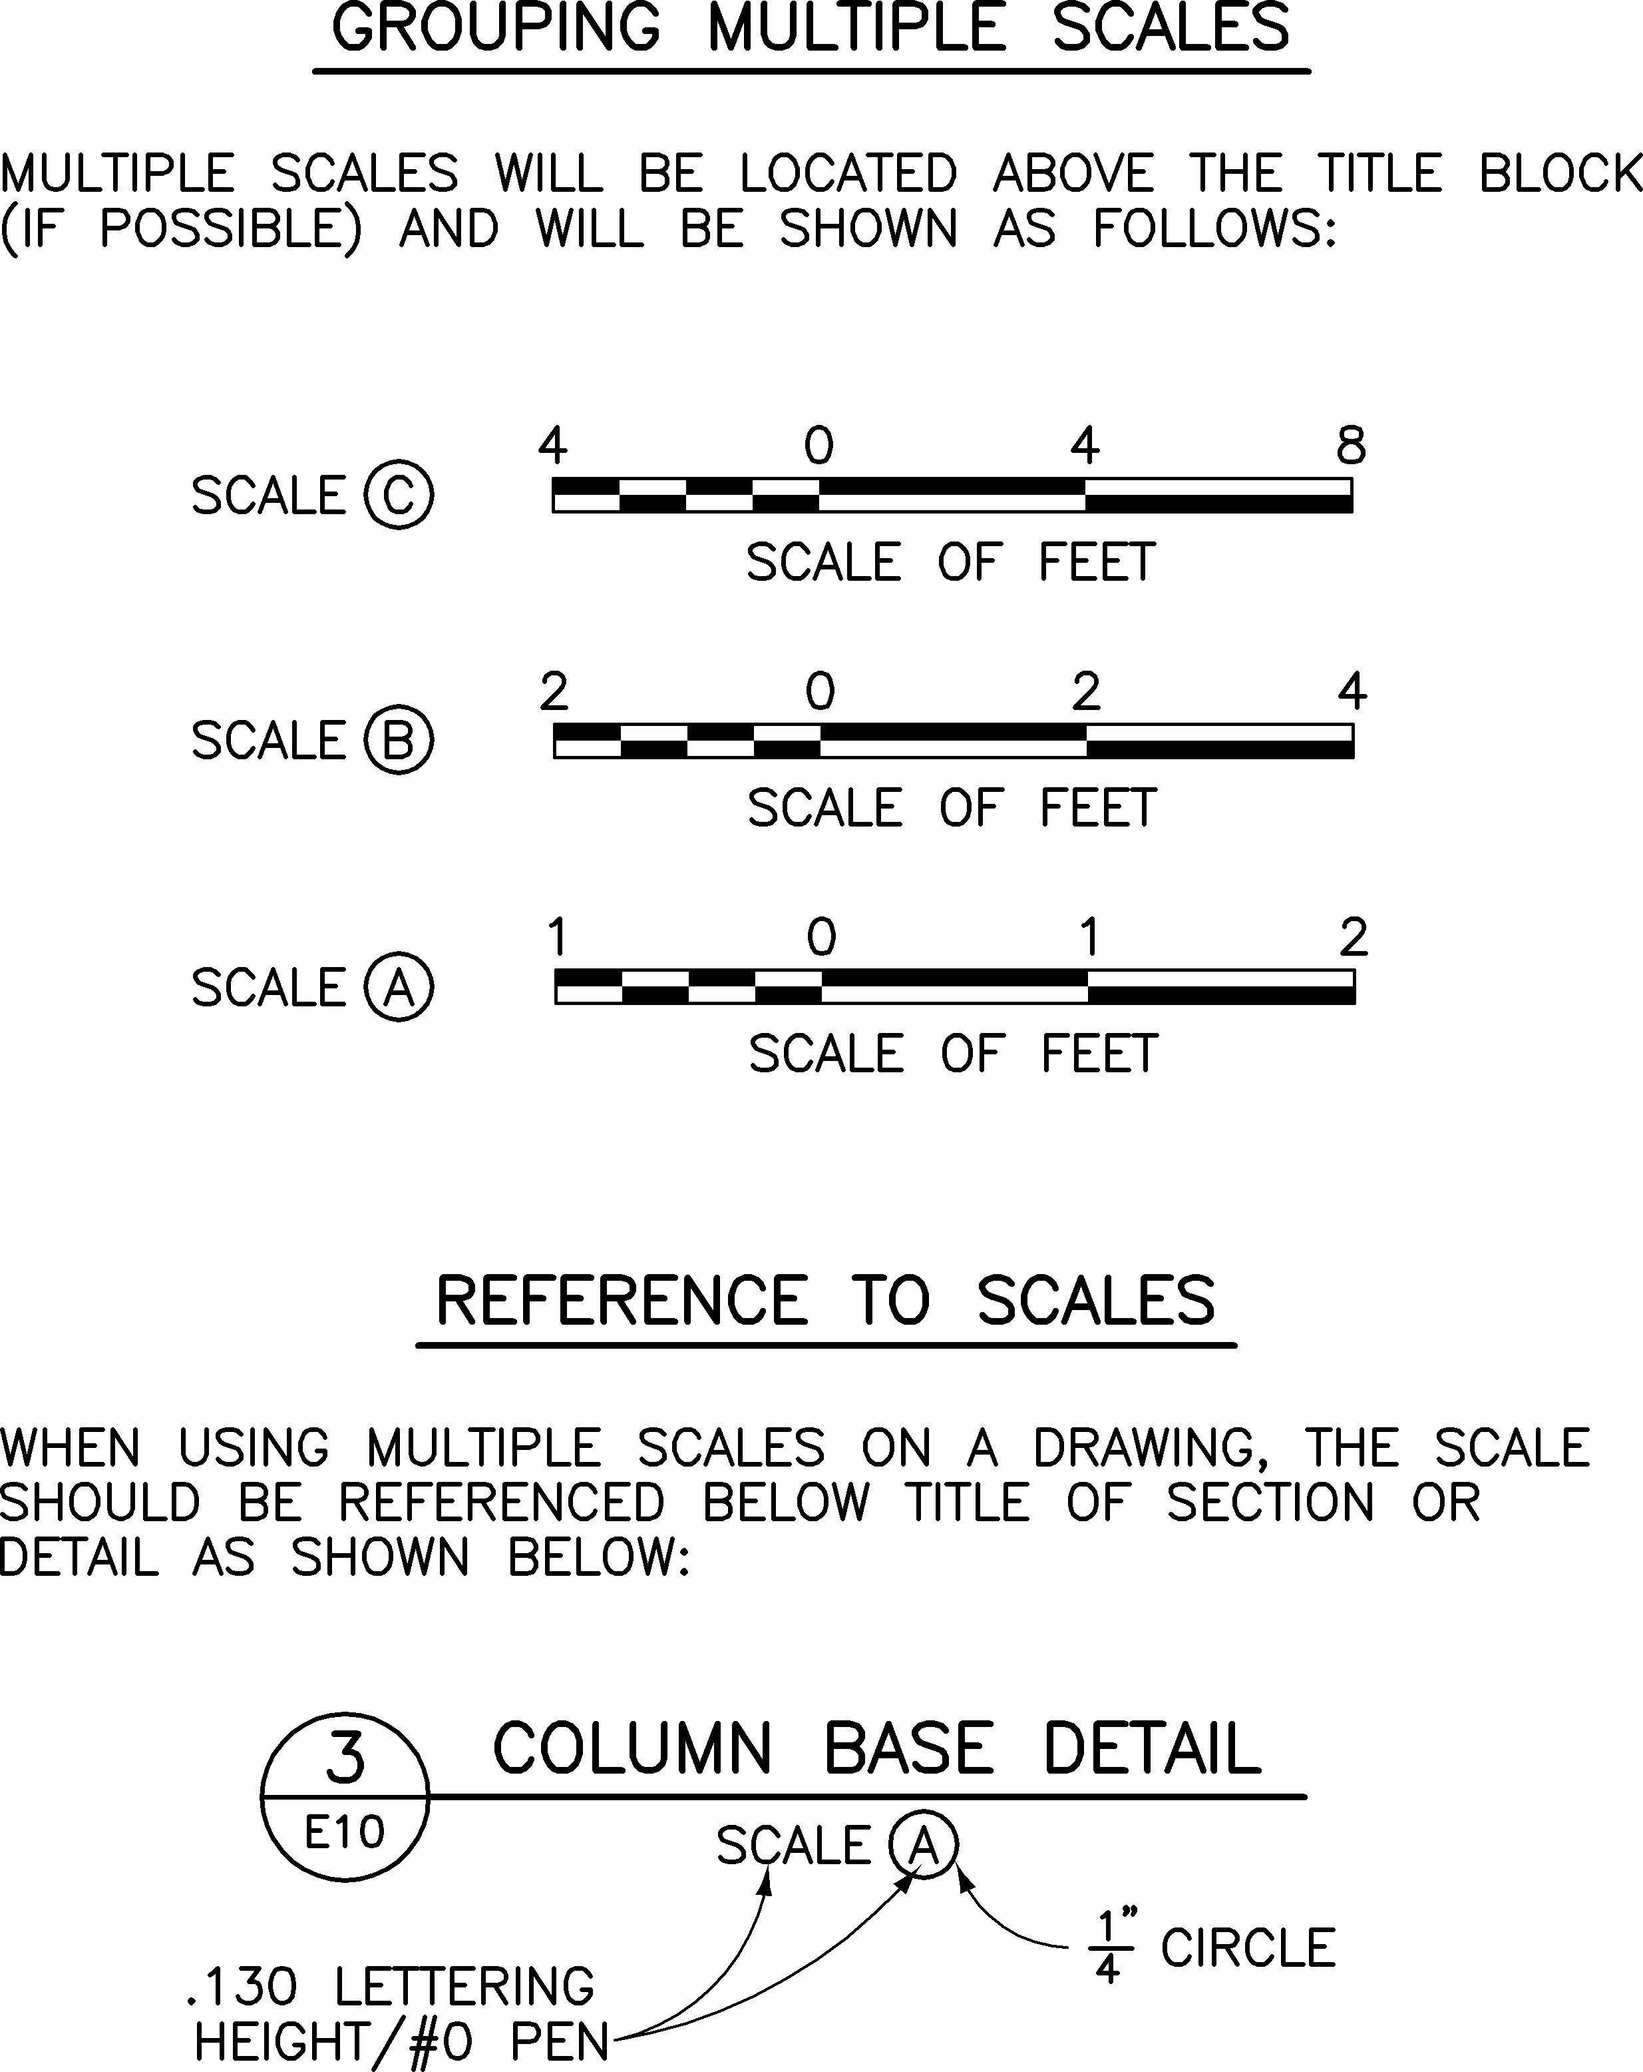
Figure 3-14 - Multiple Scales
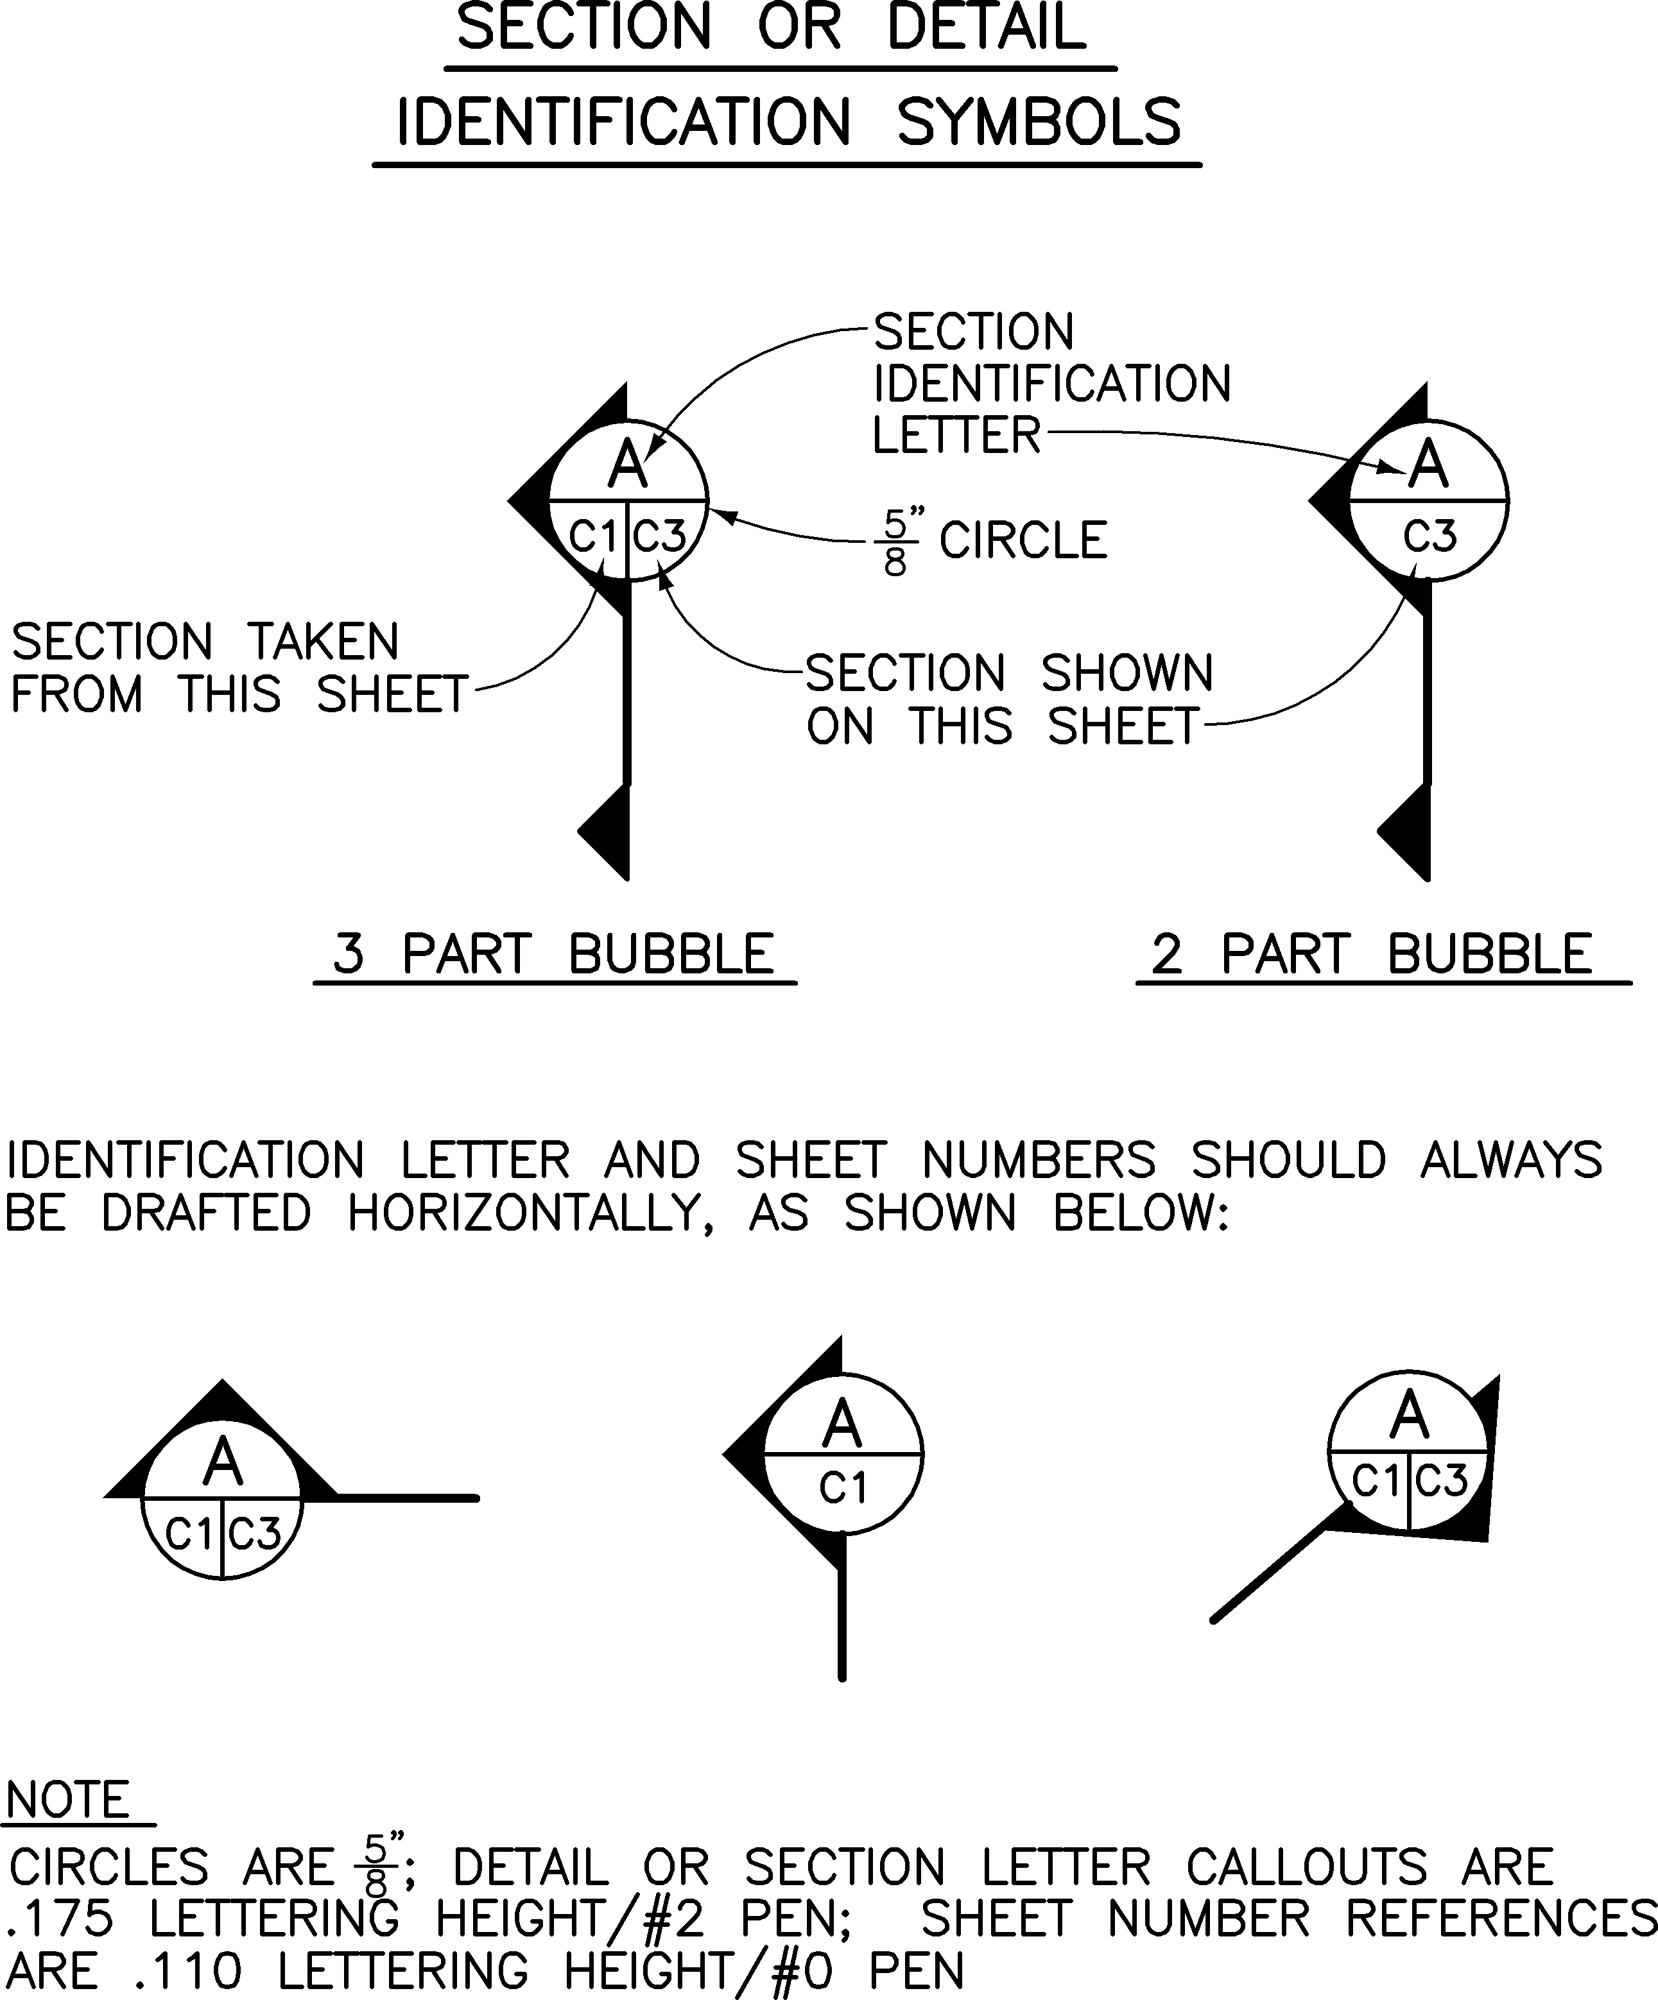
Figure 3-15 - Section or Detail Identifiation Symbols
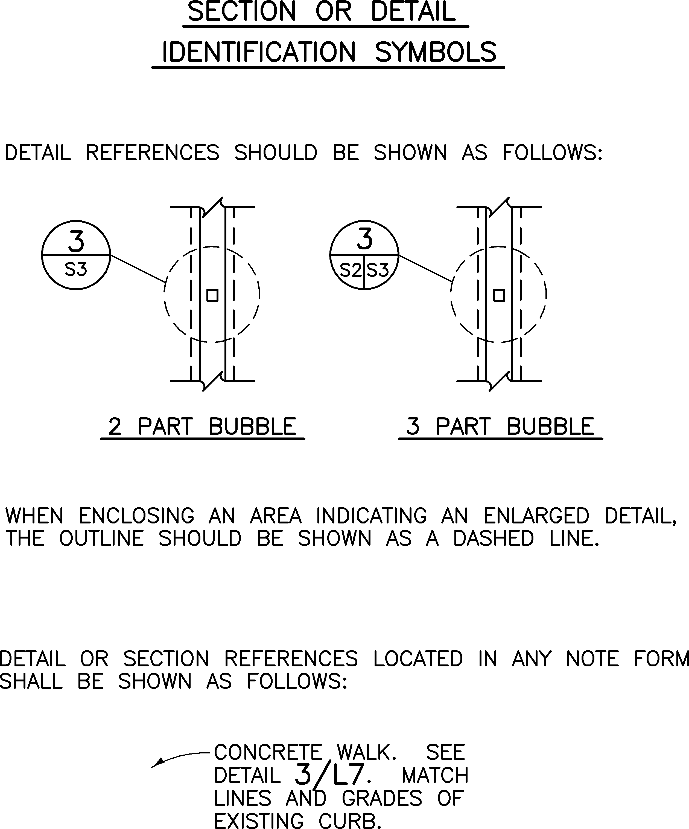

Figure 3-16 - Section or Detail Identifiation Symbols
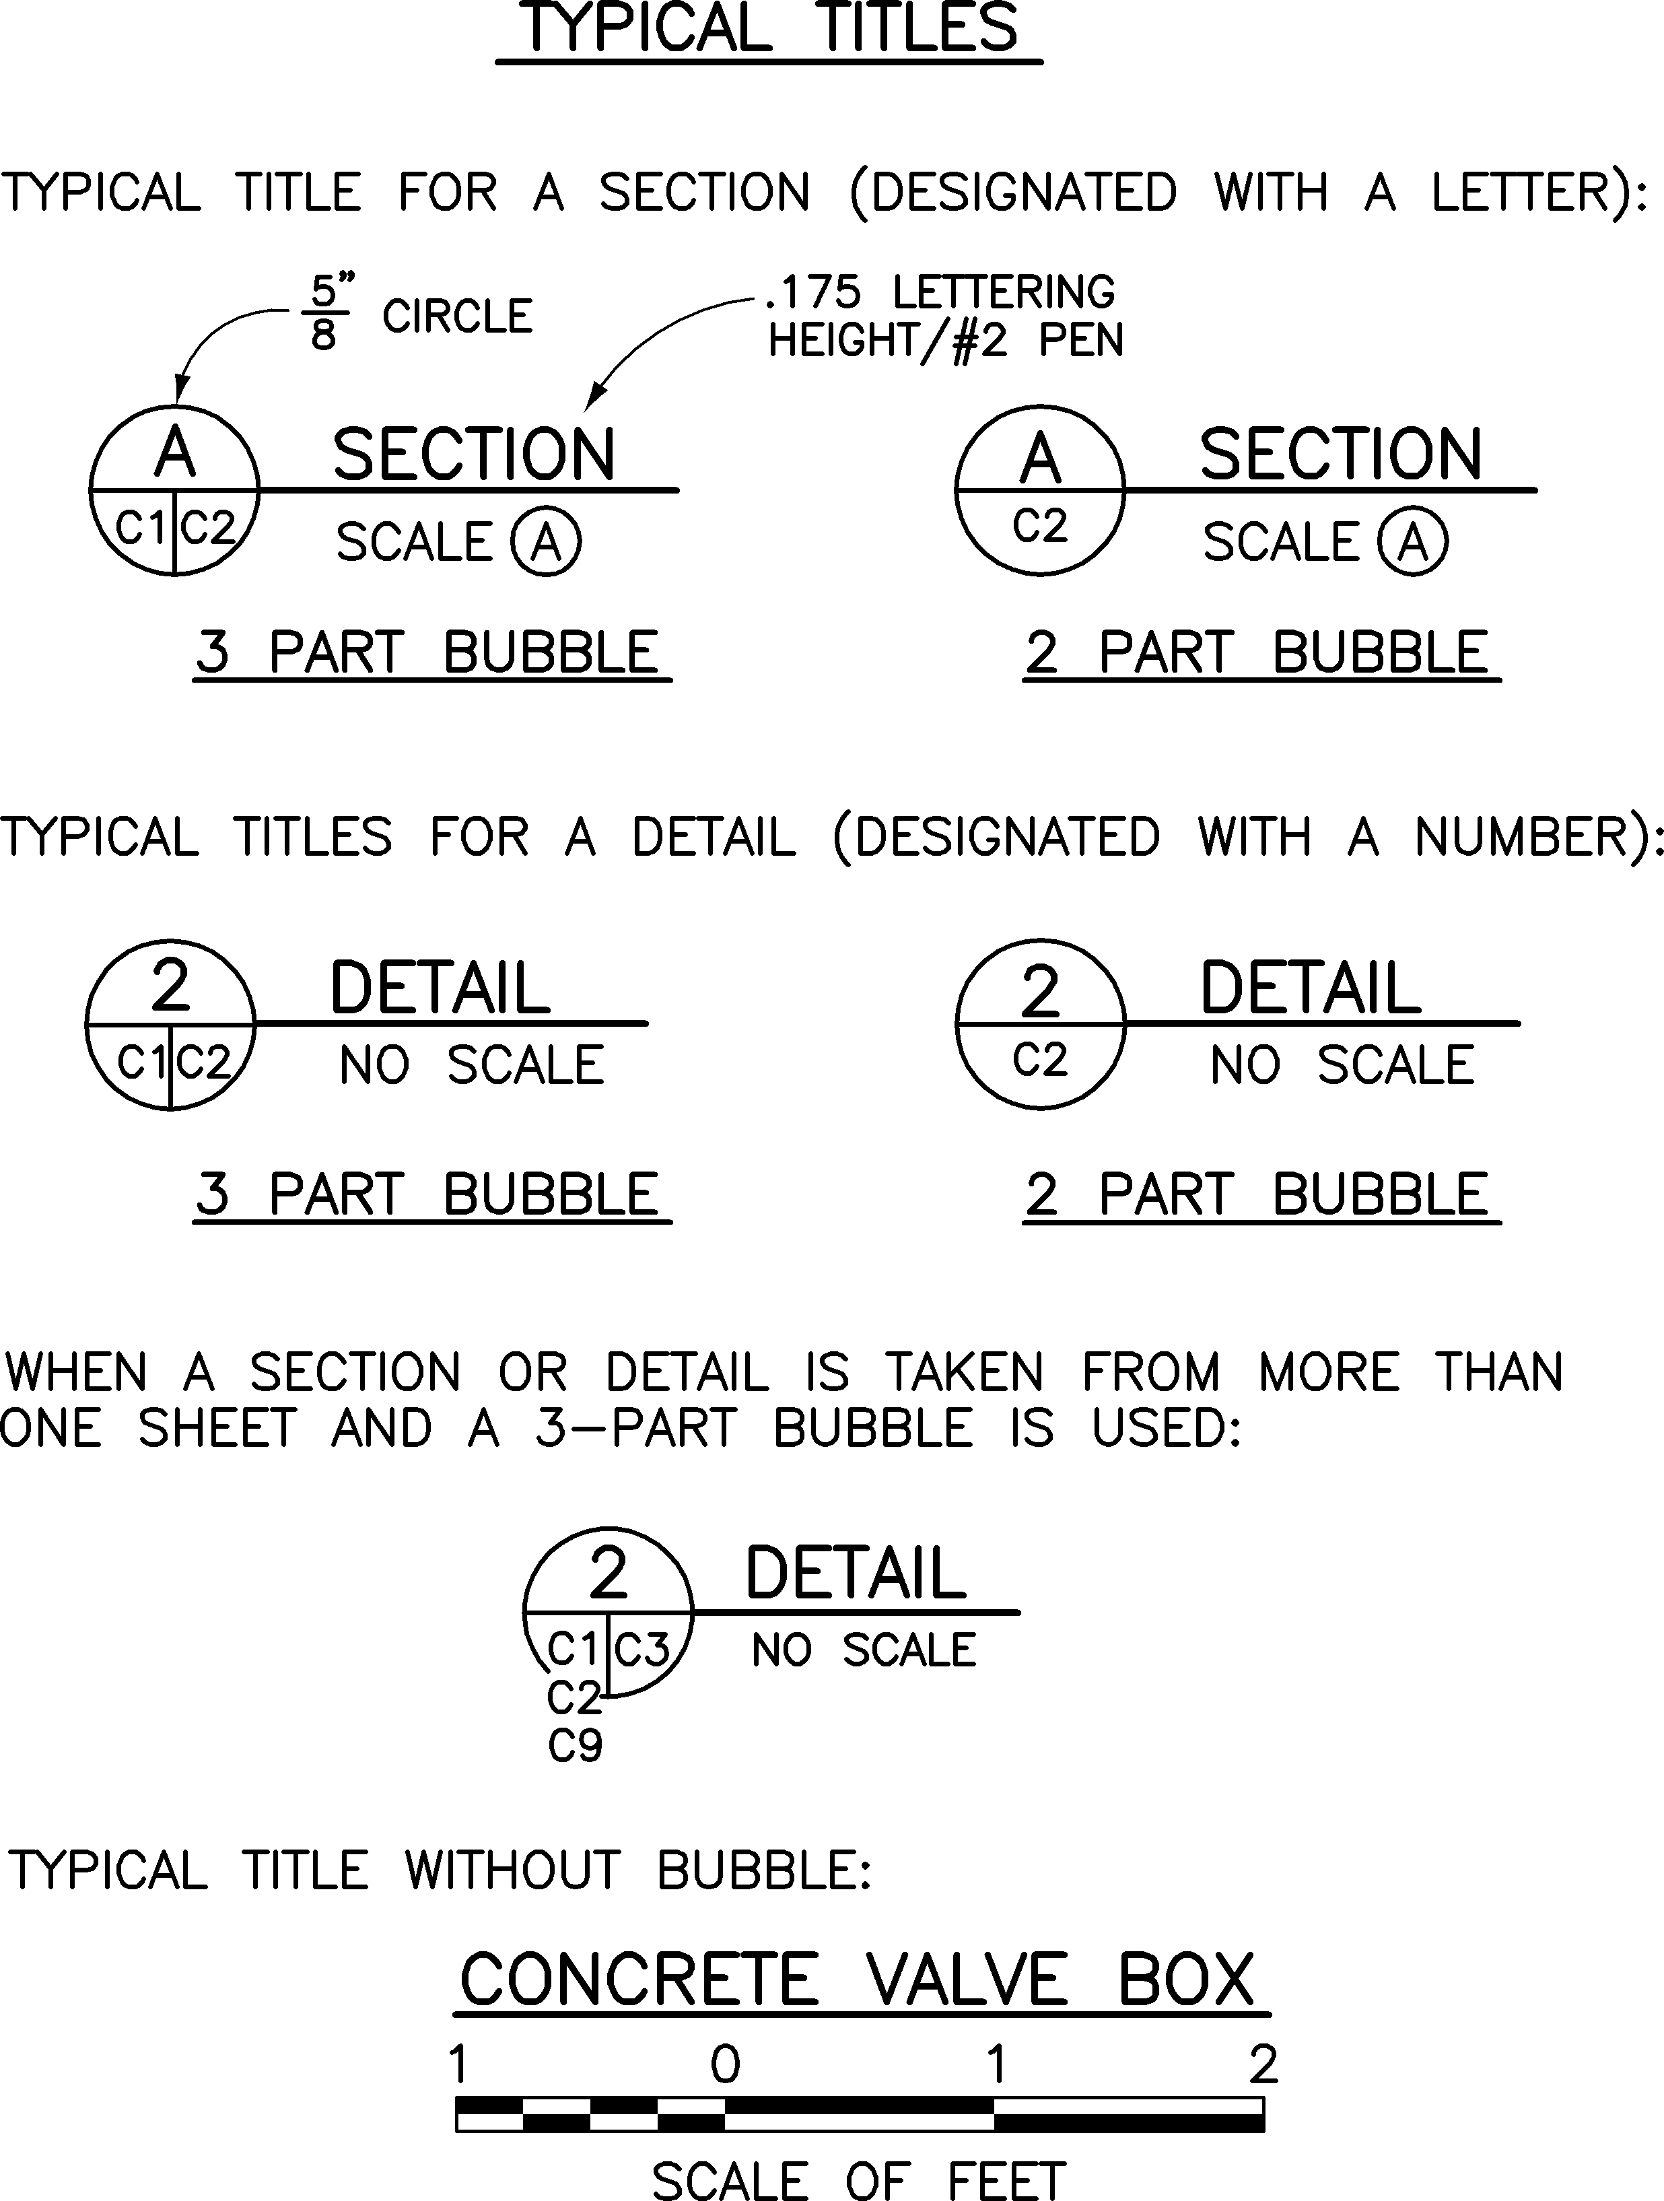
Figure 3-17 - Typical Titles
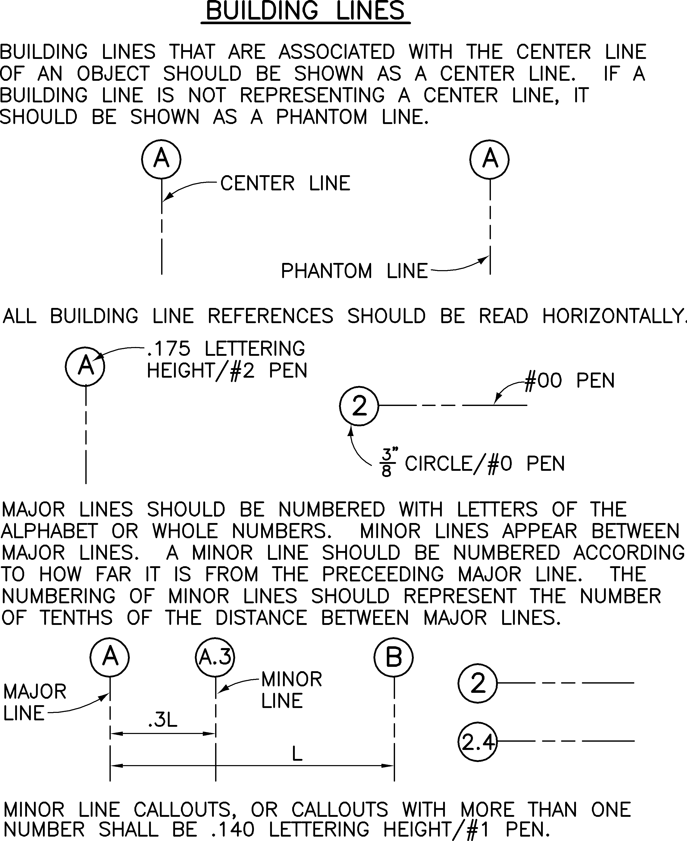
Figure 3-18 - Building Lines

Chapter 4 - Drafting Practices
NPS drawings are scanned and stored by eTIC and are often printed as half-size prints (11 inches by 17 inches). Drawings must be capable of being reproduced as clear and legible half-size prints. Line quality and adequate lettering size are essential to meet these requirements. The Construction Contractor shall provide to the NPS clearly legible drawings at all scales and in appropriate formats defined within DSC Standards.

General
Follow these drafting practices:
- Maintain even line weight.
- Avoid line congestion.
- Match line weight when making additions or changes.
- Keep drawings clean and uncreased.
- Keep erasures at a minimum, with no ghosting.
- Maintain dark, clear, sharp, uniform lines to ensure good reproduction.
- Differentiate outlines and section lines by varying the width of lines, not by changing densities. The density of the line should be constant.
- Use line work techniques for distinctive symbols and crosshatching.
- Do not use pencil for shading or toning.
- Ensure open spacing of lines and lettering.
- Clean out graphics behind text to ensure good legible drawings.

Actual Elevation Versus Reference Building Elevation
If a reference building elevation is set that is different from the actual elevation, note this on the plan sheets.

Abbreviations
Words written in full are preferred. However, abbreviations may be used if necessary to conserve space and ensure neatness and readability. Describe abbreviations in a legend and use consistently throughout a discipline. See Appendix C for NPS recommendations. Edit suggested abbreviations as needed.

Colors Used In The Review And Updating Of Drawings
Additions, changes, and corrections must be marked on check prints and as-constructed prints using the following color code:
RED--indicates additions
GREEN--indicates deletions
BLUE--indicates general notation or specific instruction to draftsman
YELLOW--indicates okay as shown (use when necessary)

Enlarged Detail
If a detail of a certain item is enlarged, show it with the same orientation as the item from which it was taken. It should not be turned 90 degrees or in reverse direction.

Layout Lines
Layout lines and guidelines used in preparing originals must be invisible on reproduced drawings and microfilm.

New Work and Existing Conditions
New work should be easily distinguishable from other information shown on the drawings. Show new work at 100% (unscreened) and show existing conditions, including text, screened at 50%. Background information shown for orientation or clarification may be screened at 50%.
Survey drawings should be shown at 100% (unscreened) to be screened later if incorporated into design drawings.

Drawings versus Specifications
Limit text within the drawings to the required notation. Avoiding duplicating information within the drawings and the written specifications.

Lettering - Sizes and Line Weights
The following line weight and lettering sizes are recommended for full-sized drawings so text is easily readable after drawings are reduced to half-size. No line weight should be less than .011 inch thickness (or .28 millimeter) if possible. When possible, use .014 inch thickness (or .35 millimeter).
Use only one type of lettering style, vertical and all uppercase.

Symbols
See Appendix C for preferred symbols and line symbols with abbreviations for the most common drawing elements. Symbols used should appear in a legend and should be used consistently throughout a discipline. Edit suggested symbols as needed.

Use of Colored Ink or Pencil
The use of colored inks or pencils on final original drawings is prohibited. USE OF INK OR PENCIL.

Line Weights
New work should be easily distinguishable from other information shown on the drawings. Show new work at 100% (unscreened) and show existing conditions, including text, screened at 50%. Background information shown for orientation or clarification may be screened at 50%.
Varying line widths on drawings substantially improve their readability. Line widths shown in Figure 4-1 were established as the standard line widths for DSC CAD drawings and now called legacy line widths. Construction Contractors currently using legacy line widths are encouraged to continue to, however DSC is recommending International Organization for Standardization's ISO 128-2:2020 Technical product documentation, General principles of representation, Basic conventions for lines (latest version), as the guide for using line widths in its electronic drawings, except as defined in EDS Chapter 3. By following the recommended line widths, legacy or ISO 128-2:2020, drawing files will be reproducible as clear and legible in all drawings.
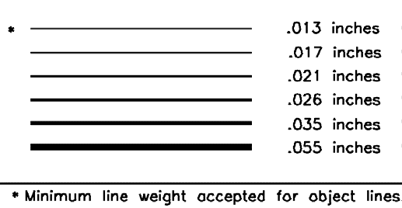
Figure 4-1 - DSC Legacy Line Widths

Pen Colors
Colors are no longer related to pen weights (line widths) that are mapped to the plotters. DSC no longer prescribes how colors are to be used in electronic drawings. Line widths in drawing files are the driving factor for readability of end product drawings. The Construction Contractor is free to use colors as needed. Please note it is the Construction Contractor’s responsibility to ensure clear and legible drawings are submitted regardless of colors used.

Lettering
Standard text height is .130 and should be maintained for most drawing annotation. A minimum lettering height of .110 is acceptable, when needed or used for special purposes such as in symbols or for stacked fractions. The following pen and lettering sizes are required for full-size drawings so text will be easily readable after drawings are reduced to half-size.
Use | Printed Height | Pen Width  Inch / Millimeter | Colors
Standard text and dimensions | 0.13 / 0.110 | 0.017 / 0.43 | Per Construction Contractor's standard format.
Sub-titles, headings | 0.14 | 0.021 / 0.53 | Per Construction Contractor's standard format.
Plan titles, detail titles, section or detail call outs | 0.175 | 0.026 / 0.66 | Per Construction Contractor's standard format.
Absolute minimum text height, used for stacked fractions, symbols | 0.110 | 0.013 / .033 | Per Construction Contractor's standard format.
Figure 4-2 - Standard Lettering Sizes
Text Height versus Printing Height: See Appendix F for reference tables addressing text height and printing height relative to model space and paper space in drawings.

Text Styles
Standard text fonts (styles) to be used on DSC drawings are True Type fonts (i.e. Arial, Arial Narrow) rather than shape files such as romans.shx. Additionally, the arch.shx font is not a standard AutoCAD font, but has been approved as an option for architectural style text. However, this font is no longer available through the NPS AutoCAD Tools, which is no longer available or supported. The shape file fonts may still be used at the Construction Contractor’s discretion, however, DSC now highly recommends using True Type fonts on all electronic drawing files produced for the DSC.
TWIZ (Text Wizard) - This NPS AutoCAD Tools command is no longer available or supported.

Leaders
A/Es are authorized to use straight or curved leaders for notes in drawings. It is the A/E’s discretion to use either curved or straight leaders. A/Es are responsible for clarity and legibility and the use of leader styles used shall remain consistent within a set of drawings.

Dimensions
DWIZ (Dimension Wizard) - Another NPS AutoCAD Tools command, similar to the text wizard, is also no longer available or supported.

Dimension Format
Dimensions 1 foot 0 inches and over should be called out in feet and inches. If a measurement other than feet and inches is accepted industry-wide to describe a product or spacing, the common measure should be used. For example:
48 inch pipe (not 4 feet pipe)
16 inch o.c. (on center) (not 1 foot 4 inch o.c.)
Both slash marks and arrows are acceptable as line terminators as long as they are consistent within a discipline.
Survey and site work layout dimensions should be feet and decimals.
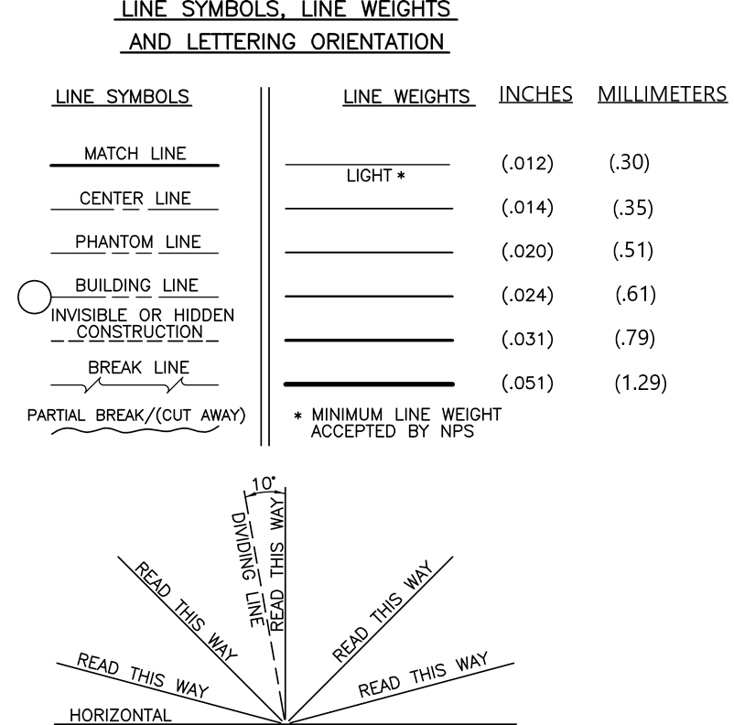
Figure 4-3 - Standard Line Symbols, Line Weights, and Lettering Orientation

Discipline Specific Guidelines

Site Work Drawings (Landscape Architecture, Civil, and Survey)
Slope designation of a utility line or a grade line of a road should be expressed as a percent of slope and the direction of the slope should be designated with a plus + or minus - symbol with an arrow. A positive slope is uphill in the direction of increasing station.
Slope designation of earthwork may be shown as run : rise. For example, 3:1, 4:1.
In special instances, slopes may be designated as inches of rise or fall per foot of run. For clarity, the direction of the slope should be designated with an arrow. For example, 1/4 inch per foot.

Architectural Drawings
On the first sheet of the architectural drawings, provide Building Code Data including:
- name and date of the major building code(s) to which the design conforms
- occupancy group
- construction type
- square footage of each building

Structural Drawings
- General Notes: Contains at a minimum:
  - design loads
  - name and date of model building code and/or design specifications to which the design conforms
  - soil bearing capacity or other foundation design values
  - structural materials description (for example, ASTM number (American Society for Testing and Matierals), allowable stresses, etc).

- Showing Elevations on Drawings:
Plan Sheets: Elevations should be shown on plan sheets (e.g. top of beam, top of footing, top of wall), as well as sections and details.

Decimal versus Feet and Inches: The method of expressing elevations should match the architectural drawings or other drawings to which the structural drawings pertain. For instance, if the building elevations on the architectural sheets are in feet and inches, the building elevations on the related structural drawings should also be in feet and inches. Elevations shown should be consistent throughout the set of drawings.
- Sections and Details:
Showing Architectural Features: Sections and details may show architectural features to enhance the information being conveyed. These architectural features should not be shown in detail but rather outlined using a phantom line.
Poche' (material symbols): Structural materials shown in section should be poche'd. When two structural steel members are shown back-to-back, reverse and stagger the hatching to increase clarity.
Use of O.C: It is normally not necessary to use O.C. to annotate on center when using the at @ symbol. It is appropriate to state O.C. in cases when panelized or modular materials are being applied to framing.
- Dimensions for Spacing of Structural Members:
Dimensions 2 feet or less: Indicated in inches.
Dimensions greater than 2 feet: Indicated in feet and inches.
- Nominal Versus Actual Size Wood:
Nominal Size: Nominal size lumber and timber should be indicated without tick marks (e.g. 2x6, 10x10).
Actual Size: Actual size lumber and timber, including glued laminated timber, should be indicated with tick marks (e.g. 8"x8" (8 inch by 8 inch), 1-3/4" (1-3/4 inches), 7-3/4" (7-3/4 inches)).
Note: For projects containing both actual size and nominal size lumber, include a statement in the General Notes explaining this convention.

- Showing Members In Framing Plans:
Single Members: Member should be shown as a solid line without span arrows.
Repetitive Members:
- Pre-Manufactured Materials: Members should be shown as the first and last two members of the layout with member identification, distance between members, how many, and spacing.
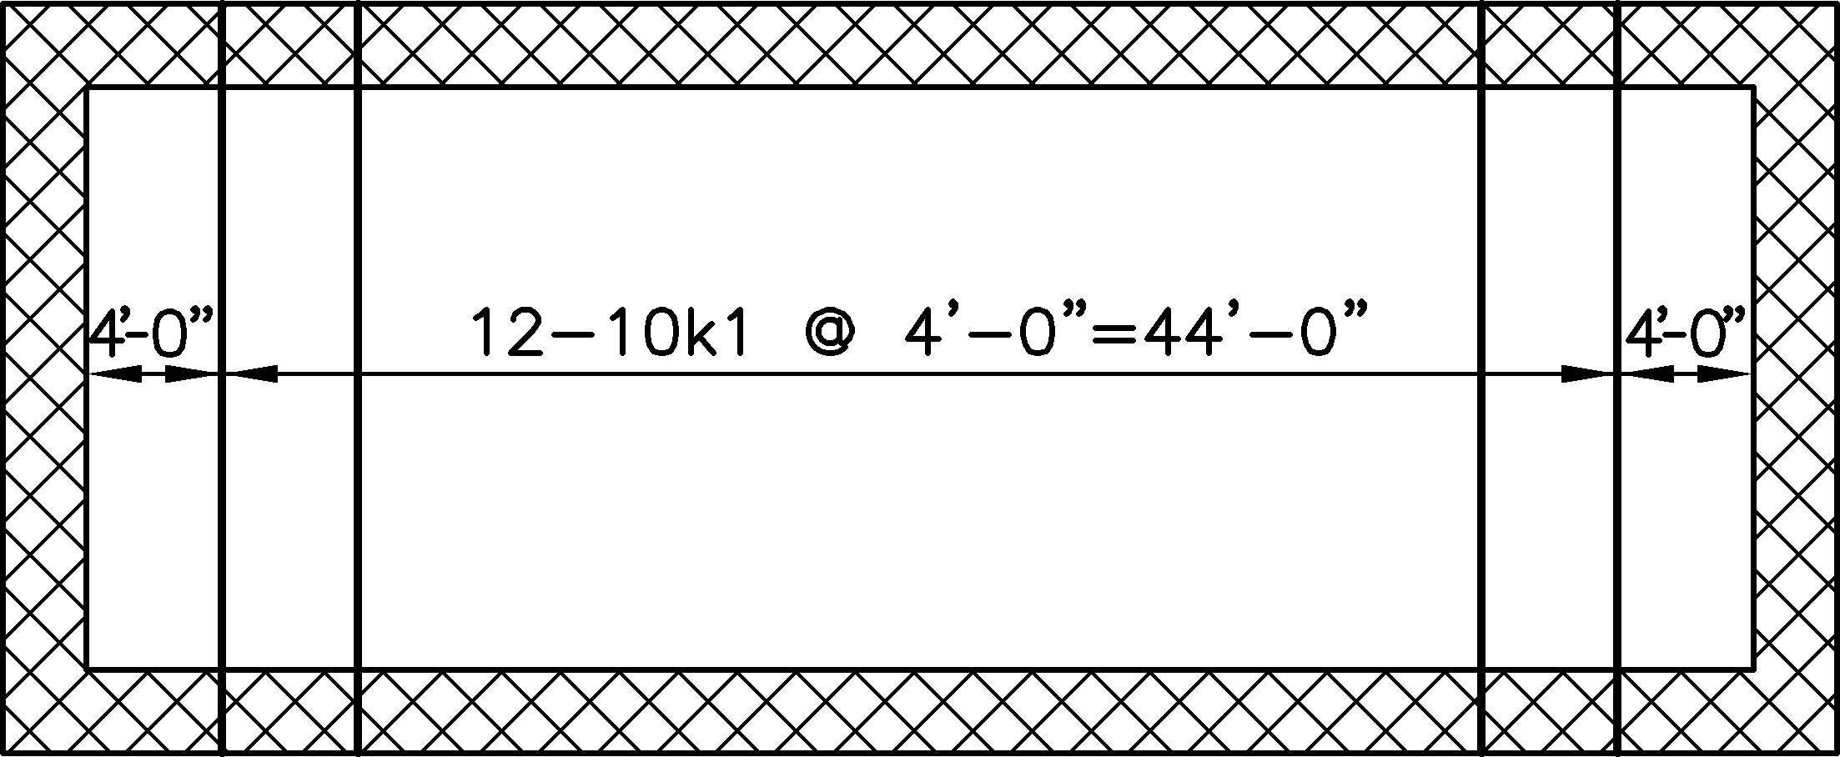
Figure 4-4 - Pre-Manufactured Materials
- 'Off-the-shelf' Materials (e.g. lumber framing): Members should be shown as one in the middle of the layout with leaders to the edges, member identification and spacing.
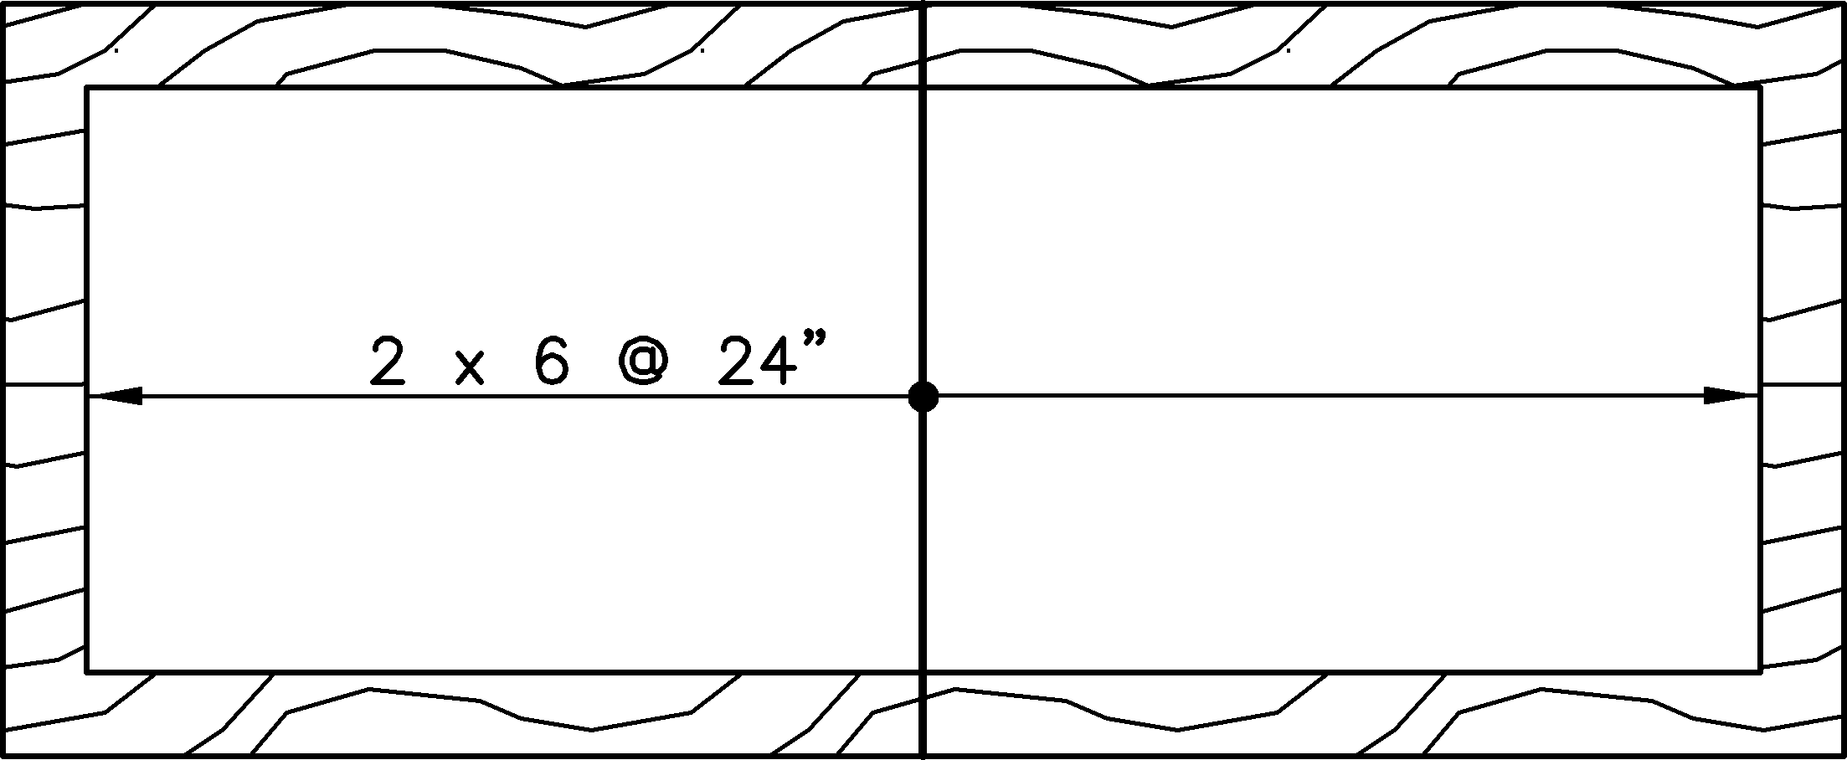
Figure 4-5 - Off-the-Shelf Materials Lumber Framing

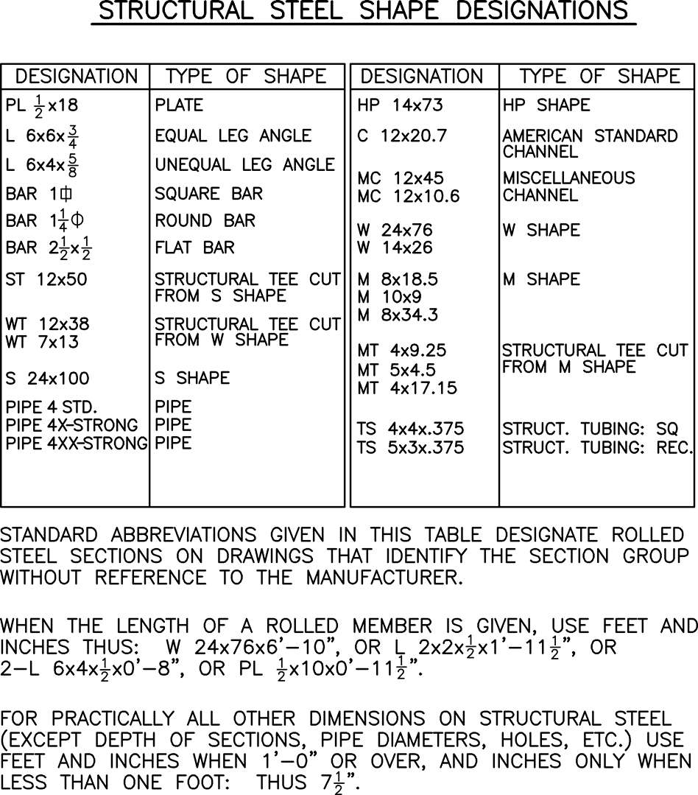
Figure 4-6 - Structural Steel Shape Designations

Standard Details
In an effort to keep layers at a minimum, the DSC layering standard for details should follow AIA NCS v6 Layer Guidelines in general and may also include user defined layers as necessary. Incorporate only the necessary layers needed for editing details easily.
The list below defines the needs that should be met to ensure compatibility with DSC AutoCAD drawings.
- Details shall be drawn full size in model space.
- Layering shall follow AIA NCS v6 Layer Guidelines.
- Dimension style should be associative.
- Use standard DSC text styles (True Type Fonts).
- Hatch should be associative.
- Hatch boundary - Use a-no plot polyline (on a not plot layer) to create boundary for hatch.
- Creator shall use the a-no plot layer for user information such as plot scale, etc.
- Place user information below the detail on this z-no plot layer.
- Details should be drawn following the Standards to insure half-size reproducibility

Drafting and Detailing References
The following is a list of detailing manuals used by the National Park Service to prepare drawings. DSC recommends using latest edition of these manuals as guidelines for detailing construction in NPS projects.
Concrete: American Concrete Institute (ACI)
Standard, Details and Detailing of Concrete Reinforcement, ACI 315
ACI Detailing Manual, SP-66
Steel: American Institute of Steel Construction (AISC)
Detailing for Steel Construction
American Welding Society (AWS) / American National Standards Institute (ANSI)
Symbols for Welding and Nondestructive Testing, ANSI/AWS A2.4
AWS Structural Welding Code/Steel, ANSI/AWS D1.1
Timber: American Institute of Timber Construction (AITC)
Timber Construction Manual, AITC 104, Typical Construction Details
Masonry: Reinforced Masonry Engineering Handbook, Clay and Concrete Masonry, 5th Edition, by James E. Amrhein
Designing and Detailing Masonry, by Christine Beall
Precast Concrete: Prestressed Concrete Institute (PCI)
PCI Drafting Handbook, MNL­119
Electrical: American National Standards Institute (ANSI)
ANSI Y32.2 Graphic Symbols for Electrical and Electronic Diagrams
ANSI Y32.9 (Control)
HVAC: American Society of Heating, Refrigerating and Air Conditioning (ASHRAE)
ASHRAE Handbook ­ Fundamentals, Abbreviations and Symbols
Plumbing: American Society of Plubming Engineers (ASPE)
ASPE Data Book
Plumbing Fixtures: American National Standards Institute (ANSI)
ANSI Y32.4, Graphic Symbols for Plumbing Fixtures
Fire Sprinkler: National Fire Protection Association (NFPA)
NFPA 170, Standard for Fire Safety Symbols

Customization

NPS AutoCAD Tools
The NPS AutoCAD Tools are no longer available or supported by the Denver Service Center. The Construction Contractor shall implement current best practices when using their CAD/BIM software to develop design and construction drawings which meet the requirements in the EDS. The accuracy and adequacy of design and drafting work and its compliance with the applicable standards remain the responsibility of the architect, engineer, designer, or drafter. Nothing contained in this EDS shall be construed as relieving the engineer, designer, or drafter of their individual responsibility for producing quality drawings.

Printing AutoCAD Drawings for DSC

CTB Files
When plotting AutoCAD drawings, the software controls the final output through the use of CTB (color-dependent plot style tables) files. The CTB files identify pen assignments related to color. The Construction Contractor may use any color assignments as long as the line weights align with the EDS.
Drawings created for DSC shall be plotted using the CAD.ctb file that was developed by the Construction Contractor when creating drawing files for the project. BIM does not use .ctb files. The NPS_HP_GRAYSCALE.ctb, which was included with the NPS AutoCAD Tools, is no longer available or supported. The Construction Contractor shall create their own .ctb file or other native files (BIM) required to meet the standards for drawings in the EDS. The .ctb/native plot file must be set up in relation to the line weight configurations called for in the EDS, which must be maintained for archival and retrieval of files.
Only one .ctb pen settings file is required (AutoCAD 2000+) for both half-size and full-size prints. (Use scale line weight feature.)
Important plotting standards to be followed for archiving and maintainability include:
- Drawings are to be plotted using paper space.
- DSC border sheet will always be inserted at full-size in paper space.
- Full-size plots are achieved by plotting at a 1:1 scale. Half-size plots are achieved by plotting at a 1:2 scale. Do not create two layouts - one full-size and one half-size.
- Construction Contractor must create their own .ctb/native file to include gray scale requirements.
- Do not rename the .ctb file.
- Do not draw objects outside the border lines (plot Extents).
- Use no-plot color to hide viewport border.
- No paper trim lines.
See CAD/BIM & Drafting QA Review Checklist for additional assistance.

Deliverables and Data Exchange

General
The following information can be used as a partial checklist of pertinent items before submitting work for approval. For a more complete checklist, see the CAD/BIM & Drafting QA Review Checklist.
- Use a CAD or BIM equivalent software to prepare drawing files.
- One .dwg = one sub-sheet
- Use DSC folder structure and file naming conventions.
- Use relative path names for external references.
- Use EDS requirements to set up line weight configuration not color dependent.
- Standard minimum text height is .130, but .110 can be used in special cases.

Delivery Media
For required deliverables (electronic and hard copy), see Hard Copy & Electronic Submittal Requirements, Design Deliverables, for Design-Bid-Build (DBB) and Design-Build (DB) and the CAD/BIM & Drafting QA Review Checklist.

Archival Quality

General
The National Park Service is responsible for the lifetime administration and maintenance of its buildings. Therefore, it is imperative that the material used for documentation of the properties or documentation of previous or current alterations to those properties meets a minimum 100 year life expectancy.
Archives are records deemed to have continuing value and are therefore retained beyond the period in which they are actively used and are important cultural resources. The NPS archives and maintains records as evidence of the government's policies and operations. These archival records are useful for historical or research purposes and to inform design for future work.

Wet Ink Printer and Ink Jet Printers
Drawing sheets produced using printers are acceptable as long as the ink is waterproof, pigmented, is a permanent base ink, and is not diluted. Lettering and line density shall be 100% black.

Use Of Photographic Reproduction
When photo drawing techniques are used (for example, photos of a site or building), they must supply a half-size, high quality bond of the photo drawing sheet, in addition to supplying the full-size original to the National Park Service.

Chapter 5 Construction Drawings

Construction Drawings

Sheet Order
Each discipline's drawings should be organized in a logical sequence which agrees with the drawings of other disciplines in the drawing set. Each discipline should begin with an overview and then become more detailed. Discipline specific notes, legends, code references, and abbreviations should be located on the first sheet of each discipline. A list of abbreviations and a legend may be combined with other disciplines into an overall listing, which is shown at the beginning of the overall set of drawings in the General section.
A typical drawing set should be in the following order:
DRAWING TYPE SUB-SHEET
Cover Sheet
* Index
General…………………………………….. G
Civil………………………………………... C
Roads
Parking
Site Utilities
Grading Plan
Landscape………………………………….. L
Architectural……………………………….. A
** Structural……………………………….. S
Mechanical………………………………… M
HVAC
Plumbing/Piping
Fire Protection
*** Electrical…………………………..…… E
Power
Lighting
Fire Detection
Intrusion Detection
Lightning Protection
* The index should be placed on the cover sheet if possible.
** Plans of a structural set should be placed before the sections and details sheets (i.e. foundation, floor, and roof framing plans should precede any of the associated sections and details).
*** The following sequence should be used: legend and abbreviations, general notes, site plan, power plan, one line diagram, lighting plan, fire and intrusion plan, lightning protection, schedules, control wiring diagrams, and control cabinet layouts.

Sub-sheet Designation and Numbering
Sub-sheet numbers should normally begin with the first letter of the discipline. For example, civil engineering work should begin with C, landscape design work with L, etc. If a discipline has more than one sub-function, these may have separate sub-sheet letters. Whole numbers should normally be used to number sub-sheets (for example M1, M2, etc.). If the project is divided into discrete areas, the designers may choose to use fractional sub-sheet numbers to differentiate the areas (for example A1.1, A2.1, etc.)

Alternative Sub-sheet Designation and Numbering
An alternative to standard sheet number requirements has been developed due to an increasing number of large-scale projects which tend to stretch the capabilities of the standard number systems for projects.Utilizing best practices from industry. the DSC is recommending the following as an alternative numbering system for larger projects.
Sheet numbers will be divided into six digits composed of four different designators for each set of drawings. The first two numbers would represent the project area of the overall project for the subject set of drawings. This is especially important if there are project areas widely separated geographically. These are called area designators, see Figure 5-1.
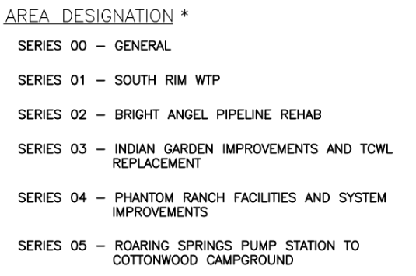
Figure 5-1 - Area Designators
The next digit in the sheet number would be for the discipline presented on the subject sheet. See Figure 5-2 for a list of typical disciplines.
The next digit in the sheet number would be for the sheet type for the information presented on the subject sheet. Sheet types such as plans, elevations, sections, etc. would be identified by this designator. Refer to Figure 5-3.
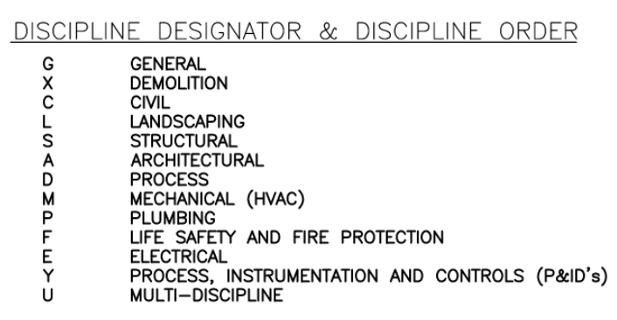
Figure 5-2 - Sheet Discipline Designators
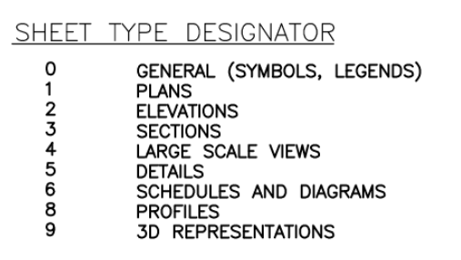
Figure 5-3 - Sheet Type Designators
The last two digits would represent the actual sheet number of the discipline and type of sheet. Refer to Figure 5-4 for a chart showing an example of how this works graphically.
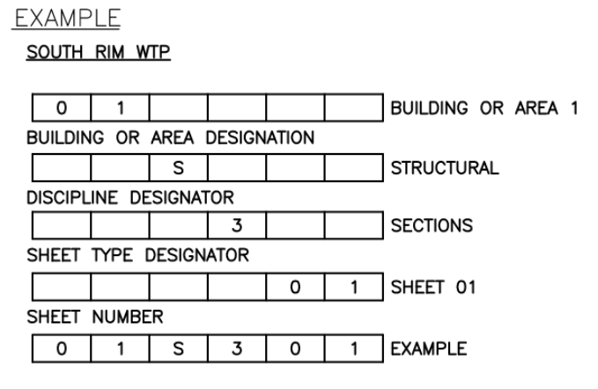
Figure 5-4 - Sheet Numbering Example
The general symbols and legend sheet on the following page is a good example.

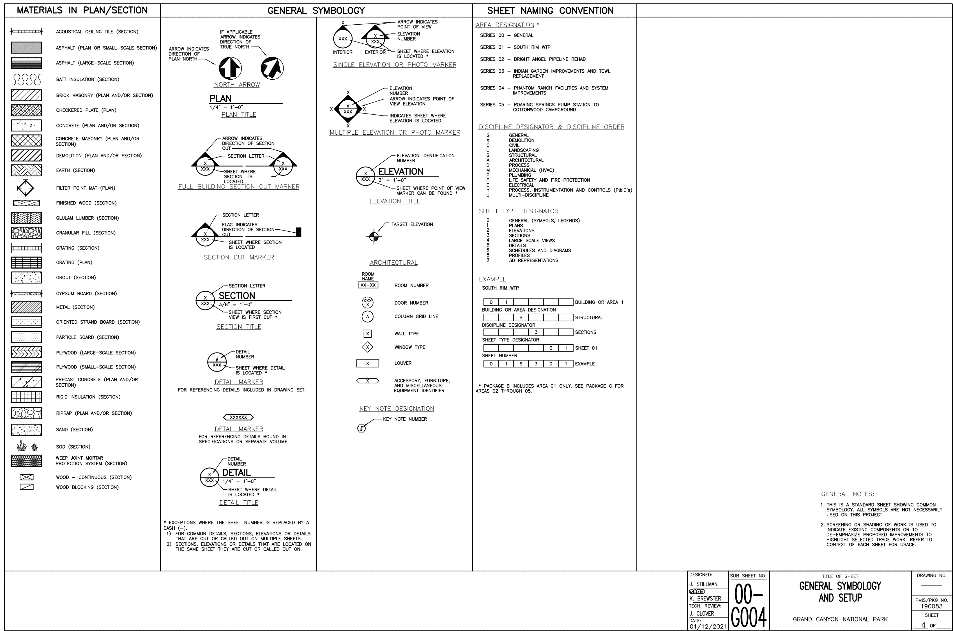
Figure 5-5 - Materials in Plan/Section, General Symbol, and Sheet Naming Convention

Appendix A

General Materials Symbols
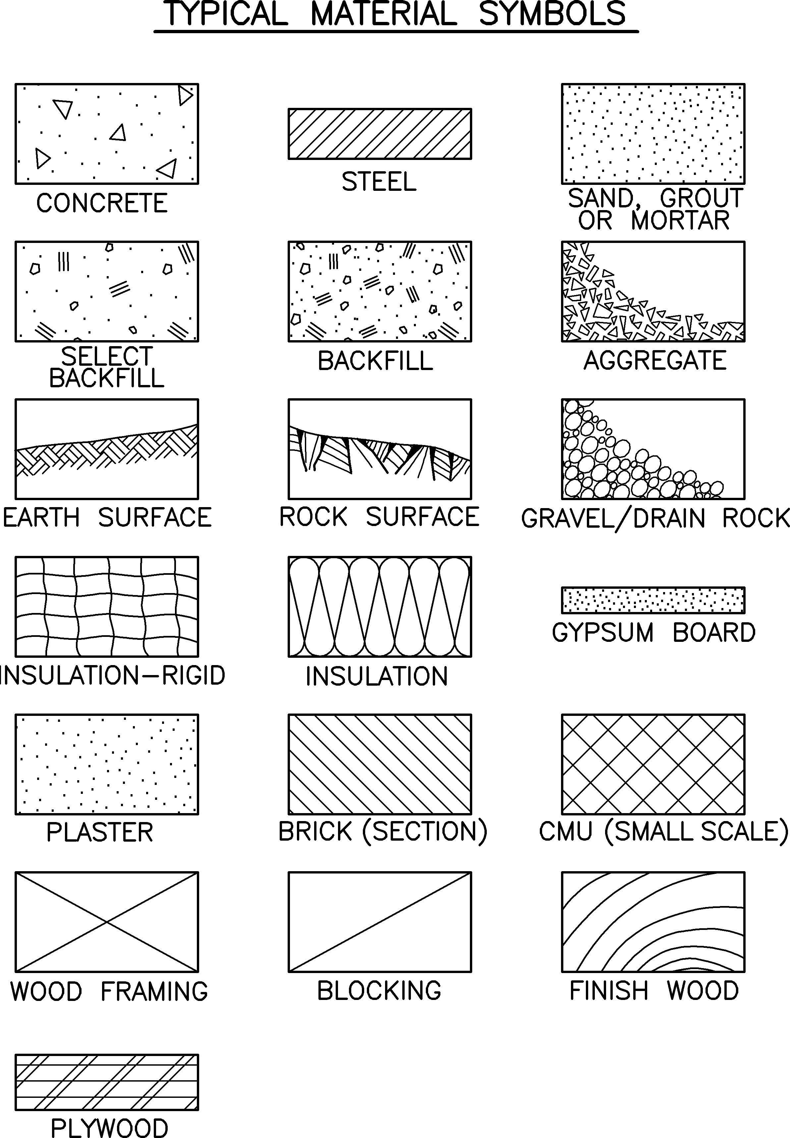
Figure A-1 - Typical Material Symbol

Appendix B

Sample Survey Sheets
Sample Survey Index Sheet
Sample Topographic Survey (Developed Area)
Sample Topographic Survey (Undeveloped Area)
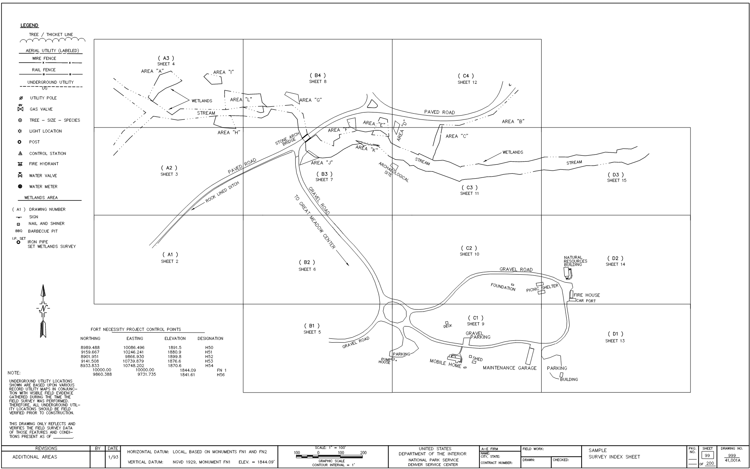
Figure B-1 - Sample Survey Index Sheet

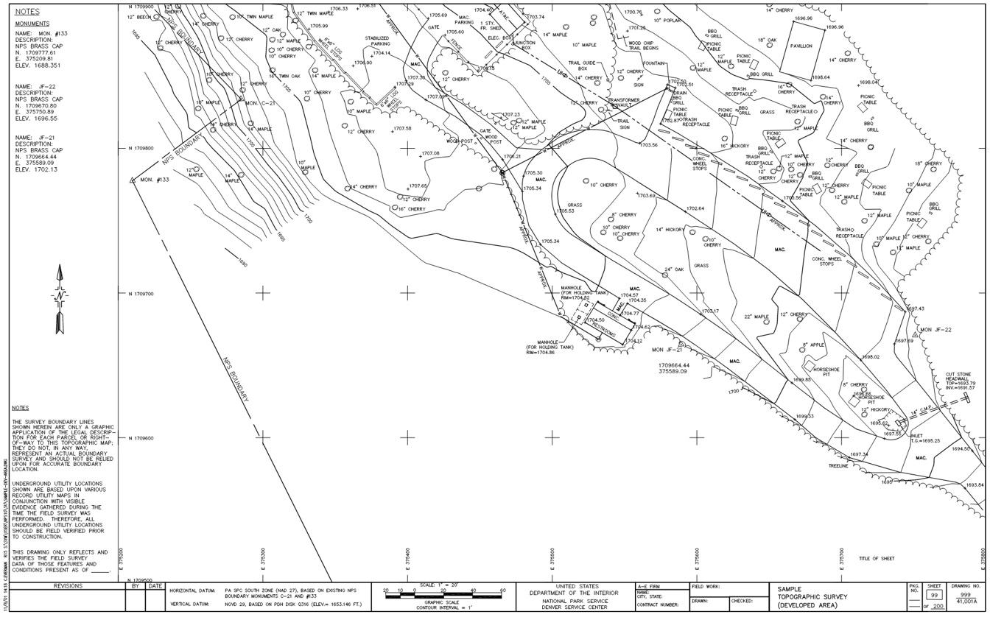
Figure B-2 - Sample Topographic Survey (Developed Area)

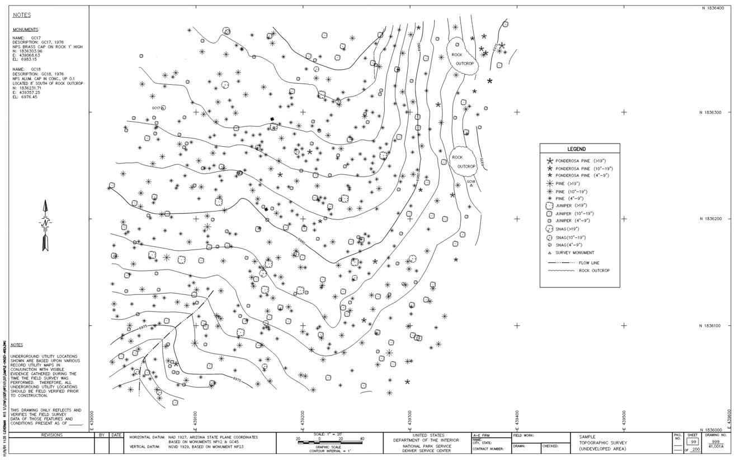
Figure B-3 - Sample Topographic Survey (Undeveloped Area)

Appendix C

Standard Abbreviations, Standard Symbols, and Sample Construction Drawings
SHEET SUB-SHEET TITLE OF SHEET
1 SAMPLE COVER SHEET
2 G1 SAMPLE PROJECT OVERVIEW SITE PLAN
3 C1 SAMPLE ABBREVIATION SHEET
4 C2 SAMPLE SYMBOL SHEET
5 C3 SAMPLE MAPPING SYMBOLS
6 C4 SAMPLE PARKING AREA LAYOUT
7 C5 SAMPLE PARKING AREA GRADING PLAN
8 C6 SAMPLE ROAD PROFILE AND SECTIONS
9 C7 SAMPLE ROADWAY CROSS SECTIONS
10 C8 SAMPLE ROADWAY PLAN AND PROFILE
11 C9 SAMPLE WATER LINE PLAN AND PROFILE
12 C10 SAMPLE SEWER PLAN AND PROFILE
13 C11 SAMPLE STANDARD DETAILS
14 C12 SAMPLE PLAN AND DETAILS FOR ROADWAY
SIGNS AND PAVEMENT MARKINGS
15 L1 SAMPLE SITE PLAN BUILDING TERRACE
16 L2 SAMPLE LANDSCAPE PLAN AND DETAILS
17 L3 SAMPLE VISITOR CENTER IRRIGATION LAYOUT
18 A1 SAMPLE FLOOR PLAN
19 A2 SAMPLE RENOVATION FLOOR PLAN
20 A3 SAMPLE ELEVATIONS
21 A4 SAMPLE SECTIONS
22 A5 SAMPLE DETAIL SHEET
23 S1 SAMPLE FOUNDATION AND FLOOR FRAMING PLAN
24 S2 SAMPLE FOUNDATION PLAN / ROOF FRAMING PLAN
25 S3 SAMPLE SECOND FLOOR FRAMING PLAN
26 S4 SAMPLE ROOF FRAMING PLAN
27 S5 SAMPLE FOUNDATION DETAILS
28 S6 SAMPLE FIRST FLOOR FRAMING SECTIONS
29 S7 SAMPLE ROOF BRACING AND DIAPHRAGM PLAN
AND JOIST BEARING DETAILS
30 M1 SAMPLE LEGEND
31 M2 SAMPLE HVAC FLOOR PLAN
32 M3 SAMPLE HVAC SECTIONS
33 M4 SAMPLE HVAC FLOW DIAGRAMS
34 M5 SAMPLE WATER SUPPLY PLAN
35 M6 SAMPLE WASTE AND VENT PLAN
36 M7 SAMPLE WASTE AND VENT ISOMETRIC
37 M8 SAMPLE FIRE PROTECTION PLAN
38 E1 SAMPLE ELECTRICAL ABBREVIATIONS
39 E2 SAMPLE ELECTRICAL SYMBOL LEGEND
40 E3 SAMPLE ELECTRICAL AND TELEPHONE SITE PLAN,
ONE LINE DIAGRAM
41 E4 SAMPLE POWER AND LIGHTING PLAN, SCHEDULES,
AND CONTROL SCHEMATIC
42 E5 SAMPLE CONTROL WIRING DIAGRAM
43 E6 SAMPLE FIRE / INTRUSION ALARM, RISER DIAGRAM,
AND LIGHTING PROTECTION
Note: These drawings are a sampling of design work of all disciplines for the National Park Service. They are not meant to represent a complete set of construction drawings. Each sheet should be viewed as an individual sheet representing good design drafting practices. Section and detail bubbles, sheet numbers, sub-sheet numbers, etc., will not cross reference.
(Insert PDF Sample Sheets Here)

Appendix D

Sample Amendment or Modification
SAMPLE COVER SHEET
SAMPLE REVISED SHEET

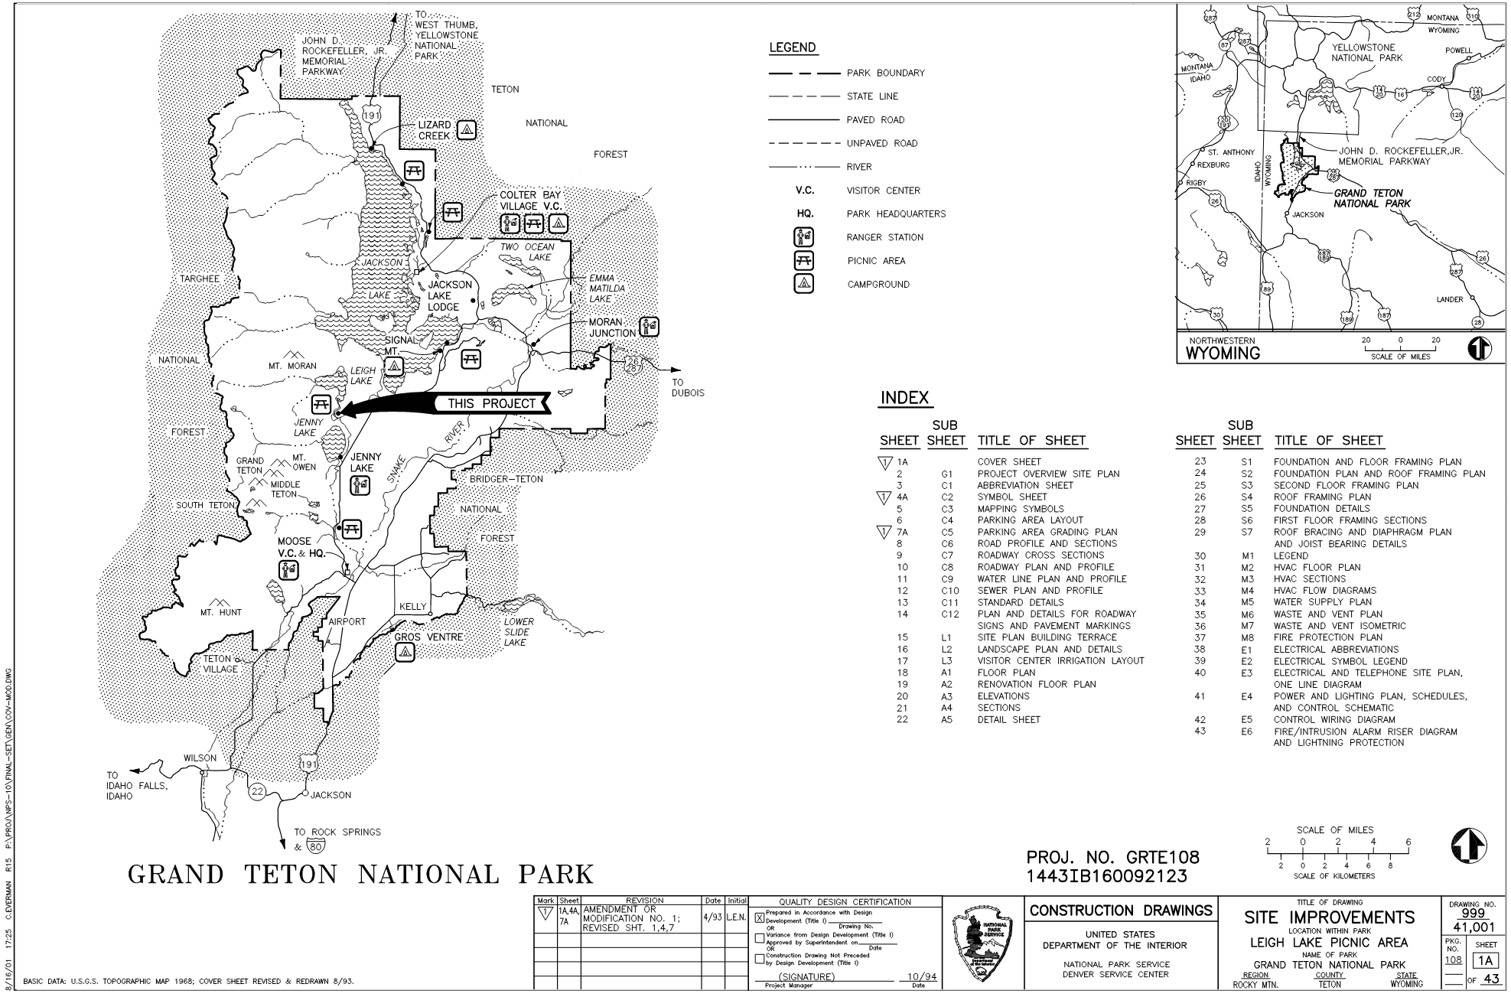
Figure D-1 - Sample Cover Sheet
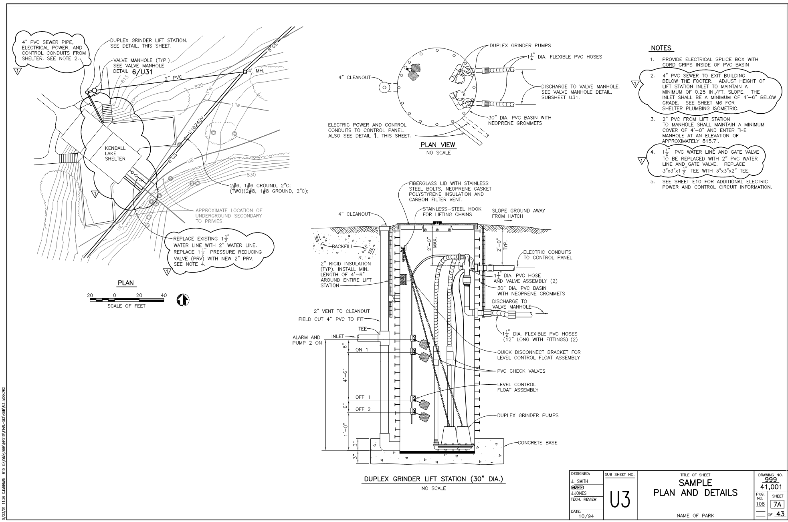
Figure D-2 - Sample Revised Sheet

Appendix E

Sample As-Constructed Drawing Cover Sheet
SAMPLE COVER SHEET

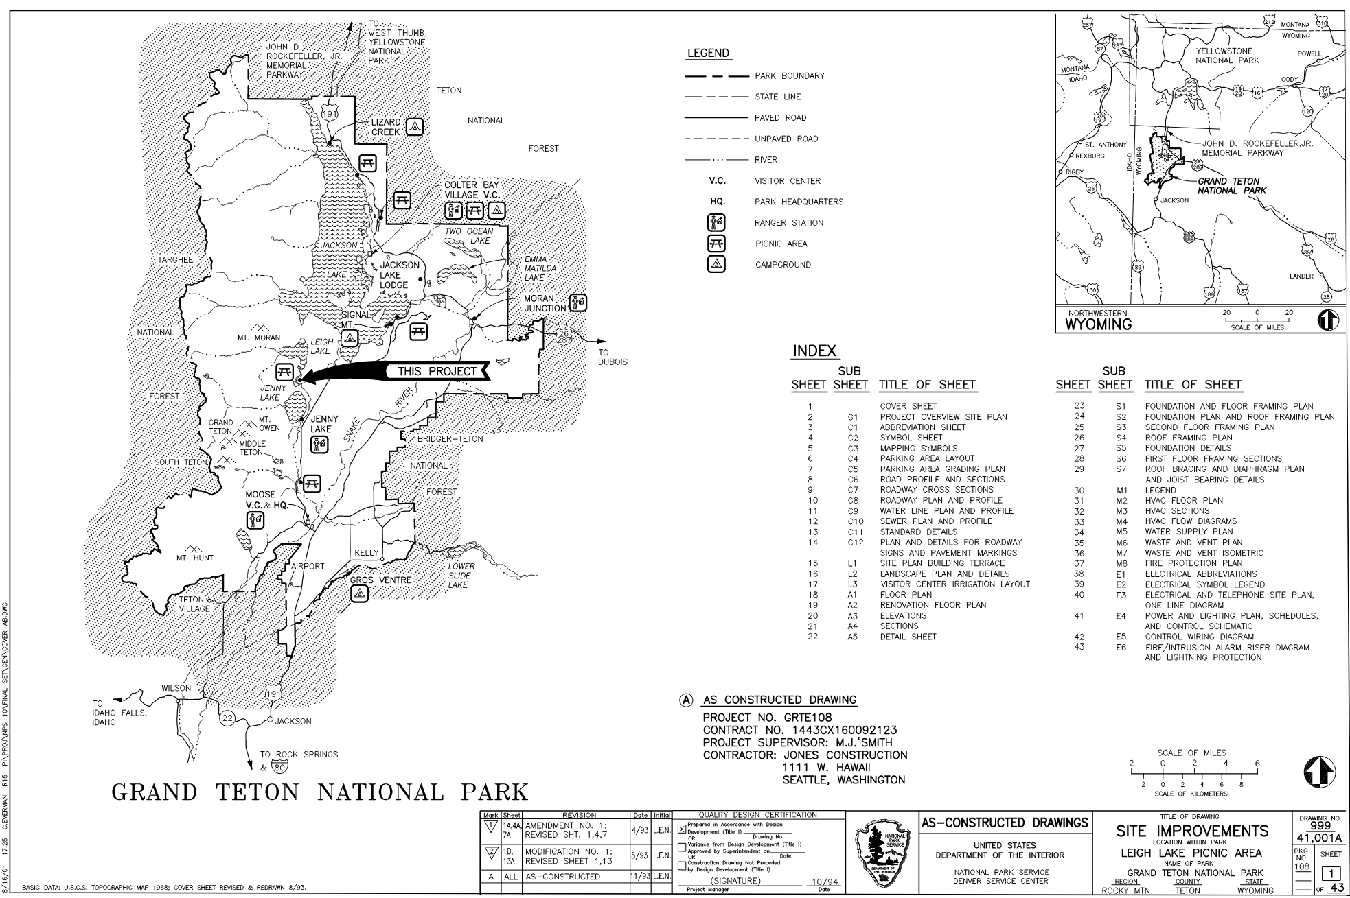
Figure E-1 - Sample As-Constructed Drawing Sheet Cover

Appendix F

Text Height versus Printing Height (Relative to Model Space)
When Model Space Drawing Unit = 1 inch
Plot Scale | PS Zoom XP | .100 | .130 | .140 | .175 | .240 | .500 | Multiplier
Full | 1 | .100 | .130 | .140 | .175 | .240 | .500 | 1.00
Half | 1/2 | .200 | .260 | .280 | .350 | .480 | 1.00 | 2.00
3 inches = 1 foot | 1/4 | .400 | .520 | .560 | .700 | .960 | 2.00 | 4.00
1-1/2 inches = 1 foot | 1/8 | .800 | 1.04 | 1.12 | 1.40 | 1.92 | 4.00 | 8.00
1 inch = 1 foot | 1/12 | 1.20 | 1.56 | 1.68 | 2.10 | 2.88 | 6.00 | 12.0
3/4 inch = 1 foot | 1/16 | 1.60 | 2.08 | 2.24 | 2.80 | 3.84 | 8.00 | 16.0
1/2 inch = 1 foot | 1/24 | 2.4 | 3.12 | 3.36 | 4.20 | 5.76 | 12.0 | 24.0
3/8 inch = 1 foot | 1/32 | 3.20 | 4.16 | 4.48 | 5.60 | 7.68 | 16.0 | 32.0
1/4 inch = 1 foot | 1/48 | 4.80 | 6.24 | 6.72 | 8.40 | 11.52 | 24.0 | 48.0
3/16 inch = 1 foot | 1/64 | 6.40 | 8.32 | 8.96 | 11.2 | 15.36 | 32.0 | 64.0
1/8 inch = 1 foot | 1/96 | 9.60 | 12.48 | 13.44 | 16.8 | 23.04 | 48.0 | 96.0
3/32 inch = 1 foot | 1/128 | 12.8 | 16.64 | 17.92 | 22.4 | 30.72 | 64.0 | 128
1/16 inch = 1 foot | 1/192 | 19.2 | 24.96 | 26.88 | 33.6 | 46.08 | 96.0 | 192

When Model Space Drawing Unit = 1 Foot
Plot Scale | PS Zoom XP | .100 | .130 | .140 | .175 | .240 | .500 | Multiplier
Full | 12 | .0083 | .0108 | .0117 | .0146 | .02 | .0417 | .0833
Half | 6 | .0167 | .0217 | .0233 | .0292 | .04 | .0833 | .1667
1 inch = 10 feet | 1/10 | 1 | 1.3 | 1.4 | 1.75 | 2.4 | 5 | 10
1 inch = 20 feet | 1/20 | 2 | 2.6 | 2.8 | 3.5 | 4.8 | 10 | 20
1 inch = 25 feet | 1/25 | 2.5 | 3.25 | 3.5 | 4.375 | 6 | 12.5 | 25
1 inch = 30 feet | 1/30 | 3 | 3.9 | 4.2 | 5.25 | 7.2 | 15 | 30
1 inch = 40 feet | 1/40 | 4 | 5.2 | 5.6 | 7 | 9.6 | 20 | 40
1 inch = 50 feet | 1/50 | 5 | 6.5 | 7 | 8.75 | 12 | 25 | 50
1 inch = 60 feet | 1/60 | 6 | 7.8 | 8.4 | 1.5 | 14.4 | 30 | 60
1 inch = 100 feet | 1/100 | 10 | 13 | 14 | 17.5 | 24 | 50 | 100

