PARK NAME
CITY, STATE

SOLICITATION 1443N########
PROJECT TITLE
ALPHA PMIS

DESIGN BUILD PROJECT SCOPE

NATIONAL PARK SERVICE
DENVER SERVICE CENTER

Table of Contents

1.0 Project Introduction 4
1.1 Scope 4
1.2 Funding Limitations 4
1.3 Location 5
1.4 Background 5
1.5 Description 5
1.6 Schedule 5
1.7 Information 5
1.8 Data and Materials to be Provided by the NPS 7
2.0 PROJECT Requirements 8
2.1 General Requirements 8
2.1.1 Scope of Work and Project Summary/Requirements 8
2.1.2 Definition of Contract Line Items 8
2.1.3 Progress Payments 10
2.1.4 Project Meetings 10
2.1.5 Project Schedule 12
2.2 Design Requirements 14
2.2.1 DB Design Development and Construction Documents 14
2.2.2 Environmental and sustainability Requirements for Design 16
2.3 Construction Requirements 16
2.3.1 Environmental and sustainability Requirements for Construction: 16
2.3.2 Schedule of Values 20
2.3.3 Construction Support 20
2.3.4 Submittals During Construction 22
2.3.5 Construction Coordination 23
2.3.6 Digital Photographs: 23
2.3.7 Quality Control 24
2.3.8 Working Hour Restrictions 27
2.3.9 Temporary Services 28
2.3.10 Access 29
2.3.11 Preservation of Adjacent Features 29
2.3.12 Existing Utilities 29
2.3.13 Hauling Restrictions 30
2.3.14 Accident Prevention 30
2.3.15 Temporary Controls 30
2.3.16 Field Engineering 31
2.3.17 Project Close-out 31
2.3.18 Substantial Completion and Final Inspection 33
2.4 Forms 34
3.0 Performance Requirements 51
3.1 Design Imperatives 51
3.2 Facility Performance 51
3.3 Elements and Products 52
4.0 Technical Specifications 55
A Substructure 55
B Shell 55
C Interiors 55
D Services 56
E Equipment and Furnishings 56
F Special Construction and Demolition 56
G Building Sitework 56
5.0 Attachments 57

1.0 Project Introduction

Red text provides instructions and guidance to complete the RFP.
Remove all red text from completed document.

Project Name: (Add Project Title and Location)

Project Number: PMIS (Add PMIS No.)

1.1 Scope

In accordance with the terms and conditions of the Contract, the Design-Build Contractor (DBC) shall perform the work of this Request for Proposal (RFP) for the National Park Service (NPS) as described below.

All Architect-Engineer (A-E) Services required in this RFP shall be performed by licensed Architects and Engineers registered in the State/Territory/Other of __________________________. (This should be the State/Territory in which the project is located and not the home State of the A-E)

The work of this RFP shall be performed in accordance with the Denver Service Center (DSC) Design-Build (DB) Workflow Website http://www.nps.gov/dsc/workflows/designbuild.htm. Listed on the DB homepage are design phases which describe the workflow process from Predesign through DB Construction Documents. Each phase has significant amounts of hypertext that links to definitions, forms, templates, samples and guidelines. In addition to the design phases there is an Information link where the definition glossary, laws, polices, guidelines, design standards, design deliverable content and format requirements, and other categories of useful information such as the “DSC Technical Bulletins” are located.

In case of conflict between this RFP and the DSC DB Workflow Website, http://www.nps.gov/dsc/workflows/designbuild.htm, this RFP will take precedence over and will be used in lieu of such conflicting portions.

The A-E remains fully responsible for determining if the standards or provisions cited on the DSC DB Workflow Website, http://www.nps.gov/dsc/workflows/designbuild.htm, have been revised or updated. Any such conflicts between the website and the identified standard or provisions shall be brought to the attention of the Contracting Officer (CO) requesting direction.

1.2 Funding Limitations

(Note: On sole-source 8(a)s the high end should be no more than 95% of the net estimated amount for construction. For competitive negotiations, the range should be similar to the requirements in the FAR. In either case, the range should be established with input from the Contracting Officer.)

The DBC Team is responsible for providing all design and construction services required for the final total lump-sum firm-fixed amount negotiated with the DBC. The total contract amount for all design and construction services is estimated to be between $______________ and $______________.

1.3 Location

This project is located ________________________________________. (Provide a detailed description of the location of the project, Park areas, and the state(s) included in the Park.)

1.4 Background

Provide a narrative describing the background of the project (i.e. how we got to this point) such as, “The water treatment for the North Forty district has been deteriorating and discharges from the treatment plant consistently exceed state standards.” The approved Schematic Designs a good source for background information.

1.5 Description

Provide a brief description of the proposed facilities and basic function.

1.6 Schedule

Design Development Documents are tied to award of the project and not Notice To Proceed. Coordinate with the Contracts Division to make sure that the SF1442 and clause DS52.211( Commencement, Prosecution, and Completion of the Work), both indicate work is to commence within 15 days after award. Consider the 15 calendar day allowance when figuring calendar day requirements for Design Development Documents since that is calendar days from award of the contract.

The work in this RFP shall be completed in accordance with the following schedule:

DB Design Development Documents:

DB Design Development Documents submitted no later than __XX__ calendar days after award.

NPS Review completed no later than __XX__ calendar days after submission of DB Design Development Documents. (Allow 15 calendar days for NPS reviews. Verify length of review period with Project Manager. Some Regions require more than 15 days.)

100% Draft DB Construction Documents:

Work on Construction Documents shall continue during the Design Development Documents review and once Design Development review comments are received they shall be addressed and incorporated in the Construction Documents.

100% Draft DB Construction Documents and written responses to the NPS DB Design Development Document Review Comments submitted no later than __XX__ calendar days after submission of DB Design Development Documents.

NPS Review completed no later than __XX__ calendar days after receipt of 100% Draft DB Construction Documents. (Allow 15 calendar days for NPS reviews. Verify length of review period with Project Manager, some Regions require more than 15 days)

Complete Stamped and Signed DB Construction Documents:

Complete Stamped and Signed DB Construction Documents and written responses to the NPS 100% Draft DB Construction Document review comments submitted no later than __XX__ calendar days after receipt of NPS 100% Draft DB Construction Document review comments. (Allow a minimum of 15 working days to address/incorporate NPS comments)

Construction:

Construction completed no later than __XX__ calendar days after award of the contract.

As-Constructed Drawings:

As- Constructed Drawings completed no later than __XX__ calendar days after Project Completion. (Typically allow 21 calendar days to complete.)

All DB Design Development, DB Construction Documents and As-Constructed Drawings shall be submitted to the NPS Project Manager.

1.7 Information

NPS Points of Contact:

Contractual:
Contracting Officer (CO): Name, Phone Number, and E-mail Address

Contract Specialist (CS): Name, Phone Number, and E-mail Address

Technical:
Project Manager (PM) and Contracting Officer’s Representative (COR): Name, Phone Number, and E-mail Address

Project Specialist (PS) and Alternate Contracting Officer’s Representative (COR): Name, Phone Number, and E-mail Address

Address:
National Park Service – Denver Service Center
12795 West Alameda Parkway
P.O. Box 25287
Denver, CO 80225

1.8 Data and Materials to be provided by the NPS

The following data and materials will be provided to the DBC and are included in Section 5 of this RFP:

Project Program
Basis of Design Report
Approved Schematic Design Preferred Alternative Documents
NPS Project Sustainability Checklist

The above three items shall always be provided to the DBC. In addition, other items may be provided. Edit the sample list below to the specific needs of the project. Add or delete as required. Coordinate with Section 5.

Existing Drawings
Existing Site Map and Underground Utilities
Snow Load Historical Data
Geotechnical Reports
Audio Visual Design Drawings
Existing Equipment Layout Plans
Park Design Guidelines
Historic Structure Reports (HSRs)
Cultural Resource Reports (CLRs)
Historic Drawings
Historic Photographs
Environmental Assessment (EA)
Finding of No Significant Impact (FONSI)
Hazmat reports

2.0 PROJECT Requirements

Research and resolve constructability issues included in the Constructability Checklist and incorporate specific language to address the issues in the appropriate paragraphs below.

2.1 General Requirements

2.1.1 Scope of Work and Project Summary/Requirements
The project will consist of the design and construction of _________________ Provide a brief description of the project

The project will include, but not be limited to, the following: Edit the sample list to the specific requirements of the project. Add or delete as required.

- Review the Schematic Design preferred alternative provided in the RFP package.
- Review site data.
- Life Cycle cost analysis
- Provide survey.
- Upon award, determine and provide design schedule of work
- Perform geotechnical analysis
- Update soil percolation tests to meet _______________ Requirements
- Submit list of required permits
- Design site, site utilities, building and foundation system
- Submit DB Design Development and DB Construction Documents for review and approval, as required
- Provide schedule of construction work.
- Secure work area and provide for continued access to the facility
- Construct project
- Create and provide operations and maintenance manual
- Provide as-constructed drawings

2.1.2 Definition of Contract Line Items

The intent of this section is to explain, in general, what is included in each contract line item, limits or cut-off points where one item ends and another begins. If no item exists for a portion of the work, include the costs in a related line item.

CONTRACT LINE ITEM NO. 1 – DESIGN: This item consists of (Describe design requirements in brief)

CONTRACT LINE ITEM NO. 2 – CONSTRUCTION: (This item may be broken up into 2 or more Line Items depending on the type of project. Different fund sources may dictate the need for additional line items like Topography, Geotech, Hazmat etc.)
This item consists of (Describe what is included in this Contract Line Item)

CONTRACT LINE ITEM NO. 3 – OPTION __ (A, B, C, etc.) – ______________ (ITEM TITLE): This item consists of (The scope of an option item must be clearly defined so that if it is awarded and combined with the base contract there will be no conflicts or overlaps. If any portion of this work replaces work in the base contract, be sure to describe that work and call for the price to include a credit or adjustment. If the Option item includes design costs make sure the description includes verbiage reminding the offerer to include those costs. In setting the timeframe for award of the Option make sure to consider the design effort in the total number of days available for award of the Option.

2.1.3 Progress Payments
Design Phase - Progress payments during the design phase of the work will be based on submission, review, and acceptance of design deliverables.

Construction Phase - Progress payments during construction will be based on the percentage of work completed on items listed on the approved schedule of values. Actual construction completed and in place will form the basis for payment. Verification of the % complete shall be initiated by the Contractor under the direction of a representative of the Contracting Officer, unless the Contracting Officer waives this requirement in a specific instance. The Contractor shall make the computations for payment based on the governments verification of work completed and in place for any periods for which progress payments are requested.

The Contractor shall furnish the originals of all field notes and all other records relating to the basis for payment, to the Contracting Officer, who shall use them as necessary to determine the final amount of progress payments. The Contractor shall retain copies of all such material furnished to the Contracting Officer.

2.1.4 Project Meetings
This meeting is more productive if held on site. It is generally easier to get park participants to the meeting and visiting the site after the meeting should be encouraged.
Before scheduling this meeting, Performance and Payment bonds for the construction portion of the project must be submitted and approved. The DB Contractor has 15 calendar days after award to commence with the work, so bonds must be submitted within that time frame to avoid delay to the schedule established in section 1.6.

Design Meeting

After the award of the contract and acceptance of the Performance and Payment bonds, the CO will arrange a design meeting with the DBC. The meeting agenda shall include the following as a minimum:

- Review and emphasize the Park needs and design objectives.
- Environmental and sustainability requirements
- Commissioning (review requirements in ASHRAE 0-2005 para. 6 and 7)
- Schedule of Values
- Design schedule (provide minimum of two color hard copies). Note: No portion of the work can begin construction until 100% Complete DB Construction Documents are approved for that portion and any other portion of the work that may be affected by it.
- Modifications during design
- Submittals during design
- Areas available for use by the DBC
- Access requirements of the Park
- Natural and Cultural Resource Protection
- Payments to the DBC

Preconstruction Meeting

The following Part 2 Project Requirement deliverables shall be submitted a minimum of one week prior to the Preconstruction Meeting.

(Edit the following the list to reflect the project requirements)

- Letter designating your Project Superintendent
- Project Schedule with construction portion fully developed.
- Accident Prevention Program
- A list of subcontractors for this project (must be same as in your proposal)
- Waste Management Plan
- Quality Control Plan
- Storm Water Pollution Prevention Plan Submittal process
- Contractor’s Commissioning Plan (CCxP)
- Historic Preservation Treatment Program

After 100% Complete DB Construction Documents are approved (or completed portions of DBCDs necessary for fast tracking the project), and prior to the start of construction, the CO will arrange an on-site Preconstruction meeting with the DBC. The meeting agenda will include the following as a minimum:

- Correspondence procedures
- Roles and responsibilities
- Lines of Authority
- Progress Payments
- Submittal process
- Resolution to comments provided by NPS on the Part 2 Project Requirements.
- Construction schedule (provide a minimum of two color hard copies and electronic copy in software it was created in) Note: No portion of the work can begin construction until 100% Complete DB Construction Documents are approved for that portion and any other portion of the work that may be affected by it.
- Labor standards
- Payroll reports
- Modifications
- Accident reporting
- Park Rules and Regulations
Edit the following for specific requirements of the project. Add or delete as required. List any park specific concerns.
- Medical emergency processes, availability, emergency numbers, and contacts.
- Park permits, burning construction waste, rules of the road, alcohol use, housekeeping, firearms, pets, natural and cultural resource concerns.
- Bridge, access road and site constraints.
- Visitation and public relations.
- Environmental and sustainability requirements for the Project, required tracking for sustainability (related submittals), use of the NPS Project Sustainability Checklist.
- Archeological Resources Protection Requirements
- Saturdays, Sundays, holidays and night work
- Traffic control

Progress Meetings

The DBC shall participate in weekly telephone conference calls with the Contracting Officer, and other project team members to update them on the following meeting agenda items:

- Approval of minutes of previous meetings
- Submittal status
- Review of off-site fabrication and delivery
- Requests for Information (RFI’s) and issues
- Modifications
- Work in progress and projected
- Schedule update (provide updated CPM schedule)
- Status of Project Record Drawings and O&M Manuals
- Other business relating to work

2.1.5 Project Schedule
General: The Contractor shall provide two (2) color copies and one electronic copy of the project schedule after award and before the design meeting. The schedule shall include a detailed design phase with design deliverable submission dates, review periods as well as a summary construction schedule with important milestones included for both phases.

Fully develop the construction portion of the schedule and submit to the Contracting Officer before the Preconstruction meeting or any construction begins. The project schedule shall be updated on a monthly basis throughout the entire contract period and until project substantial completion. The status date of each schedule update shall be 10 days before the progress payment request date.

Purpose: The purpose of the project schedule is to ensure adequate planning, coordination, scheduling, and reporting during execution of design and construction activities of the DBC. The project schedule will assist the DBC and the Contracting Officer in monitoring the progress of the work, evaluating proposed changes, and processing the DBC's monthly progress payment requests

Software: The software shall be the latest version of Microsoft Project, Primavera Project Planner, SureTrak, or approved equal.

Schedule Development: The project schedule shall cover the entire contract period. The late finish date of the project schedule shall be the same date as the established completion date of the contract.

The DBC shall use the Critical Path Method (CPM) with limited use of lead or lag durations between schedule activities. The DBC's project schedule shall consist of procurement activities (including mobilization, submittal, and the fabrication and delivery of key and long-lead procurement items) and construction activities.

The DBC's project schedule shall consist of, but not be limited to, the following for each activity:

- Identify each and every activity number with numerical designations (maximum 5-digit). Numbering of activities shall be in increments of 10.
- Concise description of the work represented by the activity (maximum 48 characters). Avoid the use of non-standard abbreviations. The work related to each activity shall be limited to one work trade.
- Activity duration in whole working days with a maximum duration of 15 work days each, unless otherwise approved by the Contracting Officer, except for non-construction activities including mobilization, shop drawing and sample submittals, fabrication of materials, delivery of materials and equipment, and concrete curing.

In developing the project schedule, the DBC shall be responsible for ensuring that subcontractor work at all tiers, as well as its own work, is included in the project schedule.

The project schedule, as developed, shall show the sequence and interdependence of activities required for complete performance of the work. The DBC shall be responsible for ensuring all work sequences are logical and the project schedule shows a coordinated work plan. Proposed durations assigned to each activity shall be the DBC's best estimate of time required to complete the activity considering the scope and resources planned for the activity. Resource loading of each activity shall list all personnel by labor category and equipment type and capacity proposed to complete the activity in the duration shown. Include permit requirements and constraints. Seasonal weather conditions shall be considered and included in the planning and scheduling of all work influenced by high or low ambient temperatures, wind and/or precipitation to ensure completion of all work within the contract time.

Project Schedule Updates

Monthly updates: The monthly updating of the project schedule shall be an integral part and basic element of the estimate upon which progress payments shall be made under this contract. If, in the judgment of the Contracting Officer, the DBC fails or refuses to provide a schedule of values and a complete schedule update or revision as specified hereinafter, the DBC shall be deemed to have not provided the required information upon which the progress payment may be made, and shall be subject to retainage of a portion of the payment.

Time Impact Analysis for Contract Modifications, Changes, Delays, and Contractor Requests Requirements: When contract modifications or changes are initiated, delays are experienced, or the DBC desires to revise the project schedule, the DBC shall submit to the Contracting Officer a written time impact analysis illustrating the influence of each modification, change, delay, or DBC request on the contract time.

Time Extensions: Activity delays shall not automatically mean that an extension of the contract time is warranted or due the DBC. It is possible that a modification, change, or delay will not affect existing critical activities or cause non-critical activities to become critical. A modification, change, or delay may result in only absorbing a part of the available total float that may exist within an activity chain of the project schedule, thereby not causing any effect on the contract time. Time extensions will be granted in accordance with the terms of the contract.

Float: Float is not for the exclusive use or benefit of either the National Park Service or the DBC. Extension of the contract time will be granted only to the extent the equitable time adjustments to the activity or activities affected by the modification, change, or delay exceeds the total (positive or zero) float available on a particular activity.

2.2 Design Requirements

2.2.1 DB Design Development and Construction Documents
This element of work shall consist of the preparation of the DB Design Development Documents and DB Construction Documents. All documents shall be prepared using the English System of Weights and Measurements, and shall be prepared in accordance with the DSC Design Standards.

http://www.nps.gov/dsc/workflows/dstandards.htm

Refer to the DSC Workflows Website for detailed information and requirements for preparation of DB Design Development Documents and DB Construction Documents.

Deliverables

The following deliverables are required (refer to Section 1.6 for schedule):

DB Design Development

DB Design Development Documents:

- Documents for NPS Review:

  - Submit _XX_ paper copies of the following Draft DB Design Development Documents for review: (Minimum of five copies required for DSC Quality Assurance Review plus a minimum of three copies for PM/PS and Park and Region review.)

- DB-Design Development Drawings
- Divisions 2 through 49 Outline Specifications
- Product File
- NPS Project Sustainability Checklist (DD Portion completed)

  - Submit one electronic copy of the Draft DB Design Development Drawings and the NPS Project Sustainability Checklist

DB Construction Documents

100% Draft DB Construction Documents

- Documents for NPS Review:

  - Submit _XX_ paper copies of the following 100% Draft DB Construction Documents for review: (Minimum of five copies required for DSC Quality Assurance Review plus a minimum of three copies for PM/PS and Park and Region review.)

- DB-Construction Drawings
- Divisions 2 through 49 Construction Specifications (Construction Specifications Institute (CSI) MasterFormat 04 Edition) A/E shall utilize and modify their own Divisions 2 through 49 Construction Specifications templates. Divisions 2 through 49 Construction
- Product File
- NPS Project Sustainability Checklist (CD Portion completed)
- Design Calculations
- Written responses to the DB Design Development Documents Review Comments (Utilize NPS Review Form)

  - Submit one electronic copy of the 100% Draft DB Construction Drawings, NPS Project Sustainability Checklist written responses and resolution to all NPS DB Design Development Document Review Comments.

Complete Stamped and Signed DB Construction Documents

Address and incorporate 100% Draft DB Construction Documents comments into the Complete Stamped and Signed DB Construction Documents and submit, for approval, per the following table, the record set of Complete Stamped and Signed DB Construction Documents for construction, NPS archiving and general use.

COMPLETE STAMPED AND SIGNED DB CONSTRUCTION DOCUMENTS | ELECTRONIC FORMATS * | HARDCOPY FORMATs
DB-Construction Drawings | AutoCAD | Full-Size Paper (ANSI D)
Divisions 2 through 49 Construction Specifications | PDF & MS-Word | N/A
Product File | PDF | N/A
NPS Project Sustainability Checklist | PDF & MS-Excel | N/A
Supplemental Design Reports (if applicable) | PDF | N/A
Design Calculations | PDF | N/A
Written responses to the 100% Draft DB Construction Documents review comments | PDF & MS-Excel | N/A
* The recipient of the electronic files is TIC.

2.2.2 Environmental and Sustainability Requirements for Design
The National Park Service has established environmental and sustainability requirements for the project. Notify the CO if conflicts arise between performance of the work and environmental and sustainability requirements. The National Park Service does not intend to limit alternative means of achieving these requirements.

Specific sustainability requirements for design may be found in Part 3, Performance Requirements, of this document, and the NPS Project Sustainability Checklist (refer to Part 5 Attachments). Complete this checklist by concisely explaining how each credit/requirement will be met.

2.3 Construction Requirements

2.3.1 Environmental and Sustainability Requirements
Specific sustainability requirements generated in design will dictate more stringent environmental requirements for this project. Refer to part 3, Performance Requirements, of this document and the NPS Project Sustainability Checklist. The following are general requirements:

- Air: Employ construction practices that minimize dust production and combustion byproducts. Edit as required per park and/or project requirements. Include local air quality requirements.

- Water: Avoid materials that can leach toxic chemicals into the ground water. Do not allow toxic chemicals to enter sewers or storm drains. Submit Stormwater Pollution Prevention Plan which includes local, state, federal requirements. Refer to NPS Project Sustainability Checklist for additional requirements.

- Soil: Protect against erosion and topsoil depletion.

- Habitats: Protect natural habitats and ecological systems on facility site (as identified in the Environmental Assessment).

- Noise: Minimize noise generation during construction. Operate power equipment in accordance with local noise restrictions. Edit as required per park and/or project requirements.

- Waste Management Goals: Employ processes that ensure the generation of as little waste as possible. Waste disposal in landfills shall be minimized.

- Recycling is a requirement of this project. Specific recycling goals were established in the NPS Project Sustainability Checklist.

- All material unsuitable for recycling must be disposed of, in a legal manner, at public or private dumping areas outside the park.

The DBC shall designate an on-site party (or parties) responsible for instructing workers and overseeing the environmental and sustainability requirements of this project. Distribute copies of the environmental and sustainability requirements to the Job Site Foreman and each Subcontractor.

Waste Management Plan: Prior to the scheduled Preconstruction meeting, the Contractor shall submit a draft Waste Management Plan to the Contracting Officer for approval. Develop and implement in accordance with ASTM E1609 and as required in the contract documents. The plan shall include (but not be limited to) the following:

- List of the recycling facilities, reuse facilities, municipal solid waste landfills, and other disposal area(s) to be used. Include name, location, and phone number.

- List of proposed materials to be reused or recycled.

- List of materials that cannot be recycled or reused with explanation or justification.

- Storage and collection methods of waste and recyclables, handling procedures, and means of keeping recyclables free of contamination.

- Description of the means of transportation of the recyclable materials and an estimate of how often bins will need to be emptied.

- Revise and resubmit Plan as required by the Contracting Officer. Approval of the Contractor’s Plan will not relieve the Contractor of responsibility for compliance with applicable environmental regulations.

Progress Documentation: Supplemental to the Waste Management Plan, document solid waste disposal, diversion, and cost/revenue analysis and submit a completed worksheet on a monthly basis. Use Appendix A - Project Waste Management Plan Worksheet, and report totals to date for all column headings. Use Appendix B for solid waste volume to weight conversions.

Prior to the commencement of the Work, schedule and conduct a meeting with the Contracting Officer to discuss the proposed Waste Management Plan and to develop mutual understanding relative to details of environmental protection.

Minimize Construction Impacts

The following mitigation measures shall be implemented to minimize the impacts of construction activities:

Edit individual sections as required:

Soil Erosion

Protect against erosion and topsoil depletion. Storm Water Pollution Prevention Plan required.

Exotic Vegetation and Noxious Weeds

Edit as required for the specific project needs. Consult with park and edit as required.

Prevent the introduction and minimize the spread of exotic vegetation and noxious weeds. Incorporate the following procedures:

Any fill, rock, or additional topsoil needed shall be obtained from a Government approved source. All areas disturbed by construction shall be re-vegetated using approved native seed and/or plants.

Vegetation Salvage and Re-vegetation Plan

Edit as required for the specific project needs. Some projects, such as interior renovation of a historic structure may not require a Vegetation Salvage and Re-vegetation Plan.

A Salvage and Re-vegetation Plan shall be required for this project. Any re-vegetation efforts shall use approved native species and/or native seed, and Park policies regarding vegetation and site restoration shall be incorporated into the plan. The plan shall consider, among other things, the use of native species, plant salvage potential, exotic vegetation and noxious weeds, and pedestrian barriers. Policy related to re-vegetation will be referenced in NPS Management Policies 2006 (Section 9.1.3.2).

Special Status Species

Edit as required for the specific project needs. Consult with park and edit as required.

To protect any unknown or undiscovered threatened, endangered, or special status species, the construction contract will include provisions for the discovery of such. The contractor should contact the park for direction for evaluation of any special species at the site.

Visitor Experience

Edit as required for the specific project needs. Consult with park and edit as required.

The following mitigation measures shall be incorporated into the action alternatives to minimize the impacts of construction activities on the visitor experience:

Air and Water Pollution Control

Air quality impacts are expected to be temporary and localized. To minimize these impacts, the following actions shall be taken:

Add unique and/or project specific requirements.

To reduce tailpipe emissions, construction equipment shall not be left idling any longer than is necessary for safety and mechanical reasons.

To reduce construction dust, water shall be applied to problem areas. Equipment shall be limited to the fenced project area to minimize soil disturbance and dust generation.

Take all necessary reasonable measures to reduce air and water pollution by any material or equipment used during construction. Keep volatile wastes in covered containers.

Storm Water Pollution Prevention Plan (SWPPP): Submit a SWPPP according to the applicable State Water Resources Control Board's (SWRCB) requirements to the Contracting Officer for approval. (See Technical Requirements.) Before starting construction, the Contractor shall implement the approved SWPPP.

Cultural Resources

Consult with park on the availability and need for an archeological monitor. Edit as required.

An archeological monitor will be present at the work site. If archeological resources are discovered at the project site while the archeological monitor is absent, all work in the vicinity of the discovery must stop immediately, and the discovery must be reported to the CO.

2.3.2 Schedule of Values

After contract award and before the Design Meeting, submit a schedule of dollar values based on the Contract Price Schedule. Breakdown each lump-sum item into component parts of design deliverables or construction work for which progress payments may be requested. The total costs for the component parts of work shall equal the contract line item amount for that lump-sum item. The Contracting Officer may request data to verify accuracy of dollar values. Include mobilization, general condition costs, overhead and profit in the total dollar value of unit price items and in the component parts of work for each lump-sum item, as described below. Do not include mobilization, general condition costs, overhead or profit as a separate item.

Do not break down unit price items. Use only the contract line item amount for unit price items.

The total cost of all items shall equal the contract sum. The Schedule of Values will form the basis for progress payments.

An acceptable Schedule of Values shall be agreed upon by the Contractor and Contracting Officer before the first progress payment is processed. A cost loaded project schedule is an acceptable substitute for a schedule of values.

2.3.3 Construction Support
(Edit the following as appropriate)

Staging Areas

Construction sites will be limited to the smallest feasible area. Ground disturbance and site management will be carefully controlled to prevent undue damage to vegetation, soils, and archeological resources and to minimize air, water, soil, and noise pollution.

Staging is limited in or near the construction area for a construction office or trailer. Construction equipment and material storage shall be located in previously disturbed areas near the construction site. All staging areas shall be returned to pre-construction conditions once construction is complete. Standards for this, and methods for determining when the standards are met, shall be developed in consultation with the CO.

Structures:
Trailers, Storage, Field Offices, Staging Area and Sheds: Location to be approved by the Contracting Officer.

DBC's Field Office: Field office shall be structurally sound construction, and weather tight. The location will be determined by NPS prior to issuing a Start Work Notice.

Storage Sheds: If used, provide weather tight sheds or other covered facilities for storage of materials subject to weather damage.

If used, all temporary water, sewer, sanitary facilities and electric utilities, shall be completely removed upon project completion. Remove temporary utility connections.

The location of the Staging Area for construction equipment will require CO approval.

A construction camp has been allowed in remote parks where campgrounds have been made available for the Contractors use by the Park or Concessionaire. Consult with park on the need and availability and edit as required.

Construction Camp: Establishment of a construction camp will not be permitted.

Construction Zones

Construction zones shall be fenced with CO approved construction barrier fencing, plastic or portable fencing, before any construction activity. The fencing shall define the construction zone and confine activity to the minimum area required for construction. All protection measures shall be clearly stated in the construction specifications, and workers will be instructed to avoid conducting activities beyond the construction zone as defined by the construction zone fencing.
Protection of Public: Fence, barricade, or otherwise block off the immediate work area to prevent unauthorized entry. Erect and maintain fencing, barricades, lights, signals, and warning signs in accordance with MUTCD-2003.

The DBC shall protect tree trunks and root systems of trees in or adjacent to work areas.

Special Construction Requirements

List all park and project specific requirements (i.e. imposed work sequences). Coordinate with Section 2.3.8, Working Hour Restrictions, and Section 2.3.10, Access.

American Recovery and Reinvestment Act (ARRA) Visitor Information Sign Requirements
All American Recovery and Reinvestment Act (ARRA) projects have special visitor information signage requirements. Coordinate with the NPS Project Manager, and choose the appropriate ARRA Visitor Information Sign Option for this project. Attach applicable ARRA sign option drawings to the end of Part 2 of the DB RFP. If this project is NOT an ARRA project, delete paragraph below.

All ARRA projects must display a project sign that meets the ARRA Visitor Information Sign Requirements (attached to the end of Part 2, Project Requirements). The ARRA project sign must be installed in a prominent location on site within 10 days after receiving the Start Work Notice for construction. The sign must be maintained throughout the contract period in like new condition and be removed within 10 days after Substantial Completion.

Parking of Construction Vehicles

Parking of vehicles shall be limited to existing roads, in legally designated areas, and within approved staging area(s).

2.3.4 Submittals during Construction
NPS Project Sustainability Checklist: Complete the construction column of the checklist by concisely explaining how each credit/requirement is met. Indicate what products or actions were installed/performed to comply with each credit/requirement.

Material Submittal and Approval Procedures: (Assess which material submittals will require Government approval prior to construction. We typically do not require formal submittals on all materials in a Design Build contract but focus on the major systems and finishes working with the Project Team, decide what submittals will require government approval and list them below. Make sure the technical specifications include GOV in the requirements for the submittals chosen.)

The following submittals will require government approval prior to procurement or performance of the work:

- All submittals pertaining to Interior finishes
- All submittals pertaining to Exterior finishes
- Fire detection system
- Submittals required to document compliance with sustainability requirements.

Submit all submittals required in the Project and Performance Requirements and those marked (GOV) in the Specifications. Submit sufficient information based upon the performance specifications for the Government to make an informed decision on compliance or lack of compliance for the items above. Submittals shall be transmitted using National Park Service form CM-16. A copy of the form is included at the end of the Project Requirements.

An on-site independent CM Representative will transmit and receive correspondence between the Denver Service Center and the DBC. Submit construction submittals a minimum of 30 days prior to the need for approval.

Contracting Officer's Review:

Any work done or orders for materials or services placed before approval shall be at the Contractor's own risk.

After reviewing submittals, the Contracting Officer will return one copy of form CM-16 and one copy of applicable (marked up) submittal sheets to the Contractor. All submitted items will be retained. The DBC is responsible for producing additional copies for his/her own use.

Samples: Samples shall be large enough to illustrate clearly the functional characteristics and full range of color, texture, or pattern. Manufacturers' Catalog Sheets: Submit only pertinent pages; mark each copy of standard printed data to identify specific products proposed for use. The Contracting Officer reserves the right to require additional submittals. After review, the Contracting Officer shall notify the DBC of approval, approved with notations, or disapproved - resubmit.

The returned submittal will be marked in one of three ways as defined below:

APPROVED: Acceptable with no corrections.

APPROVED WITH NOTATIONS: Minor corrections or clarifications are required. All comments are clear and no further review is required. The Contractor shall address all review comments when proceeding with the work.

DISAPPROVED - RESUBMIT: Rejected as not in accordance with the contract or as requiring major corrections or clarifications. The Contracting Officer will identify the reasons for disapproval. The Contractor shall revise and resubmit with changes clearly identified.

2.3.5 Construction Coordination
Notification: The Contracting Officer (CO) will provide all necessary written notification and/or direction to the contractor. An on-site independent Construction Management Representative (CMR) will co-ordinate the contractor’s construction efforts with the park staff’s daily operations and will transmit and receive correspondence between the Denver Service Center and the DBC. However, the CMR will have no authority to accept or reject work, or to authorize changes to the terms and conditions of the contracts, or to obligate the NPS for time or money.

2.3.6 Digital Images:

Provide XX (fill in the number of existing condition images required) existing condition images, and XX (fill in the number of construction progress images required) images per week documenting construction. Maintain index with each set of construction images that identifies the number, date, time, and description for each. Maintain one set of images on CD-R/DVD-R in the field office at the Project site, available at all times for reference.

Take appropriate digital images documenting construction progress and problems, such as capturing items that will not be seen later, etc. Send digital images to recipients on a weekly basis, as directed by Contracting Officer, of each work activity via e-mail in an approved format.

2.3.7 Quality Control
General

The quality of all work shall be the responsibility of the Contractor. Testing shall be the responsibility of an independent testing laboratory. Inspect and test all work as needed to ensure that the quality of materials, workmanship, construction, finish, and functional performance is in compliance with applicable specifications and drawings.

Utilize the attached Accessibility Inspection form to document compliance with the Architectural Barriers Act Accessibility Standards (ABAAS). Inspect at various stages of construction as needed to insure the finished product meets the guidelines. Fill out the applicable sections of the Accessibility Inspection Report and attach to the Quality Control Daily Report.

Quality Control Daily Reports shall be completed by the Quality Control Supervisor.

Test reports shall be completed by person performing the test.

The Contracting Officer may designate locations of tests.

When deciding whether the Contractor's Quality Control Supervisor should be a full time position with no other duties or a position with collateral duties of Project Superintendent, consider the following:

1. Design and complexity of the project.
2. Location of the project.
3. Characteristics of area construction labor market.
4. Duration of project.
5. Cost and type of contract.
6. Amount and type of off-site fabrication.

Quality Control Staff
Select the paragraph below for smaller projects, normally less than 1 million dollars, that are not complex and do not require extensive sampling and testing. Discuss with appropriate NPS personnel.

The Contractor's Quality Control Supervisor may also perform the duties of Project Superintendent.
Select the paragraph below for major projects, normally 1 million dollars and above, or for complex projects that require extensive sampling and testing and off-site fabrication. Discuss with appropriate NPS personnel.

The Contractor's Quality Control Supervisor shall be assigned no other duties.

The Contractor's designated Quality Control Supervisor shall be on the project site whenever contract work is in progress.

The Contractor's job supervisory staff may be used to assist the Quality Control Supervisor supplemented, as necessary, by additional certified testing technicians.

Testing Laboratory and Equipment:

- Employ certified independent laboratories to perform sampling and testing. The testing laboratory organization shall be certified for the type of testing work to be done.

- All measuring devices, laboratory equipment, and instruments shall be calibrated at established intervals against certified standards in accordance with NBS requirements. Upon request, measuring and testing devices shall be made available for use by the Government for verification tests.

Submittals

Quality Control Plan: Prior to the Preconstruction meeting, submit for approval a written Contractor Quality Control (CQC) plan.

If the plan requires any revisions or corrections, the Contractor shall resubmit the plan within 10 days.

The Government reserves the right to require changes in the plan during the contract period as necessary to obtain the quality specified.

No change in the approved plan may be made without written concurrence by the Contracting Officer.

The plan shall include:

A list of personnel responsible for quality control and assigned duties. Include each person's qualifications.

A copy of a letter of direction to the Contractor's Quality Control Supervisor outlining assigned duties.

Names, qualifications, and descriptions of laboratories to perform sampling and testing, and samples of proposed report forms.

Methods of performing, documenting, and enforcing quality control of all work.

Methods of monitoring and controlling environmental pollution and contamination as required by regulations and laws.
Daily Reports: Submit showing all inspections and tests on the first workday following the date covered by the report. Utilize the forms attached at the end of this section.

Test Reports: Submit Daily Test Information Sheets with Quality Control Daily Reports.

Submit failing test results and proposed remedial actions within four hours of noted deficiency.

Submit three copies of complete test results not later than one calendar days after the test was performed.

If the CQC plan and Quality Control Daily Reports are not submitted as specified, the Contracting Officer may retain all payments until such time a plan is accepted and implemented, or may retain payments for work completed on days there are no Quality Control daily reports.

Accessibility Inspection Report: Submit report (see attached Accessibility inspection report) no later than three calendar days after the inspection was performed.

Off-Site Inspection Reports: Submit prior to shipment.

Execution

Off-Site-Control: Items that are fabricated or assembled off-site shall be inspected for quality control at the place of fabrication.

On-Site Control: Notify the Contracting Officer at least 48 hours in advance of the preparatory phase meeting.

Notify the Contracting Officer at least 24 hours in advance of the initial and follow-up phases.

Quality Control Phases

Preparatory Phase: Perform before beginning each feature of work.

Review control submittal requirements with personnel directly responsible for the quality control work. As a minimum, the Contractor's Quality Control Supervisor and the foreman responsible for the feature of work shall be in attendance.

Review all applicable specifications sections and drawings related to the feature of work.

Ensure that copies of all referenced standards related to sampling, testing, and execution for the feature of work are available on site.

Ensure that provisions have been made for field control testing.

Examine the work area to ensure that all preliminary work has been completed.

Verify all field dimensions and advise the Contracting Officer of discrepancies with contract documents.

Ensure that necessary equipment and materials are at the project site and that they comply with approved shop drawings and submittals.

Document all preparatory phase activities and discussions on the Contractor's Quality Control Daily Report.

Initial Phase: As soon as work begins, inspect and test a representative portion of a particular feature of work for quality of workmanship.

Review control testing procedures to ensure compliance with contract requirements.

Document all initial phase activities and discussions on the Contractor's Quality Control Daily Report. Exact location of initial phase shall be indicated for future reference and comparison with follow-up phases.

Follow-Up Phase: Inspect and test as work progresses to ensure compliance with contract requirements until completion of work.

Additional Preparatory and Initial Phases: Additional preparatory and initial phases may be required on the same feature of work for the following reasons:

Quality of on-going work is unacceptable.

Changes occur in the applicable quality control staff, on-site production supervision, or work crew.

Work on a particular feature of work is resumed after a substantial period of inactivity.

Documentation

Maintain Quality Control Daily Reports, Daily Test Report Information Sheets, and Accessibility Inspection Reports (attached) of quality control activities and tests.

Quality Control Daily Reports may not be substituted for other written reports required under clauses of the contract, such as Disputes, Differing Site Conditions, or Changes.

Enforcement

The Contractor shall stop work on any item or feature pending satisfactory correction of any deficiency noted by the quality control staff or the Contracting Officer.

2.3.8 Working Hour Restrictions
Edit the following for specific requirements of the project. Add or delete as required:

All work and deliveries shall be limited to the weekday hours of 7:00 am to 5:00 pm unless otherwise approved by the Contracting Officer. No work shall occur on National Park Service holidays or weekends without prior approval.

2.3.9 Temporary Services
Available services may vary depending on location, Park, etc. Edit the following for specific requirements of the project. Add or delete as required:

Temporary materials may be new or used, but must be adequate in capacity for the required usage, must not create unsafe conditions, and must not violate requirements of applicable codes and standards.

Fire Protection Equipment: Observe and enforce standards of fire prevention. No open fires shall be allowed.

Vehicles and Equipment: Provide one fire extinguisher on each vehicle or piece of equipment. Extinguishers shall have a minimum UL rating of 2-A:10-B:C. A capable and qualified person shall be placed in charge of fire protection. The responsibilities shall include locating and maintaining fire protective equipment and establishing and maintaining safe torch cutting and welding procedures.

Hazard Control: Take all necessary precautions to prevent fire during construction. Do not store flammable or combustible liquids in existing structures. Provide adequate ventilation during use of volatile or noxious substances.

Spark Arresters: Equip all gasoline or diesel powered equipment used in potential forest or grass fire locations with spark arresters approved by the U. S. Forest Service. Written determinations of areas and periods of potential fire hazard will be issued by Contracting Officer. Locate internal combustion equipment so that exhausts discharge well away from combustible materials. Locate service areas a minimum of 50 feet from buildings. Shut down equipment before refueling.

Smoking: Smoking within buildings or temporary storage sheds is prohibited.

Welding: Cutting by torch or welding shall be performed only when adequate fire protection is provided.

Edit the following paragraphs as required for the specific project needs. Consult with park and edit as required.

Electricity and Lighting: Make arrangements with utility company for metered connection to existing utility and pay all costs. Coordinate work with Contracting Officer. Temporary electrical work shall meet requirements of the current version of NFPA 70 (NEC) Article 590. When temporary connections are removed, restore existing utility services to their original condition.

Telephone: The DBC shall make arrangements with the local telephone company and pay all costs if the DBC wants to have job-site telephone service.

Water: DBC shall provide potable water and pay all costs.

Heating and Cooling: Furnish temporary heating and cooling. Use of permanent heating and cooling system shall not be allowed without written authorization from Contracting Officer. When the permanent heating and cooling system is approved for use as temporary heating and cooling, pay all costs until final acceptance. Install new filters before final acceptance. Equipment warranties shall start on date of Final Acceptance.

Sanitary Facilities: Provide and maintain temporary toilet facilities in accordance with State Health Department and National Park Service regulations. Provide separate handicap accessible facilities for men and women with privacy locks. Enclosures shall be weatherproof, sight proof and of sturdy construction. Completely remove sanitary facilities on completion of work.

2.3.10 Access
Edit to include unique Park or concession activities or constraints (limited access, seasonal shutdowns, park activities, etc.).

Coordinate construction efforts with the Contracting Officer such that there is minimal impact to the work of the National Park Service personnel and the visiting public.

During construction of the scheduled facilities, the Design Build Contractor shall have continuous access to the site.

2.3.11 Preservation of Adjacent Features
Confine all operations to work limits of the project. Prevent damage to natural surroundings. Restore damaged areas outside the work limits, repairing or replacing damaged trees and plants, at no additional expense to the National Park Service.

Provide temporary barriers to protect existing trees, plants and root zones that are to remain in place. Do not remove, injure or destroy trees or other plants without prior approval. Consult with the Contracting Officer. Remove agreed upon roots and branches that interfere with construction. Carefully supervise excavation, grading, backfilling, and other construction operations near trees and plants, to prevent damage.

2.3.12 Existing Utilities
Disruptions of services shall be kept to a minimum. The contractor shall coordinate with the local utility companies. All disruptions shall be arranged at least 48 hours in advance with National Park Service and must be approved by Contracting Officer.

Construction procedures will prevent accidental disruptions to facilities outside the project limits by investigation of existing utilities and protection during construction: accidental disruptions shall be remedied at no cost to National Park Service.

2.3.13 Hauling Restrictions
Comply with all legal and local load restrictions in the hauling of materials.

2.3.14 Accident Prevention
Accident Prevention Program: Prior to the Preconstruction Meeting submit an accident prevention program. The program must be accepted by the NPS before any on site work can begin. The program shall comply with OSHA and project requirements. Include the following:

Name of responsible supervisor to carry out the program; monthly safety meetings; first aid procedures; outline of each phase of work, hazards associated with each phase and methods proposed to ensure property protection, and safety of the public, National Park Service staff and DBC employees; training; planning for possible emergency situations; housekeeping and fire protection.

Accident Reporting: Reportable accidents, defined as death, occupational disease, traumatic injury to contractor’s personnel, NPS employees or the public, property damage of any accident in excess of $100 and fires, must be reported within seven days. Complete an Accident/Property Damage Report (attached Form CM-22) and forward to the Contracting Officer.

Quality Assurance: Ensure that all employees are physically qualified to perform their assigned duties in a safe manner. Do not allow employees to work if their abilities are impaired. Operators of all equipment shall be able to understand signs, signals and operating instructions, and be capable of operating such equipment.

Accident Prevention Products: Provide the following:

- First aid facilities.
- Personnel protective equipment: Meet requirements of NIOSH and MSHA.
- Emergency instructions, including telephone numbers and reporting instruction for ambulance, physician, hospital, fire department and park police. Place in conspicuous locations at the worksite.
- Adequate egress at all times in accordance with the Life Safety Code (NFPA 241).
- Hard hats for all employees and for up to 6 visitors.
- Designate and post signs in all hardhat areas.

Training: Provide training for first aid and hazardous material handling and storage.

2.3.15 Temporary Controls
Housekeeping: Keep project neat, orderly, and in a safe condition at all times.
Edit to include weather related conditions that are unique to the park and may have an effect on construction.

Weather Protection: When inclement weather is expected, provide temporary protection, for areas where roofing, siding, windows, doors or other enclosing elements have been removed or have not been installed. Inspect protective coverings frequently to ensure that they are functioning properly.

Edit the following for specific requirements of the project. Add or delete as required:

The hurricane season begins June 1 and terminates November 30. Should a hurricane threaten the area, the park shall be secured and closed at least 24 hours before anticipated storm landfall.

2.3.16 Field Engineering
The DBC shall set initial construction stakes establishing lines, slopes, grades, reference points, base lines and bench marks as required. The DBC shall execute the work in accordance with these stakes, and perform all additional staking necessary to execute the work.

All existing survey control utilized for this project shall be preserved. Controls that are destroyed by the DBC shall be replaced by the DBC at their expense.

2.3.17 Project Close-out
Project Record Drawings: Maintain one complete full-size set of contract drawings and one full-size set of vendor-supplied drawings. Clearly mark changes, deletions, and additions using National Park Servicing standards to show actual constructed conditions. Keep record drawings current. Certification of accuracy and completeness will be required for monthly payment requisitions. On completion of the total project, submit complete record drawings.

As-Constructed Drawings: Provide as-constructed drawings by updating the Approved DB Construction Drawing AutoCAD files with information provided on the record drawings, contract modifications; and other applicable shop drawings, sketches, and data. AutoCAD files should be in compliance with NPS/DSC CAD Standards (http://cadd.den.nps.gov/standards.html).

Provide as-constructed drawings in the following formats:

- 4 half-size paper copies (2-DSC, 2-Park)
- 2 CD-ROMS, each with drawing files in both PDF and AutoCAD formats (TIC & Park)
- 1 full-size Mylar copy (TIC)
- 1 full-size paper copy (Park)

Electronic and hardcopy submissions shall comply with 100% Complete DB Construction Documents Submittal Formats on the DB Website. http://www.nps.gov/dsc/workflows/del_submitformatdb.htm

Posted Operating Instructions: Furnish operating instruction attached to or posted adjacent to equipment. Include wiring diagrams, control diagrams, control sequence, start-up adjustment, operation, lubrication, shutdown, safety precautions, procedures in case of equipment failure and other items of instruction recommended by manufacturer.

Cleaning: Before scheduling the final inspection, remove all tools, equipment, surplus materials, and rubbish. Restore or refinish surfaces that are damaged due to work of this contract to original condition. Remove grease, dirt, stains, foreign materials, and labels from finished surfaces. Thoroughly clean building interiors. Pick up and remove all construction debris from the site. At time of final inspection, project shall be thoroughly clean and ready for use.

Before submitting a request for final inspection, submit the following: Edit the following for specific requirements of the project. Add or delete as required:

- Project Record Drawings and As-Constructed Drawings: As specified above.
- Guarantees and Bonds: As specified in Performance Requirements and Specifications.
- Spare Parts and Materials: As specified in Performance Requirements and Specifications
- Operation and Maintenance Data: As specified below and in Performance Requirements and Specifications.
- Keys and Keying Schedule: Submit all keys including duplicates. Wire all keys for each lock securely together. Tag and plainly mark with lock number, equipment identification, or panel or switch number, and indicate location, such as building and room name or number.
- Operating Tools: As specified in the individual sections.
- Special Tools: One set of special tools required to operate, adjust, dismantle, or repair equipment. Special tools are those not normally found in possession of mechanics or maintenance personnel.
- System Demonstration and Training: As specified below and in Performance Requirements and Specifications.
- Mechanical and Electrical Systems: Verify the following in writing:
- All systems are complete.
- All systems have been properly started and are operational.
- All controls are complete and operational, and sequences have been checked and are functioning properly.
- Testing and Balancing Report: As required in the technical specifications.
- Completed NPS Project Sustainability Checklist.
- Commissioning (Cx)
- Final NPS Project Requirements
- Final Commissioning Plan
- Final Systems Manual
- Final Verified Test Reports
- Final Training Reports
- Final Commissioning Report
- LEED™ Documentation related to commissioning. Format as required by USGBC for submittal under the referenced green building rating system.

Operation and Maintenance Data: Provide one of 3-ring binders with operation and maintenance data, to the Contacting Officer for review, prior to the final inspection. Data shall include manufacturer's standard literature, equipment data sheets, vendor-furnished as-built drawings; custom written data not included in manufacturer’s standard literature; schedules, warranties, parts lists, test results, and subcontractor list.

After NPS review is completed, incorporate comments, and submit 3 final sets of operation and maintenance data to the Contracting Officer.

System Demonstration and Training: Train designated personnel in adjustment, operation, including seasonal and emergency operations, if applicable; maintenance; and safety requirements of equipment and systems. Instructors shall be thoroughly trained in operating theory as well as practical operation and maintenance work for each type of equipment or system. The sequence of the training shall follow the approved outline of the training guide; i.e. Operating and Maintenance Data. Individual sections specify the duration of training required. If no duration is listed, provide training of sufficient duration to adequately cover the subjects.

Training plan as required by commissioning: Training plan shall include the following for each training session:

Dates, start and finish times, and locations;

Outline of the information to be presented;

Names and qualifications of the presenters;

List of texts and other materials required to support training.

The following paragraphs are optional. Edit as required.

Videotapes or digital recordings of demonstrations and training sessions:

Provide original and one copy of each tape. Label each videotape or digital recording with the date of demonstration or training, the instructor's name, and provide an index of the contents. The index shall list the start and end time of each subject covered during the training session. The sequence of the training subjects shall follow the sequence listed in the approved training outline or as actually conducted. Provide a separate videotape or digital recording for each separate training session.

Depending on the type of project and the extent of commissioning you will need to edit the following paragraphs accordingly.

2.3.18 Substantial Completion and Final Inspection
Submit written certification that project, or designated portion of project, is substantially complete, and request in writing a final inspection. Upon receipt of written request that project is substantially complete, the Contracting Officer will proceed with inspection within 10 days of receipt of request or will advise the Contractor of items that prevent the project from being designated as substantially complete.

When work is determined to be substantially complete, the Contracting Officer will prepare a list of deficiencies ("Punch List") to be corrected before final acceptance. The Contracting Officer will issue a Letter of Substantial Completion. If work is not determined to be substantially complete, the Contracting Officer will notify the DBC in writing. After completing work, the DBC shall resubmit certification and request a new final inspection.

If, following final inspection, the work is determined to be substantially complete, Contracting Officer will prepare a list of deficiencies to be corrected before final acceptance and issue a Letter of Substantial Completion. Contractor shall complete the work described on the list of deficiencies within 30 calendar days, as weather permits. If the Contractor fails to complete the work within this time frame, the Contracting Officer may either replace or correct the work with an appropriate reduction in the contract price or charge for re-inspection costs in accordance with the Inspection of Construction clause of the contract.

Acceptance of the work: After all deficiencies have been corrected, the Contracting Officer will issue a Letter of Acceptance.

2.4 Forms
TRANSMITTAL - NATIONAL PARK SERVICE |  |  |  |  |  |  |  |  | Transmittal No.:  Sheet: 1 of:
Park: |  |  | Project: |  |  | Contract No.: |  |  | PMIS No.: |  |  | Date:
Contractor: |  |  |  |  | Subcontractor/Supplier: |  |  |  | NPS ACTION
 | Specification  Section No. |  |  | Description of Item  (Size, Type, Name, Manufacturer, Use, Etc.)
Contractor Signature |  |  |  |  |  |  | Recommended by
Title, Date |  |  |  |  |  |  | Title |  |  |  | Date
I hereby certify that this submittal has been reviewed for accuracy, completeness, and compliance with contract requirements (FAR 52.236-21)
Review Comments |  |  |  |  |  |  | Action By |  |  |  | Date
 |  |  |  |  |  |  | Contracting Officer’s Representative
 |  |  |  |  |  |  | Approval of this submittal is subject to the provisions of the contract drawings and specifications. This action is for general concurrence only and the Government is not responsible for errors or omission.
SUBMITTAL LOG DATES: From contractor [__________], To reviewer [__________], From reviewer [__________], To Contractor [__________]
Distribution: ( ) Contractor ( ) DSC File ( ) COR ( ) A/E ( ) DSC Interim ( ) COR Interim ( ) Contractor Interim CM-16Rev. 4/00

TRANSMITTAL CONTINUATION - NATIONAL PARK SERVICE |  |  |  |  |  |  |  | Transmittal No.:  Sheet: 1 of:
Park: |  |  | Project: |  |  | Contract No.: |  | PMIS No.: |  | Date:
Contractor: |  |  |  |  | Subcontractor/Supplier: |  |  | NPS ACTION
 | Specification  Section No. |  |  | Description of Item  (Size, Type, Name, Manufacturer, Use, Etc.)
Review Comments
CM-16 Rev. 06/06

DSC - CONTRACTOR ACCIDENT/PROPERTY  DAMAGE REPORT |  |  |  |  |  |  |  |  |  |  |  |  |  |  |  |  |  |  |  |  |  |  |  |  |  |  |  | Record:
 |  |  |  |  |  |  |  |  |  |  |  |  |  |  |  |  |  |  |  |  |  |  |  |  |  |  |  | Date:
Name: |  |  |  |  |  |  |  |  |  |  |  |  |  |  |  |  |  |  |  | Trade:
 |  |  |  |  |  |  |  |  |  |  |  |  |  |  |  |  |  |  |  | Birth date:
Date of Accident: |  |  |  |  |  |  |  |  |  |  |  |  |  |  |  |  |  |  |  | Time of Accident:
Contractor:
Project: |  |  |  |  |  |  |  |  |  |  |  |  |  |  |  |  |  |  |  | Location:
Description of Accident: (BE SPECIFIC. DESCRIBE WHAT HAPPENED, WHERE.):
What was employee doing when injured?
Specific body parts injured?
Type of injury (i.e. Puncture, sprain, fracture, illness, etc)
First Aid? | Yes |  | No |  |  |  |  |  |  |  |  | Medical Clinic? |  |  |  |  |  |  | Yes |  |  |  | No |  |  |  |  |  | Hospitalized? |  |  | Yes |  |  | No
Is time loss expected? |  |  |  |  | Yes |  |  |  |  | No |  |  |  |  |  | How long?
Environmental Factors:
Property Damage Involved? |  |  |  |  |  |  | Yes |  |  |  |  |  | No |  |  |  |  | Describe:
Estimated dollar amount of Damages:
Corrective Action Taken:
Contractor Reporting: |  |  |  |  |  |  |  |  |  |  |  |  |  |  |  |  |  |  |  |  |  |  |  |  |  |  |  |  |  |  | Date:
Project Inspector Reporting: |  |  |  |  |  |  |  |  |  |  |  |  |  |  |  |  |  |  |  |  |  |  |  |  |  |  |  |  |  |  | Date:
ATTACH COPIES OF ANY ADDITIONAL INFORMATION (& photos)
COMMENTS
May 12, 2004 / Form No. CM-22

CONTRACTOR'S QUALITY CONTROL DAILY REPORT
REPORT NO. _________ SHEET 1 OF _________
PROJECT |  |  |  | CONTRACT NO. |  |  | DATE
PARK |  |  |  | CONTRACTOR'S REPRESENTATIVE ON THE JOB
WEATHER (Rain, Snow, Cloudy, Windy, etc.) | RAINFALL  Inches | TEMPERATURE |  | GROUND CONDITIONS (Dry, Damp, Wet, Frozen, etc.)
 |  | MAX. | MIN.
1. PRIME CONTRACTOR
NO. EMPLOYEES BY JOB CATEGORIES |  | Hours | HEAVY EQUIPMENT ON JOB |  | NO. UNITS | HRS. WORKING
 |  |  |  |  |  | YES | NO | Comments
WORK PERFORMED BY PRIME CONTRACTOR:
MATERIALS DELIVERED |  |  |  | OFFICIAL VISITORS TO SITE
2A. SUBCONTRACTOR, _____________________________________________: (If more than one subcontractor use copies of following page.)
NO. EMPLOYEES BY JOB CATEGORIES |  | Hours | HEAVY EQUIPMENT ON JOB |  | NO. UNITS | HRS. WORKING
 |  |  |  |  |  | YES | NO | Comments
WORK PERFORMED BY SUBCONTRACTOR:
3. SPECIFIC INSPECTIONS: (Inspections performed, results, and corrective actions)

4. TESTING: 1 Check if any testing was performed today. (Complete and attach Test Report Information Sheets.)

Type and Location of Testing: ____________________________________________________________________________________

5. VERBAL INSTRUCTION RECEIVED FROM GOVERNMENT ON CONSTRUCTION DEFICIENCIES OR RE-TESTING REQUIRED:
6. REMARKS:
7. CERTIFICATION:
I certify that the above report is complete and correct and that I, or my authorized representative, have inspected all work performed this day by the prime contractor and each subcontractor and determined that all materials, equipment, and workmanship are in strict compliance with the plans and specifications except as may be noted above. ____________________________________________________________
Contractor's Quality Control Representative

SUBCONTRACTOR WORK CONTINUED: |  |  | CONTRACT NO. |  | REPORT NO. _______  SHEET ____ OF ____
2 SUBCONTRACTOR,
NO. EMPLOYEES BY JOB CATEGORIES | Hours | HEAVY EQUIPMENT ON JOB |  | NO. UNITS | HRS. WORKING
 |  |  |  |  | YES | NO | Comments
WORK PERFORMED BY SUBCONTRACTOR:
2 SUBCONTRACTOR,
NO. EMPLOYEES BY JOB CATEGORIES | Hours | HEAVY EQUIPMENT ON JOB |  | NO. UNITS | HRS. WORKING
 |  |  |  |  | YES | NO | Comments
WORK PERFORMED BY SUBCONTRACTOR:
2 SUBCONTRACTOR,
NO. EMPLOYEES BY JOB CATEGORIES | Hours | HEAVY EQUIPMENT ON JOB |  | NO. UNITS | HRS. WORKING
 |  |  |  |  | YES | NO | Comments
WORK PERFORMED BY SUBCONTRACTOR:
2 SUBCONTRACTOR,
NO. EMPLOYEES BY JOB CATEGORIES | Hours | HEAVY EQUIPMENT ON JOB |  | NO. UNITS | HRS. WORKING
 |  |  |  |  | YES | NO | COMMENTS
WORK PERFORMED BY SUBCONTRACTOR:
DAILY TEST REPORT INFORMATION SHEET

CONTRACT NO._________________________ REPORT NO. _____________
SHEET _____ OF _________
1. Individual Making Inspection or Test:
2. Testing Laboratory; Name: | Phone #:
Address:

3. Description of Work and Test Method:

4. Location of Samples and Tests or Inspections:

5. Specification Section:
6. Inspection or Test Data:

7. Test Results and Interpretations of Test Results:

8. Comments or Professional Opinion About Compliance of Inspected Work or Tested Work with contract Document Requirements:

9. Recommendations:

10. Corrective Actions Taken:

CERTIFICATION:
I certify that the above testing report is complete and correct and that all testing performed this day for this contract is in strict compliance with the plans and specifications except as noted above.

 |  | Signature of Inspector

CQC ACCESSIBILITY INSPECTION REPORT

CONTRACT NO._________________________REPORT NO. _____________ SHEET _____ OF _________

Note: This report covers only the most common accessibility requirements. This form can be expanded as needed for elements not shown. Inspect for compliance with all requirements of the ABAAS.
CQC Inspector: | Date:
- Parking and Passenger Loading Zones: Attach grading plan with running and cross slope readings noted.

Yes No Accessible parking spaces and access aisles running slope and cross slope is 1:48 (2%) or less.

Yes No Car spaces are at least 96 inches wide and van spaces 132 inches wide, and have an adjacent access aisle.

Yes No Access aisles are 60 inches wide min. and adjoin an accessible route.

Yes No Curb ramps meet slope requirements for ramps and have 36 inch minimum landing length at top of ramp.

Yes No Curb ramp flared side slopes are 1:10 (10%) or less.

Inspection Results:

Corrective Actions Needed/Taken:

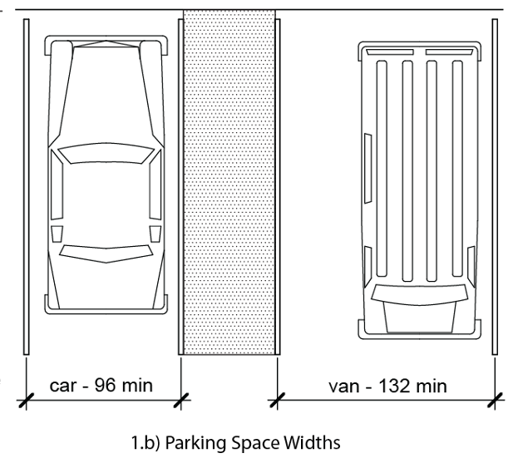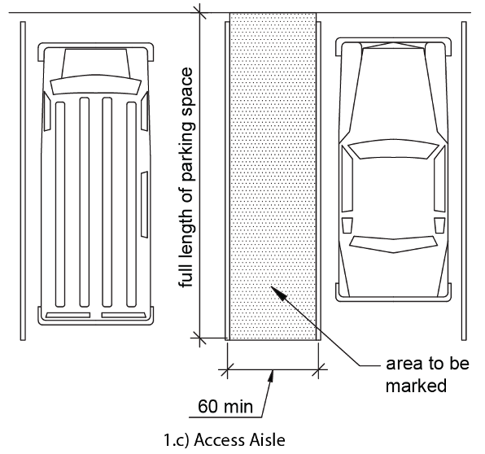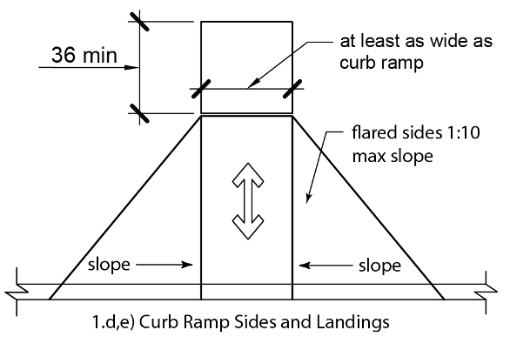
SHEET _____ OF _________
- Walking surfaces and Accessible Route: The accessible route is defined as the pedestrian route from the accessible parking and passenger loading zones to all accessible facilities and features. Attach grading plan with accessible route highlighted and running and cross slope readings noted.

Yes No Floor and ground surfaces are stable, firm, and slip resistant as defined by ADAABAAG Advisory 302.1

Yes No Running slope of all walking surfaces on the accessible route is 1:20 (5%) or less.

Yes No Cross slope of walking surfaces is 1:48 (2%) or less.

Yes No Clear widths of walking surfaces are 36 inches minimum.

Yes No Elongated openings in floor or ground surfaces are 1/2 inch wide or less.

Yes No Elongated openings are perpendicular to direction of travel.

Yes No Accessible route surface changes are 1/2 inch or less with 1/4 inch maximum vertical change.

Yes No Floor drains and grates on accessible route meet all above requirements

Inspection Results:

Corrective Actions Needed/Taken:

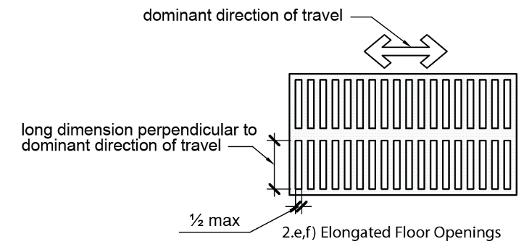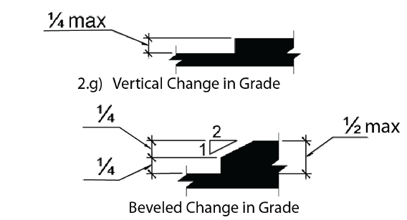

- Ramps: Ramps are defined as walking surfaces on the accessible route that are steeper than 1:20 (5%) but less than 1:12 (8.33%). Attach grading plan with running and cross slope readings noted.

Yes No Running slope is 1:12 (8.33%) or less. Measured at 2-foot intervals.

Yes No Cross slope is 1:48 (2%) or less. Measured at 2-foot intervals.

Yes No Clear width is 36 inches minimum, clear width between handrails is 36 inches minimum.

Yes No Rise for any ramp run is 30 inches maximum.

Yes No Ramps have landings at the top and the bottom of each ramp run.

Yes No Landing clear length is 60 inches minimum, running slope and cross slope of landing is 1:48 (2%) or less.

Yes No Ramps with a rise greater than 6 inches have handrails.

Yes No Ramps and landings have edge protection on both sides that prevents passage of a 4 inch diameter sphere.

Inspection Results:

Corrective Actions Needed/Taken:

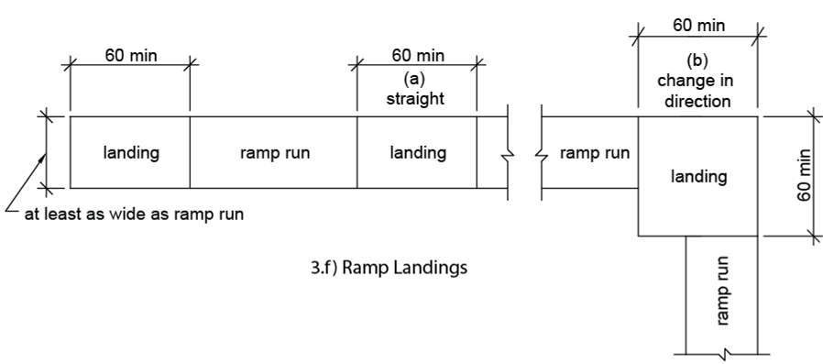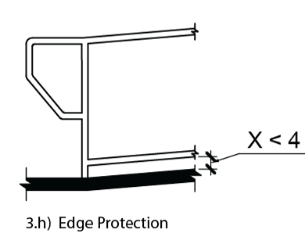
SHEET _____ OF _________
4. Handrails:

Yes No Top of handrail is 34 inches minimum and 38 inches maximum vertically above walking surfaces.

Yes No Handrails extend 12 inches minimum beyond the top and bottom of ramp runs.

Yes No Handrails extend horizontally 12 inches minimum at top of stairs.

Yes No Handrails extend at slope of the stair flight at bottom of stairs minimum one tread depth beyond last riser.

Yes No Handrail clearance is 1 ½ inches clear minimum to walls and above horizontal attachments.

Inspection Results:

Corrective Actions Needed/Taken:

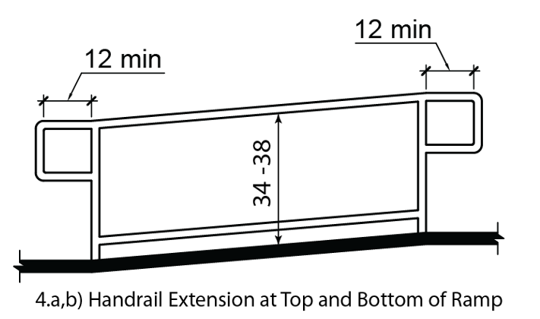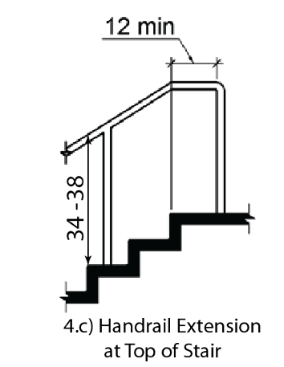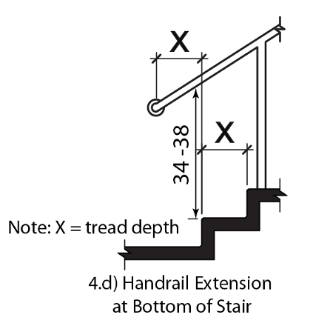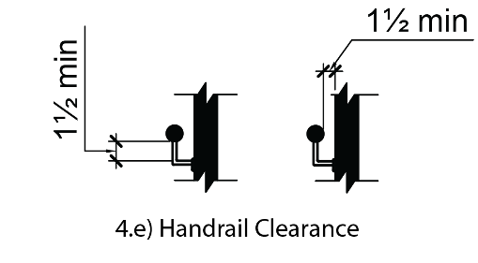
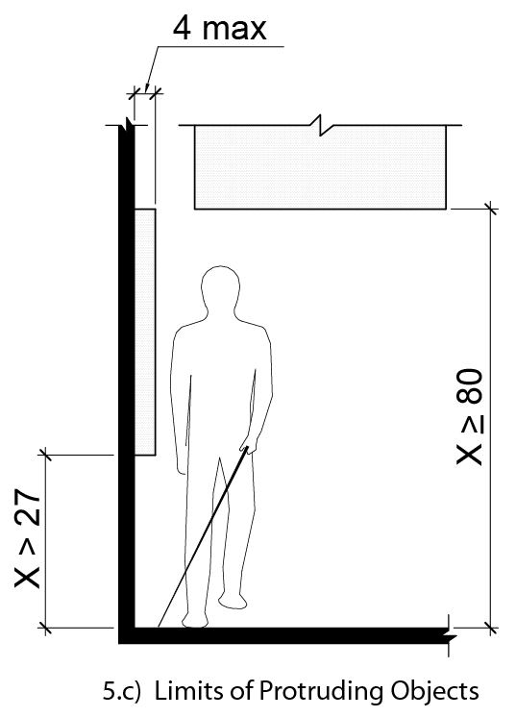
5. Drinking fountains (Two spout heights required for each drinking fountain):

Yes No Spout outlet is 36 inches maximum above the finish floor or ground for wheelchair accessible spout.

Yes No Spout outlet for standing persons is 38 inches minimum and 43 inches maximum above the finish floor.

Yes No Drinking fountain is recessed or has 27 inches maximum space from floor to bottom of fountain.

Inspection Results:

Corrective Actions Needed/Taken:

SHEET _____ OF _________
6. Toilet Compartments: Attach floor plan with as-constructed dimensions noted.

Yes No Wheelchair accessible compartment is 60 inches wide min., and 59 inches deep minimum.

Yes No Ambulatory stall is 60 inches deep min. width of 35 inches min. and 37 inches max, toilet is centered in stall.

Yes No Accessible compartment has 32 inch wide door opening minimum with door opening outward, or adequate clear space for door opening inward.

Yes No Seat height is 17 inches minimum and 19 inches maximum measured to the top of the seat.

Yes No Urinal rim is 17 inches maximum above the finish floor and 13 1/2 inches deep minimum.

Yes No Urinal has a clear floor space of 30 inches wide by 48 inches long minimum.

Yes No Side wall grab bar is 42 inches long minimum, located 12 inches maximum from the rear wall.

Yes No Rear wall grab bar is 36” long min. extends from toilet centerline 12” min. one side, 24” min. other side.

Yes No Grab bar height is 33 inches minimum and 36 inches maximum.

Yes No Toilet paper dispensers are 7 inches min. and 9 inches max. in front of the toilet to centerline of the dispenser.

Yes No Toilet paper dispenser outlet is 15 inches minimum and 48 inches maximum above the finish floor.

Yes No Centerline of the wheelchair stall toilet is 16 inches min. to 18 inches max. from the side wall.

Yes No Sinks and counters are 34 inches max. above the finish floor with 27 inches min. knee space. Sink drain pipes are insulated, or concealed.

Inspection Results:

Corrective Actions Needed/Taken:

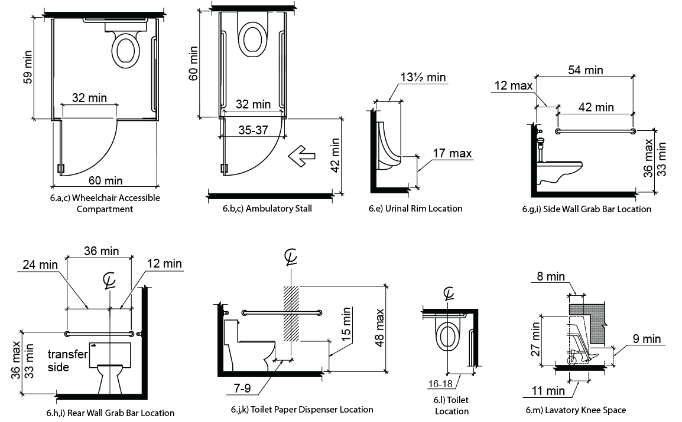
7. Service Counters, Dining and Work Surfaces: (Service counters are parallel or forward approach)

Yes No Parallel Approach. Counter is 36 inches long min. and 36 inches high max.

Yes No Forward Approach. Counter surface is 30 inches long min. and 36 inches high max, knee space under counter.

Yes No Tops of dining and work surfaces are 28 inches minimum and 34 inches maximum above the finish floor.

Inspection Results:

Corrective Actions Needed/Taken:

SHEET _____ OF _________
8. Doors:

Yes No Door openings on accessible routes provide a clear width of 32 inches minimum.

Yes No Door closers move door from open position of 90 degrees to 12 degrees from the latch is 5 seconds min.

Yes No Spring hinge doors close from open position of 70 degrees to closed position in 1.5 seconds minimum.

Yes No Fire doors have the minimum opening force allowable by the appropriate administrative authority.

Yes No Interior hinged doors have an opening force of 5 pounds maximum.

Inspection Results:

Corrective Actions Needed/Taken:

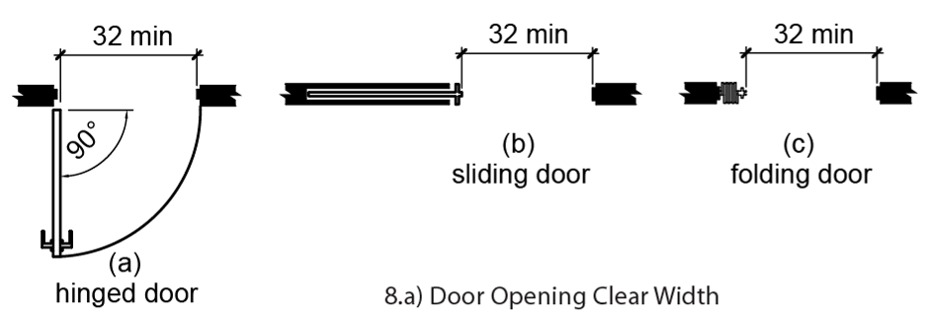

9. Signs:

Yes No Parking space signs are 60 inches minimum above finish ground surface measured to the bottom of the sign.

Yes No Van parking space sign includes the designation "van accessible".

Yes No Tactile characters on signs are 48 inches minimum and 60 inches maximum above the finish floor.

Yes No Sign is located alongside the door at the latch side.

Yes No Sign is located with a clear floor space of 18 inches by 18 inches minimum.

Inspection Results:

Corrective Actions Needed/Taken:

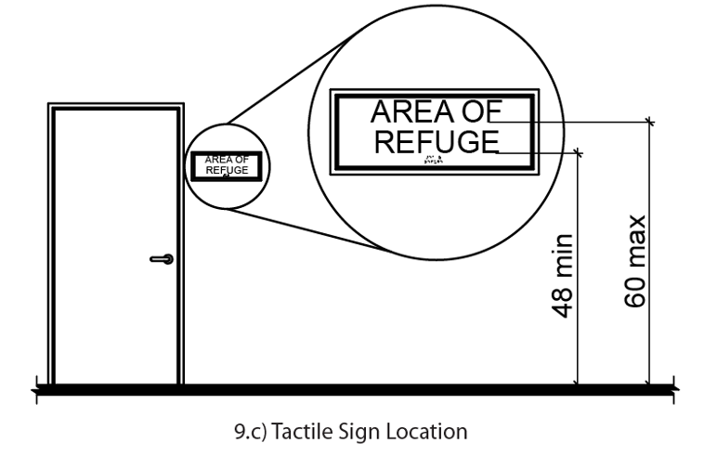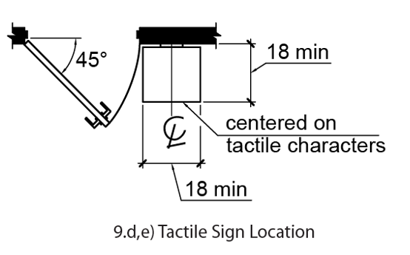

CERTIFICATION:

I certify that the above inspection report is complete and correct and that this inspection is in compliance with the contract documents.

Signature of Inspector

Appendix A
Project Waste Management Plan Worksheet
 | A | B | C | D | E | F | G | H | I | J
Material | Quantity Recycled (in tons) | Quantity Salvaged or Reused (in tons) | A + B = Total Quantity Diverted from Landfill | Quantity To Landfill (in tons) | C + D =  Total Quantity Generated  (in tons) | Tip Fee/Ton at Landfill | C x F = Tip Fee Savings resulting from Landfill Diversion | Cost of Recycling (R), Salvage (S), or Reuse (Re)  (Specify R, S, or Re) | Revenue from Recycling, Salvage, or Reuse | G - H + I = Total Cost (-) or Savings (+) from Diversion

Asphalt/Concrete
Brick/Masonry/Tile
Building Materials (doors, windows, fixtures, shingles, lumber, insulation, sheet goods, etc.)
Carpet
Carpet Padding, Foam Only
Cardboard
Ceiling Tile
Drywall
Glass
Scrap Metal
Aluminum
Copper
Steel
Unpainted Wood & Pallets
Yard Trimmings, Brush, Trees, Stumps, etc.
Garbage/Trash
Other

Column Totals
 | Total Quantity Recycled | Total Quantity Reused or Salvaged | Total Quantity Diverted from Landfill | Total Quantity To Landfill | Total Quantity Generated |  | Tip Fee Savings from Diversion | Total Cost of Recycling, Salvage, or Reuse | Revenue from Recycling, Salvage, or Reuse | Total Cost  (-) or Savings (+) from Diversion
Percentage Diverted = ______________ (C divided by E from Column Totals) Should meet 60% diversion goal

*See Appendix B for Standard Solid Waste Volume to Weight Conversions
Appendix B
STANDARD SOLID WASTE CONVERSIONS

The following sections provide conversions for solid waste and recyclable materials. Section 1 provides formulas to convert solid waste volume (cubic yards) into tons. Section 2 includes conversion factors to estimate the volume and weight of a number of solid waste and recyclable materials.

1. To convert cubic yards to tons:

A: For un-compacted trash, to convert the units of cubic yards into tons, using the standard density of trash value of 250 pounds per cubic yard:

Using “X” cubic yards, multiply by 250 pounds per cubic yard, divide by 2000 pounds per ton, to obtain value in tons.

“X” cubic yards x 250 pounds ÷ 1 ton = ______ tons
cubic yard 2000 pounds
This equals:

“X” cubic yards x 0.125 tons = _______ tons
cubic yard

In this case, 8 cubic yards = one ton.

B: To determine your own density value for un-compacted trash (instead of using the standard value of 250 pounds per cubic yard), using a 32 gallon trash can:

- Weigh the trash can both filled and empty (use a full 32 gallon trash can filled with trash roughly level to the top);
- Subtract the empty weight from the filled weight to get the weight of trash ( filled weight – empty weight = weight of trash);
- Use the formula, using “Y” your weight of trash (pounds), divided by 0.15 cubic yards per 32 gallon trash can, to obtain your value in pounds per cubic yard; which equals:

“Y” pounds / 0.15 cubic yards = ________ pounds
32 gallon can 32 gallon can cubic yard

- Substitute this value for the 250 pounds per cubic yard value in Method A above.

This would be the more accurate measure of your park’s specific waste.

C: For compacted trash, to convert cubic yards into tons:

To use a compaction ratio, multiply the appropriate ratio times the un-compacted trash weight in Formula A to obtain the compacted trash weight.

“X” cubic yards x 3 (compaction ratio) x 250 pounds x 1 ton = ______ tons
1 cubic yard 2000 pounds

Typical compaction ratios for trash:
3:1 (typical)
4:1 (higher-compaction vehicles)

If you or your hauler don’t know the compacting ratio, the typical values for compacted trash are 500 to 1000 lbs./cubic yard, average 700 lbs./cubic yard. Use 700 lbs. per cubic yard if you don’t have more accurate records.

Yellowstone's measurement analysis of compacted trash = 500 lbs./cubic yard
For compacted trash, 0.4 is used instead of 0.125 in Formula A:

“X” cubic yards x 0.4 tons = _______ tons
cubic yard

D: To convert container size to cubic yards for un-compacted waste:
If you don't have size and weight information on your specific containers, then these typical values can be used:

1 cubic yard = 202 gallons
32 gallon can = 0.15 cubic yards
60 gallon tote = 0.30 cubic yards
90 gallon tote = 0.45 cubic yards

2. EPA’s Standard Volume-to-Weight Conversion Factors

Category | Recyclable Materials  (u/c = uncompacted/ compacted & baled) | Volume | Estimated Waste (in pounds)
FOOD SCRAPS^{A} | Food scraps, solid and liquid fats | 55-gal drum | 412
GLASS | Bottles^{B}  Whole Bottles  Semicrushed Crushed (mechanically)  Uncrushed to manually broken  Refillable Whole Bottles^{C}  Refillable beer bottles  Refillable soft drink bottles  8 oz glass container | 1 yd³  1 yd³  1 yd³  55-gal drum  1 case = 24 bottles  1 case = 24 bottles  1 case = 24 bottles | 500-700  1,000-1,800  1,800-2,700  300  10-14  12-22  12
LEAD-ACID BATTERIES | Car^{D}  Truck^{E}  Motorcycle^{E} | 1 battery  1 battery  1 battery | 39.4 lb  53.3 lb lead and plastic  9.5 lb lead and plastic
METALS | Aluminum Cans^{F}  Whole  Compacted (manually)  Uncompacted  Ferrous (tin coated steel cans) ^{G}  Whole  Flattened  Whole  Major Appliances^{E}  Air conditioners (room)  Dishwashers  Dryers (clothes)  Freezers  Microwave ovens  Refrigerators  Ranges  Washers (clothes)  Water heaters | 1 yd³  1 yd³  1 full grocery bag  1 case = 24 cans  1 yd³  1 yd³  1 case = 6 cans  1 unit  1 unit  1 unit  1 unit  1 unit  1 unit  1 unit  1 unit  1 unit | 50-75  250-430  1.5  0.9  150  850  22  64.2  92  130  193  50  181.1  267  177  131
PAPER | Newspaper^{F}  Uncompacted  Compacted/baled  12 in. stack  Old Corrugated Containers^{F}  Uncompacted  Compacted  Baled  Computer Paper^{F}  Uncompacted  Compacted/baled  1 case  White Ledger^{F}  Stacked (u/c)  Crumpled (u/c)  Ream of 20# bond; 8.5”x11”  Ream of 20# bond; 8.5”x14”  White ledger pads  Tab Cards^{F}  Uncompacted  Compacted/baled  Miscellaneous Paper  Yellow legal pads^{F}  Colored message pads^{F}  Telephone directories^{H}  Mixed Ledger/Office Paper^{F}  Flat (u/c)  Crumpled (u/c) | 1 yd³  1 yd³  -  1 yd³  1 yd³  1 yd³  1 yd³  1 yd³  2,800 sheets  1 yd³  1 yd³  ream = 500 sheets  1 ream = 500 sheets  1 case = 72 pads  1 yd³  1 yd³  1 case = 72 pads  1 carton = 144 pads  1 yd³  1 yd³  1 yd³ | 360-505  720-1,000  35  50-150 (300)  300-500  700-1,100  655  1,310  42  375-465/755-925  110-205/325  5  6.4  38  605  1,215-1,350  38  22  250  380/755  110-205/610
PLASTIC^{J} | PET (Soda Bottles)  Whole bottles (uncompacted)  Whole bottles (compacted)  Whole bottles (uncompacted)  Baled  Granulated  Granulated  8 bottles (2 L size)  HDPE (Dairy)  Whole (uncompacted)  Whole (compacted)  Baled  HDPE (Mixed)  Baled  Granulated  Granulated  Other Plastic  Uncompacted  Compacted/baled  Mixed PET and HDPE (Dairy)  Whole  Film  Baled  Baled | 1 yd³  1 yd³  gaylord  30” x 62”  semiload  gaylord  16 L  1 yd³  1 yd³  32” x 60”  32” x 60”  gaylord  semiload  1 yd³  1 yd³  1 yd³  semiload  30” x 42” x 48” | 30-40  515  40-53  500-550  30,000  700-750  1  24  270  400-500  900  800-1,000  42,000  50  400-700  32  50  400-700
TEXTILES^{H} | Mixed Textiles | 1 yd³ | 175
TIRES | Car Tires  Whole tire^{E}  Crumb rubber^{K}  Truck Tires  Whole tire^{E}  Crumb rubber^{K} | 1 tire  1 tire  1 tire  1 tire | 21  12  70  60
WOOD | Wood chips^{L}  Pallets^{F} | 1 yd³  - | 725  30-100 (40 avg)
YARD TRIMMINGS^{F} | Grass Clippings  Uncompacted  Compacted  Leaves  Uncompacted  Compacted  Vacuumed | 1 yd³  1 yd³  1 yd³  1 yd³  1 yd³ | 350-450  550-1,500  200-250  300-450  350
FURNISHINGS^{E} | Foam rubber mattress | 1 mattress | 55
MUNICIPAL SOLID WASTE^{M} | Residential waste  (uncompacted at curb)  Commercial-industrial waste  (uncompacted)  MSW (compacted in truck)  MSW (landfill density) | 1 yd³  1 yd³  1 yd³  1 yd³ | 150-300  300-600  500-1,000  750-1,250

- Information obtained from Washington State.
- Draft National Recycling Coalition Measurement Standards and Reporting Guidelines presented to NRC membership. October 31, 1989.
- Personal communication with a representative from Allwaste. November 6, 1995.
- Battery Council International. 1995. 1994 National Recycling Rate Study.
- U.S. EPA. 1995. Methodology for Characterization of Municipal Solid Waste in the United States: 1994 Update. EPA530-R-96-001. Washington, DC.
- U.S. EPA. 1993. Business Guide for Reducing Solid Waste. EPA530-K-92-004. Washington, DC.
- Personal communication with a representative from the Steel Recycling Institute. November 1, 1995.
- Information obtained from Massachusetts State.
- Information obtained from New Jersey and New York States.
- Personal communication with a representative from the American Plastics Council. November 2, 1995.
- Personal communication with a representative from the Scrap Tire Management Council. November 6, 1995.
- Information obtained from Northeast Forest Products, Martin Mulch Company, and the Solid Waste Association of North America.
- Solid Waste Association of North America, Manger of Landfill Operations Training and Certification Course. January 1989.
- Information obtained from New Jersey and New York States.
3.0 Performance Requirements

3.1 Design Imperatives

Utilize the following at all stages of the design and construction processes:

- Appropriate Design Solutions for Park Use and Maintenance Capabilities
- Integration of Facilities into the Park Environment (See section 9.1.1.2 within the 2001 Management Policies)
- Compliance Consistency Reviews
- Compliance with Architectural Barriers Act Accessibility Standards (ABAAS)
- Constructability Strategies
- Quality Control
- Risk Analysis
- Scope and Budget Consistency Reviews
- Sustainable Design Practices
- Value-Based Decision-Making Methodology

3.2 Sustainability

Sustainability requirements for National Park Service projects are presented in a variety of documents. There are federally legislated requirements and Executive Orders, depending on type of work and size of the project that must be met. There are also Department of Interior (DOI) and National Park Service (NPS) policies that govern. In addition some of these policies require project certification (at one of four levels) by United States Green Building Council’s (USGBC) Leadership in Energy and Environmental Design (LEED). The NPS Project Sustainability Checklist Template provides a mechanism for identifying project specific sustainability requirements and a means to document continued compliance with those requirements. An updated list of laws, regulations, policies and background data is available at: http://www.nps.gov/dsc/workflows/dssustain.htm

This project shall meet all of the federal sustainability requirements as presented in the NPS Project Sustainability Checklist.

This project shall also incorporate sustainable design strategies to achieve at least a LEED minimum level rating. (All new construction and major renovation building projects with gross construction cost greater than $2,000,000 beginning design will be certified by a sustainable building rating system. LEED has six systems: LEED NC (New Construction), LEED EB (Existing Building), LEED CI (Commercial Interiors), LEED CS (Core and Shell), LEED H (Home), and LEED ND (Neighborhood Development. Within each system there are four levels. Select the appropriate LEED System and Level – The lowest level is “Certified. The next higher level is “Silver” and is required for all projects that include visitor centers or major visitor services facilities e.g. Visitor Centers, Education Facilities, and some Maintenance Facilities. After Silver is “Gold” followed by “Platinum”. LEED Gold and Platinum levels are encouraged where benefits, initial costs and life-cycle costs justify the investment. LEED Certification may not be applicable for significant historical buildings constrained by cultural resource or State Historical Preservation Officer requirements.) Delete if your project is a non-building project or does not have an applicable LEED standard or LEED does not apply to your project.)

Formal LEED Certification through USGBC will be required. (Include when deemed appropriate by NPS, otherwise delete.)

3.3 INTEGRATED DESIGN PRINCIPLES

Integrated Design Principles shall be employed. Use a collaborative, integrated design process that:

- Initiates and maintains an integrated project team in all stages of a project;
- Meets performance goals as defined in NPS Project Sustainability Checklist for siting, energy, water, materials, and indoor environmental quality along with other comprehensive design goals; and, ensures incorporation of these goals throughout the design and lifecycle of the building; and, (Delete irrelevant parts of this paragraph)
- Considers all stages of the building’s lifecycle, including deconstruction. (Delete, if non-building project)

3.4 Facility Performance

All work performed shall comply with applicable laws, regulations, and NPS policies and guidelines. http://www.nps.gov/dsc/workflows/laws-policies.htm

3.5 Elements and Products
Edit this section as appropriate, based on project requirements.
In addition to requirements specified in other chapters, provide products and elements that comply with the following:
- Where "no substitutions" is indicated, use only the product (or one of the products) specified.
- Elements Made Up of More Than One Product:
  - Where an element is specified by performance criteria, the project shall use construction either proven-in-use or proven-by-mock-up, unless otherwise indicated.
    - Proven-In-Use: Proven to comply by having actually been built to the same or very similar design with the same materials as specified and functioning as specified.
    - Proven-by-Mock-Up: Compliance reasonably predictable by having been tested in full-scale mock-up using the same materials and design as specified and functioning as specified. Testing need not have been accomplished specifically for this project; when published listings of independent agencies include details of testing and results, citation of test by listing number is sufficient (submittal of all test details is not required).
    - The DBC may choose whether to use elements proven-in-use or proven-by-mock-up, unless either option is indicated as specifically required.
    - Where test methods accompany performance requirements, those test methods shall be used to test the mock-up.
  - Where a type of product is specified, without performance criteria specifically applicable to the element, the project shall use the type of product specified.
  - Where more than one type of product is specified, without performance criteria specifically applicable to the element, the DBC shall use one of the types of products specified.
  - Where a type of product is specified, with applicable performance criteria, the DBC shall use either the type of product specified or another type of product that meets the performance criteria as proven-in-use or proven-by-mock-up.
  - Where more than one type of product is specified, with applicable performance criteria, the DBC shall use either one of the types of products specified or another type of product that meets the performance criteria as proven-in-use or proven-by-mock-up.
  - Where neither type of product nor performance criteria are specified, the DBC shall use products that will perform well within the specified life span of the building.
- Products:
  - Where a product is specified only by a manufacturer name and model number/brand name, the DBC shall use only that model/brand product.
  - Where the properties of a product are specified by description and/or with performance criteria, the DBC shall use products that comply with the description and/or performance criteria.
  - Where manufacturers are listed for a particular product, the DBC shall use a product made by one of those manufacturers that also complies with other requirements.
  - Where actual brand name products are not identified by either the Contracting Officer or the DBC, the DBC shall identify the products to be used.
  - In the Proposal:
    - The DBC shall identify one or more product types for each system, assembly, or element.
    - For each product type, the DBC shall identify brief descriptive or performance specifications.
    - For major manufactured products that are commonly purchased by brand name, and any other products so indicated, we will identify at least one manufacturer that will be used.
  - During DB Design Development or DB Construction Documents Submissions:
    - Where more than one product type is identified for a particular system, assembly, or element, the DBC shall identify exactly which type will be used.
    - For each product type, the DBC shall identify descriptive or performance specifications; early submittals shall be brief specifications, but complete specifications shall be provided prior to completion of construction documents.
    - For each product type, the DBC shall identify at least one manufacturer that will be used.
    - For major manufactured products that are commonly purchased by brand name, and any other products so indicated, the DBC shall provide manufacturer's product literature on at least one actual brand name product that meets the specifications, including performance data and sample warranty.
  - During Construction:
    - The DBC shall identify actual brand name products used for every product, except commodity products specified by performance or description.
    - Where a product is specified by performance requirements with test methods, and if so specified, the DBC shall provide test reports showing compliance.
    - The DBC shall provide manufacturer's product literature for each brand name product.
    - The DBC shall provide the manufacturer's certification that the product used on the project complies with the contract documents.
  - Before End of Closeout:
    - The DBC shall provide copies of all manufacturer warranties that extend for more than one year after completion.

4.0 Technical REQUIREMENTs

The technical requirements are comprised of UNIFORMAT II (a uniform classification of construction systems and assemblies) specifications with performance and quality requirements specific to the project. NPS DSC Design Standards shall be incorporated.

To the maximum extent possible, the use of prescriptive specifications should be avoided or minimized unless it is necessary for technical coordination with the parks, other physical plant systems, or integration into existing maintenance and repair procedures. Prescriptive specifications have the effect of moving design responsibility for the specific building system from the Design-Build Contractor to the Government.

The end product should be a complete, well coordinated set that references requirements covered in Parts 1, 2, and 3 of the RFP. The requirements shall be organized as follows:

A Substructure

A10 – Foundations
A20 – Basement Construction

B Shell

B10 – Superstructure
B20 – Exterior Enclosure
B30 – Roofing

C Interiors

C10 – Interior Construction
C20 – Stairs
C30 – Interior finishes

D Services

D10 – Conveying
D20 – Plumbing
D30 – HVAC
D40 – Fire Protection
D50 – Electrical

E Equipment and Furnishings

E10 – Equipment
E20 – Furnishings

F Special Construction and Demolition

F10 – Special Construction
F20 – Selective Building Demolition

G Building Sitework

G10 – Site Preparation
G20 – Site Improvements
G30 – Site Mechanical Utilities
G40 – Site Electrical Utilities
G90 – Other Site Construction

You may utilize your own UNIFORMAT II guide specifications or edit the guides available from WBDG/NAVFAC. If these guides are used, all military references must be replaced with NPS DSC Design Standards. Design and Construction submittal requirements are covered in Parts 1, 2, and 3 of the RFP so edit and coordinate references found in the technical requirements appropriately.

Part 4 Technical Requirements Sample
This is a sample document which shows typical performance specifications. This sample should not be considered complete or comprehensive and should not be used for production specifications.

Additional information: National Institute of Standards and Technology (NIST)
5.0 Attachments

Attach the documents identified in Section 1.8

