**U**

**Addressing Climate Change**

**and**

**Natural Hazards**

**Facility Planning and Design Considerations**

**January 2015**

**Level 3 Handbook**

*(This Handbook was modified in April 2018 and made accessible using Microsoft Word (MS) 2010.)*

# BACKGROUND:

The National Park Service (NPS) was established to conserve natural landscapes and historic places significant to the American people and the American story in a way that allows current and future generations to enjoy these sites long into the future. To meet the goals of this mission, visitor services, maintenance, and administrative facilities are all necessary. The dynamic landscapes preserved by many of our National Parks present a variety of hazards to current and future NPS facilities. Climate change touches every part of the National Park Service. It may create additional hazards, and also exacerbate existing hazards; presenting special challenges to facility design that must be considered.

This guidance will help provide information and context so that park decision-making appropriately addresses risks associated with natural hazards and climate change. It will ensure that the National Park Service reduces those risks to facilities and fulfills its mission to conserve natural and cultural resources established by Congress in the Organic Act of 1916.

The science surrounding climate change and its impacts is rapidly growing. For example, projections of sea level rise, storm surge, storm frequency and other impacts will almost certainly change and improve as this science develops. Accordingly, this initial guidance will be modified as new information becomes available and to address additional hazards. Park managers should approach development proposals in areas vulnerable to climate change and/or other natural hazards conservatively, understanding that current estimates of impacts may well underestimate future risk.

# INTRODUCTION

This Level 3 Handbook and the questions within are designed to support your park in planning and designing facilities that evaluate and respond to existing and projected climate change impacts and natural hazards.

When making any capital investments in facilities, Park managers should refer to this document for the three types of NPS construction design and planning: 1) new construction, 2) rehabilitation of non-historic structures and, 3) rehabilitation of historic structures.

In the case of new construction where hazards threaten the proposed area of the new facility, avoidance and relocation should be practiced wherever possible. For facilities that must be in a location at risk (i.e. beach center in a coastal floodplain) design and siting decisions must incorporate a thorough understanding of all hazards (including projected climate change impacts), and adaptive techniques must be explored for every hazard identified. Planning and design strategies should strive to reduce risk to probabilities similar to those as if the proposed facility were just beyond the hazard zone.

Rehabilitation of existing facilities may include expansion or substantial improvements, where substantial improvements are those estimated to cost 50% or more of the facility current replacement value.

For rehabilitation of non-historic structures, tough decisions regarding relocating the facility and/or the function within the facility should be considered and this guidance will walk managers through a decision making process.

Historic buildings and structures and cultural landscapes shall be evaluated for natural hazards using the same criteria as non-historic assets. Hazard mitigation measures for historic assets (or the functions within) will be designed and installed to least affect the features that contribute to its significance. However, if it is determined that modification of particular features would impair a property's integrity and character in terms of the Advisory Council's regulations at 36 CFR (Code of Federal Regulations) 800.9 such modifications will not be made.

This Handbook should be used by the project team in preparation for Regional and National Development Advisory Board (DAB) Staff Review and Presentations; specifically, this guidance should facilitate your completion of the “Emphasis Area” tab in the Automated Development Advisory Board (ADAB).

This guidance is not meant to be all inclusive, but is one of many tools used in making sound management decisions. Other tools may include Executive Orders (EO), local, state, regional and national codes and standards.

This guidance does not supersede existing mandated compliance processes and policies, but should only support and enhance those existing processes and policies. For example, Director’s Order (DO) #77-2, “Floodplain Management’ remains the compliance and policy process for facilities and siting related to floodplains, augmented by standards provided in this handbook.

Traditional planning and design decisions already include a series of questions, such as: What is the park mission and operational goals? What facilities are necessary to support critical park operations? Superimposed over those essential questions are concerns about climate change and other natural hazards for your park. Park managers, planning and design teams must weigh the importance of the operational need versus the risk posed by natural hazards in designing and locating facilities to meet that need. Historic structures located in areas of susceptible to natural hazards must be evaluated to determine their future disposition, weighing their historic significance and potential use against identified and evaluated risks. In the planning arena, decisions about adapting to natural hazards will relate to zones or developed areas. Design and construction decisions will focus on the specifics of facilities.

This document provides a decision path for dealing with Natural Hazards and Climate Change with three stops along the way. Though these stops are sequential, they are not necessarily applicable for each park situation/environment. The considerations at each “stop” are required for the management team to pause and answer - to support sound management decisions:

**STOP 1 Natural Hazard Checklist:** The first stop is a screening tool to be used at the earliest stages of project planning to determine the most likely natural hazards a project may confront. The Natural Hazard Checklist will give you some general information to help you identify the full range of risks for your park.

**STOP 2 Background Data:** After identifying general natural hazards that may pose a risk to facilities in STOP 1, you will be prompted to gather data and make judgments that are independent of the specific hazard identified, and will provide a foundation for STOP 3.

**STOP 3 Specific Hazard Considerations:** With the general natural hazards identified in STOP 1 and background data in STOP 2 you are prepared to move forward and address the risks posed by specific hazards in this STOP. This will typically involve further data gathering and analysis. This guidance provides sources for such data and questions you should address as you make facility planning and design decisions. In many cases this STOP should also include the involvement of professionals with expertise in the specific hazard and risk assessment. (Note: This handbook only includes a STOP 3 for coastal storm surge with sea level rise. Additional STOP 3’s will be developed in future iterations of the handbook. The checklist (STOP 1) and STOP 2 can still be used to identify other natural hazards that may affect your project. Those would require additional site specific information and evaluation.)

The NPS goal is that park managers have the information and context necessary to ensure that park decision-making appropriately addresses the effects of climate change and other natural hazards. This guidance must be followed when undertaking a planning effort, a major capital investment, facility rehabilitation or a recovery effort.

This Handbook is intended only to improve the internal management of the NPS, and is not intended to, and does not, create any right or benefit, substantive or procedural, enforceable at law or equity by a party against the United States, its departments, agencies, instrumentalities or entities, its officers or employees, or any other person.

## STOP 1. Natural Hazard Checklist

The checklist below is a screening tool to be used at the earliest stages of facility planning to determine the most likely natural hazards a project may confront. This general information may help project teams assess which natural hazards may be applicable for a particular project early in the facility planning and design process. As the effort continues site specific information may be required to make a determination for any of the hazards.

The checklist should be completed with input from appropriate Park personnel and specialists. If considerable questions remain about the applicability of specific hazard, contact the appropriate Region or WASO (Washington Support Office) specialist.

For each of the natural hazards listed below, the person(s) completing the checklist should indicate whether the hazard:

1. Is applicable and could pose a risk to the project and/or needs more information for a determination.
2. Is not applicable to the project for the following reason(s)
   1. Hazard does not occur due to geologic setting (e.g. no volcanoes or permafrost are present in Florida).
   2. A previous hazard assessment concluded this hazard was not applicable at this location.

The project’s checklist can be updated at various project milestones as more information is developed. By the time a team completes the schematic design phase the natural hazards applicable to the project should be identified and the checklist should no longer reflect uncertainty associated with any of the hazards listed. To achieve this level of understanding natural hazard assessment(s) may be needed for the project site.

Future versions of this handbook may address additional hazards.

| **Natural Hazard Checklist** | | | | |
| --- | --- | --- | --- | --- |
| Potential Natural Hazard | Risk or secondary hazard | Sources of General Non-site specific Data | Sources for Site Specific Data | Best Professional Judgment |
| Earthquake | * Falling objects. * Collapsing structures. * Inoperability of major building systems e.g. power, sewer, water. * Liquefaction; loss of strength to foundations, silt deposition, standing water. * Trigger to other hazards e.g. landslides, debris flows. | Thumbnail image of United States Earthquake Probability Mapping by United States Geological Survey (USGS). Click thumbnail to view larger image.  Thumbnail image of United States peak ground acceleration. Click thumbnail to view larger image.  Thumbnail image of Hawaii peak ground acceleration. Click thumbnail for to view larger image.  Thumbnail image of Alaska peak ground acceleration. Click thumbnail for to view larger image. | * International Building Code (IBC) * [United States Geological Survey (USGS): 2009 Earthquake Probability Mapping](http://geohazards.usgs.gov/eqprob/2009/) * State based mapping e.g. [Washington liquefaction susceptibility and site class maps](http://www.dnr.wa.gov/ResearchScience/Topics/GeologyPublicationsLibrary/Pages/pub_ofr04-20.aspx) * [NPS Technical Support](http://www.nature.nps.gov/geology/hazards/index.cfm) |  |
| Landslide/  Avalanche | * Rockfall. * Mud or debris slides or flows onto structures. * Mud or debris slides or flows from under structures. * Snow avalanche. | Thumbnail image of landslide hazard of the conterminous United States. Click thumbnail to view larger image. | * State geological surveys e.g. [California landslide mapping](http://www.conservation.ca.gov/cgs/geologic_hazards/landslides/Pages/Index.aspx) * [NPS Technical Support](http://www.nature.nps.gov/geology/hazards/index.cfm) |  |
| Permafrost | * Melting. * Surface collapse. * Increased landslide susceptibility. | [Thumbnail image of Alaska climate monitoring.](http://data.usgs.gov/climateMonitoring/region/show?region=alaska)  [Thumbnail image of Earth circumarctic.](http://nsidc.org/data/docs/fgdc/ggd318_map_circumarctic/) | * [Global Permafrost Zonation Index Map](http://www.geo.uzh.ch/microsite/cryodata/pf_global/) * [NPS Technical Support](http://www.nature.nps.gov/geology/hazards/index.cfm) |  |
| Cave/Karst (sinkholes) | * Surface collapse * Contamination * Abandoned Mineral Lands (AML) features | Thumbnail image of karst and potential karst areas in soluable rocks in the contiguous United States. Click thumbnail to view larger image.  Thumbnail image of Alaska, Hawaii, and Puerto Rico showing humid climate karst. Click thumbnail to view larger image. | * State geological hazards maps. * Abandoned Mineral Lands (AML) features * NPS Technical Support - [Cave and Karst](http://www.nature.nps.gov/geology/caves/index.cfm); [Abandoned Mineral Lands](http://www.nature.nps.gov/geology/aml/index.cfm) |  |
| Shrink/ Swell soils | * Damage to structure * “heaving” of ground beneath structure * Increased landslide susceptibility | [Thumbnail image of United States soil resources inventory.](http://science.nature.nps.gov/im/inventory/soils/index.cfm) | * State geological survey site-specific information * NPS Soil Resources Inventory * [NPS Technical Support](http://www.nature.nps.gov/geology/soils/index.cfm) |  |
| Coastal Storm Surge | * Rising Sea Levels * Rising Water - Wind Driven (i.e. hurricane, nor’easter) | [Thumbnail image of presidential distaster declarations related to flooding shown by county from 1965 to 2003 in the United States.](https://msc.fema.gov/webapp/wcs/stores/servlet/FemaWelcomeView?storeId=10001&catalogId=10001&langId=-1) | * [Federal Emergency Management Agency (FEMA) Map Service Center](https://msc.fema.gov/portal) * [NPS Technical Support](http://www.nature.nps.gov/geology/coastal/index.cfm) |  |
| Tsunami | * Coastal area inundation associated with earthquakes or undersea landslides. | [Thumbnail image of North America tsunami warning.](http://ntwc.arh.noaa.gov/) | * State Tsunami Inundation Mapping e.g.   [OR Tsunami Clearinghouse](http://www.oregongeology.org/tsuclearinghouse/)   * National Tsunami Watch Center * [NPS Technical Support](http://www.nature.nps.gov/geology/coastal/index.cfm) |  |
| Riverine Flood | * Flooding (i.e. snowmelt, rainfall, etc.) * Destruction of infrastructure. * Stream channel migration. * Stream bank erosion. | [Thumbnail image of presidential distaster declarations related to flooding shown by county from 1965 to 2003 in the United States.](https://msc.fema.gov/webapp/wcs/stores/servlet/FemaWelcomeView?storeId=10001&catalogId=10001&langId=-1) | * [FEMA Map Service Center](https://msc.fema.gov/portal) * [NPS Technical Support](http://www.nature.nps.gov/water/) |  |
| Flash Flood | * Sudden rising water (i.e. dry wash) * Loss of life due to unexpected flooding. | [Thumbnail image of presidential distaster declarations related to flooding shown by county from 1965 to 2003 in the United States.](https://msc.fema.gov/webapp/wcs/stores/servlet/FemaWelcomeView?storeId=10001&catalogId=10001&langId=-1) | * May require a special flood study * NPS Technical Support |  |
| Hurricane | * High wind speed. * Flying debris. * Storm Surge. | Thumbnail image of United States showing hurricane return period. Click on thumbnail to view larger image. | * Wind Speed data – from local codes * International Building Code * [FEMA Map Service Center](https://msc.fema.gov/portal) * [NPS Technical Support](http://www.nature.nps.gov/geology/coastal/index.cfm) |  |
| Tornado | * Extreme wind speed * Flying debris | Thumbnail image of United States showing average number of tornadoes per year. Click on thumbnail to view larger image. | * International Building Code * Limited Data for Local Application * NPS Technical Support |  |
| Wildfire | * Fire and Heat. * Smoke. | Thumbnail image of United States and Puerto Rico showing wildfires. Click on thumbnail to view larger image. | * International Wildland-Urban Interface Code * Limited Data for Local Application * [NPS Technical Support](http://inside.nps.gov/waso/waso.cfm?prg=777&lv=3) *Note: This link routes to an NPS intranet site which is only accessible within the NPS network.* |  |
| Volcanic Eruption | * [Lava Flows](http://volcanoes.usgs.gov/hazards/lava/index.php) * Fire * [Volcanic Secondary Hazards](http://share.inside.nps.gov/sites/WASO/PPFL/CPM/CPMD-CC/_layouts/WordViewer.aspx?id=/sites/WASO/PPFL/CPM/CPMD-CC/Shared%20Documents/Doc%20Links/Volcanic%20Flow%20Types.docx) *Note: This link routes to an NPS intranet site which is only accessible within the NPS network.* * [Toxic gas releases](http://volcanoes.usgs.gov/hazards/gas/index.php) | Thumbnail image of United States showing volcano hazard based on activity in the last 15,000 years. Click on thumbnail to view larger image. | * [USGS Volcano Hazards Program](http://volcanoes.usgs.gov/) * [NPS Technical Support](http://www.nature.nps.gov/geology/hazards/index.cfm) |  |
| Hydro-thermal Activity (e.g. geysers) | * Toxic gas release. * Explosion. * Boiling water * Steam. * Surface collapse into void. | To Be Determined | * Air quality issues and monitoring, including real-time for select locations. * [NPS Technical support](http://www.nature.nps.gov/geology/hazards/index.cfm) |  |
| Pest Infestation | * Historic/ Facility Fabric Loss * Vegetation Loss * Fauna Impacts * Infection * Injury | To Be Determined | * Integrated Pest Management * [NPS Technical Support](http://www.nature.nps.gov/biology/ipm/index.cfm) |  |

## STOP 2: Background Data

The condition, mission importance, and significance of assets are already being evaluated and recorded for a large variety of decisions. These data are independent of any natural hazard and are basic attributes that must be known to allow sound decision-making related to park priorities in light of limited resources.

The majority of the background information will be found in your park’s General Management Plan (GMP), Park Foundation Documents, Facility Management Software System (FMSS) database, Park Asset Management Plan (PAMP) or Continuity of Operations Plan. These resources provide the foundation for decisions when planning improvements for the park in an area susceptible to a natural hazard. Upon obtaining this data, you should proceed to the Specific Hazard Considerations, Stop 3 that applies to your park and review the series of considerations outlined to make the best informed decision as early as possible in your planning process.

The list of questions below identifies key aspects of the asset/function being considered regardless of a specific hazard

* Is the function/asset significant in its own right or under protection of federal law (such as eligibility for listing on the National Register of Historic Places)?
* Is the function/asset included in the park’s enabling legislation or key to the park’s legislated significance?
* Is the function/asset identified as significant in park planning?
* What is the asset’s API (Asset Priority Index)?
* What priority does this asset have in the Park Asset Management Plan (PAMP) as reflected in its optimizer band?
* What is the current replacement value (CRV) for the existing, or planned, asset?
* How important, operationally, is this function? Must it survive intact after all natural hazard events? For example, some functions must be fully operational immediately after an event, such as those necessary to safeguard life/health/safety, while others can be rebuilt/restored over time without significant risk.
* Does this asset include critical infrastructure - i.e. assets and/or systems, without which the park cannot operate or operate safely. Such systems include electric service to building(s) essential to operations (headquarters, command post, etc.), sewage systems serving public or staff restrooms, potable water systems, fire sprinkler systems for buildings essential to operations, etc. Critical infrastructure also includes systems that are essential to the protection of natural or cultural resources. Examples include security systems, fire protection systems, aspects of a Heating, Ventilating and Air Conditioning (HVAC) system that are designed to protect a nationally significant historic building, collections, or irreplaceable records from deterioration, etc.
* Where is the asset located? (Latitude and longitude, elevation, etc.)
* What are the future costs related to natural hazard risk associated with acquired land with existing assets?
* What other planning efforts have been done previously on this asset/zone?

## STOP 3: Specific Hazard Assessment

**Coastal Storm Surge with Climate Change Effects (Sea Level Change)**

Coastal flooding can be a significant risk to park assets/functions and climate change potentially amplifies this risk. To plan/design for a flooding risk, decision-makers need resources to quantify the hazard now (baseline) and for the future, including resilient/adaptable construction alternatives.

### Resources

The following data and tools to define local sea level rise (SLR) may be useful in answering the questions below:

* FEMA (Federal Emergency Management Agency) Coastal Construction Manual (CCM)
* Hazard charts showing damage charts and percent damage assessment
* NOAA (National Oceanic and Atmospheric) maps
* Local/Regional/State water resources agencies or groups
* Building Codes
* United States (US) Army Corps of Engineers – Regional or District information
* NPS Climate Change Response Program USGS (United States Geological Survey) Coastal Vulnerability Index
* ICF High-level Sea Level Rise Risk-screening Tool
* NPS Coastal Adaptation Handbook
* Adapting To Climate Change in Coastal Parks Estimating the Exposure of FMSS-Listed Park Assets to 1 meter of Sea Level Rise

### Questions

The questions below are designed to guide decision-makers through the range of alternatives that project teams could employ to maximize resiliency against coastal flood risk.

1. Baseline Hazard Risk
   * Get your Flood Insurance Rate Maps (from FEMA web site) or equivalent. What is the regulatory flood plain (100 year flood plain and/or 500 year flood plain) for the asset’s location? (See Director’s Order #77-2 and the streamlined Statement of Findings document) What is your base flood elevation (BFE)? This is essential in establishing the finished floor elevation as illustrated below.
   * Is your asset within the regulatory flood plains?
2. Future Hazard Risk and Siting
   * Establish the sea level rise (SLR) for the project. Use 2 feet as a minimum (3 feet for critical assets) but if local data indicates a higher level, use that higher level. Are you currently in a location outside the regulatory flood plain that may be within the flood plain with an adjustment for sea level rise (regulatory flood plain + SLR)?
     + Must the function occur within the regulatory flood plain + SLR and why? Is proximity to water inherently a part of the function? For example beach access, beach center, etc.
   * Is there a museum collection (including archives) and/or library located in an at risk asset?
     + Can the collections be relocated to a site outside the regulatory flood plain + SLR?
   * Can this asset/function be moved out of regulatory flood plain + SLR ? What are the alternatives and their implications?
   * Is this function located in a National Register eligible asset?
     + Must this function be located in a historic asset?
     + Will maintaining/restoring this function in the asset, taking into account any new hazard mitigation, risk further damage to the historic asset?
   * If this asset or function could be relocated, are there areas that are more stable or protected from natural hazards?
     + Are there areas within or outside the park suitable for this function? Could relocation outside the park be accomplished through leasing, agreement with another agency or organization, or does the park have authority for land acquisition outside park boundaries?
     + Are there partners who may be better situated to provide this function?
     + Assess site options against the full variety of potential hazards, including flooding, wind, hurricanes, nor’easters, etc., and account for dynamic processes of the site. For example, a site may currently be less subject to wind or floods if sheltered by a dune, but this protection will vanish if the dune erodes.
   * What is the estimated cost to repair this asset after the identified sea level flooding?
   * What is the percentage of the CRV that will be spent restoring the asset after the 100 year event?
   * Will this function/facility be adversely affected if power and/or other utilities (sewage, water supply, fuel, etc.) are unavailable for extended periods of time due to natural hazard damage to systems external to the park?
     + Are there opportunities to reduce exposure of utilities to natural hazards (burying lines, elevating certain infrastructure)?

The illustration below provides a process used to develop the finished floor elevation for projects within the floodplain for the case where the BFE (base flood elevation) is 14 feet. It incorporates adjustments to the finished floor elevation for both the A-Zone and the V-Zone. These adjustments account for sea level rise (A and V-Zones), and wave effect of sea level rise, floor structure depth and insurance risk adjustment (V-Zone only).

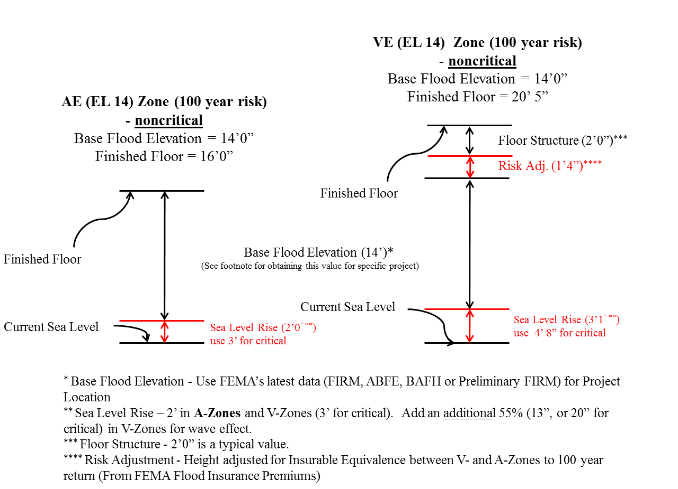

### Design and Construction

#### Overall consideration:

1. Can the need served by this asset be met through a different design in order to be more sustainable? Examples include: provide whole building ventilation systems in lieu of air conditioning; provide exterior interpretive panels in lieu of an interior visitor contact facility; provide beach changing facilities that have screening, but no roof, with separate portable restrooms in lieu of a hardened structure; provide boardwalks with sections that can be removed prior to storms, etc.
2. If the function is within a building, how has the project optimized spaces within the building to reduce overall risks from flooding, storm damage, and other natural hazards? For example, in a historic building which will remain, services such as heating/cooling/electric could be elevated.

#### Strategies:

1. Does this function require **permanent** construction (either new or existing)? Permanent construction generally has a design life of 40 years or more.
   * Is the construction in this project a “replacement” of a structure? Is this new construction where existing construction once stood?
   * Is this new construction to replace a damaged facility/asset in a different location?
   * Is there existing (and still standing) construction in the vicinity that could be used for this function?
   * What is the elevation of the lowest occupied floor (this includes “occupied” by building service equipment or storage)? Is the construction elevated above the regulatory flood plain + SLR?
   * Do existing characteristics of the site afford protection for this facility/asset, or are other protective measures being considered (e.g. sea wall, or enhanced sea wall)?
2. Can this function be accomplished using **re-locatable** construction? Such construction is permanent construction that has the potential to be moved once in its 40 year life if conditions require.
3. Can this function be accomplished using **portable or partially portable** construction? Is it plausible that the park can move and securely store such portable facilities in the time allowed to respond to a predicted storm? If portable construction is possible:
   * What natural hazard risks will it resist (e.g. what wind speed, flood level, or category of hurricane is it designed to withstand)?
   * What is the initial cost of the facility compared to a “permanent” facility?
   * What are the projected life cycle costs to remove and reposition the asset (or portions thereof) in advance of major storm events? Project teams should include the full cost of such removal multiplied by the annual probability of the event requiring the removal, e.g. if the cost for removal were $100 and the storm probability were 1 % per year, then the annual cost for removal would be $1. What park resources will be required prior to a storm and how does that fit in to the overall plan by the park to prepare for a storm?
4. Has the project considered seasonal portability (i.e. the annual relocation of the asset) to reduce risk to flooding or other natural hazards for part of the annual exposure period?
5. Can this function be accomplished with **temporary** construction? Temporary generally has a design life expectancy of less than 10 years. Temporary facilities may be interim solutions to meet an immediate requirement, with long range intent to meet the functional need in a different way, such as with a permanent facility, or through innovative approaches that require additional design or prototype development in other venues. If temporary construction is proposed, describe:
   * Storm “tolerance” of the construction (e.g. what wind speed, category of hurricane, level of flooding is it designed to withstand), and
   * What is the elevation of the lowest occupied floor (this includes “occupied” by building service equipment or storage)? Is the construction elevated above the floodplain + SLR for the life of the temporary construction? Assume a linear rate of sea level rise of 2 foot over 40 years.
   * Identify the long range strategy, rationale, and projected costs. What is the planned life of this temporary construction and what are the plans to accommodate this function in the future?
6. Can this function be accomplished with **sacrificial** construction? Sacrificial construction is that which is expected to be destroyed during an event with an average lifetime risk of 33% or greater. If sacrificial construction is proposed, describe:
   * Hazard resistance of the construction (e.g. what wind speed, category of hurricane, level of flooding is it designed to withstand),
   * Anticipated methods for and impacts of “clean up” of the associated materials if the asset is destroyed,
   * And long range strategy, rationale, and projected costs.
7. What other measures are included in the design that minimizes the investment for locations subject to risk?

With the answers to these questions, decision-makers will have explored the range of alternatives for protecting assets against flood hazard.

You have completed STOP 3: Specific Hazard Assessment, FLOOD – Coastal Storm Surge with Climate Change Effects (Sea Level Change). If you identified additional hazard risks you will want to repeat STOP 3 for those additional specific hazards.

### Authorities

* + Director’s Order #77-2, Floodplain Management
  + Executive Order 11988, Floodplain Management

*[End of FLOOD – Coastal Storm Surge with Climate Change Effects (Sea Level Change)]*

## STOP 3: Specific Hazard Considerations

**Coastal Storm Wind - UNDER CONSTRUCTION**

Coastal storms with their associated winds pose a significant risk to park assets/functions and climate change potentially amplifies this risk. To plan/design for a wind risk; decision-makers need resources to quantify the hazard now (baseline) and for the future, including resilient/adaptable construction alternatives.

### Resources

The following data and tools to define local sea level rise (SLR) may be useful in answering the questions below:

### Questions

The questions below are designed to guide decision-makers through the range of alternatives that project teams could employ to maximize resiliency against flood risk.

With the answers to these questions, decision-makers will have explored the range of alternatives for protecting assets against flood hazard.

You have completed STOP 3 Specific Hazard Assessment for WIND. If you identified additional hazard risks you will want to repeat STOP 3 for additional specific hazards.

Authorities

* + Executive Order XXXXXX

*[End of WIND – Coastal Storm Wind]*

APPENDIXES

1. Policy Authorities
   * Director’s Order #77-2, Floodplain Management
   * Executive Order 11988, Floodplain Management
   * National Park Service Management Policies Pertaining to Natural hazards – Geologic Resources Division (Excerpt - Pages 1-3 of 18)

SUPPORTING IMAGES FOR NATURAL HAZARD CHECKLIST

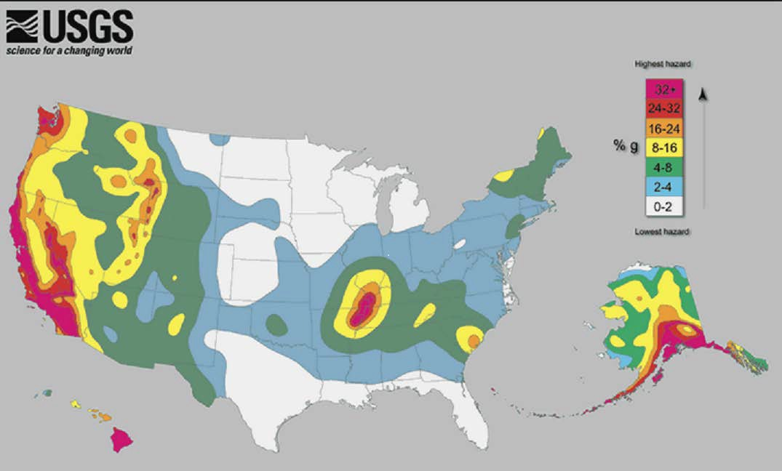

Back to Checklist

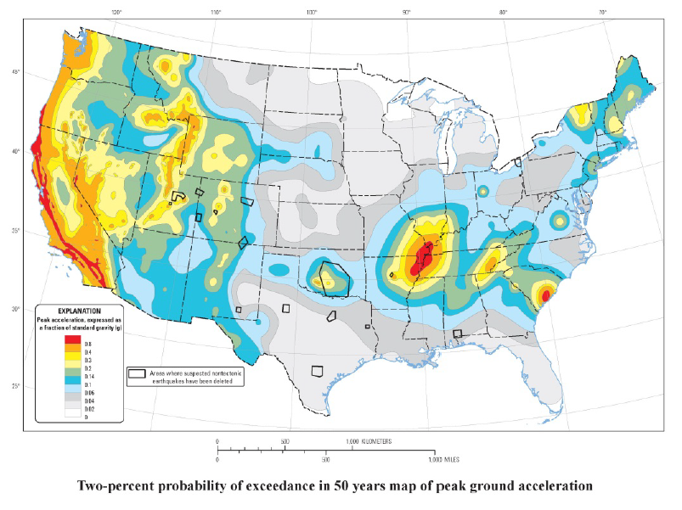

Back to Checklist

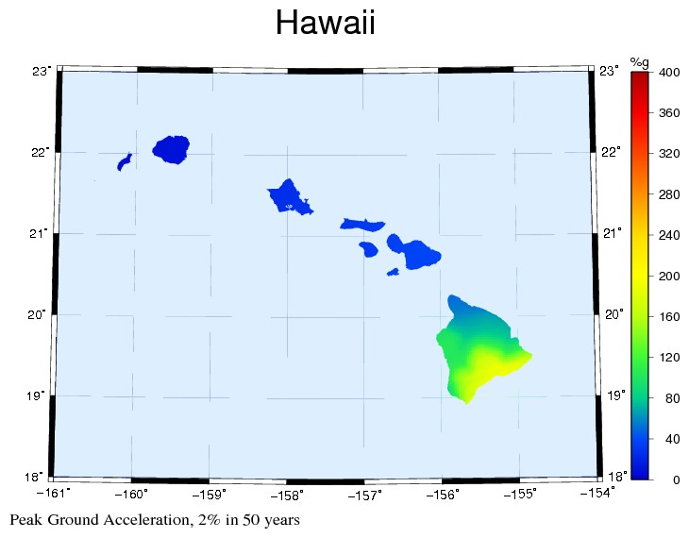

Back to Checklist

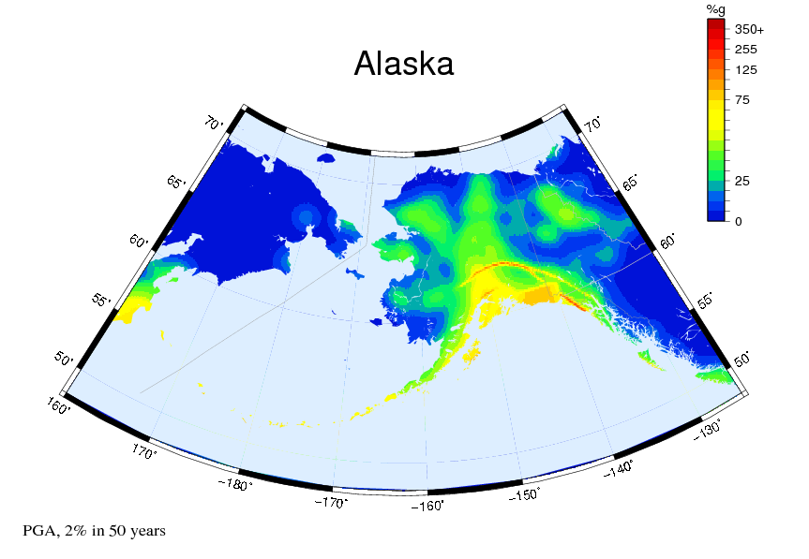

Back to Checklist

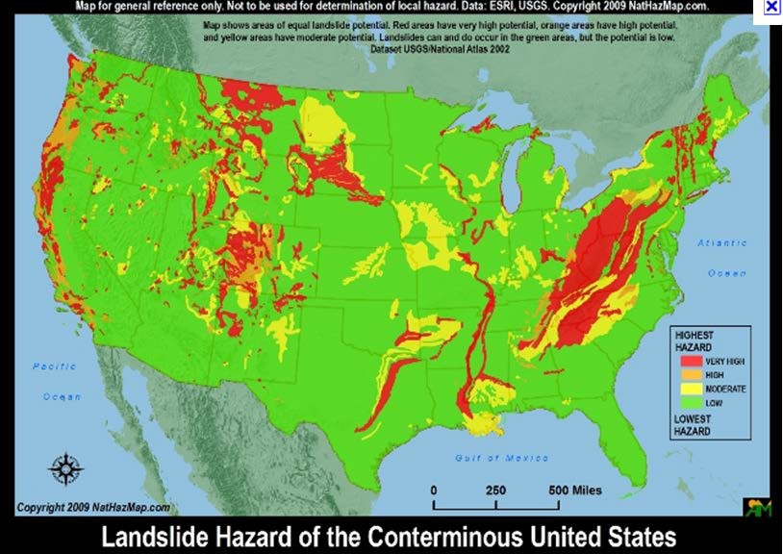

Back to Checklist

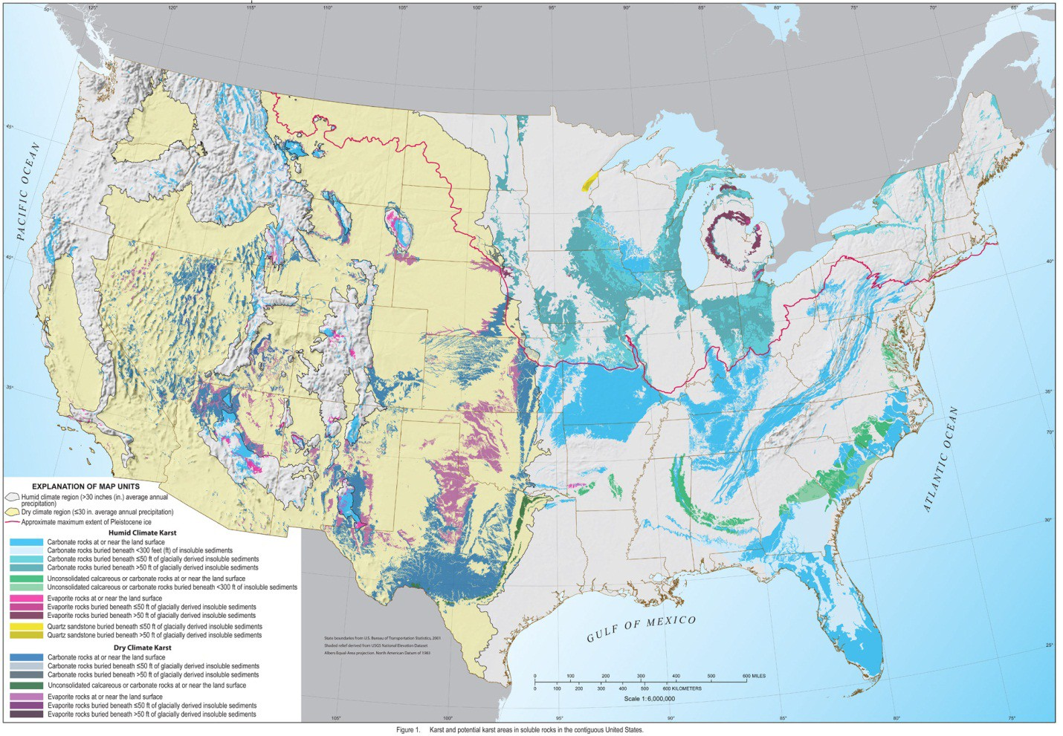

Back to Checklist

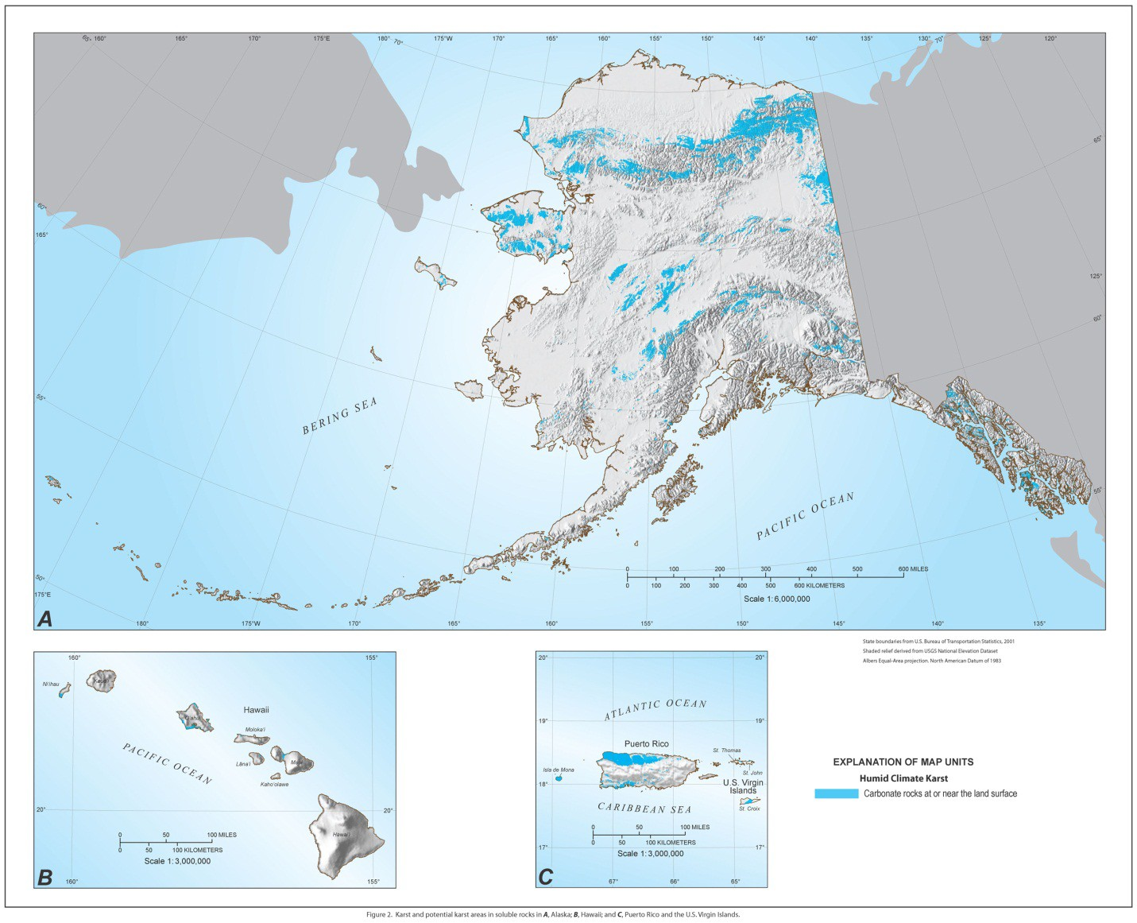

Back to Checklist

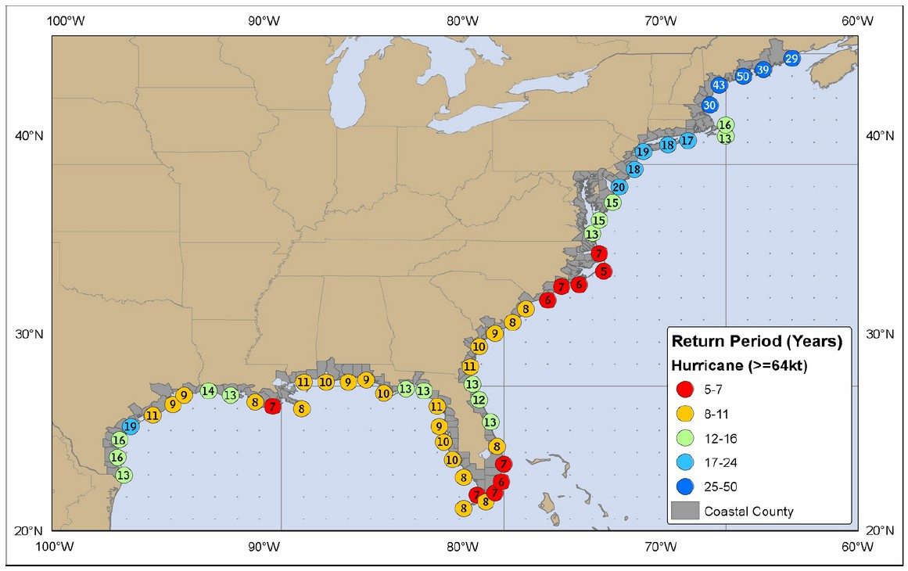

Back to Checklist

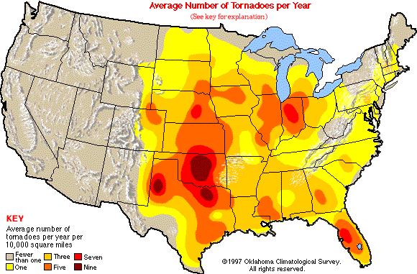

Back to Checklist

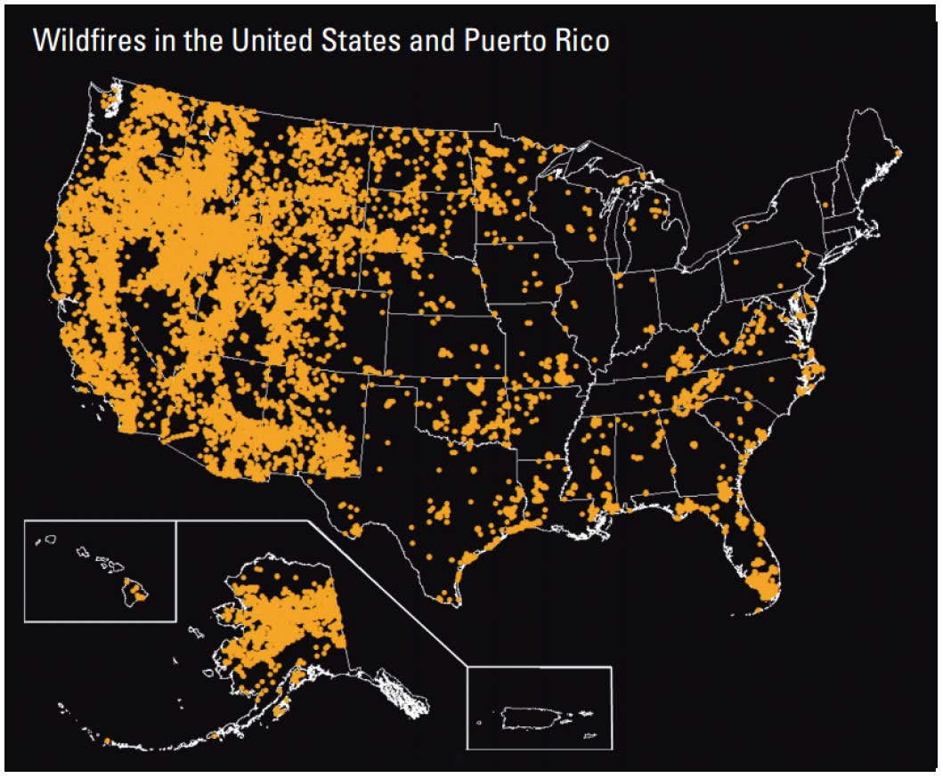

Back to Checklist

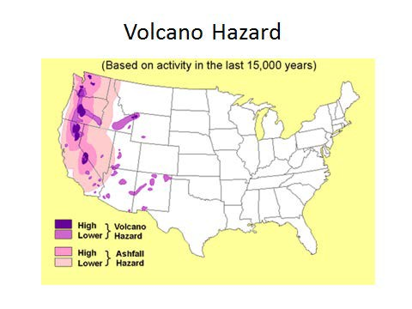

Back to Checklist