Black Canyon of the Gunnison National Park
Curecanti National Recreation Area
970-641-2337 phone
www.nps.gov/blca
www.nps.gov/cure

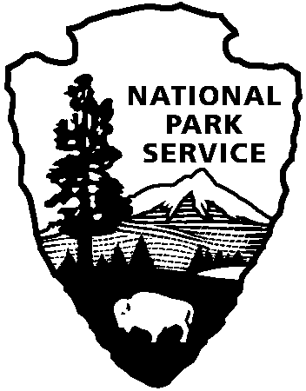
National Park Service
U.S. Department of the Interior
Black Canyon of the Gunnison and Curecanti
News Release

For Immediate Release: August 17, 2012
Contact: Sandra Snell-Dobert, 970-641-2337, ext. 227; Sandy_Snell-Dobert@nps.gov

We’re Turning 96!
Black Canyon of the Gunnison National Park and Curecanti National Recreation Area Celebrate 96th Birthday of the National Park Service

WASHINGTON: Curecanti National Recreation Area and Black Canyon of the Gunnison National Park will celebrate the 96th birthday of the National Park Service with special programs for children and families on Saturday, August 25. Curecanti will host fish art activities at the Elk Creek Visitor Center from 11:00 to 1:30. Chalk and templates will be available to create colorful schools of trout and salmon. In addition, materials and instruction will be provided to make a striking batik painting to take home (recommended for ages 8 and up).

Black Canyon will host its very own Wildlife Olympics at the High Point parking area on the south rim from 12:30-3:00. How high can you jump? How fast can you run? How far can you smell? This event will allow you to compare your abilities to those of animal champions in our very own Olympic Games. Medals will be awarded to all participants.

Both programs are designed to allow you to arrive any time within the scheduled windows, and stay as short or as long as your schedule allows.

The National Park Service was established on August 25, 1916. The United States was the first country in the world to set aside its most significant places as national parks so that they could be enjoyed by all. Today, we care for 397 national parks throughout the country – each one an important part of our collective identity. Some parks commemorate notable people and achievements, others conserve magnificent landscapes and natural wonders, and all provide a place to have fun and learn something. Plan your visit at www.nps.gov/findapark.

The mission of the National Park Service extends beyond parks into communities across the country where we work with partners to help preserve local history and create close-to-home recreational opportunities that revitalize neighborhoods and enhance the quality of life. To see what we do here in Colorado, go to www.nps.gov/CO.

www.nps.gov

