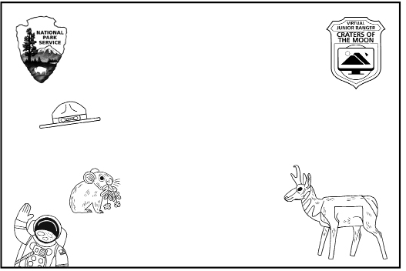

# This certifies that

your name

**is a Craters of the Moon**

# National Monument & Preserve

Virtual Junior Ranger

**As a Junior Ranger, I promise:**

To explore the wonders of the earth, from my home and in person,

so I can reach for the stars! I promise to take care of

Craters of the Moon National Monument & Preserve and other special places, so that I may enjoy them

and for future generations. I “lava” Craters of the Moon!

cut along the dotted line

|  |  |
| --- | --- |
| Congratulations on completing the Craters of the Moon Virtual Junior Ranger program!  Cut out your certificate, color it in, and write your name on it.  Color your badge, glue it to thick paper or cardboard, and carefully cut it out. Attach a piece of string or a safety pin to the back to wear it! | illustration of a badge with the text "virtual junior ranger, Craters of the Moon" and an icon of two volcanoes on a computer screen |