Work Sheet 4C
Adapting to a Brutal Land
Name: _________________________
Over 300 species of plants live at Craters despite it being hot and dry in summer and cold and snowy in winter. Each of them is adapted to living in a specific way in their environment. Some live only in cracks and crevices, some only on north sides of cinder cones, and some live in a variety of places. The reason for these differences is related to the plants' tolerance to temperature and available water.
Rate the following three habitat types from 1 to 3, wettest to driest. Then, tell what plants would grow there by writing their corresponding numbers in the appropriate place in the third column.
___________________________________________________________
Wettest to Driest Habitat Types Plants Best Suited
For Growing There
________2_____________Boise, Idaho__________3, 5____________
________1____________Brazilian Rainforest_____2, 4____________
________3____________Mojave Desert_________1, 6_____________
- Barrel cactus-a succulent plant armed with spines. Can absorb water quickly and hold it in its fleshy tissue. Doesn't like to freeze. To three feet tall.
- Strangler fig-starts out by growing on other tree's high branches to get more sunlight. Grows tendrils to forest floor for nutrients and water and then grows bigger and "strangles" the tree it started growing on. Likes warm, wet places.
- Ponderosa pine-grows in soil moist from melting snow. Needles evaporate little water in dry summers.
- Walking palm-huge dark green leaves for collecting sunlight at the bottom of a dark forest. The entire tree can move side to side over several years to find more light.
- Black cottonwood-grows quickly along rivers in warm summer, but loses its leaves before the arrival of very cold winter.
- Smoke tree-tiny light-gray leaves are resistant to drying out in wind. Has long root system to get water deep in the ground.
Rate the following Craters habitat types from 1 to 5, wettest to driest. Then read through the plant descriptions and place them in the appropriate habitat type(s). Things are not black and white in nature; most plants can be found in more than one habitat type. Hint: You must know why it matters to a plant whether it lives on the north or south side of a mountain? Which side is drier and why?
Wettest to Craters of the Moon Habitat Types Plants Best
Driest or Suited for Coolest to
Hottest Growing There
_____2__________North sides of cinder cones with deep soils____2, 4, 7, 10, 11_______
_____5___________Surface of smooth, flat lava flows_______10___________________
____4____________South sides of cinder cones with little soil__2, 3, 8, 10____________
_____1___________Caves with light shining in and thawing ice___1, 5, 10___________
_____3___________Cracks and crevices of a lava flow______1, 6, 7, 9, 10___________
- Sagebrush - large leaves in spring and small leaves in summer help it to row in full sun. Likes good soil but not shade.
- Dwarf buckwheat - many small hairs on the surface of its leaves help keep it from losing water because it lives in hot country where its long roots find rare water. A very small plant.
- Ferns – require shade and protection from drying winds.
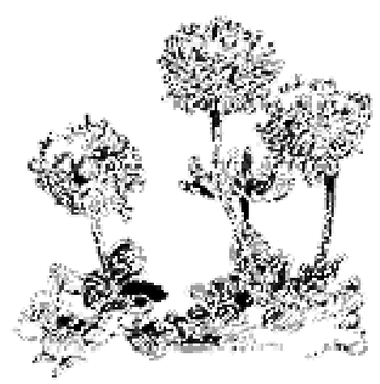

Dwarf Buckwheat
- Douglas fir - grows best in cool, moist mountains in good soil. Doesn't like full sun or growing by itself.
- Moss - grows in the coolest, wettest places, never in full sun.
- Syringa - drought tolerant plant that grows in small, sheltered areas in lava flows. 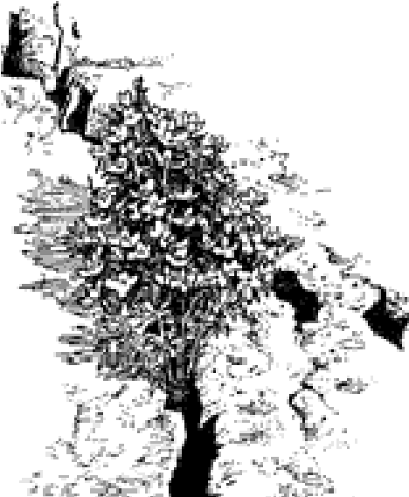

Syringa
7. Limber pine - requires soil but can survive heat, wind, and lack of rain better than most pines.
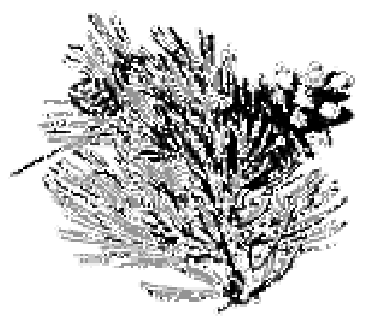

Limber Pine
8. Dwarf monkey flower - it grows up, produces seeds, and dies in three weeks during the spring. It survives only as seeds during summer and winter. Grows in full sun where few other planes can.
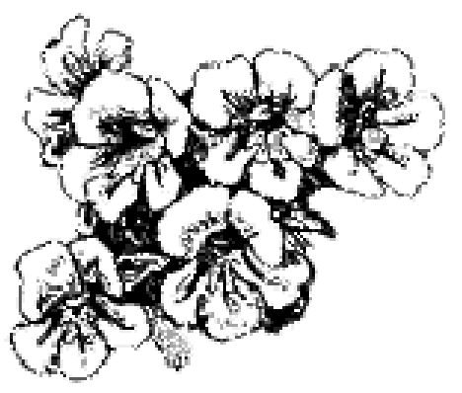

Dwarf Monkey Flower
- Gland cinquefoil - tougher than syringa, but still requires a crack or small pocket of soil to sink its roots.
- Lichens - live almost everywhere, even where practically nothing else can. They're black, yellow, green, gold, or orange and live on rocks and trees.

Lichens
11. Quaking aspen - a mountain tree whose broad leaves cannot tolerate heat and wind. Needs deep soils, shade, and moisture. Seldom grows alone.
Procedure:
Adaptation Artistry (adapted from Project WILD)
Now that the students are adaptation experts with real life plant examples, let them use their imaginations to create their own well-adapted animals. They can draw them or use clay, construction paper, pipe cleaners, etc.
The students should be able to answer the following about their species:
- What is its habitat and how is their species well adapted to it?
- What does their animal eat; how does it get its food?
- How does it move?
- What is the animal's sex?
- What is the name of the species?
Their creation should be well-adapted to all the devious environmental constraints they will hopefully create for it.
As an example, one student made a "flapper." Flappers live on school cafeteria floors where they forage on food waste. They are camouflaged to look exactly like a pancake. When no one is looking they scoot across the floor to find more food or leave before the janitor comes. Unfortunately, in schools where students are learning to waste less food, flappers are becoming endangered.

