Scientific vs. Non-Scientific Writing
Name:____________________
Robert Limbert explored Craters of the Moon in the 1920's and wrote an article about it for National Geographic in 1924. Some of his sentences from that article follow. They can be divided in two ways. Some sentences just tell the facts while others tell Limbert's opinion. Read each statement and decide which ones simply report what he saw and which sentences tell how he felt or what he believed. Label sentences that report the facts as "S" for scientific. Label sentences that report Limbert's feelings or opinions as "NS" for non-scientific.

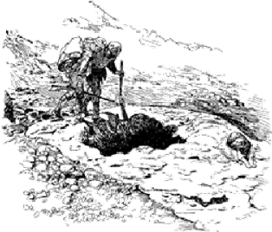
- __________“The animal life consists principally of migrant bird, rock rabbits, woodchucks, black and grizzly bears…”
- __________"...its scenery is impressive in its grandeur."
- _________"A glance at a map of Idaho shows that the southern part of the State, lying between Arco and Carey and north of Minidoka, is a vast region labeled desert or rolling plateau."
- __________“...this section is destined someday to attract tourists from all America, for its lava flows are as interesting as those of Vesuvius, Mauna Loa, or Kilauea."
- __________"The district consists of some 63 volcanic craters, lava, and cinder cones, all at present extinct or dormant."
- __________"That a region of such size and scenic peculiarity in the heart of the great Northwest could have remained practically unknown and unexplored is extraordinary."
- ___________"the peculiar features seen on those trips led me to take a third trip across the region in the hope that even more interesting phenomenon might be encountered."
- ___________"We also took with us an Airedale terrier for a camp dog."
- ___________"After drinking our fill, we made the discovery that the water was full of innumerable little bright red wrigglers that looked like small shrimp. Each was about three-sixteenths of an inch long."
- ___________"However, the water was good and one cannot afford to be squeamish in desert country."
- ___________"It is the only water in this vicinity which can be depended upon the year round."
- ___________ "Along the slope there were evidences that bears had been digging for roots and rolling rocks for ants."
- ___________ "Think of the years of travel necessary to make that mark on the rock!"
- ___________"Near here we built a signal fire that was seen by people watching for it 30 miles distant."
- ___________"The crags had magnetic properties, and the compass needle could not be depended upon when near them."
- __________"As we stood on the edge and looked down, we tried to imagine the wonderful sight when the whole lava bed was glowing red."
- ___________From the ceiling hung clusters of immense ice stalactites, sometimes touching a few stalagmites of the same material below."
- ___________"The floor was covered with ice so clear that when I first reached it I dipped down for a drink."
- ___________"The dog was in terrible shape also; it was pitiful to watch him, as he hobbled after us."
- ___________ "To be frank, I had some very queer thoughts, chief of which was, "Will anybody ever find me or shall I, like the [dead] sheep, lie here for years?"

