Small arrowhead on black background

Cowpens

National Park Service

U.S. Department of the Interior

**Washington Light Infantry Monument**

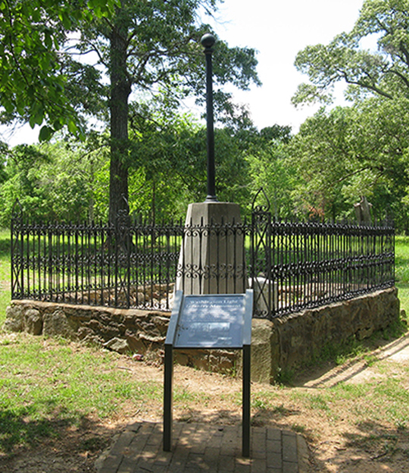**The Washington Light Infantry built this monument in 1856, several years before the Civil War, and this type of design typified Revolutionary War monuments of the era. Before the Civil War, the nation commemorated few battlefields with monuments, and most of these were in the North (such as Bunker Hill). Many southern battle sites became agricultural land and the battlefields forgotten. This monument is significant in that it represents one of the few such examples of the time period to memorialize a Revolutionary War battlefield in the South.**

**It All Started because of a Flag**

**The monument’s story starts in 1807 with the founding of the Washington Light Infantry, a South Carolina militia group based in Charleston. From its inception, the Washington Light Infantry participated as a unit in every major war involving the United States through World War I, and reinforced other units in Europe in World War II. Individual members continue to fight worldwide with the US military.**

**The militia was named in honor of George Washington, but in 1827 they also became associated with his cousin, cavalry commander Colonel William Washington. That year, Colonel Washington’s widow donated her late husband’s Eutaw flag, which had flown throughout the Southern Campaign of the Revolution, to the group.**

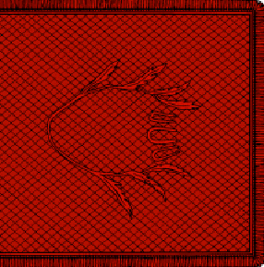

**The Eutaw Standard of Colonel William Washington’s Cavalry.** The story of the flag’s origin is as follows: “Colonel Washington spent an hour with the fair Jane Elliott before the campaign through Eutaw and the Cowpens. She [said she] would await news of the triumph of his flag. ‘But I have no flag,’ he said. ‘Then I’ll give you one!’ she replied, and cut a square of brocade from a curtain. It later flew at their wedding.”

**During the 1850s, the country as a whole was in a great deal of turmoil. The problems climaxed with the division in Kansas, as settlers in the region waged bloody battles over the issue of slavery. As this controversy continued, friction developed not only throughout the country, but within the Washington Light Infantry as well. The commanders of the unit decided they needed a common project to unify their group. The 75th anniversary of the Battle of Cowpens was coming up, and Captain Lewis Hatch decided this was the perfect opportunity. Cowpens was arguably the most important battle involving Colonel Washington, so the Washington Light Infantry decided to focus their efforts on building a monument to honor the battle.**

**Construction and Dedication**

**In April 1856, the Washington Light Infantry travelled from Charleston to Laurens, SC by train. From Laurens they marched to Spartanburg. They spent a day and a half there before arriving at the Battle of Cowpens site on April 21 and laying the monument’s foundation. To celebrate their arrival, they shot off fireworks, and a band played music. Starting work after breakfast the next day, the group built an octagonal base made with shells and sand from Fort Moultrie on Sullivan’s Island. Before sealing the base, they placed relics inside, including a bottle of water from Eutaw Springs (another important battle involving Col. Washington), a brick from a house near the Eutaw Springs battleground, an account of the Battle of Cowpens, a copy of the songs that they sang on the occasion, and a roster of the Washington Light Infantry members involved in constructing the monument. They completed the project by 2:00 on April 22 and began the dedication ceremonies. With locals and others looking on, they waved the Eutaw Flag over the monument three times, and the Cowpens Artillery fired a salute. The Washington Light Infantry changed into their dress uniforms for the remainder of the program, which included a picnic provided by the ladies of Spartanburg. Following the picnic were a prayer, scripture reading, speeches, and songs. At the conclusion of the ceremony, a photographer took a daguerreotype of the monument flanked by the Washington Light Infantry.**

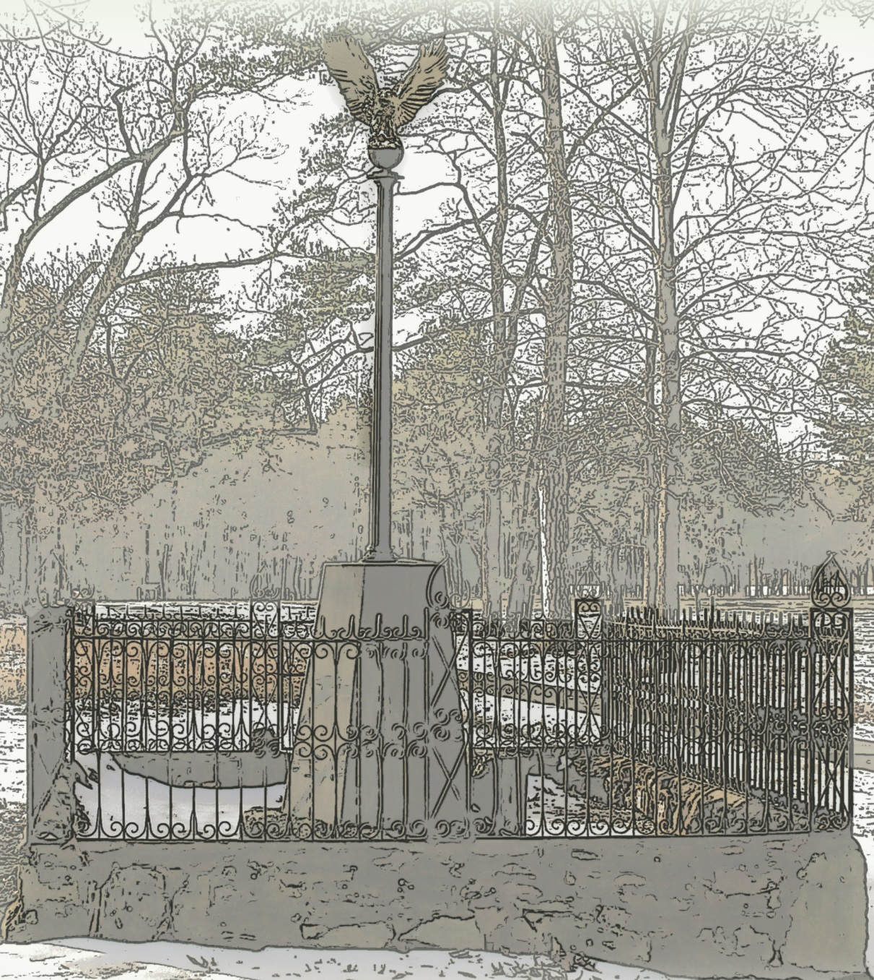

Artist’s interpretation of the original Washington Light Infantry Monument

**A Century of Neglect**

**At the time of construction, the monument stood on private property. To preserve the land, a group of Spartanburg women decided to raise funds to purchase a one-acre tract around the monument. Through a series of fundraisers and bake sales, the women purchased the deed in July 1856. A group of local men subsequently erected an iron fence around the monument. These last improvements completed the first commemorative effort of the battleground.**

**Since that time, the monument has suffered several attacks of vandalism.**

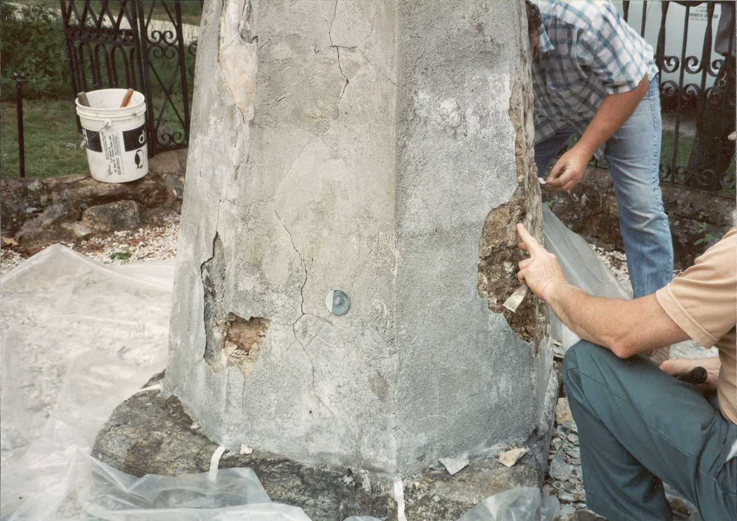

Workers repair the monument in 1980 after years of vandalism and neglect.

**With the expansion of Cowpens National Battlefield in 1972, the National Park Service began preserving the battlefield as well as the other historical structures onsite, including the Washington Light Infantry Monument. In 1980, they made repairs to restore the monument to its original state. The National Park Service is dedicated to preserving the monument as it reflects the earliest commemoration of the battlefield.**